1. Supplemental Equations

Diffusion profile matching probability modeling.
The probability of diffusion profiles matching is modelled as the following in PIXiE.

 | 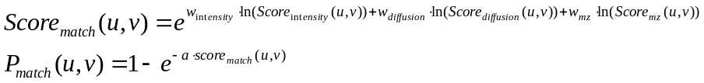 | (1)

MAP Bayesian probability models used in PIXiE.
 | 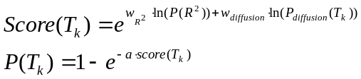 | (2)

 | 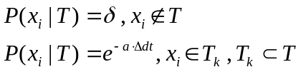 | (3)

2. The iteratively reweighted least squares option
Using the simple linear least squares, the uncertainty of drift time measurement in high-leverage peaks could contribute an unproportioned amount of overall measurement uncertainty in collision cross section, e.g., one TOF pulse of drift time error at the highest electric field could contribute ~10 Å² of error collision cross section. The iteratively reweighted least squares (IRLS) method has two benefits:
- IRLS redistributes each electric field’s contribution to the final CCS result evenly. In theory it should improve both accuracy and precision, the scale of which depends on types of error present.
- IRLS especially acts as a countermeasure to numerical and measurement errors in drift time/temperature/pressure measurements in high leverage voltage groups.
To evaluate the impact of iteratively reweighted least squares on the calculation of collision cross sections, we compared the collision cross section values that PIXiE generates to computationally predicted values. The average percentage error between predicted and experimental values was 5.2%. Turning on iteratively reweighted least squares reduces the average percentage error to 4.5%. A detailed correlation is plotted in Fig. S1. As a result, we conclude that turning on the IRLS option reduces both systematic bias and measurement uncertainties. The IRLS option is especially recommended for data with an irregular number of electric fields.

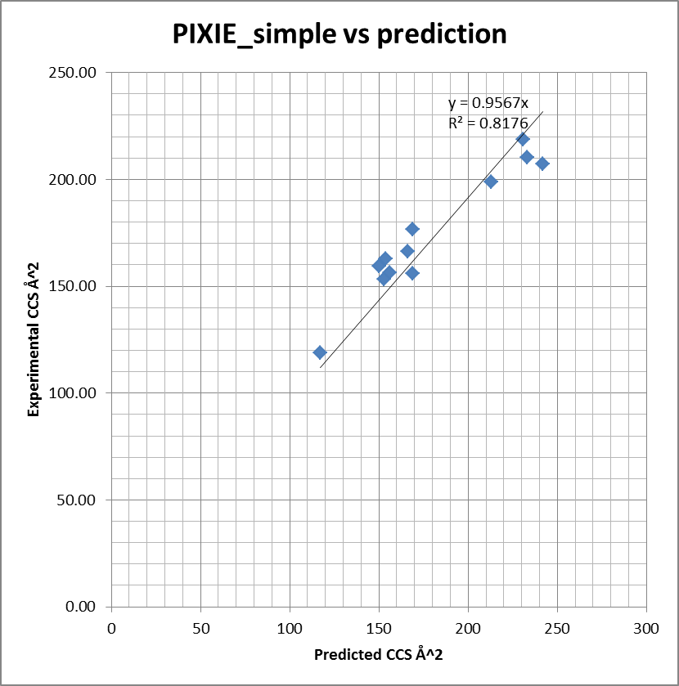 | 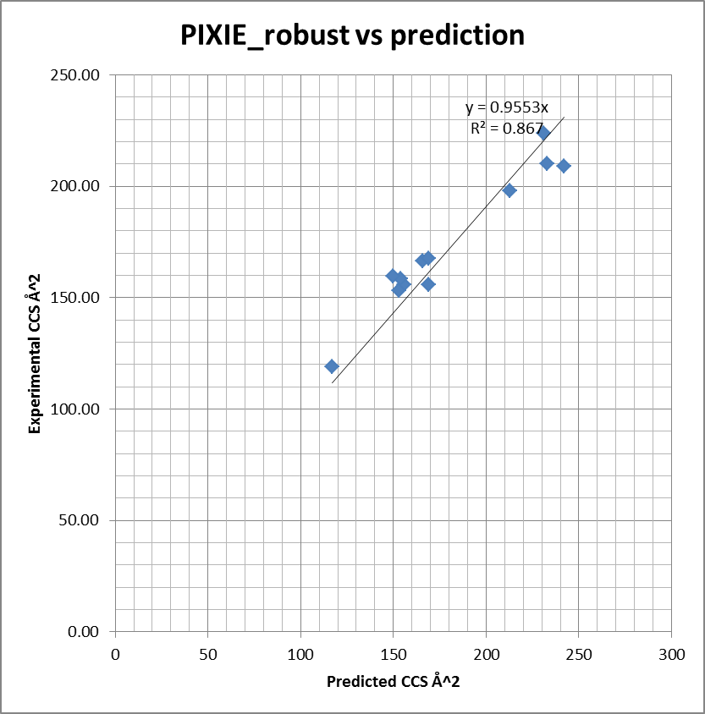
Figure S1. (a) Correlation plot of PIXiE CCS vs NWChem predicted CCS with the IRLS option off. (b) Correlation plot of PIXiE CCS vs NWChem predicted CCS with the IRLS option on.

3. In silico prediction of CCS values

3. Supplemental Table S1
Chemical |  | adduct | PIXIE CCS -IRLS | PIXIE CCS -Default | NWCHEM prediction | Literature CCS | Additional detected conformers
adenosine |  | [M+H] | 166.5 | 166.1 | 163.5 | 166 | 1 conformer, CCS = 157
adenosine |  | [M+Na] | 167.7 | 165.1
choline |  | [M+] | 119.1 | 119.0 |  | 117
cytidine |  | [M-H] | 155.9 | 156.2 | 160.8 | 156
D-tryptophan |  | [M-H] | 158.7 | 159.1 |  | 154
folicAcid |  | [M+H] | 202.0 | 198.6 |  |  | 1 conformer, CCS = 207
folicAcid |  | [M+Na] | 209.1 | 207.0 | 227.9 | 242
folicAcid |  | [M-H] | 198.1 | 198.9 |  | 213
fructose-1-6-diphosphate |  | [M-H] | 155.9 | 156.2 | 166.0 | 169
glucosamine-6-phosphate |  | [M+H] | 153.1 | 153.2 | 146.5 | 153 | 4 conformers, CCS = 156, 165, 187, 201
glucosamine-6-phosphate |  | [M+Na] | 172.0 | 172.0
glucosamine-6-phosphate |  | [M-H] | 159.7 | 155.9 |  | 150
NAD |  | [M-H] | 223.9 | 219.0 |  | 231 | 1 conformer, CCS = 176
sucrose |  | [M+Na] | 167.4 | 176.7 | 169.6 | 169
UDP-galactose |  | [M-H] | 210.3 | 210.6 |  | 233

