Data formatted for the manuscript but that may or may not go to the final manuscript goes here
Table 0. 20 exposome chemicals, PIXiE extraction and NWChem prediction
Chemical | Mobcal-NWChem prediction | PIXIE extraction
Bis(2-ethylhexyl)phthalate[M+H] | 223.21 | 215.02
Bis(2-ethylhexyl)phthalate[M+Na] | 228.44 | 205.46
BOSCALID[M-H] | 179.72 | 176.95
ESTRIOL[M-H] | 171.99 | 181.92
Fluometuron[M+H] | 154.86 | 142.85
Fluometuron[M-H] | 147.76 | 143.32
FLUROXYPYR-1-METHYLHEPTYLESTER[M+H] | 195.1 | 192.72
FLUROXYPYR-1-METHYLHEPTYLESTER[M+Na] | 194.23 | 192.38
FLUROXYPYR-1-METHYLHEPTYLESTER[M-H] | 186.15 | 180.29
HEXACONAZOLE[M+H] | 174 | 172.10
HEXACONAZOLE[M+Na] | 172 | 175.96
IMAZAPYR[M+H] | 162 | 152.14
IMAZAPYR[M+Na] | 161 | 174.48
IMAZAPYR[M-H] | 158.91 | 163.92
IMAZAQUIN[M+H] | 174.94 | 185.68
IMAZAQUIN[M+Na] | 175.75 | 191.60
IMAZAQUIN[M-H] | 180 | 175.21
ISOXABEN[M+H] | 187.99 | 182.41
ISOXABEN[M+Na] | 194.05 | 194.45
ISOXABEN[M-H] | 187.94 | 194.22
Metribuzin[M+H] | 150.65 | 142.26
Metribuzin[M-H] | 147 | 143.29
NAPROPAMIDE[M+H] | 170 | 163.19
NAPROPAMIDE[M+Na] | 171.08 | 174.49
Oryzalin[M+H] | 190.57 | 176.45
PERMETHRIN[M+Na] | 190.92 | 193.80
TDCPP[M+Na] | 170.91 | 191.20
Thiabendazole[M+H] | 144 | 136.13
Thiabendazole[M+Na] | 149.29 | 152.43
Thiabendazole[M-H] | 148 | 143.58
thiophanate_methyl[M+H] | 178 | 180.18
thiophanate_methyl[M+Na] | 177.73 | 179.77
TRIBENURON-METHYL[M+H] | 195.94 | 181.06
TRIBENURON-METHYL[M+Na] | 192.95 | 192.36

Table 1. Comparison of CCS values from literature prediction, literature experimental average, PNNL NWChem prediction, PIXiE CCS extraction with iteratively reweighted least squares turned on, PIXiE CCS extraction with iteratively reweighted least squares turned off, and hand calculation values.
 |  | Predicted | Exp. Ave. | PNNL calc | PIXiE (robust) | PIXiE (ordinary) | hand
 |  | CCS | CCS | CCS | CCS | CCS | CCS
Chemical name |  | (Å2) | (Å2) | (Å2) | (Å2) | (Å2) | (Å2)
Adenosine | [M+H]+ | 166 | 151 | 164 | 166 | 166 | 166
Folic acid | [M+Na]+ | 213 | 202 | 228 | 209 | 207 | 207
Folic acid | [M-H]- | 242 | 188 | 244 | 198 | 199 | 199
Taurine | [M+H]+ | 127 | 124 | 128 | 130 | 136 | 136
Sucrose | [M+Na]+ | 170 | 171 | 170 | 167 | 177 | 177
Fructose 1,6-bisphosphate | [M-H]- | 169 | 150 | 166 | 156 | 156 | 156
Glucosamine 6-phosphate | [M+H]+ | 153 | 150 | 147 | 153 | 153 | 153
Glucosamine 6-phosphate | [M-H]- | 150 | 146 | 152 | 160 | 160 | 160

Table 2. PIXiE robust vs literature experimental vs literature prediction
chemical | P(H|X) | ionization | CSB | Waters | DUKE | Predicted | PIXiE | m/z | Note
Adenosine | 0.385061 | [M+H] | 152 | 152 | 150 | 166 | 166 | 268.1094 | 1 conformer, CCS = 157
Choline | 0.708064 | [APCI] | 119 | 119 | 113 | 117 | 119 | 104.1065
Cytidine | 0.380021 | [M-H] | 150 | 148 | 146 | 156 | 156 | 242.0741
FolicAcid | 0.596102 | [M+Na] | 203 | 202 | 202 | 202 | 209 | 464.1315
FolicAcid | 0.743599 | [M-H] | 185 | 189 | 191 | 242 | 198 | 440.1287
Fructose-1-6-diphosphate | 0.743116 | [M-H] | 149 | 150 | 152 | 169 | 156 | 338.9857
Glucosamine-6-phosphate | 0.006906 | [M+H] | 153 | 150 | 148 | 153 | 153 | 260.0553 | 4 comformers, CCS = 156, 165, 187, 201
Glucosamine-6-phosphate | 0.445685 | [M-H] | 143 | 147 | 148 | 150 | 160 | 258.0363
NAD | 0.24026 | [M-H] | 225 | 224 | 230 | 231 | 224 | 662.0969 | 1 conformer, CCS = 176
Sucrose | 0.535309 | [M+Na] | 161 | 167 | 166 | 169 | 167 | 365.1105
UDP-Galactose | 0.796945 | [M-H] | 203 | 200 | 210 | 233 | 210 | 565.0408

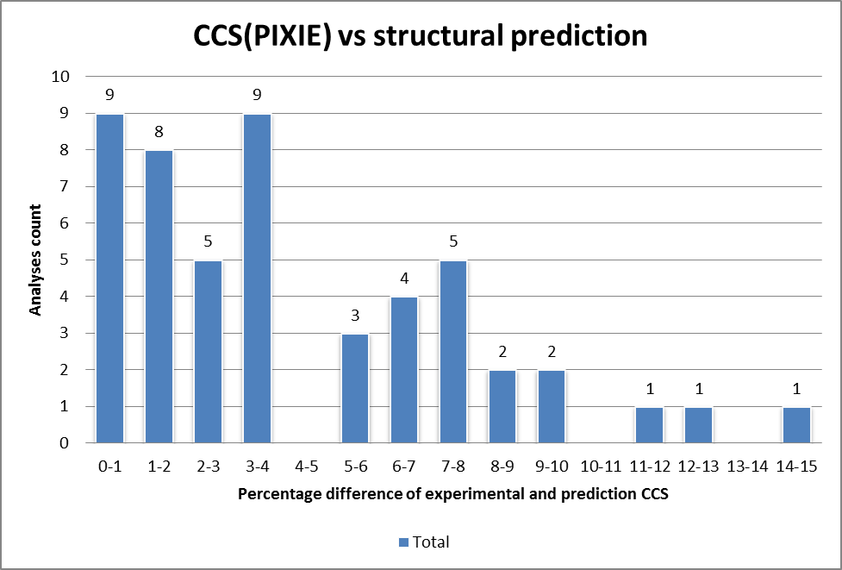
Supplementary Figure 1 a) Frequency plot of PIXiE CCS vs NWChem prediction. Supplementary Figure 1 b) Correlation plot of PIXiE CCS vs NWChem prediction
