Inconsistency between bottom-up and top-down global gross primary production and soil respiration

Jinshi Jian1, Alexey Shiklomanov1, Ben Bond-Lamberty1*

1. Joint Global Change Research Institute, Pacific Northwest National Laboratory, 5825 University Research Ct. #3500, College Park, MD 20740 USA

**Summary**

The terrestrial carbon cycle strongly influences global climate change. Both top-down (e.g., remote sensing and earth system models) and bottom-up (derived from field measurements) estimates have been made of major components (e.g., gross primary production, GPP, and soil respiration, RS) of the terrestrial carbon cycle, as well as their response to global climate change. However, these top-down and bottom-up estimates have not been compared for consistency.

In this study, we first partitioned historical GPP estimates into their NPP and autotrophic respiration components, and calculated global RS (74±21 Pg C yr-1, 95% confidence interval). There is only a ~28% probability that these estimates are consistent with the previous global RS estimates from literature (86±6 Pg C yr-1). Second, based on the global RS estimates collected from literature, we then partitioned RS into its different components (shoot and root respiration), and calculated the resulting implied global GPP (145±46 Pg C yr-1), which had ~29% probability of being consistent with the global GPP estimates by remote sensing or ecosystem models (122±13 Pg C yr-1). This highlights the inconsistence between bottom-up and top-down based GPP and RS estimates that have a ~20 Pg C gap between them. The reasons of the inconsistency need further study for better understanding global terrestrial carbon cycling in the future.

**Abbreviations**: RS – soil respiration, RSG – global annual mean soil respiration, Rroot – root respiration, Rshoot – shoot respiration, Ra – total autotrophic respiration, Fire – NPP burned by fire, Csink – NPP going to underground as carbon sink, Herb – NPP consumed by herbivore, RC – Rroot to RS ratio.

**Main**

We compared the bottom-up estimated GPP (pink density distribution in Figure 1 a) with the collected GPP estimates from publication in the past decades (lightblue density distribution in Figure 1 a), we found a big mismatch between them, with only ~28% possibility they will consistent each other (i.e., GPP estimates from the published papers, 111-134, with only ~28% chance falls in the bottom-up GPP distribution). We compared the top-down estimated global RS (pink density distribution in Figure 1 b) with the collected global RS estimates from publication in the past decades (light-blue density distribution in Figure 1 b), we found a big mismatch between them, with only ~29% possibility they will consistent each other (i.e., global RS estimates from the published papers, 81-92, with only ~29% chance falls in the top-down global RS distribution).

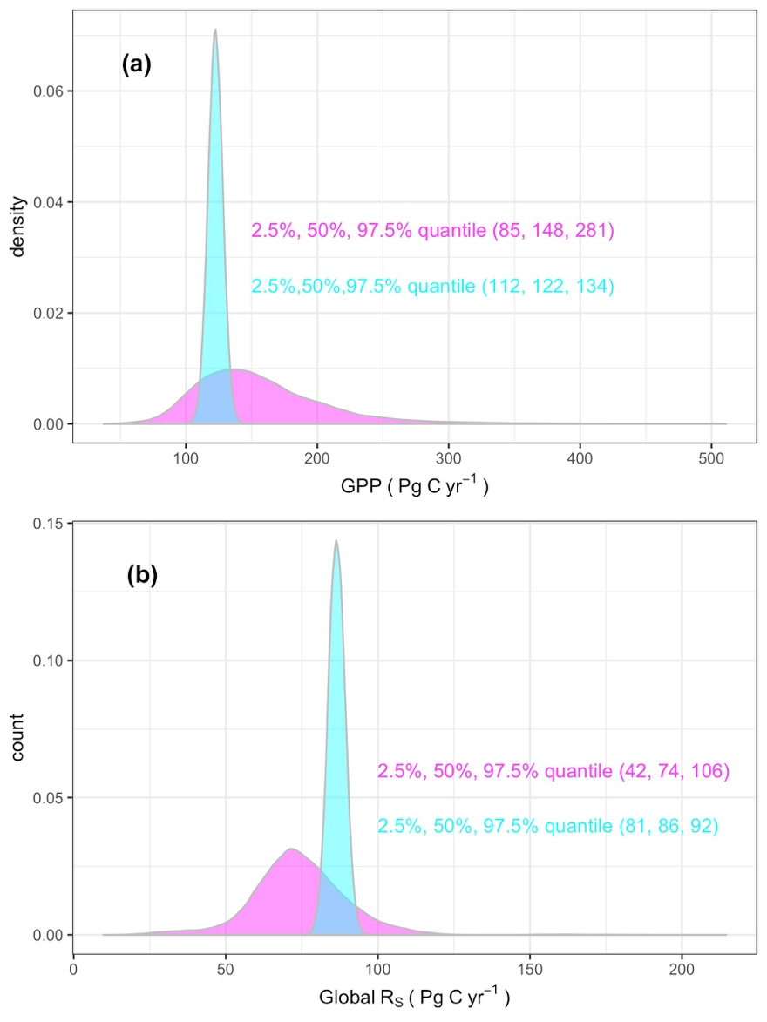

Figure 1. Mismatch between bottom-up-GPP (pink histogram) and GPP estimates collected from historical publications (bottom-up-GPP, light blue). Mismatch between top-down estimated global soil respiration (pink) and global soil respiration estimates collected from historical publication (bottom-up-RS, light blue).

**Method**

**Here we conducted a summary analysis of global terrestrial carbon cycling to compare and explore the consistency of top-down and bottom-up GPP and global RS estimates.** To make this comparison, we evaluated two approaches to partitioning the global carbon cycle from known estimates of the various fluxes and calculated the unknowns (Figure 2, Figure S1–S4 and Table S1–S4). Soil respiration consumed the photosynthetic carbon assimilation, which was fixed by plant, or called gross primary production (GPP). Plant autotrophic respiration (including leaf respiration and stem respiration (Rshoot) and root respiration (Rroot)) consumed part of GPP, the left part was called net primary productivity (NPP). Part of NPP consumed by heterotrophic respiration (Rh), other part of NPP was consumed by herbivores, burned by fire or becomes long term carbon storage (carbon sink), and the sum of root respiration (Rroot) and heterotrophic respiration (Rh) is soil respiration. Theoretically, if we know the pathway of each part of global annual GPP, we can estimate global mean annual soil respiration (top-down RSG). Similarly, if we can accurately measure each component of carbon cycle, we can estimate GPP (bottom-up GPP).

***Data collection***

**We collected 17 published RSG estimates from articles, with approximately half of studies reported RSG standard deviation (SD, n=9, Table S1) and change rate during a period (n=7, Table S1).** The reported RSG range from 68 to 98 Pg C yr-1, with an average RSG of 85 Pg C yr-1. The RSG were estimated from 1970s to 2010s, and the RSG estimate showed a clear increase trend from the earlier years to the modern year (increase rate = 0.52 Pg C yr-2, Figure S1 b). However, this rate is much higher than the average increase rate reported by previous studies (mean = 0.06 Pg C yr-2, n=7, Figure S1 c).

**We collected 77 GPP estimates from published articles, with only 10 of estimates reported corresponding SD, and 26 estimates reported corresponding trend during a period (Table S2).** The reported GPP estimates were from 1950s to 2010s, ranged from 71 to 183 Pg, and with an average of 125 Pg C yr-1. There is a clear positive relationship between GPP and estimate-year, with an increase rate of 0.29 Pg C yr-2, Figure S1 e), which is very close to the mean of reported increase rates (0.26 Pg C yr-2, Figure S1 f). Furthermore, the extreme high (183.39 Pg) and low (71.73 Pg) GPP estimates does not affect the overall mean GPP (125 Pg), but the trend decrease to 0.08 Pg C yr-2 if these two estimates were excluded (Figure S1 e).

**Global NPP estimates were directly from a previous meta-analysis (Table S3 and Figure S2 a).** In order to estimate Rh, we collected published estimates on NPP going to the terrestrial (Csink), NPP components burned by fire, and NPP components consumed by herbivores (Table S3).

**RS consists of heterotrophic respiration (Rh) and root respiration (Rroot).** Despite the difficulty, many studies separated RS into Rroot and Rh and many of those Rroot-to-RS ratio (RC) have been compiled into the SRDB-V41 (Figure S2). We used all RC values from SRDB-V4 whenever it is larger than 0 and smaller than 1, totally 617 RC values were used in this study. RC values covered 9 vegetation types, but the majority were from forest, grassland, agriculture, and shrubland, all other vegetation types only have 16 samples (Figure S2 c).

**Autotrophic respiration (Ra) consists of root respiration (Rroot) and shoot respiration (Rshoot),** **Rroot-to-Ra ratio is required to separate Ra into Rroot and Rshoot.** Rroot-to-Ra ratio used in this study were from two sources: (1) We collected 35 Ra-to-Ra ratio estimates from 28 studies (Table S4); (2) We obtained additional 87 Rroot-to-Ra ratio estimates from SRDB-V4 (Table S4). Rroot-to-Ra ratio covered 7 vegetation types (Figure S3), but mainly from forest, all other vegetation types only have 11 samples. The following equations were used to calculate Ra (when it was not directly reported), Rroot-to-Ra-ratio, and Rroot-to-Rshoot-ratio:

Ra = ecosystem-respiration – heterotrophic-respiration (1)

Ra = GPP – NPP (2)

Rroot-Ra ratio = Rroot/Ra (3)

Rroot-Rshoot ratio = Rroot/(Ra-Rroot) (4)

**Ra is a major component of the terrestrial carbon cycling and it consumes a major part of plants sequestrated carbon by photosynthesis (GPP).** Ra-to-GPP-ratio used in this study were from two sources: (1) We conducted a literature search and collected 123 Ra-to-GPP-ratio estimates (Table S5); (2) We obtained additional 117 Ra-to-PP-ratio estimates from SRDB-V4. Ra-to-GPP-ratio used in this study covered 9 vegetation types, but mainly from forest and grassland, all the other vegetation types only have 14 samples (Figure S4).

***Bottom-up GPP estimation***

**According to the bottom-up Global RS estimates, Root-to-RS ratio (RC), and Rroot-to-Rshoot ratio (data come from SRDB), Rroot and Rshoot can be estimated. Then, GPP can be calculated (bottom-up GPP, Figure 2).** In the past decades, many models have been developed to estimate global RS (bottom-up global RS estimates, n=17, Figure S1, most of the estimates were based on the field measured RS data, e.g., SRDB). In addition, autotrophic respiration can be separated into root respiration and shoot respiration. Many studies have been conducted to separate Ra into Rroot and Rshoot, and thus Rroot-to-Ra ratio, Rroot-to-Rshoot ratio can be calculated as flowing equations:

then Rshoot can be calculated based on the Rroot and Rroot-to-Rshoot ratio, finally, bottom-up GPP can be calculated (Figure 2). We then compare the bottom-up GPP with GPP from publication in the past decades (top-down GPP) to determine the consistency between the bottom-up and top-down GPP.

***Top-down global RS estimation***

**According to the top-down GPP, NPP, Ra-to-GPP ratio, Rroot-to-Ra ratio, and Rshoot-to-Ra ratio, GPP can be separated into Rh, Rshoot, and Rroot, and thus, global RS can be calculated (top-down global RS, Figure 2).** Many efforts have been made to estimate GPP using both remote sensing and ecosystem modeling methods in the past decades (n=77, Figure S1). GPP can be further separated into NPP, carbon consumed by herbivore, carbon burned by fire, carbon going to terrestrial as carbon sink, and carbon consumed by autotrophic respiration (Ra). Based on 251estimates (Table S2), global annual mean NPP from 1862 to 2011 was estimated to be 56.20 Pg C yr-1 (±1.78, 95% confidence interval calculated from the original data). When substract carbon consumed by herbivores, fire, and land sink from NPP, global Rh between 1961 and 2014 can be estimated (Rh = NPP - Herbivores - Csink – Fire, Figure 2 and Table S1-S3). In addition, Ra can be estimated through following equations:

Ra = GPP × Ra-GPP ratio (5)

Ra = GPP – NPP (6)

Ra can be further separate into Rroot and Rshoot (Figure 2). Finally, top-down global RS can be calculated (Figure 2). We then compare the top-down RSG with RSG from publication in the past decades (bottom-up RSG) to determine the consistency between the bottom-up and top-down RSG.

***Bootstrap resampling***

**We used a bootstrap resampling approach to get the best estimate for each component in the bottom-up and top-down process.** Sample size of each component in the bottom-up and top-down approach is different, and many of them do not following normal distribution (Figure S1-S4). We thus used a boosting resampling approach to regenerate the samples for each component (details please see the Github repository). For the Rroot-to-RS-ratio (RC), Rroot-to-Ra-ratio, and Ra-to-GPP ratio, we further separated them by ecosystem types, and weighted by their area (area of each ecosystem were from the IGBP ecosystem land classification, <https://climatedataguide.ucar.edu/climate-data/ceres-igbp-land-classification>).

***Components important analysis***

**Need results from Alexey.**

****Figure 2. Diagram shows bottom-up approach to estimate GPP (above) and top-down approach to estimate global soil respiration (bottom). Solid filled boxes denote the values collected from the literature. The dashed boxes denote calculated values. All units are Pg C yr-1. Abbreviations used are as follows: GPP-Gross Primary Production, NPP-Net Primary Production, Ra-autotrophic respiration, Rroot-root respiration, Rshoot-shoot respiration, Rh-heterotrophic respiration, RSG-global soil respiration, Fire-NPP components burned by fire, Csink-NPP piece going to terrestrial as carbon sink, Herb-NPP amount consumed by herbivore. For details and references about each carbon component, please see supplemental material Table S1-S5 and Table S1-S4.

Supplemental information for

Inconsistency between bottom-up and top-down global gross primary production and soil respiration

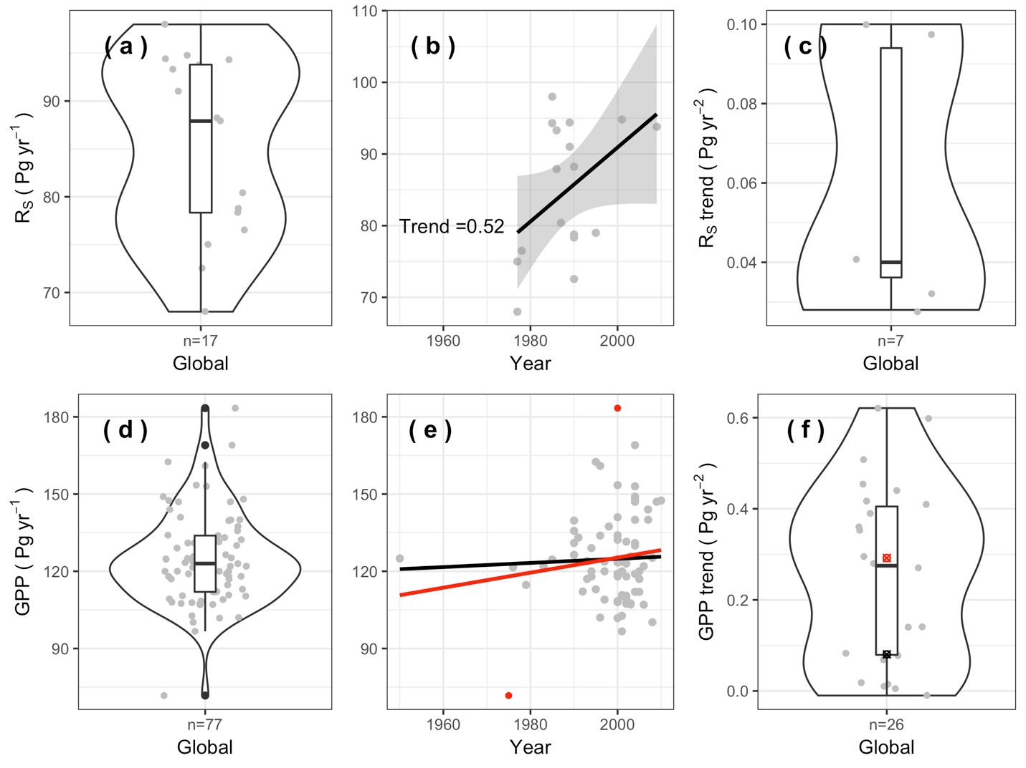

**Figure S1.** Global soil respiration (RSG, n=17, top panels) and gross primary production (GPP, n=77, bottom panels) collected from published literature, most GPP and global RS were estimated from the similar time period. (a and d) Box within violin plots showed the distribution of RSG and GPP; (b and e) RSG and GPP trend with time, the black and red lines in panel e represent linear regression with all GPP estimates and extreme high and low (red dots) estimates excluded, respectively; (c and f) reported RSG (n=7) and GPP (n=26) increase rate. Note that when GPP range was reported in the literature, the mean year was used.

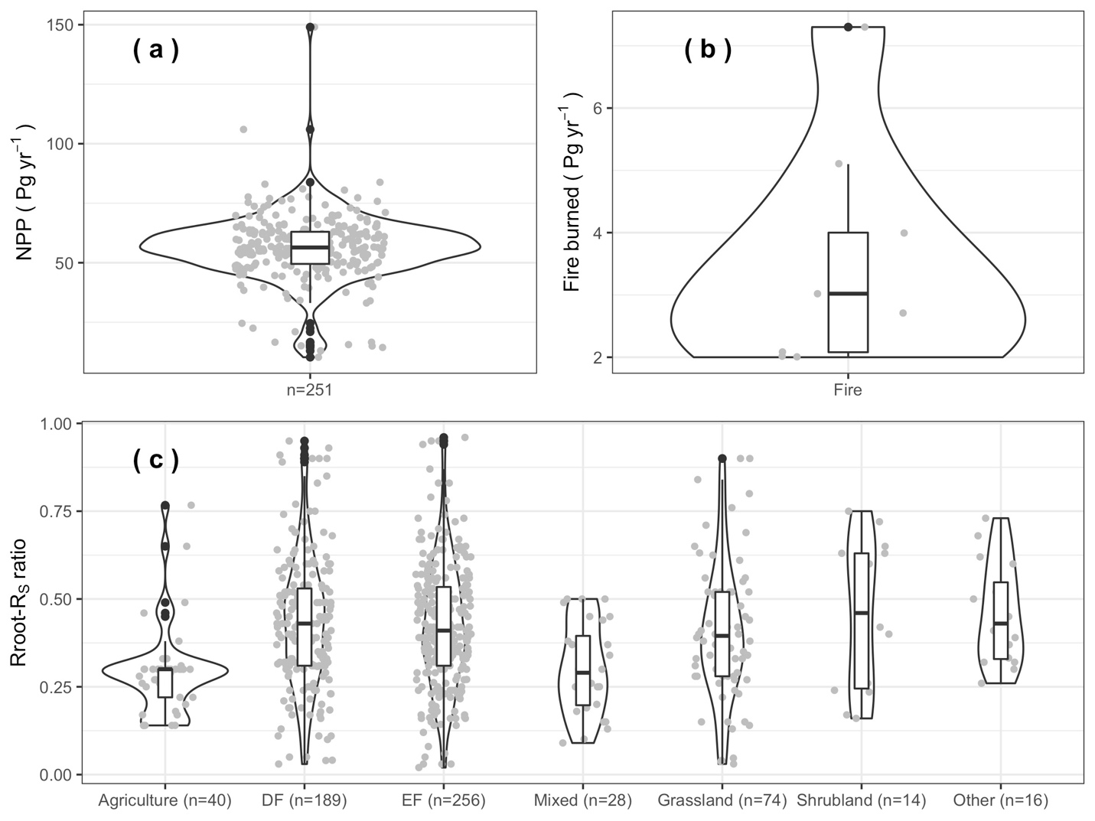

**Figure S2.** NPP, fire burned NPP, and Rroot-RS ratio collected from previous literature.Violin plots (enclosed areas) show distribution of each group; boxplots inside show the 25%, 50%, and 75% quantiles in each distribution. Rroot-RS ratio were grouped into agriculture, deciduous forest (DF), evergreen forest (EF), mixed forest (MF), grassland, shrubland, and other vegetation types.

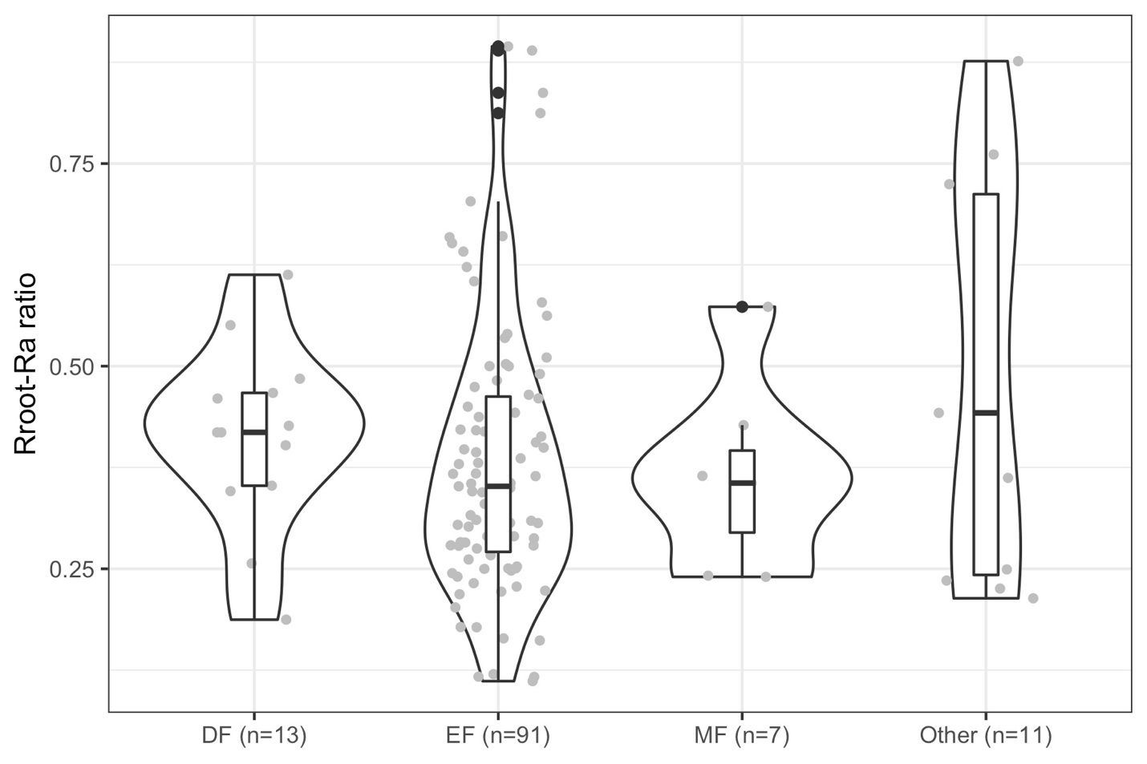

**Figure S3.** Rroot-Ra ratio grouped by vegetation types. Violin plots (enclosed areas) show distribution of Rroot-Ra ratio values; boxplots inside show the 25%, 50%, and 75% quantiles in each distribution. Rroot-Ra ratio were grouped into deciduous forest (DF), evergreen forest (EF), mixed forest (MF), and other vegetation types.

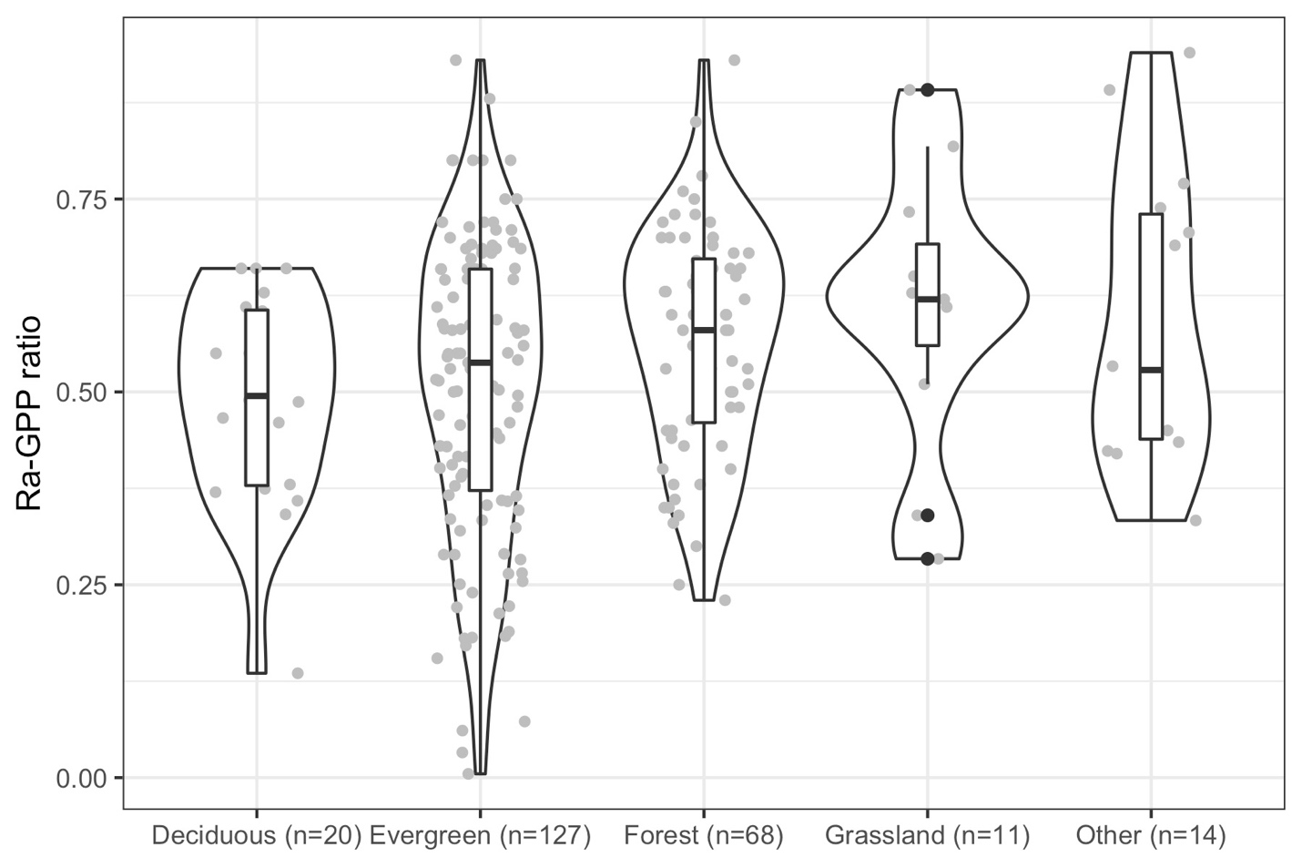

**Figure S4.** Ra-GPP ratio grouped into different vegetation types.Violin plots (enclosed areas) show distribution by ecosystem; boxplots inside show the 25%, 50%, and 75% quantiles in each distribution. Ra-GPP ratio were grouped into deciduous forest (DF), evergreen forest (EF), other forest (the leaf habit information not available in the literature), grassland, and other vegetation types.

Table S1. Summary of global soil respiration (RSG, units: Pg yr-1), standard deviation (SD), and trend collected from publication. RSG estimates were estimated between 1970s and 2010s, totally 17 RSG, with 9 reported corresponding SD, and 7 reported corresponding RSG trend.

|  |  |  |  |  |  |
| --- | --- | --- | --- | --- | --- |
| **Year** | **Period** | **RSG (Pg yr-1)** | **SD (Pg yr-1)** | **Trend (Pg yr-2)** | **Reference** |
| 1977 | 1977 | 75.00 | / | / | 2 |
| 1977 | 1962-1992 | 68.00 | / | / | 3 |
| 1978 | 1962-1994 | 76.50 | / | / | 4 |
| 1987 | 1980-1994 | 80.40 | 16.90 | 0.098 | 5 |
| 1985 | 1962-2008 | 98.00 | 12.00 | 0.100 | 6 |
| 1995 | 1980-2010 | 79.00 | 7.65 | / | 7 |
| 1989 | 1970-2008 | 94.40 | 4.59 | 0.040 | 8 |
| 1989 | 1966-2012 | 91.00 | 2.04 | 0.090 | 9 |
| 1985 | 1960-2010 | 94.30 | 9.13 | / | 10 |
| 2001 | 2001 | 94.80 | / | / | 11 |
| 2009 | 2009 | 93.80 | / | / | 11 |
| 1990 | 1964-2016 | 78.76 | / | / | 12 |
| 1990 | 1964-2016 | 88.22 | / | / | 12 |
| 1990 | 1964-2016 | 78.34 | 2.24 | 0.028 | 13 |
| 1990 | 1964-2016 | 72.55 | 7.13 | 0.032 | 13 |
| 1986 | 1960-2012 | 93.30 | 3.11 | 0.040 | 14 |
| 1986 | 1961-2011 | 87.90 | / | / | 15 |

Table S2. Summary of global GPP (units: Pg yr-1), corresponding standard deviation (SD), and trend collected from publication. GPP estimates were estimated between 1950s and 2010s, totally 77 GPP were collected, with 9 and 26 GPP estimates also reported corresponding SD and trend.

|  |  |  |  |  |  |  |
| --- | --- | --- | --- | --- | --- | --- |
| **Year** | **Period** | **GPP**  **(Pg C yr-1)** | **SD**  **(Pg C yr-1)** | **Trend**  **(Pg C yr-2)** | **Notes** | **Reference** |
| 1975 | 1975 | 71.73 |  |  |  | 16 |
| 1994 | 1990-1999 | 120.00 |  |  |  | 17 |
| 1991 | 1991 | 133.10 |  |  | Temperature data was 1991 | 18 |
| 1995 | 1995 | 113.00 |  |  |  | 19 |
| 1979 | 1965-1994 | 114.70 |  |  |  | 20 |
| 2000 |  | 183.39 |  |  |  | 21 |
| 1976 | 1953-1999 | 121.50 |  |  |  | 22 |
| 2000 |  | 153.48 |  |  |  | 23 |
| 2000 |  | 124.70 |  |  |  | 24 |
| 1994 | 1990-1999 | 118.00 |  |  | Ciais rt al (120) | 25 |
| 1985 | 1971-2000 | 124.60 | 2.70 | 0.440 | Interannual SD | 26 |
| 1998 | 1997-1999 | 137.40 |  |  |  | 27 |
| 1990 | 1980-2000 | 135.70 | 21.71 |  |  | 28 |
| 1996 | 1992-1999 | 160.95 |  |  | Estimated from figure 3 | 29 |
| 1983 | 1965-2000 | 122.00 |  |  |  | 30 |
| 2002 | 2001-2003 | 109.29 | 27.32 |  |  | 31 |
| 1992 | 1982-2001 | 112.13 |  | 0.280 | Average of six estimations | 32 |
| 1950 | 1900-2000 | 125.00 |  | 0.140 |  | 33 |
| 2000 | 2001-2003 | 108.42 |  |  | From Table 1 | 34 |
| 2001 | 2001-2003 | 110.76 |  |  | From Table 1 | 34 |
| 2002 | 2001-2003 | 107.82 |  |  | From Table 1 | 34 |
| 2003 | 2001-2003 | 107.50 |  |  | From Table 1 | 34 |
| 2000 | 2001-2003 | 101.79 |  |  | From Table 1 | 34 |
| 2001 | 2001-2003 | 102.71 |  |  | From Table 1 | 34 |
| 2002 | 2001-2003 | 124.82 |  |  | From Table 1 | 34 |
| 2003 | 2001-2003 | 125.75 |  |  | From Table 1 | 34 |
| 2000 | 2001-2003 | 123.41 |  |  | From Table 1 | 34 |
| 2001 | 2001-2003 | 123.72 |  |  | From Table 1 | 34 |
| 2000 | 2000-2001 | 132.25 |  |  | Average of two estimations | 35 |
| 2002 | 2001-2004 | 131.50 |  |  |  | 36 |
| 2001 | 2001 | 96.67 |  |  | Average of D0, D1and P1 | 37 |
| 1993 | 1981-2004 | 124.00 |  |  |  | 38 |
| 2000 | 2000 | 118.00 |  |  |  | 39 |
| 2000 | 2000-2003 | 108.00 |  |  |  | 40 |
| 2001 | 2000-2003 | 110.33 |  |  |  | 40 |
| 2002 | 2000-2003 | 107.40 |  |  |  | 40 |
| 2003 | 2000-2003 | 107.09 |  |  |  | 40 |
| 1990 | 1980-2000 | 126.40 |  |  |  | 41 |
| 1990 | 1980-2000 | 139.70 |  | 0.27 |  | 41 |
| 1990 | 1980-2000 | 131.00 |  |  |  | 41 |
| 1994 | 1986-2002 | 129.00 |  |  | P-fixed | 42 |
| 2001 | 2001 | 120.00 |  |  |  | 43 |
| 2006 | 2000-2011 | 107.00 |  |  |  | 44 |
| 2002 | 2001-2003 | 118.00 | 26.00 |  |  | 45 |
| 1993 | 1982-2004 | 117.00 |  |  |  | 46 |
| 2002 | 1998-2005 | 123.00 |  |  |  | 47 |
| 2000 | 1992-2008 | 119.00 | 6.00 |  |  | 48 |
| 2002 | 2000-2003 | 110.50 | 21.30 |  |  | 49 |
| 2000 | 2000 | 134.00 |  |  |  | 50 |
| 2000 | 2000 | 141.00 |  |  | From Figure 7 | 51 |
| 2010 | 2010 | 147.50 |  |  | From Figure 7 | 51 |
| 2004 | 1997-2010 | 119.00 |  | 0.018 | From Table 3 | 52 |
| 2004 | 1997-2010 | 112.00 |  | 0.005 | From Table 3 | 52 |
| 2004 | 1997-2010 | 148.00 |  | 0.078 | From Table 3 | 52 |
| 2004 | 1997-2010 | 147.00 |  | 0.417 | From Table 3 | 52 |
| 2004 | 1997-2010 | 130.00 |  | 0.353 | From Table 3 | 52 |
| 2004 | 1997-2010 | 131.00 |  | 0.262 | From Table 3 | 52 |
| 2004 | 1997-2010 | 149.00 |  | 0.621 | From Table 3 | 52 |
| 2004 | 1997-2010 | 140.00 |  | 0.598 | From Table 3 | 52 |
| 2004 | 1997-2010 | 153.00 |  | 0.508 | From Table 3 | 52 |
| 2004 | 1997-2010 | 169.00 |  | 0.454 | From Table 3 | 52 |
| 2005 | 2000-2010 | 117.00 | 13.00 | 0.410 | ENSEMBLE | 53 |
| 2005 | 2000-2010 | 112.00 |  | 0.280 | MODIS | 53 |
| 2005 | 2000-2010 | 120.00 |  |  | MTE | 53 |
| 1995 | 1980-2009 | 162.50 |  |  | The global damping time constant method | 54 |
| 2009 | 2003-2015 | 147.00 | 16.00 |  | NIRv | 55 |
| 2007 | 2007 | 140.00 |  |  | SIF | 56 |
| 2000 | 1992-2008 | 119.00 | 6.00 | 0.083 | MPI-BGC | 48 |
| 2007 | 2000-2014 | 144.00 |  | 0.069 | SVR | 57 |
| 1997 | 1982-2013 | 109.00 |  | 0.010 | FLUXCOM ANN | 57 |
| 1997 | 1982-2013 | 120.00 |  | -0.010 | FLUXCOM MARS | 57 |
| 1997 | 1982-2013 | 123.79 |  | 0.015 | FLUXCOM RF | 57 |
| 2008 | 2001-2016 | 100.21 |  | 0.360 | MODIS C6 | 57 |
| 1996 | 1982-2011 | 133.87 |  | 0.295 | PR | 57 |
| 2008 | 2000-2016 | 125.20 |  | 0.390 | VPM | 58 |
| 1996 | 1982-2011 | 102.00 |  | 0.141 | GIMMS | 57 |
| 2006 | 2001-2011 | 122.00 | 25.00 | 0.27 | BESS | 59 |

Table S3. Summary of published global carbon burned by fire, consumed by herbivores animals, and carbon sink to terrestrial ecosystem. N/A means data not available.

|  |  |  |  |
| --- | --- | --- | --- |
| **Item** | **Period** | **Amount (Pg C yr-1)** | **Reference** |
| NPP (n=251) | 1862-2011 | 56.20 (average of 251 observations) | 60 |
| Herbivores consumed (2.20) | / | 1.40 (± 0.20) | 61 |
|  | / | 3.00 | 62 |
| Fire consumed carbon (3.53) | 1997-2009 | 2.00 | 63 |
|  | 1960s | 3.50 (± 1.50) | 64 |
|  | / | 7.30 | 50 |
|  | 1901-2002 | 4.00 | 65 |
|  | 1980-2000 | 5.10 | 66 |
|  | 1920-1970 | 2.02 | 67 |
|  | 1970-2010 | 2.71 | 67 |
|  | 1900-2000 | 3.02 (± 0.30) | 68 |
|  | 1960-2000 | 2.08 | 69 |
| Land sink carbon (2.10) | 1959-2014 | (2.10± 0.28) | 70 |
| Carbon washed away by fresh water  (1.90) | / | 1.90 | 71 |
|  | / | 1.70 | 72 |
|  | / | 2.10 | 73 |
| Rroot-RS ratio | 1960-2015 | / | 1 |
| Ra-GPP ratio | 1960-2015 | / | 1,74 |

Table S4. Summary of root respiration to autotrophic respiration ratio and shoot respiration to autotrophic respiration ratio collected from studies.

|  |  |  |  |
| --- | --- | --- | --- |
| **Fshoot (%)** | **Froot (**%) | **Vegetation** | **Reference** |
| 50.00 | 50.00 | EF | 75 |
| 88.00 | 12.00 | EF | 76 |
| 55 | 45.00 | EF | 77 |
| 54.00 | 46.00 | DF | 78 |
| 72.50 | 27.5 | EF | 79 |
| 71.00 | 29.00 | EF | 80 |
| 77.70 | 22.30 | EF | 80 |
| 53.98 | 46.02 | EF | 80 |
| 51.77 | 48.23 | EF | 80 |
| 57.35 | 42.65 | DF | 80 |
| 75.54 | 24.45 | EF | 80 |
| 71.78 | 28.22 | EF | 80 |
| 65.42 | 34.58 | DF | 80 |
| 46.52 | 53.48† | EF | 81 |
| 75.08 | 24.92 | CRO | 82 |
| 53.30 | 46.70 | DF | 83 |
| 30.00 | 70.00 | SAV | 84 |
| 42.68 | 57.32† | MF | 85 |
| 57.28 | 42.72 | MF | 86 |
| 70.99 | 29.01 | EF | 87 |
| 65.22 | 34.78 | MF | 88 |
| 50.96 | 49.04 | EF | 89 |
| 63.57 | 36.43† | EF | 90 |
| 63.29 | 36.71† | EF | 91 |
| 64.43 | 35.57 | EF | 92 |
| 53.53 | 46.47† | EF | 93 |
| 71.72 | 28.28 | EF | 94 |
| 50.01 | 49.99 | EF | 95 |
| 63.79 | 36.21 | GRA | 96 |
| 65.45 | 34.55 | EF | 97 |
| 57.27 | 42.73† | EF | 98 |
| 74.94 | 25.06 | EF | 99 |
| 76.45 | 23.55 | CRO | 100 |
| 73.85 | 26.15† | EF | 101 |
| 76.00 | 24.00† | MF | 102 |

Label † means that root respiration was estimated from model: RA0.5 = -7.97 + 0.93Rs0.5 (units: g c m-2 yr-1) 103.

Table S5. Summary of collected Ra-GPP ratio from publication.

|  |  |  |  |  |
| --- | --- | --- | --- | --- |
| **Vegetation** | **Leaf_habit** | **Ra-GPP-ratio** | **Notes** | **Reference** |
| Crop | Aldalfa | 42.00 |  | 104 |
| Crop | Maize, rice and, wheat | 45.00 |  | 104 |
| Grassland | Shortgrass prairie | 34.00 |  | 104 |
| Grassland | Shortgrass prairie | 51.00 |  | 104 |
| Grassland | Tall grass prairie | 61.00 |  | 104 |
| Grassland | Tall grass prairie | 65.00 |  | 104 |
| Grassland | Tall grass prairie | 62.00 |  | 104 |
| Forest | Evergreen | 75.00 |  | 104 |
| Forest | Evergreen | 88.00 |  | 104 |
| Forest | Evergreen | 66.00 |  | 104 |
| Forest | Evergreen | 72.00 |  | 104 |
| Forest | Evergreen | 66.00 |  | 104 |
| Forest | Evergreen | 53.00 |  | 104 |
| Forest | Evergreen | 58.00 |  | 104 |
| Forest | Evergreen | 62.00 |  | 104 |
| Forest | Evergreen | 71.00 |  | 104 |
| Forest | Evergreen | 44.00 |  | 104 |
| Forest | Evergreen | 56.00 |  | 104 |
| Forest | Evergreen | 46.00 |  | 104 |
| Forest | Evergreen | 39.00 |  | 104 |
| Forest | Evergreen | 43.00 |  | 104 |
| Forest | Evergreen | 47.00 |  | 104 |
| Forest | Deciduous | 37.00 |  | 104 |
| Forest | Deciduous | 66.00 |  | 104 |
| Forest | Evergreen | 32.00 |  | 104 |
| Forest | Evergreen | 71.00 |  | 104 |
| Forest | Evergreen | 55.00 |  | 104 |
| Forest | Evergreen | 58.00 |  | 104 |
| Forest | Evergreen | 55.00 |  | 104 |
| Forest | Evergreen | 93.00 |  | 104 |
| Forest | Deciduous | 50.00 |  | 104 |
| Forest | Deciduous | 54.00 |  | 104 |
| Forest | Deciduous | 55.00 |  | 104 |
| Forest | Deciduous | 61.00 |  | 104 |
| Forest | Deciduous | 38.00 |  | 104 |
| Forest | Evergreen | 72.00 |  | 104 |
| Forest | Evergreen | 68.00 |  | 104 |
| Forest | Evergreen | 61.00 |  | 104 |
| Forest | Evergreen | 69.00 |  | 104 |
| Forest | Evergreen | 75.00 |  | 104 |
| Forest | Evergreen | 68.00 |  | 104 |
| Forest | Evergreen | 72.00 |  | 104 |
| Forest | Deciduous | 55.00 |  | 104 |
| Forest | Deciduous | 66.00 |  | 104 |
| Wetland | Temperate coastal salt marsh | 77.00 |  | 104 |
| Wetland | Temperate coastal salt marsh | 69.00 |  | 104 |
| Tundra | Arctic tundra | 50.00 |  | 104 |
| Forest |  | 76.00 | Direct up-scaled estimation | 74 |
| Forest |  | 66.00 | Direct up-scaled estimation | 74 |
| Forest |  | 70.00 | Direct up-scaled estimation | 74 |
| Forest |  | 70.00 | Direct up-scaled estimation | 74 |
| Forest |  | 72.00 | Direct up-scaled estimation | 74 |
| Forest |  | 63.00 | Direct up-scaled estimation | 74 |
| Forest |  | 45.00 | Direct up-scaled estimation | 74 |
| Forest |  | 50.00 | Direct up-scaled estimation | 74 |
| Forest |  | 70.00 | Direct up-scaled estimation | 74 |
| Forest |  | 64.00 | GPP-NPP | 74 |
| Forest |  | 70.00 | GPP-NPP | 74 |
| Forest |  | 93.00 | GPP-NPP | 74 |
| Forest |  | 73.00 | GPP-NPP | 74 |
| Forest |  | 72.00 | GPP-NPP | 74 |
| Forest |  | 69.00 | GPP-NPP | 74 |
| Forest |  | 66.00 | GPP-NPP | 74 |
| Forest |  | 66.00 | GPP-NPP | 74 |
| Forest |  | 65.00 | GPP-NPP | 74 |
| Forest |  | 53.00 | GPP-NPP | 74 |
| Forest |  | 60.00 | GPP-NPP | 74 |
| Forest |  | 56.00 | GPP-NPP | 74 |
| Forest |  | 58.00 | GPP-NPP | 74 |
| Forest |  | 53.00 | GPP-NPP | 74 |
| Forest |  | 50.00 | GPP-NPP | 74 |
| Forest |  | 54.00 | GPP-NPP | 74 |
| Forest |  | 56.00 | GPP-NPP | 74 |
| Forest |  | 58.00 | GPP-NPP | 74 |
| Forest |  | 63.00 | GPP-NPP | 74 |
| Forest |  | 65.00 | GPP-NPP | 74 |
| Forest |  | 68.00 | GPP-NPP | 74 |
| Forest |  | 73.00 | GPP-NPP | 74 |
| Forest |  | 60.00 | GPP-NPP | 74 |
| Forest |  | 60.00 | GPP-NPP | 74 |
| Forest |  | 43.00 | GPP-NPP | 74 |
| Forest |  | 45.00 | GPP-NPP | 74 |
| Forest |  | 25.00 | GPP-NPP | 74 |
| Forest |  | 30.00 | GPP-NPP | 74 |
| Forest |  | 38.00 | GPP-NPP | 74 |
| Forest |  | 35.00 | GPP-NPP | 74 |
| Forest |  | 33.00 | GPP-NPP | 74 |
| Forest |  | 85.00 | GPP-NPP | 74 |
| Forest |  | 62.00 | TER-Rh | 74 |
| Forest |  | 63.00 | TER-Rh | 74 |
| Forest |  | 63.00 | TER-Rh | 74 |
| Forest |  | 38.00 | TER-Rh | 74 |
| Forest |  | 34.00 | TER-Rh | 74 |
| Forest |  | 40.00 | TER-Rh | 74 |
| Forest |  | 44.00 | TER-Rh | 74 |
| Forest |  | 35.00 | TER-Rh | 74 |
| Forest |  | 48.00 | TER-Rh | 74 |
| Forest |  | 50.00 | TER-Rh | 74 |
| Forest |  | 51.00 | TER-Rh | 74 |
| Forest |  | 58.00 | TER-Rh | 74 |
| Forest |  | 58.00 | TER-Rh | 74 |
| Forest |  | 60.00 | TER-Rh | 74 |
| Forest |  | 67.00 | TER-Rh | 74 |
| Forest |  | 68.00 | TER-Rh | 74 |
| Forest |  | 75.00 | TER-Rh | 74 |
| Forest |  | 78.00 | TER-Rh | 74 |
| Forest |  | 23.49 |  | 74 |
| Forest |  | 42.80 |  | 74 |
| Forest |  | 39.66 |  | 74 |
| Forest |  | 53.08 |  | 74 |
| Forest |  | 70.23 |  | 74 |
| Forest |  | 48.46 |  | 74 |
| Forest | Evergreen | 50.15 |  | 105 |
| Forest | Deciduous | 66.00 |  | 105 |
| Forest | Evergreen | 53.00 |  | 105 |
| Forest | Evergreen | 50.26 |  | 106 |
| Forest | Deciduous | 69.99 |  | 106 |
| Forest | Evergreen | 62.86 |  | 106 |
| Forest | Evergreen | 53.97 |  | 106 |
| Forest | Evergreen | 48.95 |  | 106 |
| Forest | Deciduous | 40.55 |  | 106 |
| Forest | Evergreen | 41.61 |  | 106 |
| Forest | Deciduous | 65.42 |  | 106 |

**TO DO NEXT**

* Components importance analysis: Uncertainty × Sensitivity = Importance (discuss with Alexey).
* Which component needs more information and measurements in the future (the components have most influence on the top-down or bottom-up estimates (as suggested by Min Chen), and those components has most importance (analysis from above)).
* What does a 28-29% chance of consistency mean? We’ll need to put that in context.
* Which is more likely (i.e., bigger GPP or smaller global soil respiration, RSG), Bayesian approach, discuss with Alexey.
* Joint probability: given *both* distributions, what's the most likely GPP and Rs values? "Here's our best guess at reconciling these two data sources".

**Comments and notes**

* Potential of Rs to benchmark other measurements and other parts of the C cycle. <https://link.springer.com/article/10.1007%2Fs11104-016-3084-x>
* Why matches top-down and bottom-up estimates is important, what it means to global climate change prediction, global terrestrial carbon sink CESM?

**What if GPP is really 145 PgC/yr, not 122?**

* [Lisa Welp was right](https://www.nature.com/articles/nature10421)
* A number of CMIP5 models, mostly notably, are [much too low](https://agupubs.onlinelibrary.wiley.com/doi/10.1002/2015RG000483)
* MODIS and MTE far too low
* Upscaling wrong? (E.g. not accounting for tropical forests correctly.) Or is FLUXNET underestimating GPP?
* More rapid cycling of C than thought
* [Residence time](http://dx.doi.org/10.1073/pnas.1515160113) lower, and turnover higher, than thought?
* Consistent? "...we find that the ecosystem carbon turnover times simulated by state-of-the-art coupled climate/carbon-cycle models vary widely and that numerical simulations, on average, tend to underestimate the global carbon turnover time by 36 per cent." [Carvalhais et al. 2014](https://www.nature.com/articles/nature13731)

**What if Rs is really 75 Pg C/yr, not 85?**

* Our upscaling of chamber measurements is fundamentally wrong.
* Some unexpected constraint? E.g. tropical data is not representative of full suite of productivity, biased high?
* ESMs such as Had-GEM2 are [too high](https://iopscience.iop.org/article/10.1088/1748-9326/8/3/034034) - either in their temperature sensitivity, or basal rates, or ...?
* The [oldest global Rs estimates](https://agupubs.onlinelibrary.wiley.com/doi/full/10.1029/2018EF000866) are much more accurate than ones in the last 20 years
* "The results suggest that previous eddy-covariance-based estimates of global photosynthesis  
  and respiration are probably biased high" [Keenan et al. 2019](http://dx.doi.org/10.1038/s41559-019-0809-2)
* "The data could mean that the world's landmasses are taking up 7% more C than scientists thought" re [https://www.atmos-chem-phys.net/19/8687/2019](https://www.atmos-chem-phys.net/19/8687/2019/).
* What about CMIP5/CMIP6/TRENDY/etc.?
* BBL will email Rodrigo about September 10th meeting, etc.

**Reference**

1. Bond-Lamberty, B. P. & Thomson, A. M. A Global Database of Soil Respiration Data, Version 4.0. *ORNL DAAC* (2018).

2. Schlesinger, W. H. Carbon Balance in Terrestrial Detritus. *Annu. Rev. Ecol. Syst.* **8**, 51–81 (1977).

3. Raich, J. W. & Schlesinger, W. H. The global carbon dioxide flux in soil respiration and its relationship to vegetation and climate. *Tellus* **44 B**, 81–99 (1992).

4. Raich, J. W. & Potter, C. S. Global patterns of carbon dioxide emissions from soils. *Global Biogeochem. Cycles* **9**, 23–36 (1995).

5. Raich, J. W., Potter, C. S. & Bhagawati, D. Interannual variability in global soil respiration, 1980–94. *Glob. Chang. Biol.* **8**, 800–812 (2002).

6. Bond-Lamberty, B. & Thomson, A. Temperature-associated increases in the global soil respiration record. *Nature* **464**, 579–82 (2010).

7. Hashimoto, S. A new estimation of global soil greenhouse gas fluxes using a simple data-oriented model. *PLoS One* **7**, 1–7 (2012).

8. Chen, S. *et al.* A new estimate of global soil respiration from 1970 to 2008. *Chinese Sci. Bull.* **58**, 4153–4160 (2013).

9. Hashimoto, S. *et al.* Global spatiotemporal distribution of soil respiration modeled using a global database. *Biogeosciences Discuss.* **12**, 4331–4364 (2015).

10. Xu, M. & Shang, H. Contribution of soil respiration to the global carbon equation. *J. Plant Physiol.* **203**, 16–28 (2016).

11. Adachi, M., Ito, A., Yonemura, S. & Takeuchi, W. Estimation of global soil respiration by accounting for land-use changes derived from remote sensing data. *J. Environ. Manage.* **200**, 97–104 (2017).

12. Jian, J., Steele, M. K., Thomas, R. Q., Day, S. D. & Hodges, S. C. Constraining estimates of global soil respiration by quantifying sources of variability. *Glob. Chang. Biol.* **24**, 4143–4159 (2018).

13. Jian, J., Steele, M. K., Day, S. D. & Thomas, R. Q. Future Global Soil Respiration Rates Will Swell Despite Regional Decreases in Temperature Sensitivity Caused by Rising Temperature. *Earth’s Futur.* **6**, 1539–1554 (2018).

14. Zhao, Z. *et al.* Model prediction of biome-specific global soil respiration from 1960 to 2012. *Earth’s Futur.* **5**, 715–729 (2017).

15. Warner, D. L., Bond-Lamberty, B., Jian, J., Stell, E. & Vargas, R. Spatial predictions and associated uncertainty of annual soil respiration at the global scale. *Global Biogeochem. Cycles* (2019).

16. Box, E. Geographical dimensions of terrestrial net and gross primary productivity. *Radiat. Environ. Biophys.* **15**, 305–322 (1978).

17. Ciais, P. *et al.* A three-dimensional synthesis study of 18O in atmospheric COz. *J. Geophys. Res.* **102**, 5857–5872 (1997).

18. Ruimy, A., Dedieu, G. & Saugier, B. TURC: A diagnostic model of continental gross primary productivity and net primary productivity. *Global Biogeochem. Cycles* **10**, 269–285 (1996).

19. Thompson, M. V. & Randerson, J. T. Impulse response functions of terrestrial carbon cycle models: Method and application. *Glob. Chang. Biol.* **5**, 371–394 (1999).

20. Kucharik, C. J., Foley, J. A. & Delire, C. Testing the performance of a dynamic global ecosystem model: Water balance, carbon balance, and vegetation structure. *Global Biogeochem. Cycles* **14**, 795–825 (2000).

21. Knorr, W. & Heimann, M. Uncertainties in global terrestrial biosphere modeling, part I: a comprehensive sensitivity analysis with a new photosynthesis and energy balance scheme. *Global Biogeochem. Cycles* **15**, 207–225 (2001).

22. Ito, A. A global-scale simulation of the CO2 exchange between the atmosphere and the terrestrial biosphere with a mechanistic model including stable carbon isotopes , 1953 – 1999. *Tellus* **55**, 596–612 (2003).

23. Still, C. J., Berry, J. A., Collatz, G. J. & DeFries, R. S. Global distribution of C 3 and C 4 vegetation: Carbon cycle implications. *Global Biogeochem. Cycles* **17**, 6-1-6–14 (2003).

24. Ito, A. & OIKAWA, A. Global Mapping of Terrestrial Primary Productivity and Light-Use Efficiency with a Process-Based Model. in *Global Environmental Change in the Ocean and on Land* (eds. Shiyomi, M., H.Kawahata, Koizumi, H., Tsuda, A. & Awaya, Y.) 343–358 (2004).

25. Woodward, F. I. & Lomas, M. R. Vegetation dynamics--simulating responses to climatic change. *Biol. Rev.* **79**, 643–670 (2004).

26. Ito, A. Climate-related uncertainties in projections of the twenty-first century terrestrial carbon budget: Off-line model experiments using IPCC greenhouse-gas scenarios and AOGCM climate projections. *Clim. Dyn.* **24**, 435–448 (2005).

27. Krinner, G. *et al.* A dynamic global vegetation model for studies of the coupled atmosphere-biosphere system. *Global Biogeochem. Cycles* **19**, 1–33 (2005).

28. Rayner, P. J. *et al.* Two decades of terrestrial carbon fluxes from a carbon cycle data assimilation system (CCDAS). *Global Biogeochem. Cycles* **19**, GB2026 (2005).

29. Sasai, T., Ichii, K., Yamaguchi, Y. & Nemani, R. Simulating terrestrial carbon fluxes using the new biosphere model “biosphere model integrating eco-physiological and mechanistic approaches using satellite data” (BEAMS). *J. Geophys. Res.* **110**, 1–18 (2005).

30. Zeng, N., Mariotti, A. & Wetzel, P. Terrestrial mechanisms of interannual CO2 variability. *Global Biogeochem. Cycles* **19**, 1–15 (2005).

31. Zhao, M., Heinsch, F. A., Nemani, R. R. & Running, S. W. Improvements of the MODIS terrestrial gross and net primary production global data set. *Remote Sens. Environ.* **95**, 164–176 (2005).

32. Ito, A. & Sasai, T. A comparison of simulation results from two terrestrial carbon cycle models using three climate data sets. *Tellus Ser. B-Chemical Phys. Meteorol.* **58**, 513–522 (2006).

33. Law, R. M., Kowalczyk, E. a. & WANGs, Y.-P. Using atmospheric CO 2 data to assess a simplified carbon-climate simulation for the 20th century. *Tellus B* **58**, 427–437 (2006).

34. Zhao, M., Running, S. W. & Nemani, R. R. Sensitivity of Moderate Resolution Imaging Spectroradiometer (MODIS) terrestrial primary production to the accuracy of meteorological reanalyses. *J. Geophys. Res. Biogeosciences* **111**, 1–13 (2006).

35. Demarty, J. *et al.* Assimilation of global MODIS leaf area index retrievals within a terrestrial biosphere model. *Geophys. Res. Lett.* **34**, 1–6 (2007).

36. Sasai, T., Okamoto, K., Hiyama, T. & Yamaguchi, Y. Comparing terrestrial carbon fluxes from the scale of a flux tower to the global scale. *Ecol. Modell.* **208**, 135–144 (2007).

37. Thornton, P. E. & Zimmermann, N. E. An improved canopy integration scheme for a Land Surface Model with prognostic canopy structure. *J. Clim.* **20**, 3902–3923 (2007).

38. Qian, H., Joseph, R. & Zeng, N. Response of the terrestrial carbon cycle to the El Nino-Southern Oscillation. *Tellus Ser. B-Chemical Phys. Meteorol.* **60**, 537–550 (2008).

39. Jacobson, M. Z. & Streets, D. G. Influence of future anthropogenic emissions on climate, natural emissions, and air quality. *J. Geophys. Res. Atmos.* **114**, 1–21 (2009).

40. Zhang, Y., Xu, M., Chen, H. & Adams, J. Global pattern of NPP to GPP ratio derived from MODIS data: Effects of ecosystem type, geographical location and climate. *Glob. Ecol. Biogeogr.* **18**, 280–290 (2009).

41. Arora, V. K. *et al.* The Effect of terrestrial photosynthesis down regulation on the twentieth-century carbon budget simulated with the CCCma Earth System Model. *J. Clim.* **22**, 6066–6088 (2009).

42. Alton, P. B. How useful are plant functional types in global simulations of the carbon, water, and energy cycles? *J. Geophys. Res. Biogeosciences* **116**, 1–14 (2011).

43. Prentice, I. C. *et al.* The Carbon Cycle and Atmospheric Carbon Dioxide. in *Contribution of Working Group I to the Fourth Assessment Report of the Intergovernmental Panel on Climate Change, 2007* (eds. Solomon, S. et al.) 183–287 (Cambridge University Press, 2007).

44. Yebra, M., Van Dijk, A. I. J. M. J. M., Leuning, R. & Guerschman, J. P. Global vegetation gross primary production estimation using satellite-derived light-use efficiency and canopy conductance. *Remote Sens. Environ.* **163**, 206–216 (2015).

45. Ryu, Y. *et al.* Integration of MODIS land and atmosphere products with a coupled-process model to estimate gross primary productivity and evapotranspiration from 1 km to global scales. *Global Biogeochem. Cycles* **25**, 1–24 (2011).

46. Bonan, G. B. *et al.* Improving canopy processes in the Community Land Model version 4 (CLM4) using global flux fields empirically inferred from FLUXNET data. *J. Geophys. Res.* **116**, 1–22 (2011).

47. Beer, C. *et al.* Terrestrial Gross Carbon Dioxide Uptake: Global Distribution and Covariation with Climate. *Sicence* **329**, 834–839 (2010).

48. Jung, M. *et al.* Global patterns of land-atmosphere fluxes of carbon dioxide, latent heat, and sensible heat derived from eddy covariance, satellite, and meteorological observations. *J. Geophys. Res. Biogeosciences* **116**, 1–16 (2011).

49. Yuan, W. *et al.* Global estimates of evapotranspiration and gross primary production based on MODIS and global meteorology data. *Remote Sens. Environ.* **114**, 1416–1431 (2010).

50. Gerber, S., Joos, F. & Prentice, C. Sensitivity of a dynamic global vegetation model to climate and atmospheric CO2. *Glob. Chang. Biol.* **10**, 1223–1239 (2004).

51. Raddatz, T. J. *et al.* Will the tropical land biosphere dominate the climate-carbon cycle feedback during the twenty-first century? *Clim. Dyn.* **29**, 565–574 (2007).

52. Anav, A. *et al.* Reviews of Geophysics primary production : A review. *Rev. Geophys.* **53**, 785–818 (2015).

53. Chen, M. *et al.* Regional contribution to variability and trends of global gross primary productivity. *Environ. Res. Lett.* **12**, 105005 (2017).

54. Welp, L. R. *et al.* Interannual variability in the oxygen isotopes of atmospheric CO 2 driven by El Niño. *Nature* **477**, 579–582 (2011).

55. Badgley, G., Anderegg, L. D. L., Berry, J. A. & Field, C. B. Terrestrial gross primary production: Using NIR V to scale from site to globe . *Glob. Chang. Biol.* 1–10 (2019). doi:10.1111/gcb.14729

56. Joiner, J. *et al.* Estimation of terrestrial global gross primary production (GPP) with satellite data-driven models and eddy covariance flux data. *Remote Sens.* **10**, 1–38 (2018).

57. Ryu, Y., Berry, J. A. & Baldocchi, D. D. What is global photosynthesis? History, uncertainties and opportunities. *Remote Sens. Environ.* **223**, 95–114 (2019).

58. Zhang, Y. *et al.* A global moderate resolution dataset of gross primary production of vegetation for 2000–2016. *Sci. Data* **4**, 1–13 (2017).

59. Jiang, C. & Ryu, Y. Multi-scale evaluation of global gross primary productivity and evapotranspiration products derived from Breathing Earth System Simulator (BESS). *Remote Sens. Environ.* **186**, 528–547 (2016).

60. Ito, A. A historical meta-analysis of global terrestrial net primary productivity: are estimates converging? *Glob. Chang. Biol.* **17**, 3161–3175 (2011).

61. Doughty, C. E. & Field, C. B. Agricultural net primary production in relation to that liberated by the extinction of Pleistocene mega-herbivores: an estimate of agricultural carrying capacity? *Environ. Res. Lett.* **5**, 044001 (2010).

62. Whittaker, R. H. & Likens, G. E. Carbon in the biota. in *Carbon and biosphere* (eds. Woodwell, G. M. & Pecan, E. V) 281–302 (National Technical Information Service, 1973).

63. van der Werf, G. R. *et al.* Global fire emissions and the contribution of deforestation, savanna, forest, agricultural, and peat fires (1997–2009). *Atmos. Chem. Phys.* **10**, 11707–11735 (2010).

64. Crutzen, P. & Andreae, M. O. Biomass burning in the tropics: Impact on atmospheric chemistry and biogeochemical cycles. *Science (80-. ).* **250**, 1669–1678 (1990).

65. Piao, S. *et al.* Spatiotemporal patterns of terrestrial carbon cycle during the 20th century. *Global Biogeochem. Cycles* **23**, 1–16 (2009).

66. Zaehle, S., Sitch, S., Smith, B. & Hatterman, F. Effects of parameter uncertainties on the modeling of terrestrial biosphere dynamics. *Global Biogeochem. Cycles* **19**, 1–16 (2005).

67. Mieville, A. *et al.* Emissions of gases and particles from biomass burning during the 20th century using satellite data and an historical reconstruction. *Atmos. Environ.* **44**, 1469–1477 (2010).

68. Mouillot, F., Narasimha, A., Balkanski, Y., Lamarque, J.-F. & Field, C. B. Global carbon emissions from biomass burning in the 20th century. *Geophys. Res. Lett.* **33**, 2–5 (2006).

69. Schultz, M. G. *et al.* Global wildland fire emissions from 1960 to 2000. *Global Biogeochem. Cycles* **22**, 1–17 (2008).

70. Le Quéré, C. *et al.* Global carbon budget 2015. *Earth Syst. Sci. Data* **7**, 349–396 (2015).

71. Cole, J. J. *et al.* Plumbing the global carbon cycle: Integrating inland waters into the terrestrial carbon budget. *Ecosystems* **10**, 171–184 (2007).

72. Bastviken, D. *et al.* Freshwater methane emissions offset the continental carbon sink. *Science (80-. ).* **331**, 50 (2011).

73. Deemer, B. R. *et al.* Greenhouse Gas Emissions from Reservoir Water Surfaces: A New Global Synthesis. *Bioscience* **XX**, biw117 (2016).

74. Piao, S. *et al.* Forest annual carbon cost: A global-scale analysis of autotrophic respiration. *Ecology* **91**, 652–661 (2010).

75. Allen, L. H. & Lemon, E. R. Carbon dioxide exchange and turbulence in a Costa Rican tropical rain forest. in *Vegetation and the Atmosphere* (ed. Monteith, J. .) **2**, 265–308 (Academic Press, 1976).

76. Yoda, K. Community respiration in a lowland rain forest in Pasoh, peninsular Malaysia. *Ecol* **33**, 183–197 (1983).

77. Yoda, K. Estimation of community respiration. in *Biological Production in a Warm Temperate Evergreen Oak Forest of Japan* (eds. Kira, K., Ono, Y. & Hosokawa, T.) **18**, 112–131 (Univ. Tokyo Press, 1978).

78. Edwards, N. T., Shugart, H. H., McLaughlin, S. B., Harris, W. F. & Reichle, D. E. Carbon metabolism in terrestrial ecosystems. in *Dynamic Properties of Forest Ecosystems* (ed. Reichle, D. E.) 499–536 (Cambridge Univ. Press, 1981).

79. Ryan, M. G., Hubbard, R. M., Pongracic, S., Raison, R. J. & Murtrie, R. E. M. C. Foliage, fine-root, woody-tissue and stand respiration in Relation To Nitrogen Status. *Tree Physiol.* **16**, 333–343 (1996).

80. Ryan, M. G., Lavigne, M. B. & Gower, S. T. Annual carbon cost of autotrophic respiration in boreal forest ecosystems in relation to species and climate. *J. Geophys. Res.* **102**, 28871–28883 (1997).

81. Law, B. E., Ryan, M. G. & Anthoni, P. M. Seasonal and annual respiration of a ponderosa pin ecosystem. *Glob. Chang. Biol.* **5**, 169–182 (1999).

82. Suleau, M. *et al.* Respiration of three Belgian crops: Partitioning of total ecosystem respiration in its heterotrophic, above- and below-ground autotrophic components. *Agric. For. Meteorol.* **151**, 633–643 (2011).

83. Granier, A. *et al.* The carbon balance of a young beech forest. *Funct. Ecol.* **14**, 2000 (2000).

84. Chen, X., Hutley, L. B. & Eamus, D. Carbon balance of a tropical savanna of northern Australia. *Oecologia* **137**, 405–416 (2003).

85. Bolstad, P. V, Davis, K. J., Martin, J., Cook, B. D. & Wang, W. Component and whole-system respiration fluxes in northern deciduous forests. *Tree Physiol.* **24**, 493–504 (2004).

86. Curtis, P. S. *et al.* Respiratory carbon losses and the carbon-use efficiency of a northern hardwood forest, 1999-2003. *New Phytol.* **167**, 437–456 (2005).

87. Davidson, E. A., Richardson, A. D., Savage, K. E. & Hollinger, D. Y. A distinct seasonal pattern of the ratio of soil respiration to total ecosystem respiration in a spruce-dominated forest. *Glob. Chang. Biol.* **12**, 230–239 (2006).

88. Nagy, M. T., Janssens, I. A., Curiel Yuste, J., Carrara, A. & Ceulemans, R. Footprint-adjusted net ecosystem CO2 exchange and carbon balance components of a temperate forest. *Agric. For. Meteorol.* **139**, 344–360 (2006).

89. Zhang, Y. *et al.* Annual variation of carbon flux and impact factors in the tropical seasonal rain forest of Xishuangbanna, SW China. *Sci. China, Ser. D Earth Sci.* **49**, 150–162 (2006).

90. Jassal, R. S. *et al.* Components of ecosystem respiration and an estimate of net primary productivity of an intermediate-aged Douglas-fir stand. *Agric. For. Meteorol.* **144**, 44–57 (2007).

91. Zha, T., Xing, Z., Wang, K. Y., Kellomaki, S. & Barr, A. G. Total and component carbon fluxes of a scots pine ecosystem from chamber measurements and eddy covariance. *Ann. Bot.* **99**, 345–353 (2007).

92. Keith, H. *et al.* Multiple measurements constrain estimates of net carbon exchange by a Eucalyptus forest. *Agric. For. Meteorol.* **149**, 535–558 (2009).

93. Kolari, P. *et al.* CO 2 exchange and component CO 2 fl uxes of a boreal Scots pine forest. *Boreal Environ. Res.* **14**, 761–783 (2009).

94. Malhi, Y. *et al.* Comprehensive assessment of carbon productivity, allocation and storage in three Amazonian forests. *Glob. Chang. Biol.* **15**, 1255–1274 (2009).

95. Wieser, G. *et al.* Respiratory fluxes in a Canary Islands pine forest. *Tree Physiol.* **29**, 457–466 (2009).

96. Zhang, P., Tang, Y., Hirota, M., Yamamoto, A. & Mariko, S. Use of a regression method to partition sources of ecosystem respiration in an alpine meadow. *Soil Biol. Biochem.* **41**, 663–670 (2009).

97. Hermle, S., Lavigne, M. B., Bernier, P. Y., Bergeron, O. & Paré, D. Component respiration, ecosystem respiration and net primary production of a mature black spruce forest in northern Quebec. *Tree Physiol.* **30**, 527–540 (2010).

98. Ryan, M. G. *et al.* Factors controlling Eucalyptus productivity: How water availability and stand structure alter production and carbon allocation. *For. Ecol. Manage.* **259**, 1695–1703 (2010).

99. Tan, Z. *et al.* Carbon balance of a primary tropical seasonal rain forest. *J. Geophys. Res. Atmos.* **115**, 1–17 (2010).

100. Jans, W. W. P. *et al.* Carbon exchange of a maize (Zea mays L.) crop: Influence of phenology. *Agric. Ecosyst. Environ.* **139**, 316–324 (2010).

101. Campoe, O. C., Stape, J. L., Laclau, J. P., Marsden, C. & Nouvellon, Y. Stand-level patterns of carbon fluxes and partitioning in a Eucalyptus grandis plantation across a gradient of productivity, in Sao Paulo State, Brazil. *Tree Physiol.* **32**, 696–706 (2012).

102. Matteucci, M. *et al.* Components, drivers and temporal dynamics of ecosystem respiration in a Mediterranean pine forest. *Soil Biol. Biochem.* **88**, 224–235 (2015).

103. Bond-Lamberty, B., Wang, C. & Gower, S. T. A global relationship between the heterotrophic and autotrophic components of soil respiration? *Glob. Chang. Biol.* **10**, 1756–1766 (2004).

104. Amthor, J. S. & Baldocchi, D. D. Terrestrial higher plant respiration and net primary production. in *Terrestrial global productivity* (eds. Roy, J., Mooney, H. A. & Saugier, B.) 33–59 (Academic Press: San Diego, CA, USA, 2001).

105. Kinerson, R. S., Ralston, C. W. & Wells, C. G. Carbon cycling in a loblolly pine plantation. *Oecologia* **29**, 1–10 (1977).

106. Luyssaert, S. *et al.* CO2 balance of boreal, temperate, and tropical forests derived from a global database. *Glob. Chang. Biol.* **13**, 2509–2537 (2007).