Inconsistency between bottom-up and top-down global gross primary production and soil respiration

1. Joint Global Change Research Institute, Pacific Northwest National Laboratory, 5825 University Research Ct. #3500, College Park, MD 20740 USA

**1. Summary**

The terrestrial carbon cycle strongly influences global climate change. Both top-down (e.g., remote sensing and earth system models) and bottom-up (derived from field measurements) estimates have been made of major components (e.g., gross primary production, GPP, and soil respiration, RS) of the terrestrial carbon cycle, as well as their response to global climate change. However, these top-down and bottom-up estimates have not been compared for consistency.

In this study, we first partitioned historical GPP estimates into their NPP and autotrophic respiration components, and calculated global RS (74±21 Pg C yr-1, 95% confidence interval). There is only a ~28% probability that these estimates are consistent with the previous global RS estimates from literature (86±6 Pg C yr-1). Second, based on the global RS estimates collected from literature, we then partitioned RS into its different components (shoot and root respiration), and calculated the resulting implied global GPP (145±46 Pg C yr-1), which had ~29% probability of being consistent with the global GPP estimates by remote sensing or ecosystem models (122±13 Pg C yr-1). This highlights the inconsistence between bottom-up and top-down based GPP and RS estimates that have a ~20 Pg C gap between them. The reasons of the inconsistency need further study for better understanding global terrestrial carbon cycling in the future.

**Abbreviations**: RS – soil respiration, Rroot – root respiration, Rshoot – shoot respiration, Ra – total autotrophic respiration, Fire – NPP burned by fire, Csink – NPP going to underground as carbon sink, Herb – NPP consumed by herbivore, RC – Rroot to RS ratio.

**2. Method**

**2.1 Bottom-up approach to estimate GPP**

In the past decades, many models have been developed to estimate global RS (n=17, panel (d) of Figure S1, most of the estimates were based on the field measured RS data, e.g., SRDB). According to the Root to RS ratio (RC) and Rroot/Rshoot ratio (data come from SRDB), Rroot and Rshoot can be estimated. Then, GPP can be calculated as: GPP = NPP + Ra (panel a in Figure 1).

**2.2 Top-down approach to estimate global RS**

Many efforts have been made to estimate GPP using both remote sensing and ecosystem modeling methods in the past decades (n=77, panel (a) of Figure S1). GPP can be further separated into NPP and Ra. We then estimated Rh by subtracting those carbon burned by fire, going to underground (Csink), and consumed by herbivore. Ra can be further separated into root respiration and shoot respiration. Lastly, global RS can be estimated as: RS = Rh + Rroot.

**2.3 Bootstrap resampling**

We used a bootstrap resampling approach to get the best estimate for each component in the bottom-up and top-down process. Sample size of each component in the bottom-up and top-down approach is different, and many of them do not following normal distribution (Figure S1-S4). We thus used a boosting resampling approach to regenerate the samples for each component (details please see the markdown file in Github). For the Rroot to RS ratio (RC), Rroot to Ra ratio, and Ra to GPP ratio, we further separated them by ecosystem types, and weighted by their area (area of each ecosystem were from the IGBP ecosystem land classification, <https://climatedataguide.ucar.edu/climate-data/ceres-igbp-land-classification>).



Figure 1. Diagram shows bottom-up approach to estimate GPP (a) and top-down approach to estimate global soil respiration (b).

**3. Results**

We compared the bottom-up estimated GPP (pink density distribution in Figure 2) with the collected GPP estimates from publication in the past decades (lightblue density distribution in Figure 2), we found a big mismatch between them, with only ~28% possibility they will consistent each other (i.e., GPP estimates from the published papers, 111-134, with only ~28% chance falls in the bottom-up GPP distribution).

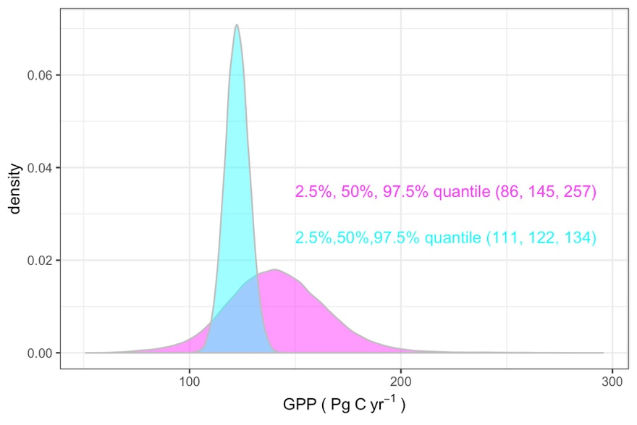

Figure 2. Mismatch between bottom-up estimated GPP (pink histogram) and GPP estimates collected from historical publications (light blue).

We compared the top-down estimated global RS (pink density distribution in Figure 3) with the collected global RS estimates from publication in the past decades (lightblue density distribution in Figure 3), we found a big mismatch between them, with only ~29% possibility they will consistent each other (i.e., global RS estimates from the published papers, 81-92, with only ~29% chance falls in the top-down global RS distribution).

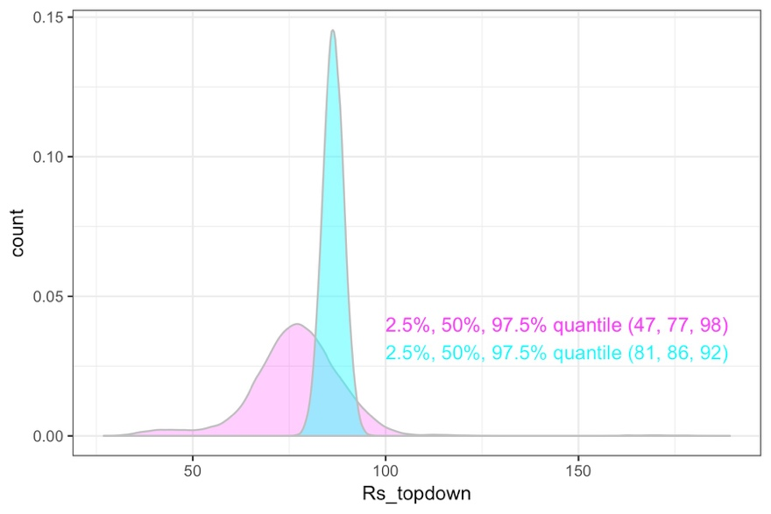

Figure 3. Mismatch between top-down estimated global soil respiration (pink) and global soil respiration estimates collected from historical publication (light blue).

Supplemental information for

Inconsistency between bottom-up and top-down global gross primary production and soil respiration

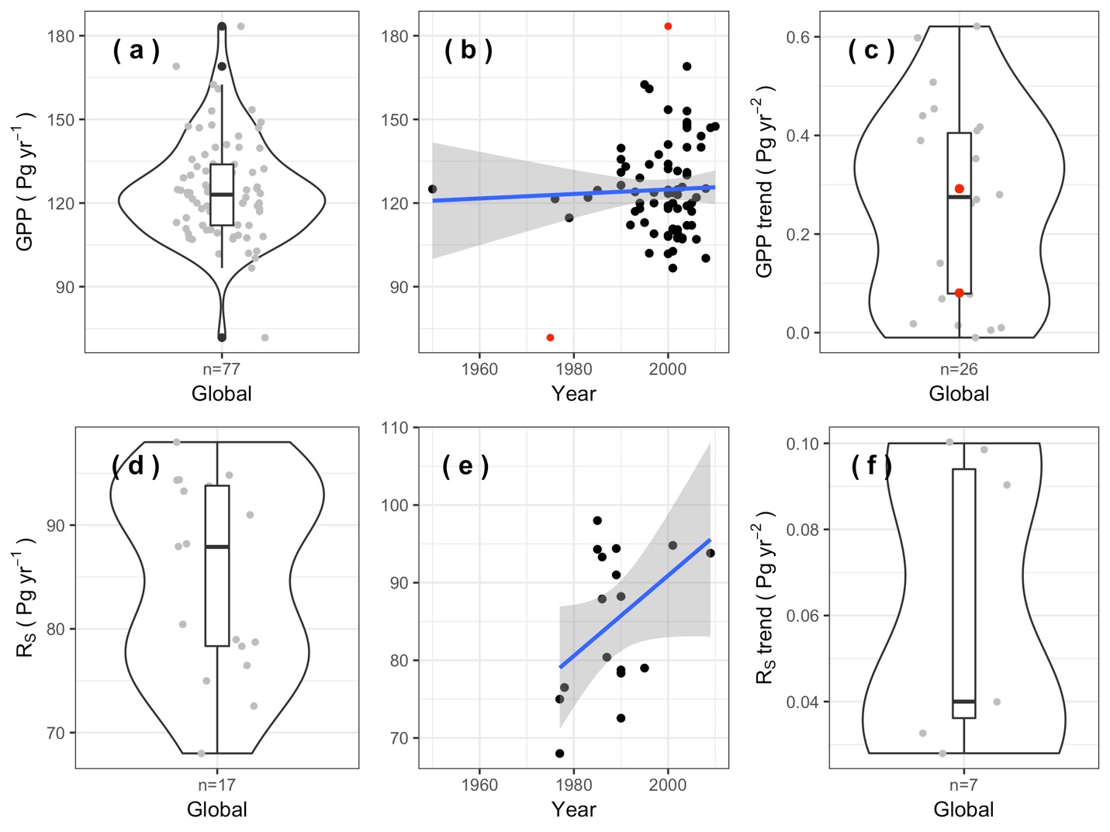

**Figure S1.** GPP collected from published literature (n=77, panel a), GPP trend with time (panel b), and reported GPP increase rate (n=26, panel c). Note that when GPP range was reported in the literature, the mean year was used. Most GPP and global RS were estimated from the similar time period.

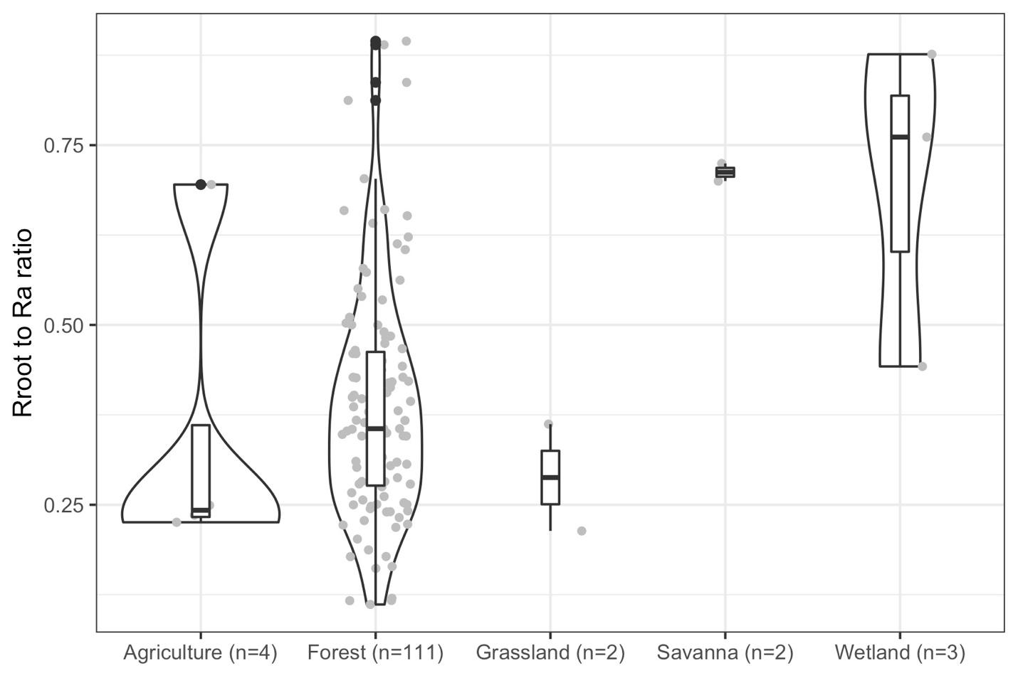

**Figure S2.** Rroot to Ra ratio by ecosystems. Violin plots (enclosed areas) show distribution of ratio values; boxplots inside show the 25%, 50%, and 75% quantiles in each distribution. Rroot to Ra ratio values for agriculture, grassland, savanna, and wetland were merged into one group when resampling due to the small sample size.

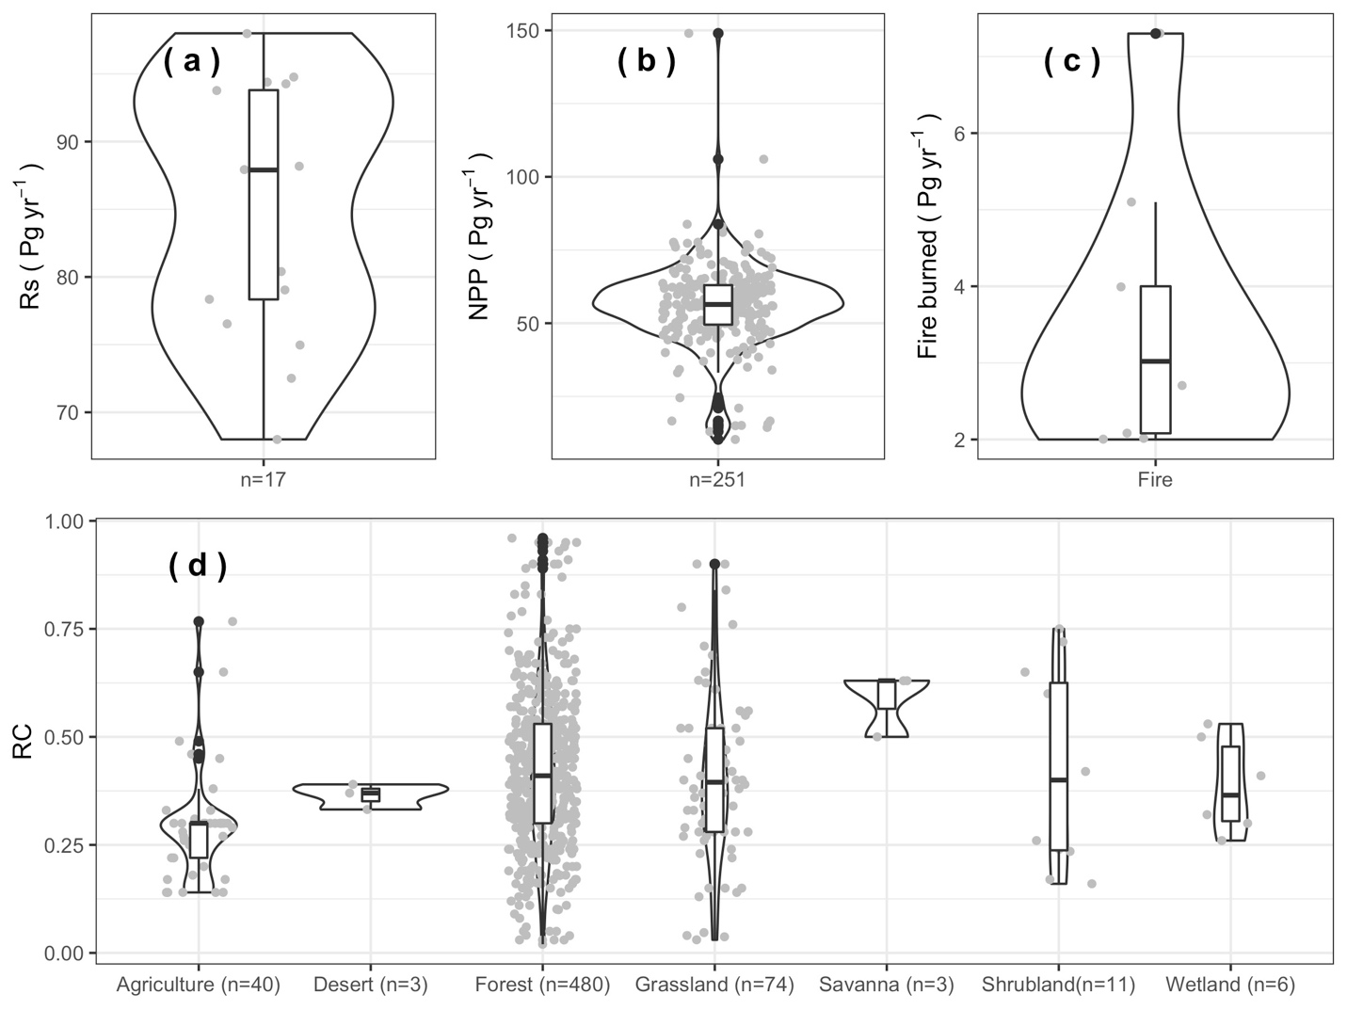

**Figure S3.** Global RS, NPP, and fire burned NPP collected from previous literature.Violin plots (enclosed areas) show distribution of each group; boxplots inside show the 25%, 50%, and 75% quantiles in each distribution. Rroot to RS ratio (RC) values for desert, savanna, shrubland, and wetland were merged into one group when resampling due to the small sample size.

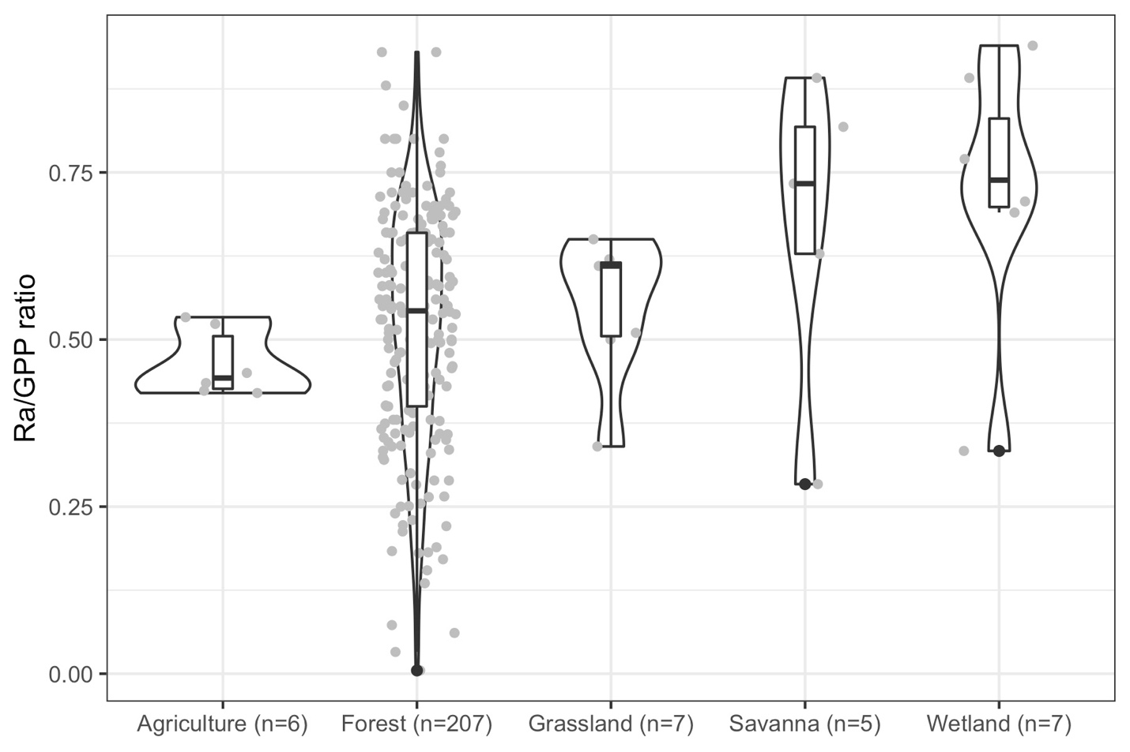

**Figure S4.** Ra to GPP ratio distribution.Violin plots (enclosed areas) show distribution by ecosystem; boxplots inside show the 25%, 50%, and 75% quantiles in each distribution. Ra to GPP ratio values for agriculture, grassland, savanna, and wetland were merged into one group when resampling due to the small sample size.

**Comments and notes**

* Components importance analysis: Uncertainty × Sensitivity = Importance (discuss with Alexey).
* Which component needs more information and measurements in the future (the components have most influence on the top-down or bottom-up estimates (as suggested by Min Chen), and those components has most importance (analysis from above)).
* What does a 28-29% chance of consistency mean? We’ll need to put that in context.
* Which is more likely (i.e., bigger GPP or smaller global soil respiration, RSG), Bayesian approach, discuss with Alexey?
* Potential of Rs to benchmark other measurements and other parts of the C cycle. <https://link.springer.com/article/10.1007%2Fs11104-016-3084-x>
* Why matches top-down and bottom-up estimates is important, what it means to global climate change prediction, global terrestrial carbon sink?

**What if GPP is really 145 PgC/yr, not 122?**

* [Lisa Welp was right](https://www.nature.com/articles/nature10421)
* A number of CMIP5 models, mostly notably CESM, are [much too low](https://agupubs.onlinelibrary.wiley.com/doi/10.1002/2015RG000483)
* MODIS and MTE far too low
* Upscaling wrong? (E.g. not accounting for tropical forests correctly.) Or is FLUXNET underestimating GPP?
* More rapid cycling of C than thought
* [Residence time](http://dx.doi.org/10.1073/pnas.1515160113) lower, and turnover higher, than thought?
* Consistent? "...we find that the ecosystem carbon turnover times simulated by state-of-the-art coupled climate/carbon-cycle models vary widely and that numerical simulations, on average, tend to underestimate the global carbon turnover time by 36 per cent." [Carvalhais et al. 2014](https://www.nature.com/articles/nature13731)

**What if Rs is really 75 Pg C/yr, not 85?**

* Our upscaling of chamber measurements is fundamentally wrong.
* Some unexpected constraint? E.g. tropical data is not representative of full suite of productivity, biased high?
* ESMs such as Had-GEM2 are [too high](https://iopscience.iop.org/article/10.1088/1748-9326/8/3/034034) - either in their temperature sensitivity, or basal rates, or ...?
* The [oldest global Rs estimates](https://agupubs.onlinelibrary.wiley.com/doi/full/10.1029/2018EF000866) are much more accurate than ones in the last 20 years
* "The results suggest that previous eddy-covariance-based estimates of global photosynthesis  
  and respiration are probably biased high" [Keenan et al. 2019](http://dx.doi.org/10.1038/s41559-019-0809-2)
* "The data could mean that the world's landmasses are taking up 7% more C than scientists thought" re [https://www.atmos-chem-phys.net/19/8687/2019](https://www.atmos-chem-phys.net/19/8687/2019/).