A topdown approach to estimate global soil respiration

Jinshi Jian1

1 Department of Crop and Soil Environmental Sciences, Virginia Tech, Blacksburg, VA, USA

*Corresponding Author: Jinshi Jian ([jinshi@vt.edu](mailto:jinshi@vt.edu))

Target: Geographical research letters

**Inferring Rs from global terrestrial carbon cycle**

Soil respiration (Rs), consists of heterotrophic respiration (Rh) and autotrophic respiration (Ra), is a major part of global carbon cycle. However, it is still difficult to partition Rs into Ra and Rh in global scale. Here, we presented an indirect method to quantify global Ra and Rh. Based on 251estimates, Ito (2011) found that 56.20 Pg C yr-1 (±1.78, 95% confidence interval calculated from the original data) from 1862 to 2011. When substract carbon consumed by herbivores (Doughty & Field, 2010; Whittaker & Likens, 1973), fire (van der Werf *et al.*, 2010; Crutzen & Andreae, 1990; Gerber *et al.*, 2004; Piao *et al.*, 2009; Zaehle *et al.*, 2005; Mieville *et al.*, 2010; Schultz *et al.*, 2008), land sink (Le Quéré et al., 2015), and carbon washed away and released by freshwater (Cole *et al.*, 2007; Bastviken *et al.*, 2011; Deemer *et al.*, 2016) from NPP, global Rh between 1961 and 2014 can be estimated (Rh = NPP - Herbivores - LandSink - Fire - FreshWater). Based on a global analysis of the relationship between the heterotrophic and autotrophic components of soil respiration (Bond-Lamberty, Wang, & Gower, 2004), Ra to Rh ratio (Ra/Rh) was 0.65 (±0.16, recalculated based on original data from (Bond-Lamberty et al., 2004)), and the global Ra can be estimated through equation: Ra = Rh × 0.75.

This conclusion is supported by the Rs estimate that emerges from quantifying Rs from global flux estimates of other components of the terrestrial carbon cycle. To make this comparison, we evaluated two approaches to partitioning the global carbon cycle from known estimates of the various fluxes and calculated the unknowns (Fig.5, Table S1 and S2). Both gross primary production (GPP, the atmospheric carbon that is synthesized into carbohydrates by plants) and net primary production (NPP, the remainder of C after portions are respired by plants (Ra)) are known quantities, where GPP is 120 Pg C yr-1 (Prentice *et al.* (2007)) and NPP is 56.2 Pg C yr-1 (Ito, 2011). In the first approach, from NPP we substracted carbon stored in the land sink (2.10 ±0.28 Pg C; Le Quéré *et al.* (2015)), burned by fire (3.53 Pg), drained and released to the atmosphere by fresh water (1.9 Pg), and consumed by forest and grassland herbivores (2.2 Pg C) (Fig.5a and Table S1). The remainder was the carbon consumed by soil dwelling hetrotrophic respiration [Rh, 46.47 (±2.06) Pg C yr-1], which does not include aboveground hetrotrophic respiration (Fig.5a). Based on a global analysis of the relationship between the Rh and belowground autotrophic (Rab) components of soil respiration (Bond-Lamberty et al., 2004), we used the ratio Rab/Rh = 0.75 (±0.16) to estimate Rab (35.18 ±8.98 Pg C yr-1) (Fig.5a and Table S1). The sum of Rh and Rab equaled an Rs of 81.86±10.55 Pg C yr-1, very close to the SKT_MS1 estimate for global Rs (80.99 Pg C yr-1). In the second approach to estimating Rs from the carbon cycle, we substracted the Rh calculated above from GPP to estiamte autrotrophic respiration (Ra), which equaled to 63.80 (± 1.78) Pg C yr-1(Fig.5b). Based on known fractions, we estimated C respired by roots (Rroots = 23.37±3.58 Pg C yr-1), stems (Rstem = 16.01±2.91 Pg C yr-1), and leaves (Rleaf = 24.42±3.71 Pg C yr-1) (Fig.5b). The sum of Rroot and Rh was 69.54 (±5.36) Pg C yr-1, very close to the global annual Rs estimats from the SKT_HYP_MS1 model (66.62 to 75.75 Pg C yr-1). In sum, global annual mean Rs estimated by partitioning from global carbon flux ranged from 69.54 (±5.36) Pg C yr-1 to 81.65 (±10.55) Pg C yr-1, very close to the global mean Rs estimated based on the SKT_HYP model (70.85 Pg C yr-1) and SKT model (80.99 Pg C yr-1).

**3.3.** **Global carbon cycle and soil respiration**

Here we conducted a summary analysis of global terrestrial carbon cycling to evaluate which estimate from the models close to the real global mean annual soil respiration. Soil respiration consumed the photosynthetic carbon assimilation which was fixed by plant, or called gross primary production (GPP). Plant autotrophic respiration (including fraction of leaf respiration (Fl), fraction of stem respiration (Fs) and fraction of root respiration (Fr)) consumed part of GPP, the left part was called net primary productivity (NPP). Part of NPP consumed by heterotrophic respiration (Rh), other part of NPP was consumed by herbivores, burned by fire or becomes long term carbon storage (carbon sink), and the sum of leaf respiration (Fl) and heterotrophic respiration (Rh) is soil respiration. Theoretically, if we know the pathway of each part of global annual GPP, we can estimate global mean annual soil respiration.

In order to identify the magnitude of global mean annual GPP, we collected 35 literatures reported GPP from 1975 to 2011, the 35 reported GPP range from 71.73 to 183.39 Pg (table 3). The average GPP was 123.55 Pg, which was close to IPCC’s estimation (120 Pg, 3rd assessment). When the lowest estimation (71.73 Pg) and the highest estimation (183.39 Pg) was excluded, the GPP estimations range from 97 to 160.95 Pg (figure 3), and the average was 123.31 Pg.

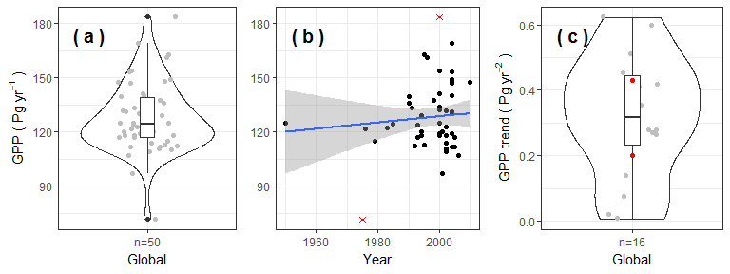

Fig.1 Histogram of the 50 estimates of gross primary production (GPP, a) and temporal change of GPP from 1950 to 2010 (b).

Fig.2 Histogram

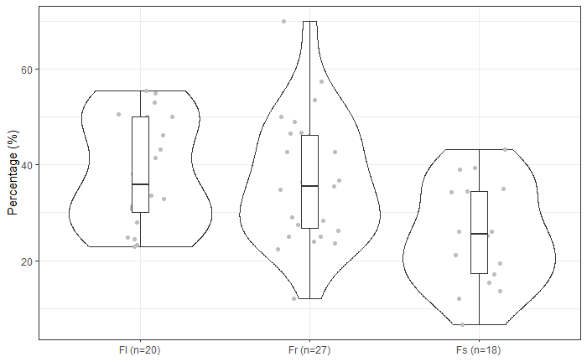

Fig.3 Histogram



Fig. 4 Terrestrial carbon cycling pathway. Solid filled boxes denote the values are mean (± 95% confidence interval) of data collected from the literature. The dashed boxes denote calculated values. All units are Pg C yr-1. Abbreviations used are as follows: Gross Primary Production (GPP) was from (Prentice et al., 2007), Net Primary Production (NPP), autotrophic respiration (Ra), belowground autotrophic respiration (Rab), root respiration (Rroot), stem respiration (Rstem), leaf respiration (Rleaf), belowground heterotrophic respiration (Rh), and Soil respiration (Rs). Calculation in panel (a): Rh =NPP - Herbivores - Land Sink - Fire - Freshwater. Calculation in panel (b): Ra = GPP - NPP, Rroot = Ra × proportion of Rroot to Ra (0.37), Rstem = Ra × proportion of Rstem to Ra (0.25), Rleaf = Ra × proportion of Rleaf to Ra (0.38). For details and references about each carbon component, please see supplemental material Table S1 and Table S2.

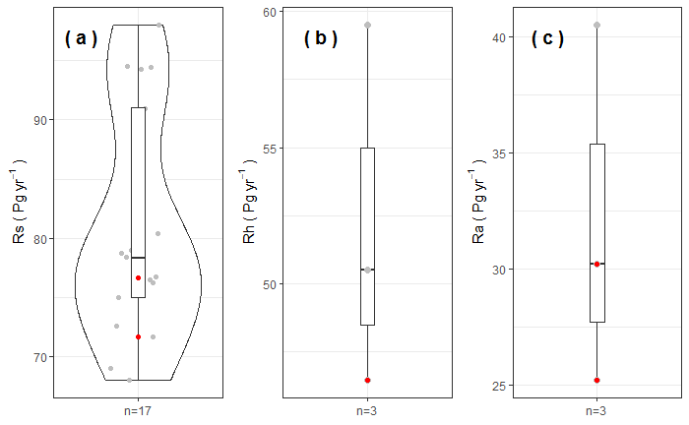

Fig. 5 Terrestrial

**References:**

Bastviken, D., Tranvik, L. J., Downing, J., Crill, J. a, M, P., & Enrich-prast, A. (2011). Freshwater methane emissions offset the continental carbon sink. *Science*, *331*(6013), 50. https://doi.org/10.1126/science.1196808

Bond-Lamberty, B., Wang, C., & Gower, S. T. (2004). A global relationship between the heterotrophic and autotrophic components of soil respiration? *Global Change Biology*, *10*(10), 1756–1766. https://doi.org/10.1111/j.1365-2486.2004.00816.x

Cole, J. J., Prairie, Y. T., Caraco, N. F., McDowell, W. H., Tranvik, L. J., Striegl, R. G., … Melack, J. (2007). Plumbing the global carbon cycle: Integrating inland waters into the terrestrial carbon budget. *Ecosystems*, *10*(1), 171–184. https://doi.org/10.1007/s10021-006-9013-8

Crutzen, P., & Andreae, M. O. (1990). Biomass burning in the tropics: Impact on atmospheric chemistry and biogeochemical cycles. *Science*, *250*(4988), 1669–1678.

Deemer, B. R., Harrison, J. A., Li, S., Beaulieu, J. J., DelSontro, T., Barros, N., … Proof, B. P.--uncorrected. (2016). Greenhouse Gas Emissions from Reservoir Water Surfaces: A New Global Synthesis. *BioScience*, *XX*(X), biw117. https://doi.org/10.1093/biosci/biw117

Doughty, C. E., & Field, C. B. (2010). Agricultural net primary production in relation to that liberated by the extinction of Pleistocene mega-herbivores: an estimate of agricultural carrying capacity? *Environmental Research Letters*, *5*(4), 044001. https://doi.org/10.1088/1748-9326/5/4/044001

Gerber, S., Joos, F., & Prentice, C. (2004). Sensitivity of a dynamic global vegetation model to climate and atmospheric CO2. *Global Change Biology*, *10*, 1223–1239. https://doi.org/10.1111/j.1365-2486.2004.00807.x

Le Quéré, C., Moriarty, R., Andrew, R. M., Canadell, J. G., Sitch, S., Korsbakken, J. I., … Boden, T. A. (2015). Global carbon budget 2015. *Earth System Science Data*, *7*(2), 349–396.

Mieville, A., Granier, C., Liousse, C., Guillaume, B., Mouillot, F., Lamarque, J. F., … Pétron, G. (2010). Emissions of gases and particles from biomass burning during the 20th century using satellite data and an historical reconstruction. *Atmospheric Environment*, *44*(11), 1469–1477. https://doi.org/10.1016/j.atmosenv.2010.01.011

Piao, S., Ciais, P., Friedlingstein, P., De Noblet-Ducoudré, N., Cadule, P., Viovy, N., & Wang, T. (2009). Spatiotemporal patterns of terrestrial carbon cycle during the 20th century. *Global Biogeochemical Cycles*, *23*(4), 1–16. https://doi.org/10.1029/2008GB003339

Prentice, I. C., Farquhar, G. D., Fasham, M. J. R., Goulden, M. L., Heimann, M., Jaramillo, V. J., … Wallace, D. W. R. (2007). The Carbon Cycle and Atmospheric Carbon Dioxide. In S. Solomon, D. Qin, M. Manning, Z. Chen, M. Marquis, K. B. Averyt, … H. L. Miller (Eds.), *Contribution of Working Group I to the Fourth Assessment Report of the Intergovernmental Panel on Climate Change, 2007* (pp. 183–287). Cambridge, United Kingdom and New York, NY, USA: Cambridge University Press.

Schultz, M. G., Heil, A., Hoelzemann, J. J., Spessa, A., Thonicke, K., Goldammer, J. G., … van Het Bolscher, M. (2008). Global wildland fire emissions from 1960 to 2000. *Global Biogeochemical Cycles*, *22*(2), 1–17. https://doi.org/10.1029/2007GB003031

van der Werf, G. R., Randerson, J. T., Giglio, L., Collatz, G. J., Mu, M., Kasibhatla, P. S., … van Leeuwen, T. T. (2010). Global fire emissions and the contribution of deforestation, savanna, forest, agricultural, and peat fires (1997–2009). *Atmospheric Chemistry and Physics*, *10*(23), 11707–11735. https://doi.org/10.5194/acp-10-11707-2010

Whittaker, R. H., & Likens, G. E. (1973). Carbon in the biota. In G. M. Woodwell & E. V Pecan (Eds.), *Carbon and biosphere* (pp. 281–302). U.S.: National Technical Information Service.

Zaehle, S., Sitch, S., Smith, B., & Hatterman, F. (2005). Effects of parameter uncertainties on the modeling of terrestrial biosphere dynamics. *Global Biogeochemical Cycles*, *19*(3), 1–16. https://doi.org/10.1029/2004GB002395