|  |
| --- |
| Title: Can soil respiration measured at mean temperature represents actual soil respiration |
| author: “Jinshi” |
| date: “March 26, 2019” |
| output: |
| html_document: |
| df_print: paged |
| bibliography: bibliography.ris |

# 1. The spatial destribution of global Rs sites

* We have much more measured Rs from the middle latitude region
* It is difficult to measure soil respiration all year around in the cold region
* Developed contries most located at Middle latitude region, thus recieved more funds to support the Rs measurements

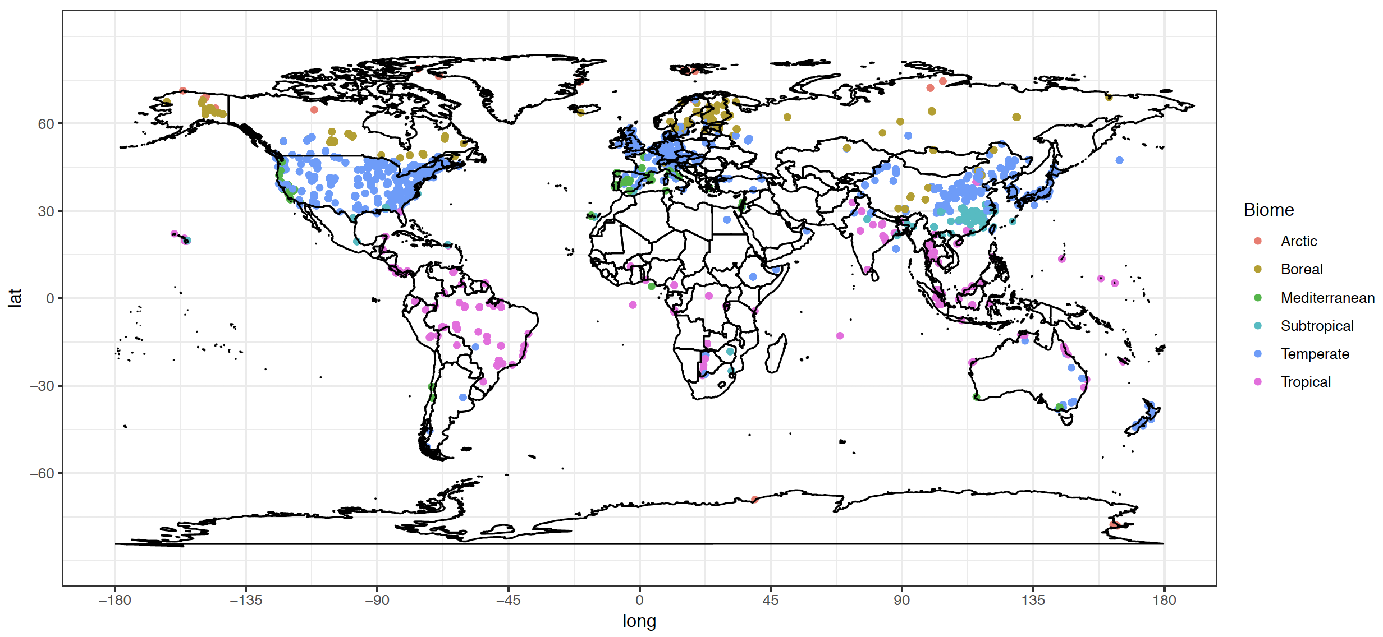

Global spatial destribution of soil repiration sites

* Rs measurements from cold region is more importent, but how to increase the measurements?
* Making equipment works normal in cold condition
* Increase funds input
* Measured once per day to get daily mean

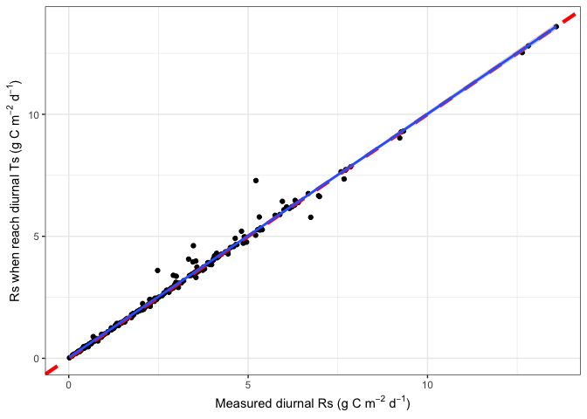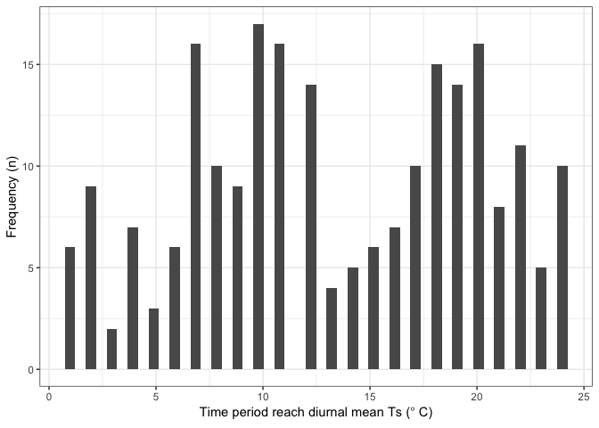

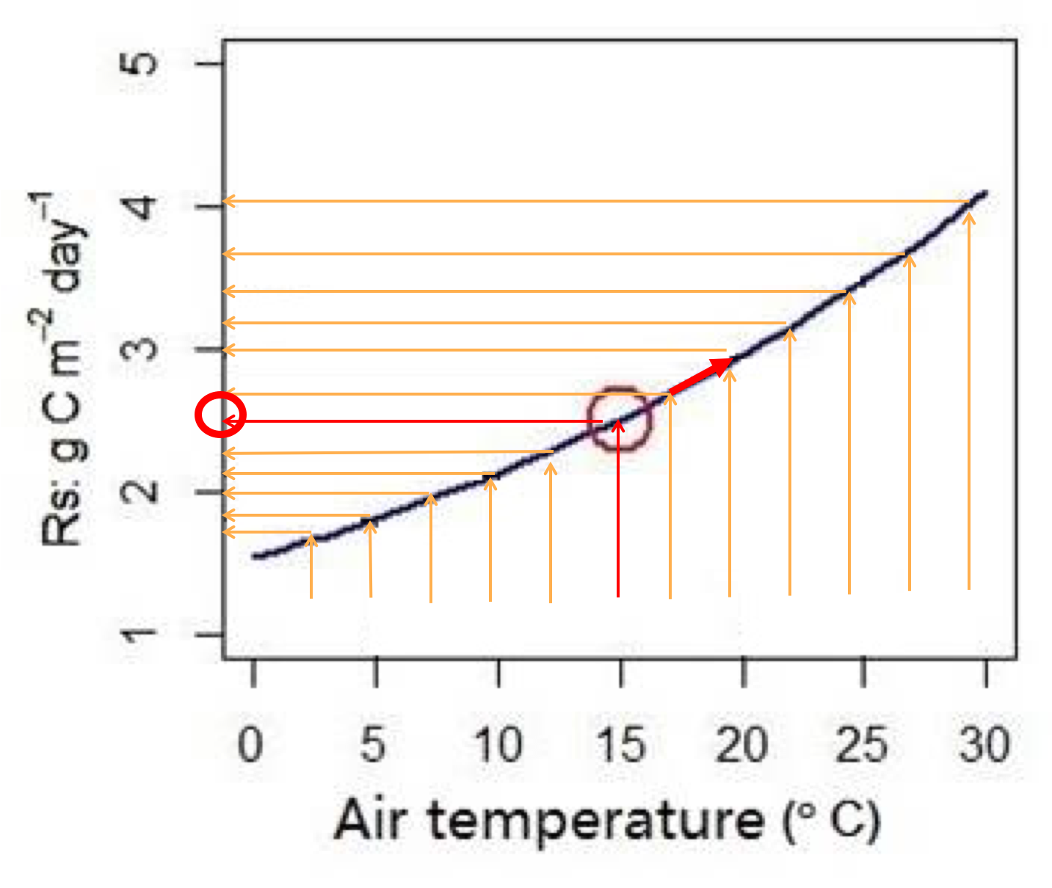

Rs measured at diurnal soil temperature

* Measure once per year to get a annual Rs mean? **Bahn’s approach** [Bahn et al. (2004) Biogeosciences]

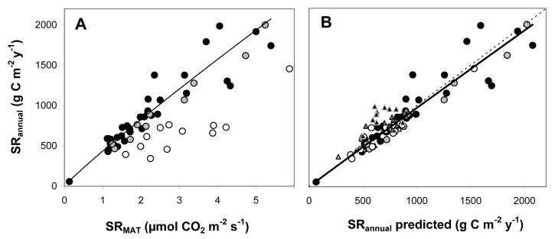

Rs measured at mean annual soil temperature

* Rs measured at annuam mean temperature linearly related with annual Rs rate
* Rs at mean temperature: soil respiration measured at annual mean temperature / monthly mean temperature / daily mean temperature
* Rs_annual ~ Rs_mat (Rs_bahn)
* Rs_annual = 455.8 * Rs_mat^1.0054 (R^2 = 0.94, p<0.001)

# 2. The object of this analysis are

* Whether Rs measured at annuam mean soil temperature can represent annual Rs rate?
* Annuam mean air temperature (e.g., average of 12 monthes’ air temperature of 2000) / Mean annual air temperature (1964-2014)
* If not, when and what is the mechanism?
* Update the model?

# 3. Mthods

**Data** * SRDB_V4 – Rs_Annual * Annual mean soil temperature (reported in the papers or can be calculated with simple assumption) * Relationship between Rs and soil temperature (SRDB_V4) * Air temperature (University of Daleware global precipitation and air temperature data, 1964-2014, half degree spatial resolusion) * 823 records from 253 studies

**Statistics** * According the the relationship between Rs and Ts, we can estimate Rs_mat base on the annual mean soil temperature / T_Annual / MAT * Using Bahn (2010, Biogeoscience model: Rs_annual = 455.8 * Rs_mat^1.0054) to predict Rs_annual based on Rs_mat * Comparing Rs_annual and Rs_annual_bahn to evaluate the performance of Bahn model across the global

**Update Bahn’s model** * If Bahn (2010) model does not predict Rs_annual in all conditions * Update Bahn (2010) model (e.g., including drought parameter, other parameters?)

## Warning: Removed 3 rows containing missing values (geom_point).

## Saving 7 x 5 in image

## Warning: Removed 3 rows containing missing values (geom_point).

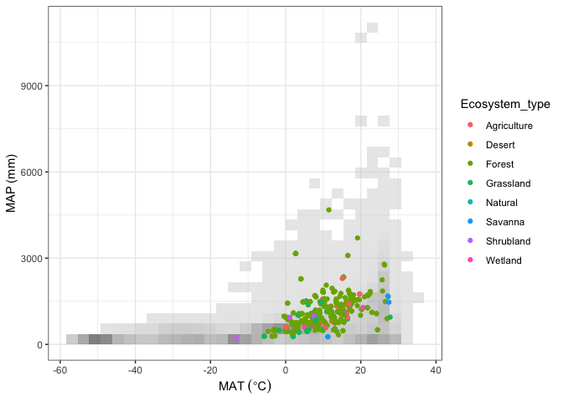

## 3.2 test the relationship between Rs_annual and Rs_mat

## Mon Apr 1 18:28:23 2019 -------------------+++++-------------------  
## Mon Apr 1 18:28:23 2019 Bahn relationship for these data:  
##   
## Call:  
## lm(formula = Rs_TAIR ~ Rs_annual, data = sdata)  
##   
## Residuals:  
## Min 1Q Median 3Q Max   
## -1006.45 -84.72 14.90 93.38 964.58   
##   
## Coefficients:  
## Estimate Std. Error t value Pr(>|t|)   
## (Intercept) 0.64266 13.67584 0.047 0.963   
## Rs_annual 0.85184 0.01466 58.126 <2e-16 ***  
## ---  
## Signif. codes: 0 '***' 0.001 '**' 0.01 '*' 0.05 '.' 0.1 ' ' 1  
##   
## Residual standard error: 185.1 on 821 degrees of freedom  
## Multiple R-squared: 0.8045, Adjusted R-squared: 0.8043   
## F-statistic: 3379 on 1 and 821 DF, p-value: < 2.2e-16

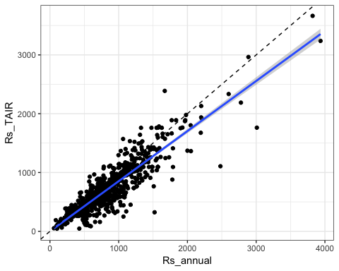

## [1] "test intercept=0 and slope=1"  
## [1] "p_intercept = 0.9625, p_slope = 0"

## 3.3 Ts sources (MGRsD, MGRsD_TAIR, From paper, Rs_Ts_relationship)

## Saving 7 x 5 in image

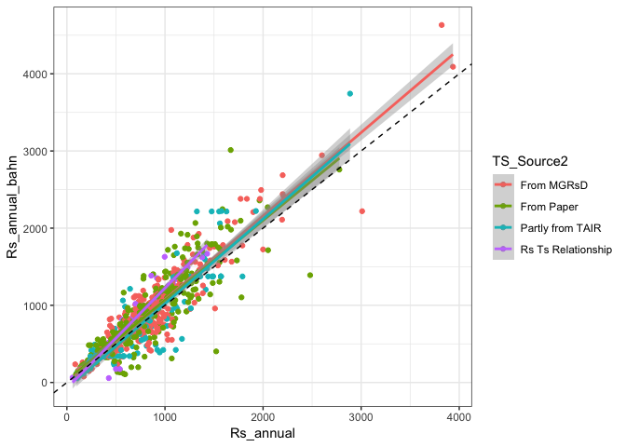

## 3.4 Annual Rs or Ts coverage effect

## Saving 5 x 4 in image

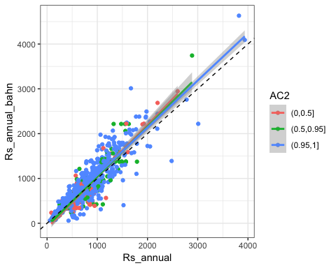

## Saving 5 x 4 in image

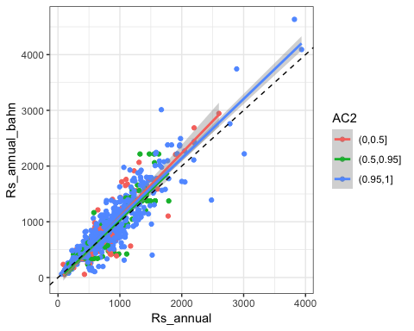

## 3.4.1 Test whether extreme high Rs values affect the regression

* Cinclusion: no

srdb_01 <- filtration1(srdb_orig)  
figB_01 <- Rs_comparion_figure( srdb_01 )

## Mon Apr 1 18:28:25 2019 -------------------+++++-------------------  
## Mon Apr 1 18:28:25 2019 -------------------+++++-------------------  
## Mon Apr 1 18:28:25 2019 Doing main figure comparing Rs_annual and Rs_annual_bahn

## Warning: Removed 508 rows containing missing values (geom_errorbarh).

## Mon Apr 1 18:28:25 2019 Saving outputs/4.2.1-Rs (Figure 2).pdf

## Saving 5 x 4 in image

## Warning: Removed 508 rows containing missing values (geom_errorbarh).

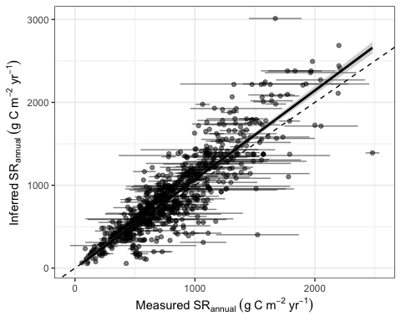

test_extreme <- Rs_annual_bahn_test(srdb_01, srdb_01$Rs_annual_bahn)

## Mon Apr 1 18:28:25 2019 -------------------+++++-------------------  
## Mon Apr 1 18:28:25 2019 How are Rs_annual and Rs_annual_bahn_Temp related?  
## Mon Apr 1 18:28:25 2019 sdata rows = 817 cols = 35  
## Mon Apr 1 18:28:25 2019 Model summary:  
##   
## Call:  
## lm(formula = temp ~ Rs_annual, data = sdata)  
##   
## Residuals:  
## Min 1Q Median 3Q Max   
## -1268.81 -106.13 19.11 112.93 1222.65   
##   
## Coefficients:  
## Estimate Std. Error t value Pr(>|t|)   
## (Intercept) -3.44879 18.40984 -0.187 0.851   
## Rs_annual 1.07364 0.02057 52.207 <2e-16 ***  
## ---  
## Signif. codes: 0 '***' 0.001 '**' 0.01 '*' 0.05 '.' 0.1 ' ' 1  
##   
## Residual standard error: 229.6 on 815 degrees of freedom  
## Multiple R-squared: 0.7698, Adjusted R-squared: 0.7695   
## F-statistic: 2726 on 1 and 815 DF, p-value: < 2.2e-16  
##   
## Mon Apr 1 18:28:25 2019 Plotting and saving model diagnostics...

## Mon Apr 1 18:28:25 2019 Plotting and saving model residuals...

## Mon Apr 1 18:28:26 2019 Saving outputs/3-modelresids.pdf

## Saving 5 x 4 in image

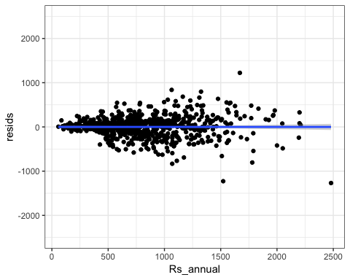

## Mon Apr 1 18:28:26 2019 Test H0 of intercept=0: p-value = 0.8514454  
## Mon Apr 1 18:28:26 2019 Test H0 of slope=1: p-value = 0.0003626346

m_extreme <- test_extreme[[ 1 ]]  
m1_extreme <- test_extreme[[ 2 ]]  
intercept_test <- summary( m_extreme )$coefficients[ 1, 4 ]  
slope_test <- summary( m1_extreme )$coefficients[ 2, 4 ]  
intercept_test

## [1] 0.8514454

slope_test

## [1] 0.0003626346

## 3.4.2 Effect of maximum allowed divergence between global climate data set and site-specific air temperature

* Does TAIR_dev and TAIR_LT<_dev affect the relationship – YES!!!!!
* TAIR_LTM_dev = with( srdb, abs( MAT_Del - MAT ) )
* Does TAIR_LTM_dev () pull the slope off 1? – YES!!!!!
* TAIR_dev <- with( srdb, abs( TAnnual_Del - Study_temp ) )
* Figure E. Effect of maximum allowed divergence between global climate data set and site-specific air temperature, when given. As we throw out data points with high divergence, R2 goes up (top panel) and RSE goes down (bottom, g C m-2 yr-1).

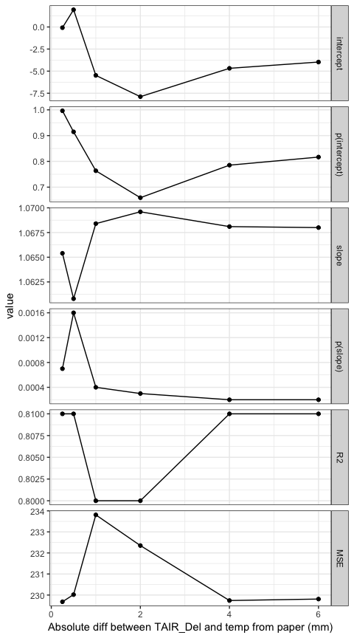

## Warning: Removed 467 rows containing missing values (geom_errorbarh).

## Saving 5 x 4 in image

## Warning: Removed 467 rows containing missing values (geom_errorbarh).

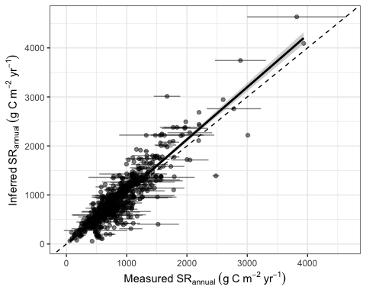

## Saving 5 x 4 in image

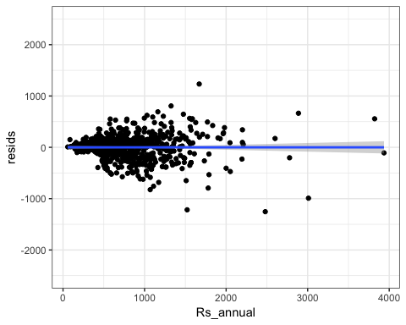

## 3.4.3 Effect of maximum allowed divergence between annual precipitation from paper and Del

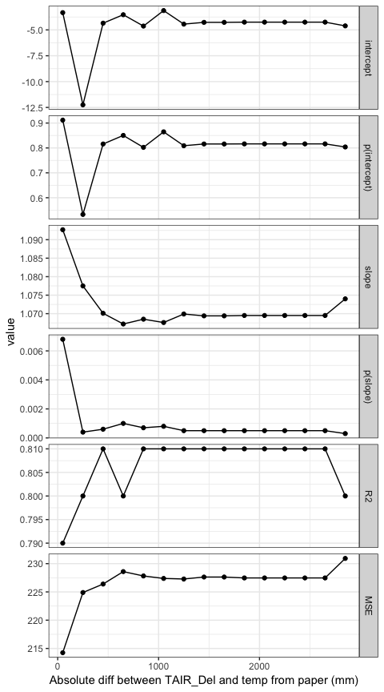

# 4. Results

## 4.1 Using Ts, TAnnual or MAT

### 4.1.1 Using soil temperature

##   
## Call:  
## lm(formula = bahn ~ Rs_annual, data = sdata)  
##   
## Residuals:  
## Min 1Q Median 3Q Max   
## -1270.56 -106.41 19.13 116.92 1221.77   
##   
## Coefficients:  
## Estimate Std. Error t value Pr(>|t|)   
## (Intercept) -4.35814 17.24982 -0.253 0.801   
## Rs_annual 1.07472 0.01849 58.140 <2e-16 ***  
## ---  
## Signif. codes: 0 '***' 0.001 '**' 0.01 '*' 0.05 '.' 0.1 ' ' 1  
##   
## Residual standard error: 233.5 on 821 degrees of freedom  
## Multiple R-squared: 0.8046, Adjusted R-squared: 0.8043   
## F-statistic: 3380 on 1 and 821 DF, p-value: < 2.2e-16

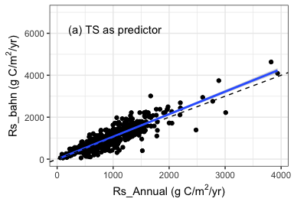

## Mon Apr 1 18:28:29 2019 -------------------+++++-------------------  
## Mon Apr 1 18:28:29 2019 How are Rs_annual and Rs_annual_bahn_Temp related?  
## Mon Apr 1 18:28:29 2019 sdata rows = 823 cols = 143  
## Mon Apr 1 18:28:29 2019 Model summary:  
##   
## Call:  
## lm(formula = temp ~ Rs_annual, data = sdata)  
##   
## Residuals:  
## Min 1Q Median 3Q Max   
## -1270.56 -106.41 19.13 116.92 1221.77   
##   
## Coefficients:  
## Estimate Std. Error t value Pr(>|t|)   
## (Intercept) -4.35814 17.24982 -0.253 0.801   
## Rs_annual 1.07472 0.01849 58.140 <2e-16 ***  
## ---  
## Signif. codes: 0 '***' 0.001 '**' 0.01 '*' 0.05 '.' 0.1 ' ' 1  
##   
## Residual standard error: 233.5 on 821 degrees of freedom  
## Multiple R-squared: 0.8046, Adjusted R-squared: 0.8043   
## F-statistic: 3380 on 1 and 821 DF, p-value: < 2.2e-16  
##   
## Mon Apr 1 18:28:29 2019 Plotting and saving model diagnostics...

## Mon Apr 1 18:28:29 2019 Plotting and saving model residuals...

## Mon Apr 1 18:28:29 2019 Saving outputs/3-modelresids.pdf

## Saving 4 x 2.8 in image

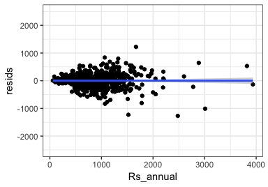

## Mon Apr 1 18:28:29 2019 Test H0 of intercept=0: p-value = 0.800603  
## Mon Apr 1 18:28:29 2019 Test H0 of slope=1: p-value = 5.798985e-05

## [1] 0.800603

## [1] "slope = 0.075"

## [1] 5.798985e-05

### 4.1.2 Using T_Annual

##   
## Call:  
## lm(formula = bahn ~ Rs_annual, data = sdata)  
##   
## Residuals:  
## Min 1Q Median 3Q Max   
## -2450.9 -173.4 -0.7 152.1 4964.1   
##   
## Coefficients:  
## Estimate Std. Error t value Pr(>|t|)   
## (Intercept) -29.03769 27.56454 -1.053 0.292   
## Rs_annual 1.03055 0.02954 34.889 <2e-16 ***  
## ---  
## Signif. codes: 0 '***' 0.001 '**' 0.01 '*' 0.05 '.' 0.1 ' ' 1  
##   
## Residual standard error: 373.1 on 821 degrees of freedom  
## Multiple R-squared: 0.5972, Adjusted R-squared: 0.5967   
## F-statistic: 1217 on 1 and 821 DF, p-value: < 2.2e-16

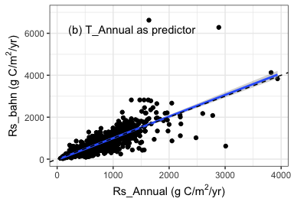

## Mon Apr 1 18:28:30 2019 -------------------+++++-------------------  
## Mon Apr 1 18:28:30 2019 How are Rs_annual and Rs_annual_bahn_Temp related?  
## Mon Apr 1 18:28:30 2019 sdata rows = 823 cols = 143  
## Mon Apr 1 18:28:30 2019 Model summary:  
##   
## Call:  
## lm(formula = temp ~ Rs_annual, data = sdata)  
##   
## Residuals:  
## Min 1Q Median 3Q Max   
## -2450.9 -173.4 -0.7 152.1 4964.1   
##   
## Coefficients:  
## Estimate Std. Error t value Pr(>|t|)   
## (Intercept) -29.03769 27.56454 -1.053 0.292   
## Rs_annual 1.03055 0.02954 34.889 <2e-16 ***  
## ---  
## Signif. codes: 0 '***' 0.001 '**' 0.01 '*' 0.05 '.' 0.1 ' ' 1  
##   
## Residual standard error: 373.1 on 821 degrees of freedom  
## Multiple R-squared: 0.5972, Adjusted R-squared: 0.5967   
## F-statistic: 1217 on 1 and 821 DF, p-value: < 2.2e-16  
##   
## Mon Apr 1 18:28:30 2019 Plotting and saving model diagnostics...

## Mon Apr 1 18:28:30 2019 Plotting and saving model residuals...

## Warning: Removed 2 rows containing non-finite values (stat_smooth).

## Warning: Removed 2 rows containing missing values (geom_point).

## Mon Apr 1 18:28:30 2019 Saving outputs/3-modelresids.pdf

## Saving 4 x 2.8 in image

## Warning: Removed 2 rows containing non-finite values (stat_smooth).  
  
## Warning: Removed 2 rows containing missing values (geom_point).

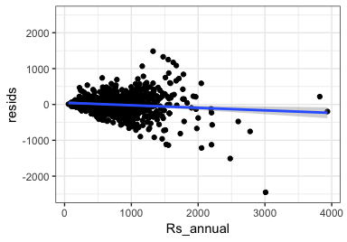

## Mon Apr 1 18:28:30 2019 Test H0 of intercept=0: p-value = 0.2924477  
## Mon Apr 1 18:28:30 2019 Test H0 of slope=1: p-value = 0.3012956

## [1] 0.2924477

## [1] "slope = 0.031"

## [1] 0.3012956

### 4.1.3 Using MAT

##   
## Call:  
## lm(formula = bahn ~ Rs_annual, data = sdata)  
##   
## Residuals:  
## Min 1Q Median 3Q Max   
## -2357.10 -167.81 -1.63 142.82 2745.59   
##   
## Coefficients:  
## Estimate Std. Error t value Pr(>|t|)   
## (Intercept) -32.10088 24.31519 -1.32 0.187   
## Rs_annual 1.00343 0.02606 38.51 <2e-16 ***  
## ---  
## Signif. codes: 0 '***' 0.001 '**' 0.01 '*' 0.05 '.' 0.1 ' ' 1  
##   
## Residual standard error: 329.1 on 821 degrees of freedom  
## Multiple R-squared: 0.6437, Adjusted R-squared: 0.6432   
## F-statistic: 1483 on 1 and 821 DF, p-value: < 2.2e-16

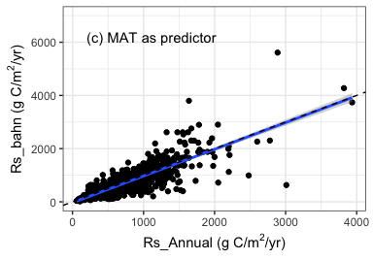

## Mon Apr 1 18:28:31 2019 -------------------+++++-------------------  
## Mon Apr 1 18:28:31 2019 How are Rs_annual and Rs_annual_bahn_Temp related?  
## Mon Apr 1 18:28:31 2019 sdata rows = 823 cols = 143  
## Mon Apr 1 18:28:31 2019 Model summary:  
##   
## Call:  
## lm(formula = temp ~ Rs_annual, data = sdata)  
##   
## Residuals:  
## Min 1Q Median 3Q Max   
## -2357.10 -167.81 -1.63 142.82 2745.59   
##   
## Coefficients:  
## Estimate Std. Error t value Pr(>|t|)   
## (Intercept) -32.10088 24.31519 -1.32 0.187   
## Rs_annual 1.00343 0.02606 38.51 <2e-16 ***  
## ---  
## Signif. codes: 0 '***' 0.001 '**' 0.01 '*' 0.05 '.' 0.1 ' ' 1  
##   
## Residual standard error: 329.1 on 821 degrees of freedom  
## Multiple R-squared: 0.6437, Adjusted R-squared: 0.6432   
## F-statistic: 1483 on 1 and 821 DF, p-value: < 2.2e-16  
##   
## Mon Apr 1 18:28:31 2019 Plotting and saving model diagnostics...

## Mon Apr 1 18:28:31 2019 Plotting and saving model residuals...

## Warning: Removed 1 rows containing non-finite values (stat_smooth).

## Warning: Removed 1 rows containing missing values (geom_point).

## Mon Apr 1 18:28:31 2019 Saving outputs/3-modelresids.pdf

## Saving 4 x 2.8 in image

## Warning: Removed 1 rows containing non-finite values (stat_smooth).  
  
## Warning: Removed 1 rows containing missing values (geom_point).

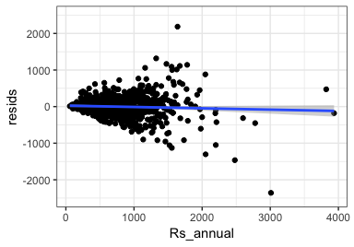

## Mon Apr 1 18:28:31 2019 Test H0 of intercept=0: p-value = 0.1871366  
## Mon Apr 1 18:28:31 2019 Test H0 of slope=1: p-value = 0.8953088

## [1] 0.1871366

## [1] "slope = 0.003"

## [1] 0.8953088

## 4.2 Analysis when Rs_mat cannot represent Rs_annual

## 4.2.2 Does Ecosystem_type affects the relationship between Rs_annual and Rs_mat

## Ecosystem R2_mv Slope_mv p_slope_mv intercept_mv  
## Rs_annual Agriculture 0.80 1.08 0.0001 -6.25  
## Rs_annual1 Forest 0.74 0.87 0.0042 94.20  
## Rs_annual2 Grassland 0.82 1.12 0.0000 -33.00  
## Rs_annual3 Shrubland 0.81 1.08 0.0001 -3.57  
## Rs_annual4 Wetland 0.80 1.08 0.0001 -4.97  
## p_intercept_mv MSE_mv  
## Rs_annual 0.7245 235.24  
## Rs_annual1 0.0167 271.45  
## Rs_annual2 0.0617 217.13  
## Rs_annual3 0.8376 233.75  
## Rs_annual4 0.7765 234.40

## geom_path: Each group consists of only one observation. Do you need to  
## adjust the group aesthetic?  
## geom_path: Each group consists of only one observation. Do you need to  
## adjust the group aesthetic?  
## geom_path: Each group consists of only one observation. Do you need to  
## adjust the group aesthetic?  
## geom_path: Each group consists of only one observation. Do you need to  
## adjust the group aesthetic?  
## geom_path: Each group consists of only one observation. Do you need to  
## adjust the group aesthetic?  
## geom_path: Each group consists of only one observation. Do you need to  
## adjust the group aesthetic?

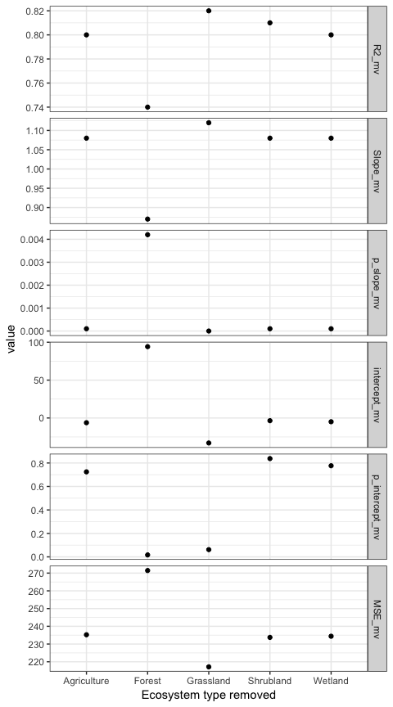

## Ecosystem R2_kp Slope_kp p_slope_kp intercept_kp  
## Rs_annual Agriculture 0.74 1.04 0.7725 38.73  
## Rs_annual1 Forest 0.83 1.13 0.0000 -43.81  
## Rs_annual2 Grassland 0.73 0.88 0.0459 89.44  
## Rs_annual3 Shrubland 0.68 0.74 0.1066 101.92  
## Rs_annual4 Wetland 0.80 0.92 0.5972 63.88  
## p_intercept_kp MSE_kp  
## Rs_annual 0.6262 170.87  
## Rs_annual1 0.0199 217.52  
## Rs_annual2 0.1264 316.26  
## Rs_annual3 0.3434 174.53  
## Rs_annual4 0.4887 159.16

## geom_path: Each group consists of only one observation. Do you need to  
## adjust the group aesthetic?  
## geom_path: Each group consists of only one observation. Do you need to  
## adjust the group aesthetic?  
## geom_path: Each group consists of only one observation. Do you need to  
## adjust the group aesthetic?  
## geom_path: Each group consists of only one observation. Do you need to  
## adjust the group aesthetic?  
## geom_path: Each group consists of only one observation. Do you need to  
## adjust the group aesthetic?  
## geom_path: Each group consists of only one observation. Do you need to  
## adjust the group aesthetic?

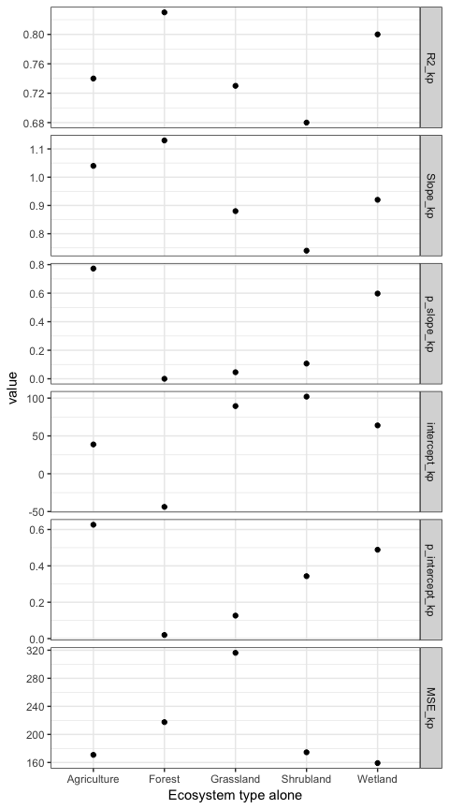

## Warning: Removed 495 rows containing missing values (geom_errorbarh).

## Saving 7 x 5 in image

## Warning: Removed 495 rows containing missing values (geom_errorbarh).

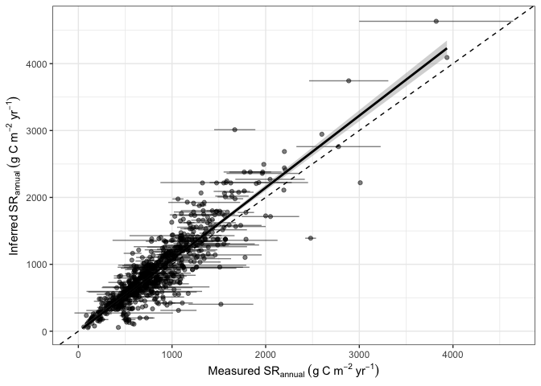

## Saving 7 x 5 in image

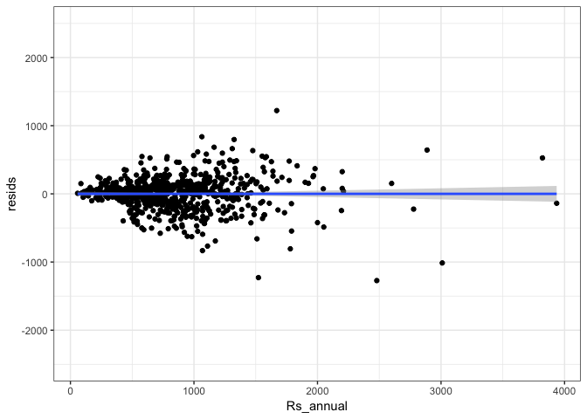

## Warning: Removed 16 rows containing missing values (geom_errorbarh).

## Saving 7 x 5 in image

## Warning: Removed 16 rows containing missing values (geom_errorbarh).

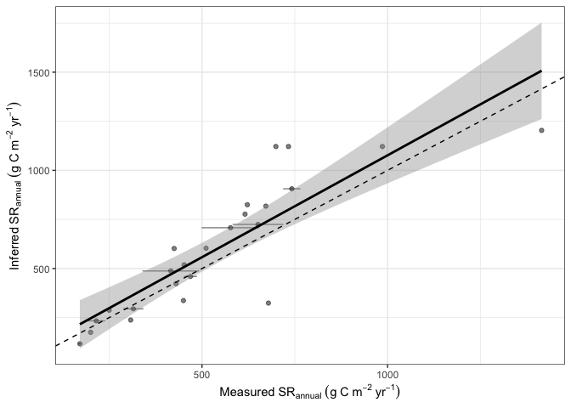

## Saving 7 x 5 in image

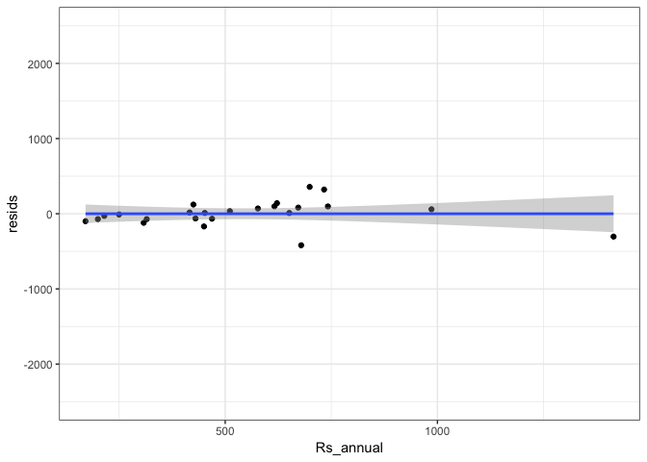

## Warning: Removed 503 rows containing missing values (geom_errorbarh).

## Saving 7 x 5 in image

## Warning: Removed 503 rows containing missing values (geom_errorbarh).

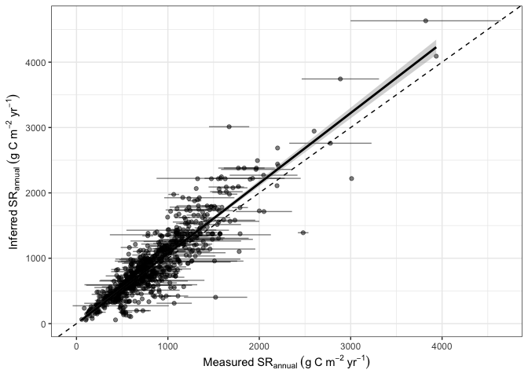

## Saving 7 x 5 in image

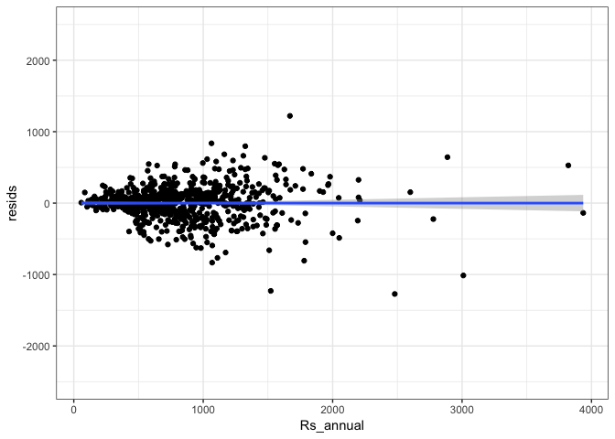

## Warning: Removed 8 rows containing missing values (geom_errorbarh).

## Saving 7 x 5 in image

## Warning: Removed 8 rows containing missing values (geom_errorbarh).

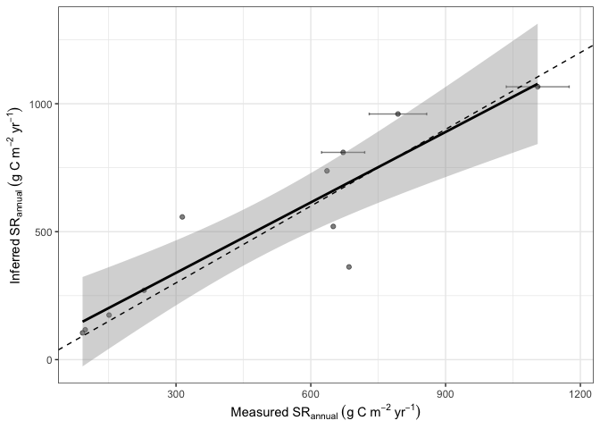

## Saving 7 x 5 in image

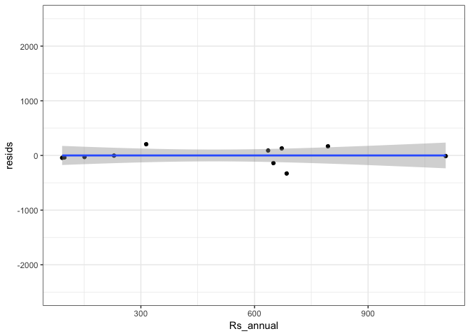

## 4.2.3 Does Meas_method affects the relationship

## Warning: Removed 54 rows containing missing values (geom_errorbarh).

## Saving 7 x 5 in image

## Warning: Removed 54 rows containing missing values (geom_errorbarh).

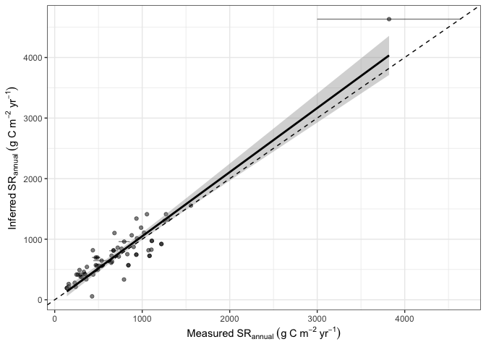

## Saving 7 x 5 in image

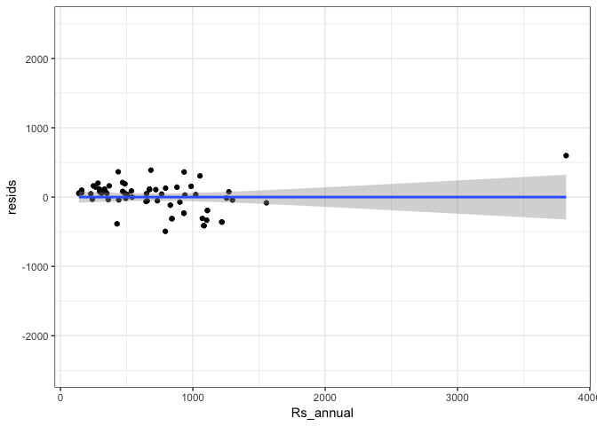

## Warning: Removed 457 rows containing missing values (geom_errorbarh).

## Saving 7 x 5 in image

## Warning: Removed 457 rows containing missing values (geom_errorbarh).

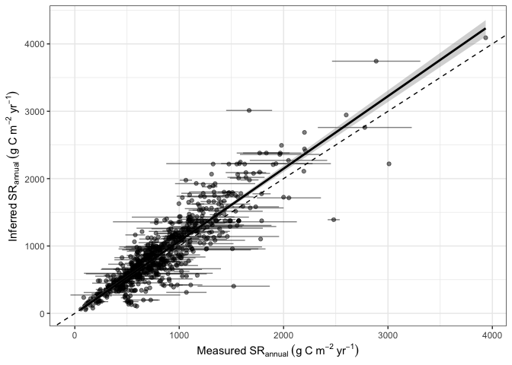

## Saving 7 x 5 in image

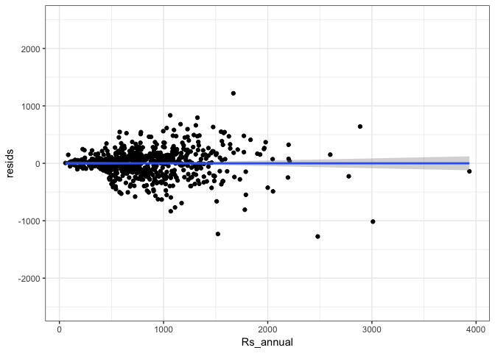

### 4.2.4 RA or RH dominated sites differ?

## Saving 5 x 4 in image

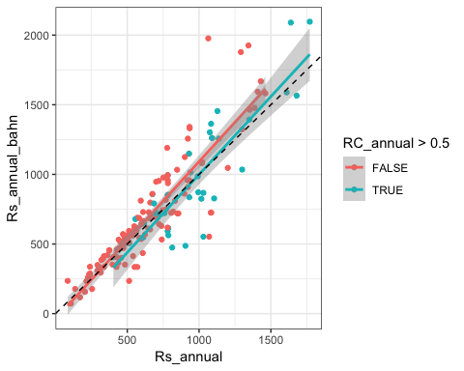

### 4.2.5 Biome effect

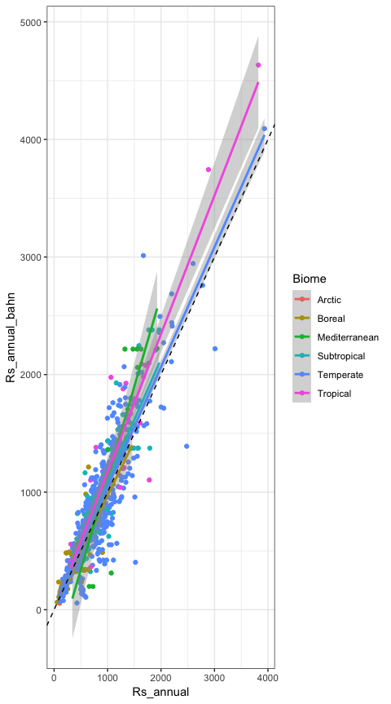

## geom_path: Each group consists of only one observation. Do you need to  
## adjust the group aesthetic?  
## geom_path: Each group consists of only one observation. Do you need to  
## adjust the group aesthetic?  
## geom_path: Each group consists of only one observation. Do you need to  
## adjust the group aesthetic?  
## geom_path: Each group consists of only one observation. Do you need to  
## adjust the group aesthetic?  
## geom_path: Each group consists of only one observation. Do you need to  
## adjust the group aesthetic?  
## geom_path: Each group consists of only one observation. Do you need to  
## adjust the group aesthetic?

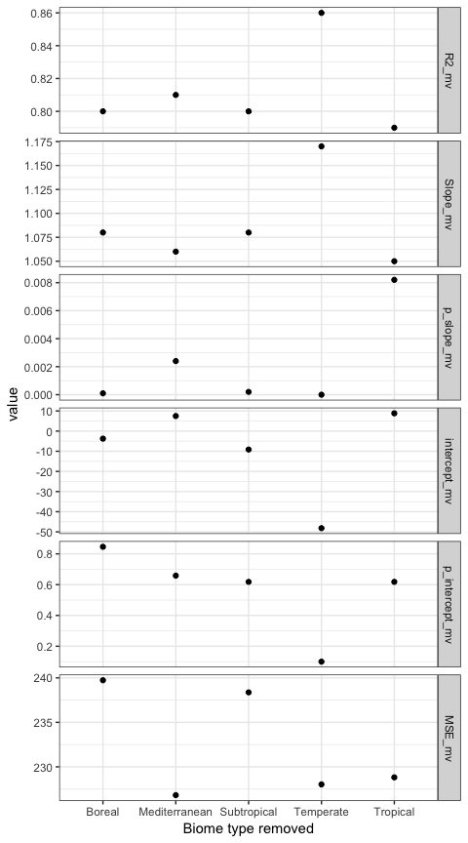

## geom_path: Each group consists of only one observation. Do you need to  
## adjust the group aesthetic?  
## geom_path: Each group consists of only one observation. Do you need to  
## adjust the group aesthetic?  
## geom_path: Each group consists of only one observation. Do you need to  
## adjust the group aesthetic?  
## geom_path: Each group consists of only one observation. Do you need to  
## adjust the group aesthetic?  
## geom_path: Each group consists of only one observation. Do you need to  
## adjust the group aesthetic?  
## geom_path: Each group consists of only one observation. Do you need to  
## adjust the group aesthetic?

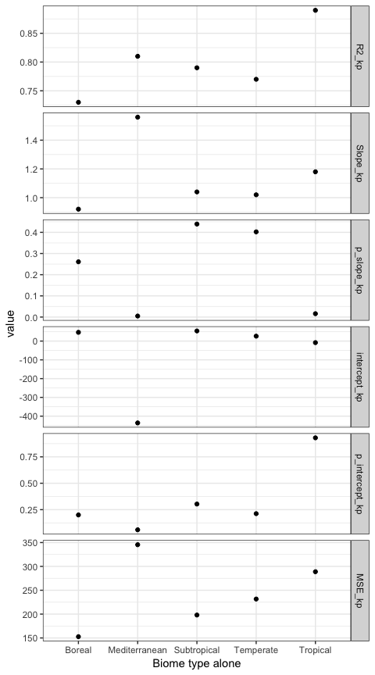

## 4.2.6 TAIR and precipitation variability affect?

## Saving 5 x 4 in image

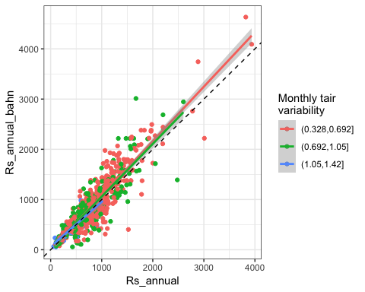

## Saving 5 x 4 in image

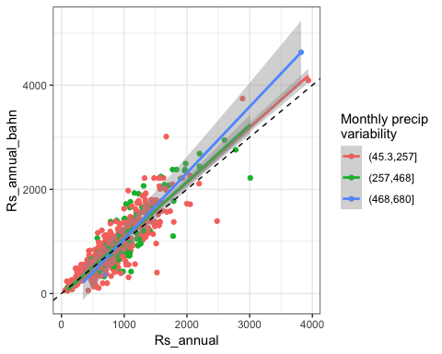

## 4.2.7 Does drought affect?

## Warning in qt((1 - level)/2, df): NaNs produced

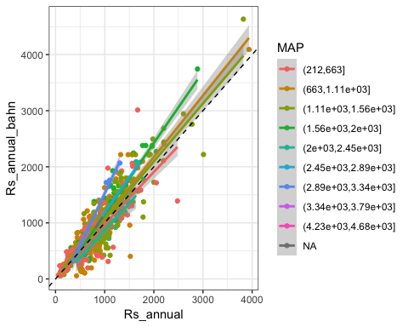

## Saving 5 x 4 in image

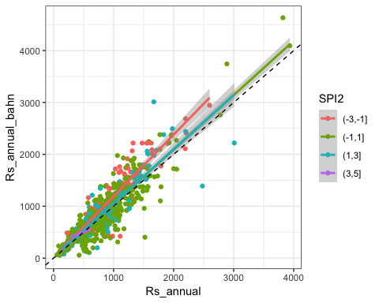

## Saving 5 x 4 in image

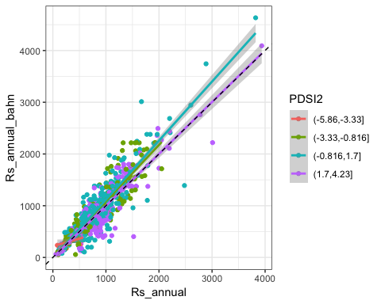

# 5. Discussion & questions

# 6. More analysis in the future

* 1 T&Drought function (Maybe use PDSI)
* 2 seprete out Agriculture & Wetland
* 3 Using SD information with boosting?
* 4 Use Rs_mat predict Rh?
* 5 Use this approach estimate global Rs
* 6 Think about application