NATIONAL RESEARCH UNIVERSITY ITMO

Faculty of Software Engineering and Computer Technology

**Artificial Intelligence Systems**

Laboratory Work № 1

Student

Phan Ngoc Tuan

Group № P3321

Supervisor: Yulia A.Koroleva

Contents

**1.** **INTRODUCTION** 3

**2.** **TASK STATEMENT** 3

**3.** **THEORETICAL BACKGROUND** 3

3.1 Linear Regression Algorithm 3

3.2 Logistic Regression Algorithm 4

**4.** **DATASET PREPROCESSING** 4

**5.** **MODEL IMPLEMENTATION** 7

**6.** **MODEL TRAINING** 12

**7.** **MODEL EVALUATION** 14

**8.** **CONCLUSION** 17

# **INTRODUCTION**

This laboratory work aims to provide a practical understanding of fundamental machine learning algorithms by implementing Linear Regression and Logistic Regression from scratch using an object-oriented programming (OOP) approach. The goal is to build, train, and evaluate these models on real-world datasets, analyze the learning process through visualization, and interpret the results

1. **TASK STATEMENT**

The following objectives were defined for this work:

1. Implement the Linear Regression and Logistic Regression algorithms from scratch using OOP principles in Python
2. Train and test the models on two datasets:
   * Linear Regression for predicting continuous values on the “California Housing” dataset
   * Logistic Regression for binary classification on the “Titanic” datasets
3. Visualize and analyze the learning process by plotting the loss reduction and metric improvement (e.g., F1-score, Accuracy, R²) over training epochs.

The implementation was allowed to use only the following libraries for auxiliary operations: NumPy, Pandas, Polars, PyTorch, Matplotlib, and Seaborn.

1. **THEORETICAL BACKGROUND**

## Linear Regression Algorithm

The goal of Linear Regression id to find a linear relationship between input features **X** and a continuous target variable **y**. The core steps of the gradient descent algorithm are as follows:

$$y_{pred}=X . ω+b$$

$$error=y_{pred}-y_{true}$$

$$∇_{ω}=\frac{2}{N} . X^{T}.error$$

$$ω :=ω-α.∇_{ω}$$

$$b :=b-α.∇_{b}$$

where $ω$ are the weights, $b$ is the bias, $α$ is the learning rate, and $N$ is the number of samples.

## Logistic Regression Algorithm

Logistic Regression is used for binary classification. It applies a sigmoid function to the linear output to predict probabilities. The weight update rules are derived using gradient descent on the binary cross-entropy loss:

$$z=X . ω+b$$

$$y_{pred}= σ\left(z\right)=\frac{1}{1+e^{-z}}$$

$$error=y_{pred}-y_{true}$$

$$gradient=\frac{X^{T}.err}{N}$$

$$ω=ω-α.gradient$$

1. **DATASET PREPROCESSING**

In this section, the dataset is preprocessed to facilitate machine understanding of its contents. The main steps included:

* Checking dataset structure, missing values, duplicates.
* Visualizing distributions and correlation matrix.
* Dropping redundant columns.
* Normalizing numerical features to the range [-1, 1].

The preprocessing code is presented in Listing 1. Figures 1 and 2 illustrate the correlation matrices before and after processing.

import matplotlib.pyplot as plt  
import torch  
import pandas as pd  
import numpy as np

df_house = pd.read_csv('datasets/California_Houses.csv')  
df_house.head()

df_house.describe()

df_house.hist(bins=20, figsize=(20, 15))  
plt.show()

df_titanic = pd.read_csv('datasets/Titanic-Dataset.csv')  
df_titanic.head()

df_titanic.describe()

plt.style.use('default')  
  
  
def plot_correlation_matrix(table):  
 numeric_cols = table.select_dtypes(include=[np.number]).columns  
 corr_matrix = table[numeric_cols].corr().values  
  
 plt.figure(figsize=(14, 10))  
  
 im = plt.imshow(corr_matrix, cmap='coolwarm', interpolation='nearest')  
 plt.colorbar(im, label='Correlation коэф.')  
  
 plt.xticks(range(len(numeric_cols)), numeric_cols, rotation=45, ha='right')  
 plt.yticks(range(len(numeric_cols)), numeric_cols)  
  
 for i in range(len(numeric_cols)):  
 for j in range(len(numeric_cols)):  
 plt.text(j, i, f'{corr_matrix[i, j]:.2f}',  
 ha='center', va='center',  
 color='white' if abs(corr_matrix[i, j]) > 0.5 else 'black')  
  
 plt.title('Correlation matrix')  
 plt.tight_layout()  
 plt.show()

*# Check null*df_house.isnull().any(axis=0)

df_titanic.isnull().any(axis=0)

df_titanic['Age'] = df_titanic['Age'].fillna(df_titanic['Age'].median())  
df_titanic['Embarked'] = df_titanic['Embarked'].ffill()  
  
selected_cols_titanic = df_titanic.drop(columns=['Cabin', 'Name', 'Ticket'])

selected_cols_house = df_house.drop_duplicates()  
selected_cols_house.shape

plot_correlation_matrix(selected_cols_house)

selected_cols_house = selected_cols_house.drop(columns=['Tot_Bedrooms', 'Population', 'Longitude', 'Households', 'Distance_to_LA', 'Distance_to_SanDiego', 'Distance_to_SanFrancisco', 'Distance_to_SanJose'])  
  
plot_correlation_matrix(selected_cols_house)

plot_correlation_matrix(selected_cols_titanic)

selected_cols_titanic = selected_cols_titanic.drop(  
 columns=['PassengerId', 'SibSp', 'Sex_male', 'Embarked_Q', 'Embarked_S'])  
  
plot_correlation_matrix(selected_cols_titanic)

def normalize_data(df):  
 normalized_df = df.copy()  
  
 for col in normalized_df.columns:  
 col_min = df[col].min()  
 col_max = df[col].max()  
  
 if col_max == col_min:  
 normalized_df[col] = 0.0  
 else:  
 normalized_df[col] = 2 * (normalized_df[col] - col_min) / (col_max - col_min) - 1  
  
 return normalized_df

Code listing 1 - preprocessing script

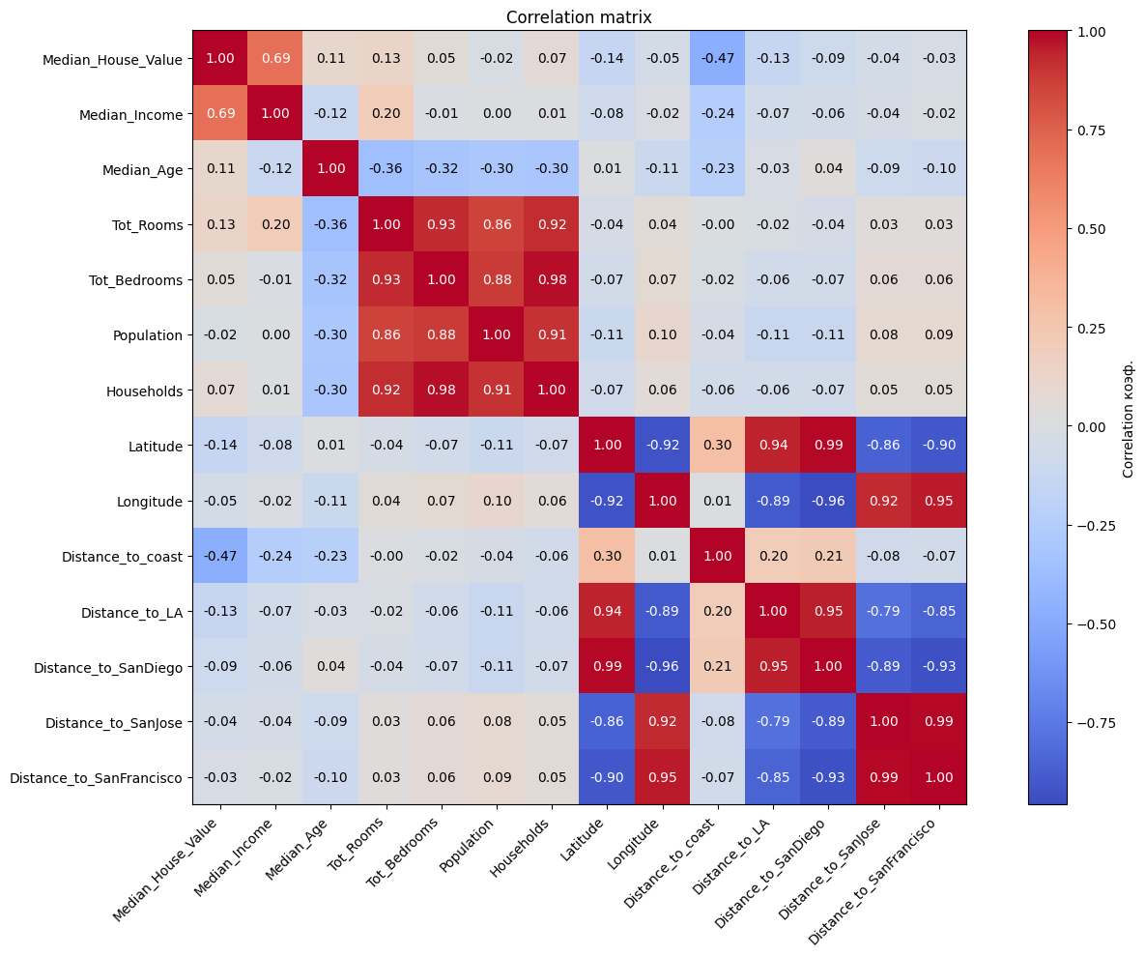

Fig. 1 – Correlation matrix before preprocessing

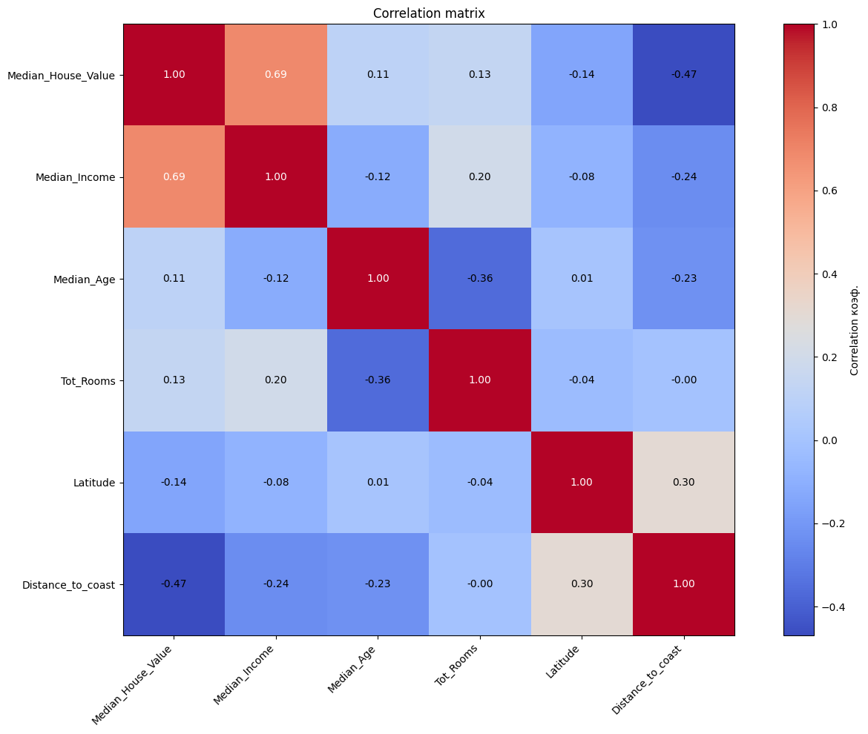

Fig. 2 – Correlation matrix after preprocessing

1. **MODEL IMPLEMENTATION**

Custom classes were developed for both regression models.

* Class Linear Regression – implements linear regression with metrics: MSE, RMSE, MAE, and R².
* Class Logistic Regression – implements logistic regression with metrics: Accuracy, Precision, Recall, F1-score, and binary cross-entropy loss.

Both models include methods for training (fit), prediction (predict), evaluation (evaluate), and visualization of training dynamics.

class LinearRegression:  
  
 def __init__(self, learning_rate: float = 0.01, num_iterations: int = 1000, regularization: str = None,  
 alpha: float = 0.01, l1_ratio: float = 0.5):  
 self.learning_rate = learning_rate  
 self.num_iterations = num_iterations  
 self.train_metrics = []  
 self.weights = None  
 self.bias = None  
 self.loss_his = []  
 self.metric_his = []  
 *#Lab 2 task 1* self.regularization = regularization  
 self.alpha = alpha  
 self.l1_ratio = l1_ratio  
  
 def calc_metrics(self, y, y_pred):  
 *# MSE* mse = torch.mean((y - y_pred) ** 2)  
  
 *# RMSE* rmse = torch.sqrt(mse)  
  
 *# MAE* mae = torch.mean(torch.abs(y - y_pred))  
  
 *# R²* ss_total = torch.sum((y - torch.mean(y)) ** 2)  
 ss_residual = torch.sum((y - y_pred) ** 2)  
 r2 = 1 - (ss_residual / ss_total)  
  
 return {  
 'MSE': mse.item(),  
 'RMSE': rmse.item(),  
 'MAE': mae.item(),  
 'R2': r2.item()  
 }  
  
 def fit(self, X: torch.Tensor, y: torch.Tensor) -> list:  
 if not isinstance(X, torch.Tensor) or not isinstance(y, torch.Tensor):  
 raise ValueError("X and y must be torch. Tensor objects")  
  
 num_samples, num_features = X.shape  
 self.weights = torch.randn((num_features, 1), dtype=torch.float32) * 0.01  
 self.bias = torch.zeros(1, dtype=torch.float32)  
  
 for epoch in range(self.num_iterations):  
 y_pred = torch.matmul(X, self.weights) + self.bias  
  
 mse_loss = torch.mean((y_pred - y) ** 2)  
  
 *# Lab 2 task 1* reg_loss = 0  
 if self.regularization == 'l2':  
 reg_loss = self.alpha * torch.sum(self.weights ** 2)  
 elif self.regularization == 'l1':  
 reg_loss = self.alpha * torch.sum(torch.abs(self.weights))  
 elif self.regularization == 'elasticnet':  
 reg_loss = self.alpha * (  
 self.l1_ratio * torch.sum(torch.abs(self.weights)) + (1 - self.l1_ratio) * torch.sum(  
 self.weights ** 2))  
  
 total_loss = mse_loss + reg_loss  
  
 self.loss_his.append(total_loss.item())  
  
 grad_weights = (2 / num_samples) * torch.matmul(X.T, (y_pred - y))  
 grad_bias = (2 / num_samples) * torch.sum(y_pred - y)  
  
 *# Lab 2 task 1* if self.regularization == 'l2':  
 grad_weights += 2 * self.alpha * self.weights  
 elif self.regularization == 'l1':  
 grad_weights += self.alpha * torch.sign(self.weights)  
 elif self.regularization == 'elasticnet':  
 grad_weights += self.alpha * (  
 self.l1_ratio * torch.sign(self.weights) + 2 * (1 - self.l1_ratio) * self.weights)  
  
 self.weights -= self.learning_rate * grad_weights  
 self.bias -= self.learning_rate * grad_bias  
  
 train_metrics = self.calc_metrics(y, y_pred)  
 self.metric_his.append(train_metrics)  
  
 if epoch % 100 == 0:  
 print(f"Epoch {epoch}: Loss={mse_loss.item()}, R²={train_metrics['R2']}")  
  
 def predict(self, X: torch.Tensor) -> torch.Tensor:  
 if self.weights is None or self.bias is None:  
 raise ValueError("Model must be trained before making predictions")  
 if not isinstance(X, torch.Tensor):  
 raise ValueError("Input X must be a torch.Tensor")  
  
 return torch.matmul(X, self.weights) + self.bias  
  
 def evaluate(self, X, y):  
 y_pred = self.predict(X)  
 metrics = self.calc_metrics(y, y_pred)  
 return metrics, y_pred

Code listing 2 - Class Linear Regression

class LogisticRegression:  
  
 def __init__(self, learning_rate: float = 0.01, num_iterations: int = 1000, regularization: str = None,  
 alpha: float = 0.01, l1_ratio: float = 0.5):  
 if learning_rate <= 0:  
 raise ValueError("Learning rate must be positive.")  
 if num_iterations <= 0:  
 raise ValueError("Number of iterations must be positive.")  
  
 self.learning_rate = learning_rate  
 self.num_iterations = num_iterations  
 self.weights = None  
 self.bias = None  
 self.loss_his = []  
 self.metric_his = []  
 self.regularization = regularization  
 self.alpha = alpha  
 self.l1_ratio = l1_ratio  
  
 def sigmoid(self, z: torch.Tensor) -> torch.Tensor:  
 z = torch.clamp(z, -10, 10)  
 return 1 / (1 + torch.exp(-z))  
  
 def binary_cross_entropy(self, y_true: torch.Tensor, y_pred_proba: torch.Tensor) -> torch.Tensor:  
 epsilon = 1e-8  
 y_pred_proba = torch.clamp(y_pred_proba, epsilon, 1 - epsilon)  
 return -torch.mean(y_true * torch.log(y_pred_proba) + (1 - y_true) * torch.log(1 - y_pred_proba))  
  
 def calc_metrics(self, y: torch.Tensor, y_pred_proba: torch.Tensor) -> dict:  
  
 y_pred_class = (y_pred_proba > 0.5).float()  
  
 accuracy = torch.mean((y_pred_class == y).float())  
  
 true_positives = torch.sum((y_pred_class == 1) & (y == 1))  
 predicted_positives = torch.sum(y_pred_class == 1)  
 actual_positives = torch.sum(y == 1)  
  
 precision = true_positives / (predicted_positives + 1e-8)  
 recall = true_positives / (actual_positives + 1e-8)  
  
 f1 = 2 * (precision * recall) / (precision + recall + 1e-8)  
  
 loss = self.binary_cross_entropy(y, y_pred_proba)  
  
 return {  
 'accuracy': accuracy.item(),  
 'precision': precision.item(),  
 'recall': recall.item(),  
 'f1': f1.item(),  
 'loss': loss.item()  
 }  
  
 def fit(self, X: torch.Tensor, y: torch.Tensor) -> None:  
 if not isinstance(X, torch.Tensor) or not isinstance(y, torch.Tensor):  
 raise ValueError("Inputs X and y must be torch.Tensor objects.")  
 if X.ndim != 2 or y.ndim != 2:  
 raise ValueError("X must be 2D and y must be 2D (num_samples, 1).")  
 if X.shape[0] != y.shape[0]:  
 raise ValueError("Number of samples in X and y must match.")  
 if y.shape[1] != 1:  
 raise ValueError("y must have shape (num_samples, 1).")  
  
 num_samples, num_features = X.shape  
  
 self.weights = torch.randn((num_features, 1), dtype=torch.float32) * 0.01  
 self.bias = torch.zeros(1, dtype=torch.float32)  
  
 for epoch in range(self.num_iterations):  
 linear_output = torch.matmul(X, self.weights) + self.bias  
 y_pred_proba = self.sigmoid(linear_output)  
  
 loss = self.binary_cross_entropy(y, y_pred_proba)  
  
 *# Lab 2 task 1* reg_loss = 0  
  
 if self.regularization == 'l2':  
 reg_loss = self.alpha * torch.sum(self.weights ** 2)  
 elif self.regularization == 'l1':  
 reg_loss = self.alpha * torch.sum(torch.abs(self.weights))  
 elif self.regularization == 'elasticnet':  
 reg_loss = self.alpha * (  
 self.l1_ratio * torch.sum(torch.abs(self.weights)) + (1 - self.l1_ratio) * torch.sum(  
 self.weights ** 2))  
  
 total_loss = loss + reg_loss  
 self.loss_his.append(total_loss.item())  
  
 error = y_pred_proba - y  
 dw = torch.matmul(X.T, error) / num_samples  
 db = torch.sum(error) / num_samples  
  
 if self.regularization == 'l2':  
 dw += 2 * self.alpha * self.weights  
 elif self.regularization == 'l1':  
 dw += self.alpha * torch.sign(self.weights)  
 elif self.regularization == 'elasticnet':  
 dw += self.alpha * (  
 self.l1_ratio * torch.sign(self.weights) + 2 * (1 - self.l1_ratio) * self.weights  
 )  
  
 self.weights -= self.learning_rate * dw  
 self.bias -= self.learning_rate * db  
  
 if epoch % 10 == 0:  
 metrics = self.calc_metrics(y, y_pred_proba)  
 self.metric_his.append(metrics)  
  
 if epoch % 100 == 0:  
 print(f"Epoch {epoch}: Loss={loss.item()}, "  
 f"Accuracy={metrics['accuracy']}, F1={metrics['f1']}")  
  
 def predict_proba(self, X: torch.Tensor) -> torch.Tensor:  
 if self.weights is None or self.bias is None:  
 raise ValueError("Model must be trained before prediction.")  
 if X.shape[1] != self.weights.shape[0]:  
 raise ValueError("Input feature dimension must match model weights.")  
  
 return self.sigmoid(torch.matmul(X, self.weights) + self.bias)  
  
 def predict(self, X: torch.Tensor, threshold: float = 0.5) -> torch.Tensor:  
 probabilities = self.predict_proba(X)  
 return (probabilities > threshold).float()  
  
 def evaluate(self, X: torch.Tensor, y: torch.Tensor) -> dict:  
 if y.shape[1] != 1:  
 raise ValueError("y must have shape (num_samples, 1).")  
 y_pred_proba = self.predict_proba(X)  
 return self.calc_metrics(y, y_pred_proba)  
  
 def plot_f1_accuracy(self):  
 f1_scores = [metrics['f1'] for metrics in self.metric_his]  
 accuracies = [metrics['accuracy'] for metrics in self.metric_his]  
  
 epochs = [i * 100 for i in range(len(self.metric_his))]  
  
 plt.figure(figsize=(10, 6))  
  
 plt.plot(epochs, f1_scores, 'blue', label='F1 Score')  
 plt.plot(epochs, accuracies, 'red', label='Accuracy')  
  
 plt.xlabel('Epochs')  
 plt.ylabel('Value')  
 plt.title('F1 and Accuracy')  
 plt.legend()  
 plt.grid(alpha=0.3)  
 plt.ylim(0, 1.05)  
 plt.show()

Code listing 3 - Class Logistic Regression

1. **MODEL TRAINING**

For the California housing dataset, the linear regression model was trained.

X_house = pd.read_csv('in_house.csv').values  
y_house = pd.read_csv('out_house.csv').values  
  
X_house = torch.tensor(X_house, dtype=torch.float32)  
y_house = torch.tensor(y_house, dtype=torch.float32)  
  
train_size = int(0.8 * len(X_house))  
X_h_train, X_h_test = X_house[:train_size], X_house[train_size:]  
y_h_train, y_h_test = y_house[:train_size], y_house[train_size:]  
  
*# Lab 2 task 1*reg_types = [None, 'l1', 'l2', 'elasticnet']  
labels = ['No Reg', 'L1', 'L2', 'ElasticNet']  
losses_all = []  
  
for reg in reg_types:  
 model = LinearRegression(learning_rate=0.01, num_iterations=1000, regularization=reg, alpha=0.05, l1_ratio=0.5)  
 model.fit(X_h_train, y_h_train)  
 losses_all.append(model.loss_his)

Code listing 4 - Linear Regression Model Training

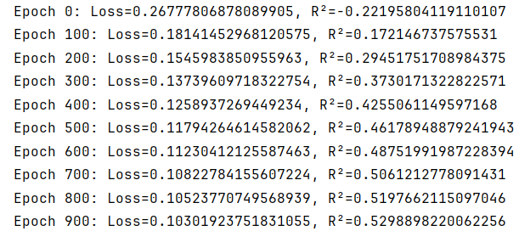

Fig. 3 – Loss and R² every 100 epochs.

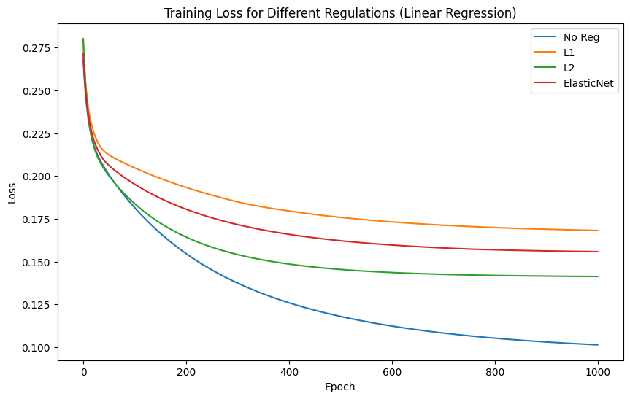

Fig. 4 – Error decrease during training (blue line).

For the Titanic dataset, the logistic regression model was trained.

X_titanic = pd.read_csv('in_titanic.csv').values  
y_titanic = pd.read_csv('out_titanic.csv').values  
  
X_titanic = torch.tensor(X_titanic, dtype=torch.float32)  
y_titanic = torch.tensor(y_titanic, dtype=torch.float32)  
  
train_size = int(0.8 * len(X_titanic))  
X_t_train, X_t_test = X_titanic[:train_size], X_titanic[train_size:]  
y_t_train, y_t_test = y_titanic[:train_size], y_titanic[train_size:]  
  
reg_types = [None, 'l1', 'l2', 'elasticnet']  
labels = ['No Reg', 'L1', 'L2', 'ElasticNet']  
losses_all = []  
  
for reg in reg_types:  
 model = LogisticRegression(learning_rate=0.01, num_iterations=1000,  
 regularization=reg, alpha=0.05, l1_ratio=0.5)  
 model.fit(X_t_train, y_t_train)  
 losses_all.append(model.loss_his)

Code listing 5 - Logistic Regression Model Training

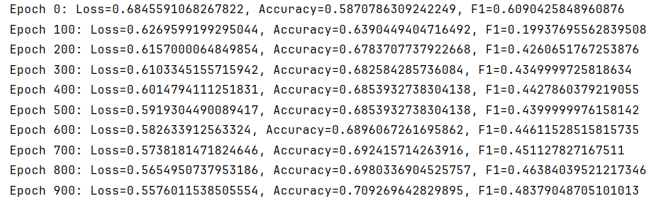

Fig. 5 – Loss, Accuracy and F1 every 100 epochs.

1. **MODEL EVALUATION**

Model evaluation results are presented in Listing 5.

Metrics on training and testing datasets:

* Mean Squared Error (MSE).
* Root Mean Squared Error (RMSE).
* Mean Absolute Error (MAE).
* R² score.

metrics_train, y_train_pred = model.evaluate(X_h_train, y_h_train)  
  
metrics_test, y_test_pred = model.evaluate(X_h_test, y_h_test)  
  
print("Training Metrics:")  
print(f"MSE: {metrics_train['MSE']}")  
print(f"RMSE: {metrics_train['RMSE']}")  
print(f"MAE: {metrics_train['MAE']}")  
print(f"R²: {metrics_train['R2']}")  
  
print("\nTest Metrics:")  
print(f"MSE: {metrics_test['MSE']}")  
print(f"RMSE: {metrics_test['RMSE']}")  
print(f"MAE: {metrics_test['MAE']}")  
print(f"R²: {metrics_test['R2']}")

Code listing 6 - Model evaluation

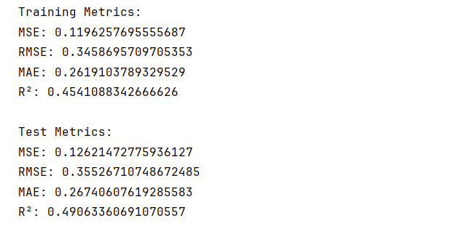

Fig. 6 – MSE, RMSE, MAE, R2

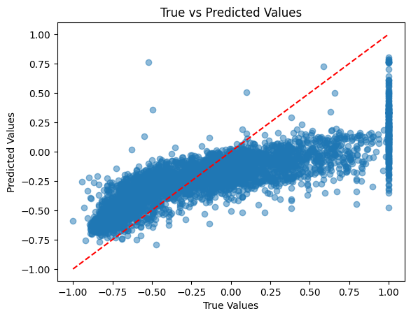

Fig. 7 – MSE, RMSE, MAE, R2

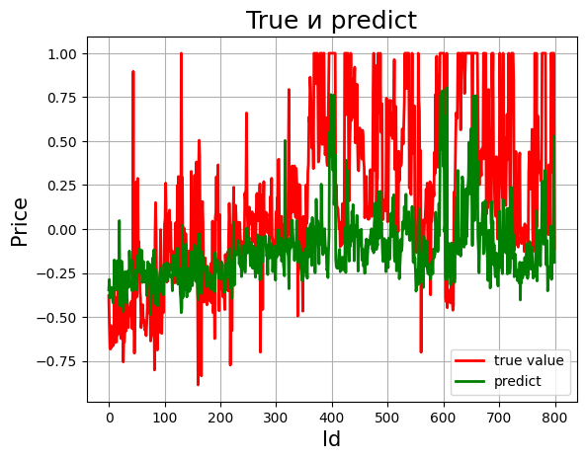

Fig. 8 – Real vs predicted comparison

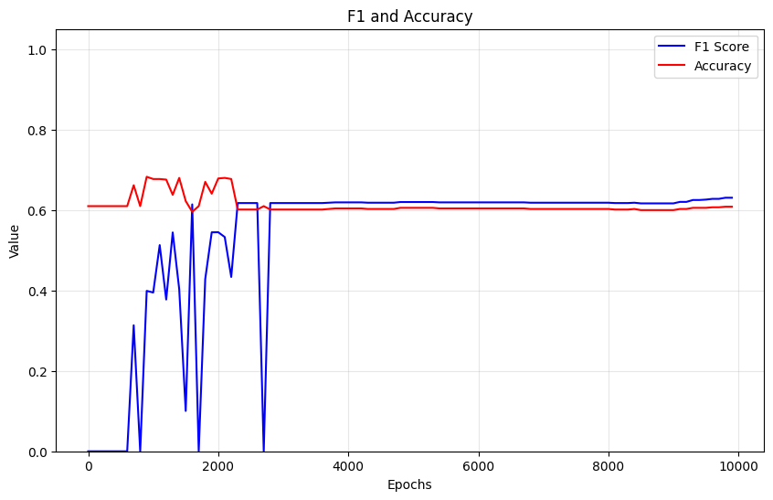

Fig. 9 – Logistic regression F1 and accuracy

1. **CONCLUSION**

This laboratory work allowed the student to study the stages of machine learning model training, understand the role of evaluation metrics, and practice preprocessing of datasets. The implementation of regression algorithms from scratch deepened the understanding of optimization methods and metric interpretation.