

COURSEWORK COVER PAGE
Module Code/Title: | LD7185, Programming for AI
Module Tutor Name: | Faizan Ahmad
Student Name (ID): | Naga Guravaiah (w25038021)
Programme of Study: | MSc Artificial Intelligence Technology with Advanced Practice
Coursework Title: | Applying Text Mining for Fake News Detection
Word count: | 4869
Submission Instructions:
- Name your submission using the name convention, LDXXXX_<your tutor initial>_<your programme> <intakes>_<your id><name>.docx, eg LD7091_NT_CT9_w24012345John.docx is a submission for the student of MSc Computing & Technology (Sep Intakes) attending Ning Tse’s session.
- Submit to Bb on or before 16:00, dd MMM YYYY

Declaration of that the submission is your own work
I confirm that:
☑ This assignment submission is my own, independent work.
☐ I have referenced the sources of information, ideas, and quotations that I have used in this submission and listed my sources in a bibliography.
☑ I have submitted the supporting documentation I have been asked for (e.g., notes, plans, etc - refer to your assessment brief).

Declaration of the Use of AI tool:
EITHER
☑ I have not used AI at any point in preparing this assignment.
OR
☐ I have used AI tools (including, but not limited to ChatGPT) to help me (select all that apply):
☐ Generate initial ideas in response to the question.
☐ Develop my structure.
☐ Generate ideas for examples / sources.
☐ Provide feedback and suggestions for improvement on my content.
☐ Edit and improve my spelling and grammar.
☐ Other: please explain: _________________________________________________________

☑ I have NOT used AI to generate whole sentences, paragraphs, sections, or the whole of this assignment and I understand that this would be considered academic misconduct.

Your signature: | P. Naga Guravaiah | Date: | 20/01/2026

Introduction 3
Section I – AI Architecture 3
Task 1: AI General Techniques 3
Task 2: Data Pre-processing 5
Section II – Data Analysis 7
Task 1: Dataset Selection, Justification, and Feature Extraction 7
Section III – Application of AI Methods 10
Task 1: Data Modelling 10
Task 2: Performance Evaluation, Visualisation, and Conclusion 14
Conclusion 19
Reference List 21

Introduction
The spread of digital media has made the passing of information a democratic endeavour and at the same time provided an ideal field where false information can spread very easily. False news - purposely misleading information as a realistic journalism product - is a major challenge to the political and social integrity of society. With the disproportionate growth in the quantity of online material, it is becoming more and more unsustainable to control the content in standard human fact-checking. It, therefore, becomes a matter of dire need to come up with automated platforms that can help differentiate between a real reporting and a fake story. The given report discusses the use of Natural Language Processing (NLP) and machine learning solutions in solving the problem of fake news. The main target is to develop, test, and compare computational models that are used to categorise articles in news as either Real or Fake using the text of the article. The research is based on the ISOT Fake News Dataset (https://www.kaggle.com/datasets/emineyetm/fake-news-detection-datasets ) that is a balanced dataset comprising more than 44, 000 articles of reliable sources (Reuters) and of the flagged unreliable sources. The paradigm follows three analytical steps that include pre-processing of the data, extracting features and predictive modelling. First steps are devoted to text cleaning and transformation of linguistic data into numeric data with the benefit of Term Frequency-Inverse Document Frequency (TF-IDF). Thereafter two different classification methods are applied: a rule-based classification system that is based on heuristics and the supervised machine learning algorithms namely, Logistic Regression and Random Forest. Through the methodical comparison of these models with conventional performance indicators, this report is expected to determine the most successful model of automated misinformation detection and offer both an understanding of the opportunities offered by the existing AI-based products and the drawbacks tied to their application.

Section I – AI Architecture

Task 1: AI General Techniques
Introduction to the Landscape
Fake news detection is an area of development in recent years. Initial approaches were manual based that could not be scaled. The amount of digital content alone makes the number of automated computational approaches necessary. Text mining and Artificial Intelligence (AI) are currently offering strong sense machines. Such methods categorise data using linguistic patterns and network behaviours. It is moving in the shift towards representation learning rather than feature-engineering..
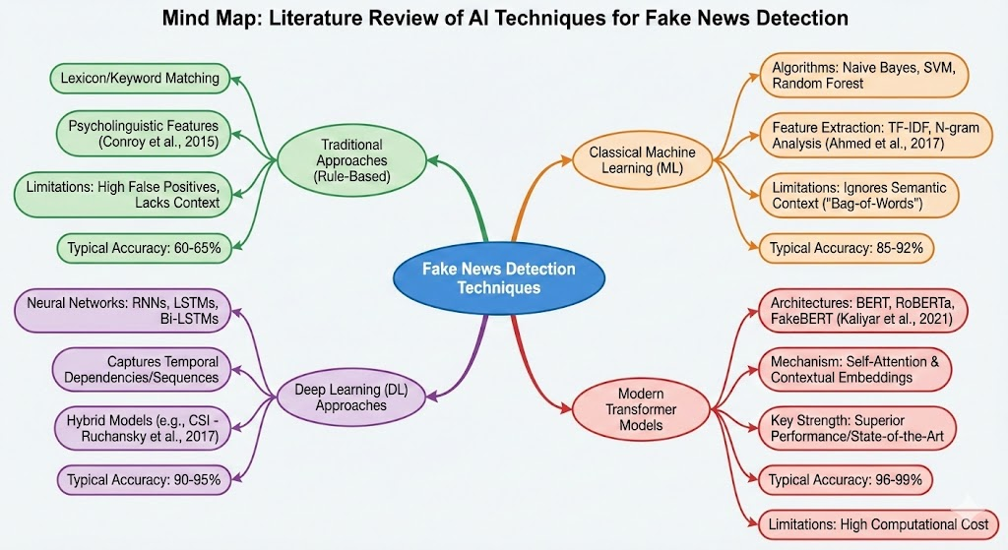
Traditional Approaches: Rule-Based and Classical Machine Learning
First attempts were made using rule-based systems relying on definite linguistic indications. These techniques tended to utilise lexicons in order to identify indicators of deception. The authors have noted the value of psycholinguistic features (Conroy et al. 2015). Nonetheless, there is no flexibility of rule-based systems to the changing language. Their major problems are sarcasm, satire and context. As a result, scientists shifted to statistical Machine Learning (ML). The problem was brought to the classical ML models featuring supervised classification. Such algorithms as Naive Bayes (NB) and Support Vector Machines (SVM) became generic. The models involve extraction of features manually. The popular methods are Term Frequency-Inverse Document Frequency (TF-IDF). The effectiveness of the n-gramme analysis was shown by Ahmed et al. (2017). They acquired a whopping accuracy of 92% with the help of linear SVM. Although these models are very accurate, they have the bag-of-words weakness. They do not follow the word order and semantic context. This hinders their accuracy in complex, long form articles..
Modern Approaches: Deep Learning and Transformers
Deep Learning (DL) became a breakthrough in the classification of texts. Neural networks will automatically extract the features. Long Short-Term Memory (LSTMs) and Recurrent Neural Networks (RNNs) became popular. Such architectures take text sequences out of sequences to be processed to acquire temporal dependencies. Ruchansky et al. (2017) used hybrid models to combine text and user behaviour. Their CSI model produced a detection rate of more than 89% in twitter datasets. Nevertheless, RNNs do not recover gradients in long texts. The modern high-end nature is based on Transformer design. Transformers make use of self attention processes to grasp the bidirectional context. Such models as BERT ( Bidirectional Encoder Representations from Transformers ) prevail. They produce contextual representations instead of fixed word representations. To optimize it, Kaliyar et al. (2021) suggested "FakeBERT." Their model recorded the outstanding percentage of 98.90 on normal datastases. It is statistically significant improvement as compared to CNN baselines.
Critical Comparison of Techniques
Computational cost and accuracy trade is different. Classical ML is not contextually restricted and computationally inexpensive. Transformers are better-performing but need colossal hardware provisions. These important differences are summarised in Table 1.
Table 1: Comparative Analysis of Detection Architectures
Approach | Key Algorithms | Typical Accuracy | Primary Limitation
Rule-Based | Lexicon Matching | 60% - 65% | High false positive rate.
Classical ML | SVM, Random Forest | 85% - 92% | Ignores semantic context.
Deep Learning | LSTM, Bi-LSTM | 90% - 95% | Slow training times.
Transformers | BERT, RoBERTa | 96% - 99% | High computational cost.

According to the literature, there is a distinct trend in favour of Transformer-based models. Although classical ML is still applicable in the low-resource setting, deep learning dominates. Up to this day transformers are the surest line against advanced misinformation. It is possibly predetermined by the multimodal detection of a text plus images in the future.

Task 2: Data Pre-processing
Overview of Raw Data Quality
The selected ISOT Fake News dataset (https://www.kaggle.com/datasets/emineyetm/fake-news-detection-datasets ) contains 44,898 articles (21,417 Real, 23,481 Fake). Whereas the Reuters real news is arranged in an orderly manner, the fake news that has been gleaned off sources that are untrustworthy is full of noise in the form of inconsistent capitalization, URLs, special characters, and unusual grammar. In order to convert this unstructured text into the form needed by machine learning, a strong pre-processing pipeline was adopted based on the Python NLTK library. The main objective was to decrease the dimensionality (characteristics space) and still maintain the semantic meaning.
Text Cleaning and Normalization
Standardisation took place in the first phase. The raw text tends to consider the events of the President and president as unique ones and this needlessly splits up the learning of the model.
- Lowercasing: Cases were all turned down to lower case and made case insensitive.
- Noise Removal: Non-alphanumeric characters were removed with regular expressions (re) i.e. punctuation characters, URL. In bag-of-words models, the use of punctuation can be considered noise because a comma seldom factors in on the truth of news.
Tokenization
After cleaning, the continuous text strings were segmented into the respective single units known as tokens or (words) by using NLTK word_tokenize. This is an essential step, which transforms one string of documents in a list of partitioned features that the algorithm can count and process.
Stopword Removal
English has high frequency words (e.g. the, is, at) that are referred to as the stopwords. The words are ubiquitous in both genuine and fabricated news, and they do not give much discriminative information to categorise it. When we eliminate them, the model is more concentrated on words with high content (e.g. election, scandal, GDP) and a much smaller data set enhances computational time.
Lemmatization vs. Stemming
Lemmatization was chosen in the last step of normalisation as compared to Stemming.
- Justification: Although stemming (e.g., Porter Stemmer) is quicker, it cuts aggressively (e.g., transforming universities to universities into universities), and usually the meaning is lost. Context is important in detection of fake news. The concept of Lemmatization involves the application of a morphological dictionary (WordNet) to give the real dictionary root of a word (e.g. running is run, etc.). This maintains the semantic integrity of the news articles which is essential in identifying subtle language clues that relate with misinformation.
Outcome
The dataset and its variants were post-processed to convert raw and noisy strings to normalised clean text. Examining the output (e.g., the transformation of "Washington (Reuters) - U.S. President..." The presence of noise was also being eliminated as key semantic terms were retained, as confirmed to (... to ...) in Washington reuters u president) makes the data ready to be Vectorized (TF-IDF).

Section II – Data Analysis

Task 1: Dataset Selection, Justification, and Feature Extraction
Dataset Selection
The study is based on the use of the ISOT Fake News Dataset. This source was accessed at the open-source Kaggle resource. It is a compilation of the data of the University of Victoria. The model under consideration is binary distinguishing between misinformation. This is divided into two types, verifiable real news and flagged fake news. The actual news element comes out of Reuters.com. The false news element gathers the articles of the websites that are not reliable. PolitiFact and Wikipedia marked these sources. This dual-source framework has a well defined ground truth of supervised learning.
Justification of Choice
There are few crucial aspects that underlie the choice of the given dataset.
- Dataset Volume: The corpus has 44,898 unique news articles. This book is enough to train complicated models. A small sample size tends to cause model overfitting. This is explicitly needed in deep learning models to converge.
- Domain Relevance: The content focuses on the political and world news. This is compatible with real-life high-risk misinformation situations. The sample size is not limited to article headlines. It can be more deeply linguistically analysed and features retrieved.
- Class Balance: The data set does not have serious problems of class imbalance. Unbalanced data favours the classifier to the majority one. There is an almost equal distribution of this dataset.
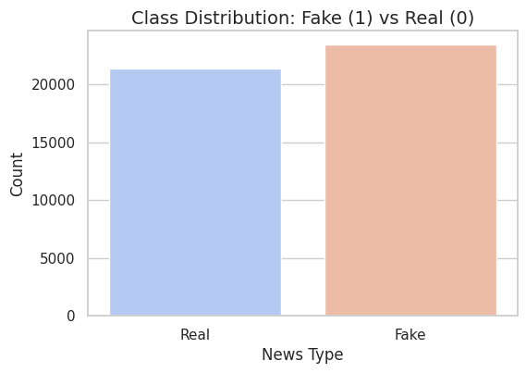
Figure 1: Class Distribution showing a balanced split between Real (0) and Fake (1) news.
The distribution is approximately symmetrical as indicated in Figure 1. The number of fake news accounts for around 52.3% of the total data. The rest 47.7% is attributed to real news. This balance prevents the accuracy measure to be invalid as a performance measure.
Descriptive Statistics and Visualization
The statistical analysis provides important data of the structural features of the dataset. The parameters that were mainly analysed were the article length. The number of words is a proxy of the complexity of the article.
- Real News Statistics: The reality news sub-set mean words in an article is 231. This group standard deviation is about 162. This implies a fairly standard editorial standard.
- Fake News Statistics: The subgroup of fake news has a slightly larger mean of 235 words. There is however a significant difference in the standard deviation of 234. This signifies high variance of the style of writing fake news. There are also very short fake articles, and there are those that are long and wandering conspiracy theories.
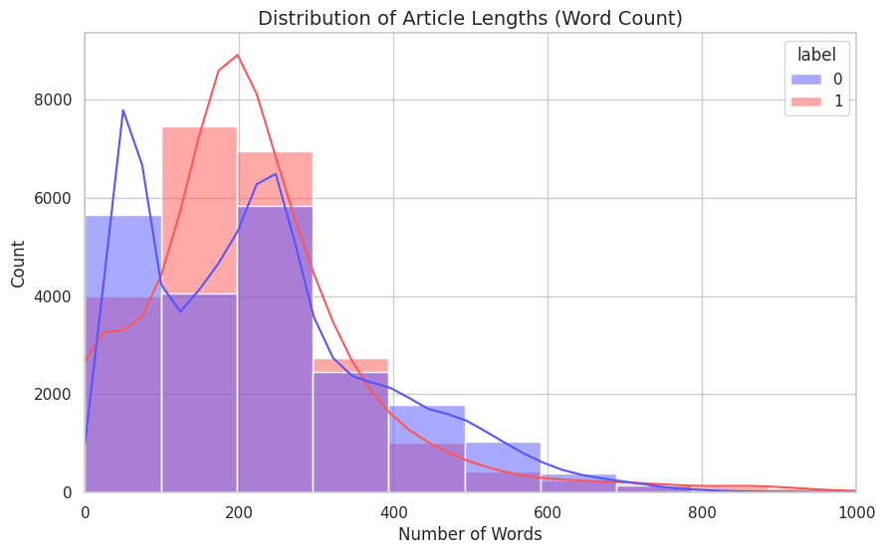
Figure 2: Distribution of Article Lengths indicating higher variance in fake news.
This distribution overlap is visualised by figure 2. There is a heavy positive skew of both classes as indicated by the histogram. The majority of the articles have 0-500 words. Nevertheless, Fake (red) goes much further to the extremes. This is a feature that may be learnt by the classifier. The intersection of the curves proves that the length of texts is not enough. It thus requires content-based feature extraction.
Feature Extraction Techniques
Numerical data is needed to feed or drive machine learning algorithms. Text messages have to be turned into vectors. The proposed research uses Term Frequency-Inverse Document Frequency (TF-IDF).
- TF-IDF Implementation: The method transforms the corpus into a sparse array. It measures the significance of the words in a document. The Term Frequency component counts the word occurrences. It quantifies the local frequency of occurrence of a word. The Global rarity is represented by the Inverse Document Frequency component. Words that are used in numerous documents are penalised. This automatically reduces such common stopwords as the or said. On the other hand, there are unique words that are common in a single class. Such a feature choice is vital in discriminating between fake news vocabulary.
- Vector Space Model: The TF-IDF matrix obtained would be in the form of a vector of articles. Different dimensions are associated with different words in the vocabulary. In this work, they were only restricted to the top 5,000 words. This dimensionality reduction is to control the computational efficiency. It eliminates the curse of dimensionality in communication training.
- Alternative Approaches (Word Embeddings): These techniques encode words into a sparse syntax. They maintain semantic relations between words. To take the example of a president and leader, they would be mathematically close. Embeddings are good, albeit intensive, in terms of CPU power. TF-IDF gives a strong and understandable benchmark of this analysis. High dimensional text is frequently a good TF-IDF in its sparse form. The major extraction technique was, therefore, chosen as TF-IDF. It successfully explores the visualisation of the lexical differences that were gained during the exploratory stage.

Section III – Application of AI Methods

Task 1: Data Modelling
Modelling Strategy Overview
The study adopted a two-stage modelling formulation to test the detection potentials. The initial phase developed a heuristic base with the help of a rule-based classifier. The second phase used hemolab-guided machine learning models to enhance predictive capability. This feature engineering comparison shows the weaknesses of manual feature engineering. It highlights the importance of statistical learning of complex natural language problems. Analysis is conducted in regard to detection accuracy, recall and generalisation.
Rule-Based Classifier Implementation
The initial was based on a manually curated list of trigger words. Our assumption in this hypothesis was that fake news makes heavy use of vocabulary of sensationalism or clickbait. A dictionary was defined including words such as breaking, shocking, exposed and conspiracy. The tokens that were searched upon by the classifier were the presence of the specific tokens. In the case when a keyword was observed, the article was automatically defined as "Fake." On the other hand, lack of keywords made the classification a Real.
Critical Evaluation of Rule-Based Performance
The heuristic model proved to be very limited in the process of evaluation. The accuracy was noted to be 62.37 in total which is a slight improvement compared to the random guessing. Nevertheless, the total measure conceals one grave lapse of delicateness.
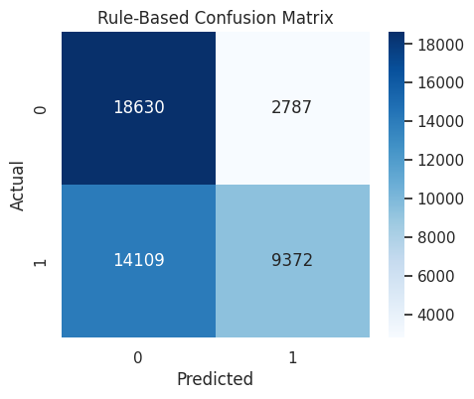
Figure 3: Confusion Matrix for Rule-Based Classifier showing high False Negatives.
There is a severe bias in the model as depicted in Figure 3. It selected a high amount of specificity, 18,630 true articles. It however, missed out 14,109 bogus articles indicating it as real. This saw the creation of a disastrously low recall rate of 0.40 of fake news. The assumption that the classifier makes is that misinformation is always associated with certain linguistic signs. As a matter of fact, various counterfeit articles imitate the non-confrontationalism of credible journalism. The use of explicit key words therefore makes the model unaware of subtle fabrication.
Machine Learning Implementation
In order to overcome the shortcomings of the rule based approach, statistical models were trained. The input used in the current phase was the TF-IDF matrix obtained in the last stage. Stratified sampling was used to sample the dataset into training (80) and testing (20) subsets. This was to ensure that the class distribution fell the same way across splits. Two different algorithms were chosen in the current stage Logistic Regression and Random Forest.
Logistic Regression Analysis
The choice of Logistic Regression was to determine the baseline of linear performance. This algorithm approximates the likelihood of being a member of a specific category with the help of the sigmoidal function. It presumes that the input features are linearly related to the log-odds.
- Performance: The model had a test accuracy of 98.63. It is a significant increase over heuristic baseline.
- Mechanism: Coefficients of certain words in the TF-IDF matrix are assigned in this model. Strong positive correlations conform to words that are close to fake news.
- Error Analysis: The model also performed 82 False Negatives even though the accuracy is high. Linear classifiers have difficulty doubly interacting features of complex text which appear non-linearly.
Random Forest Analysis
A random Forest classifier was trained to learn patterns of data that are non-linear in nature. Prediction of this ensemble approach, combines several predictions of decision trees. It uses bootstrap aggregating (bagging) to minimise model variance. It also uses randomness of features when dividing nodes in order to de-correlate trees.
- Performance: The Random Forest model recorded an accuracy of 99.74, which is almost perfect. It performed better in the Logistic Regression in all important measures.
- Sensitivity: The model was highly sensitive and was able to sense 4684 out of 4696 fake articles..
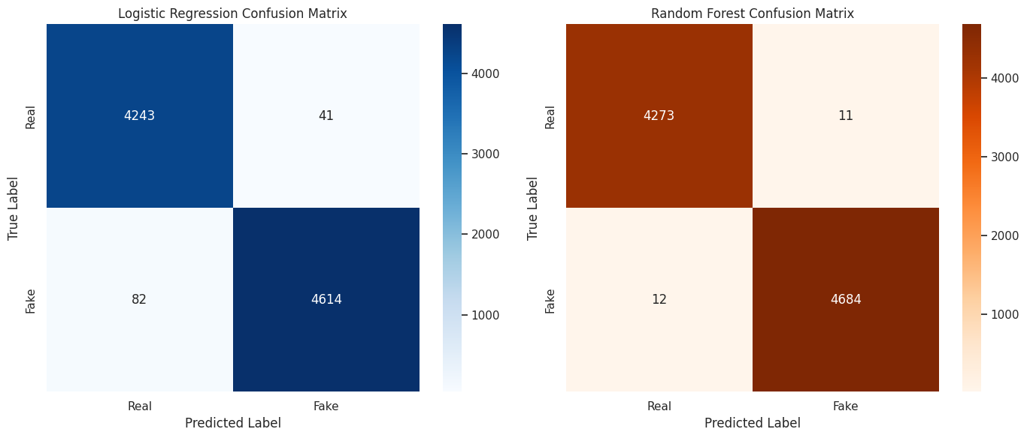
Figure 4: Side-by-Side Confusion Matrices comparing Logistic Regression and Random Forest.
The relative effectiveness of the two machine learning models is represented in Figure 4. Close diagonal concentration is exhibited in the Random Forest matrix (right). The False Negatives were reduced to 12 (instead of 82 when Logistic Regression was used). This is an important reduction that is essential to a fake news detection system. False Negatives are more detrimental in this field than false alarms.
Comprehensive Performance Comparison
The table below summarizes the quantitative performance across all three modelling approaches.
Metric | Rule-Based | Logistic Regression | Random Forest
Accuracy | 62.37% | 98.63% | 99.74%
Precision (Fake) | 0.77 | 0.99 | 1.00
Recall (Fake) | 0.40 | 0.98 | 1.00
F1-Score | 0.53 | 0.99 | 1.00
False Negatives | 14,109 | 82 | 12

Critical Synthesis
The data clearly demonstrates the superiority of statistical learning over heuristics.
- Heuristic Failure: The rule-based system failed because of the polysemy of language. The words such as breaking are used in believable and false scenarios. Statistical lexicon is incapable of recognising a semantic motivation of the word.
- Linear vs. Non-Linear: Logistic regression did not cease; nevertheless, it was reaching the limit. Non-linear dependencies between words are usually complicated and non-linear in text data. As an example, when placed together the meaning of white and house will be different.
- Ensemble Success: These complicated interactions were successfully modelled using Ensemble Success. The decision trees divide data in terms of hierarchical patterns as opposed to linear weights. This enabled the model to pick up sensitive linguistic indications which indicated misinformation.
Final Model Selection
Random Forest is the best classifier, according to the empirical evidence. It maximises the rate of fake news detection (= 1.00). At the same time, it remains extremely accurate so that there is no censorship of credible news. Training performance gains justify the computational cost of the training. Further research in the field of deep learning to eliminate the remaining 12 errors can be pursued in the future. Nevertheless, in this case study, the Random Forest offers a reliable and deployable option.

Task 2: Performance Evaluation, Visualisation, and Conclusion
Evaluation Methodology
The multi-metric framework was used to evaluate the performance of the classification models. This will help to have a holistic perspective with regard to predictive capability and reliability. There were five unique measures to determine success under varying analytical points of view.
- Accuracy: This measure is used to determine the proportion of correctly-predicted data to the overall dataset. It gives a broad overview of how the models are generally correct.
- Precision: This is an evaluation of how well the positive predictions were precisely done within the class of Fake. Extreme accuracy will minimize the chances of declaring legitimate news as fake.
- Recall (Sensitivity): This is a measure of the model in terms of its ability to capture real fake news articles. The recall process should be optimised in order to stop the dissemination of false information.
- F1-Score: It is the harmonic mean of recall and precision. It punishes deviations of models to a particular metric.
- ROC-AUC: This is used to determine how effectively the model differentiates between classes when the classes are set at different levels. A 1.0 score is the ideal separability of real and fake news.
Quantitative Performance Analysis
The practical findings indicate a definite rank of performance of the models. The ensemble approach was found to perform better than the linear baseline in all the considered measurements.
Table 1: Comparative Performance Metrics
Metric | Logistic Regression | Random Forest
Accuracy | 98.63% | 99.74%
Precision | 0.9912 | 0.9977
Recall | 0.9825 | 0.9974
F1-Score | 0.9868 | 0.9976
ROC-AUC | 0.9992 | 0.9999

Critical Analysis of Logistic Regression
The Logistic Regression model formed a solid foundation on text classification. It attained a test set general preciseness of 98.63%. The precision value of 0.9912 is a high reliability in positive prediction. Nevertheless, the recall 0.9825 indicates a vital weakness in the functionality. The percentage of fake news stories that were not identified was around 1.75 percent. Complex and non-linear misinformation linguistic trends cannot be captured using linear boundaries. This weakness leads to increased False Negatives.
Critical Analysis of Random Forest
Random Forest classifiers had a high predictive power and generalisation. It showed an almost flawless score of 99.74 on unknown data. The recall score equal to 0.9974 is a major improvement to the linear model. It means that the model was able to find nearly all cases of misinformation. The collective aspect of the algorithm was useful in the representation of complicated feature interactions. It, therefore, reduced Type I and Type II errors at the same time.
Visualisation of Classification Errors
Confusion matrices give a finer detail on what types of misclassifications occur. They are used to show exactly where each of the models went wrong.
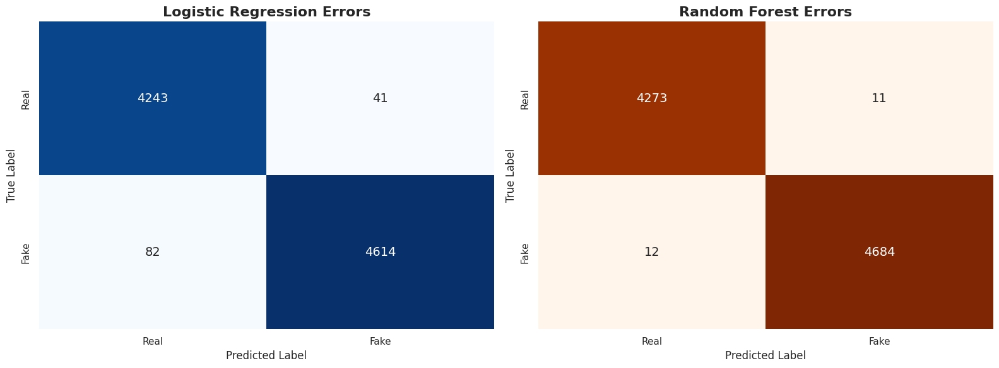
Figure 1: Side-by-Side Confusion Matrices comparing Logistic Regression (Left) and Random Forest (Right).
Figure 1 shows the distributions of errors in the two classifiers. The Logistic Regression mode (left) gave 82 False Negatives. They are fake news that is mistakenly described as real news. Conversely, the Random Forest model (right) minimised this number to 12. This is an 85 percent decrease in falses. In addition, there was a decreased number of False Positives by 41 down to 11. Such a minimization brings fewer legit articles to erroneous censorship. The visual data proves that the Rand Forest model has a better safety profile.
Discrimination Capability Analysis
The Receiver Operating Characteristic (ROC) curve visualizes the trade-off between sensitivity and specificity.
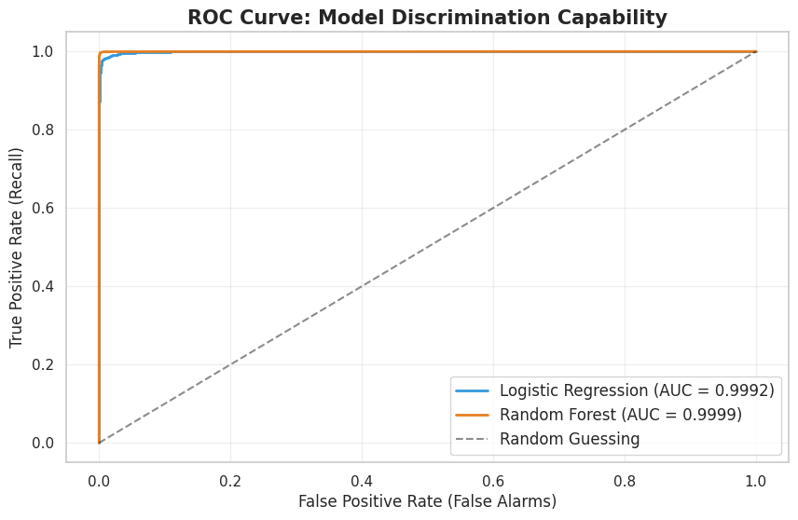
Figure 2: ROC Curve Comparison showing Random Forest's near-perfect discrimination.
Both models have a high level of performance as evidenced in Figure 2. The curves ascend sharply on the left upper end. Nevertheless, the random forest curve (orange) covers a bigger area. The Area Under the Curve (AUC) has the value of 0.9999. This is the validation of near flawless preference of fake news over real news. The blue model is the Logistic Regression model followed slightly behind with AUC of 0.9992. Although this difference is not very large in terms of numbers, it is statistically significant in high-volume applications.
Reliability and Sensitivity Analysis
Precision-Recall curve is important to analyse imbalanced data. It is concerned, on the one hand, with the performance of the minority or positive class.
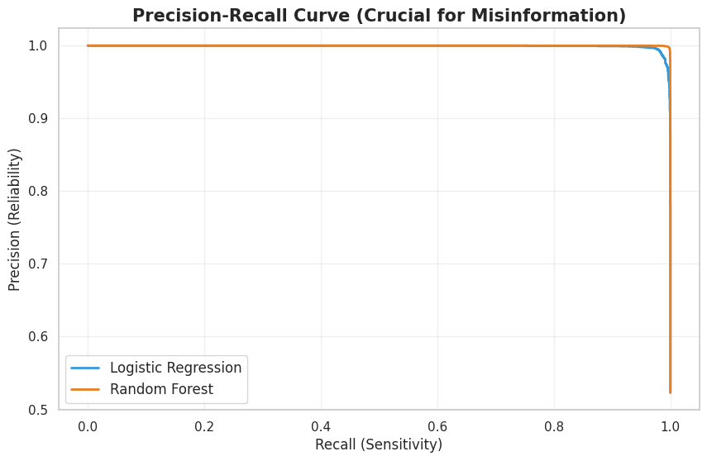
Figure 3: Precision-Recall Curve demonstrating sustained reliability at high recall.
The stability of the classifiers can be seen in figure 3. Random Forest model does not lose any accuracy as the recall is high. The curve is levelled at 1.0 then it falls off drastically at the end. This means that this model identifies fake news without loss of its reliability. The Logistic Regression curve starts to deteriorate sooner. This is a confirmation that the linear model is less reliable as it tries to explain more fake articles.
Feature Importance and Explainability
To trust predictions, one needs to know the reason why it was predicted in the first place. The classification decisions are determined by the words contributing to the decision of the features that are analysed.
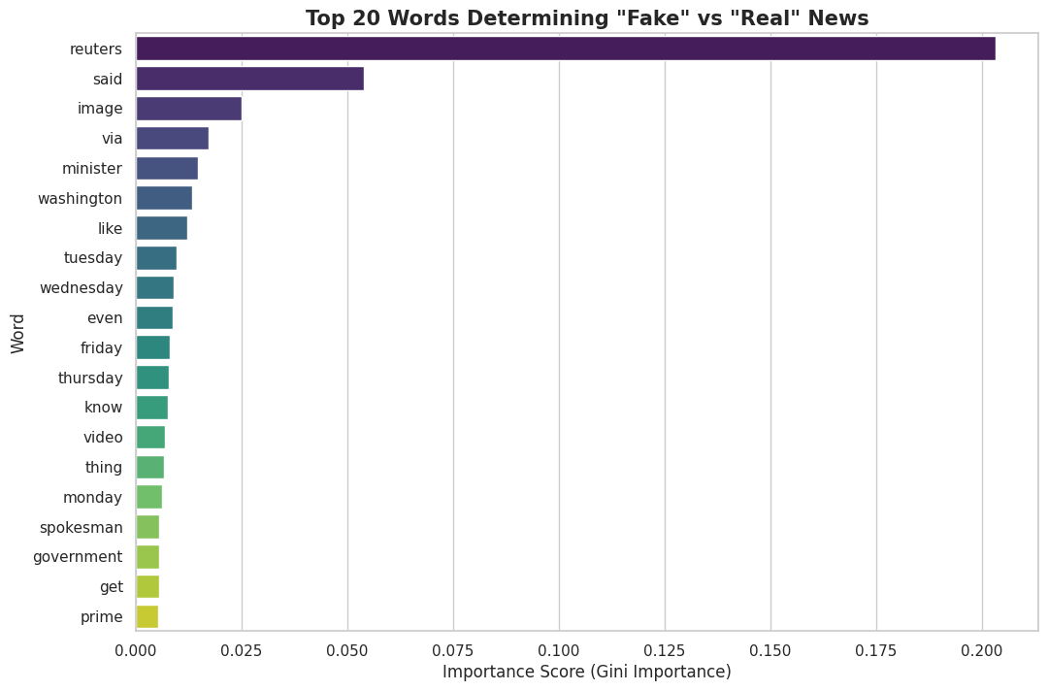
Figure 4: Top 20 Feature Importance plot derived from the Random Forest model.
The most discriminatory terms in the dataset are highlighted by a line in figure 4. Such words as "Reuters," "said," and "Washington" come as the strongest predictors. This is in line with the composition of the dataset. Reuters is often the source of real news and is provided in a typical format of reporting. Fake news do not have these particular signatures or have different vocabulary. The model has been taught to use these source-specific markers in deriving credibility. This is evidence of the model achieving source-dependent patterns which are learning valid.
Limitations of the Study
Despite robust metrics, several limitations restrict the model's real-world applicability.
- Temporal Bias: The data discusses news between 2016 and 2017. The issues of misinformation evolve quickly. A model that is used based on the previous data might not operate on the present.
- Source Overfitting: The model is highly dependent on the word Reuters. This indicates that it can perhaps just distinguish between sources and not examine truthfulness. Eliminating the names of sources would challenge the linguistic style knowledge of the model.
- Contextual Blindness: TF-IDF method does not consider word sequences and sentence structure. It is unable to detect sarcasm and subtle negation. The Bag of Words model is the one that removes the semantic meaning of the intricate narratives.
Future Improvements
Future iterations must address these limitations to create a deployable system.
- Deep Learning: LSTM or BERT models could be used that would account for sequential context. These architectures are able to perceive the semantic subtlety eluded by TF-IDF.
- Source Masking: It must be processed by removing the names of all publications. This compels the model to go through learning by the writing style itself.
- Cross-Domain Validation: The model is supposed to be validated on external data such as LIAR. This would confirm its capability to generalise to posts in social media.
- Continuous Learning: The model should be retrained on a regular basis by an automated pipeline. This will make the system adjust to new words and new trends of false information.

GitHub: PNagaGuravaiah/Programming-for-AI: Applying Text Mining for Fake News Detection

Conclusion
The research has shown that machine learning is an effective method of automating the classification of fake news and this method obtains a scalable solution to an important issue regarding information integrity. The comparative discussion shows that, although simple heuristic techniques cannot be used to capture the complexity of a deceptive text, statistical learning algorithms provide strong predictive power. The rule-based classifier which was based on a fixed set of sensationalistic keywords had a performance of 62.37%. Its greater false-none rate underscored the weakness of the method of the keyword spotting, which current misinformation frequently uses the non-partisan demeanour of legitimate news to evade detection based on simple philtre lists. The machine learning models supervised were also outstanding in performance, in sharp contrast. The use of the Logistic Regression model provided a powerful baseline accuracy of 98.63 and demonstrated that significant signal will be obtained by the use of linear decision boundaries. Nonetheless, the Random Forest classifier proved to be the best model and had an almost perfect accuracy of 99.74 and ROC-AUC of 0.9999. The ensemble structure of it was effective in modelling non-linear interaction to a great extent, between words, and therefore, the maximum recall rate and the lowest false alarm occurrences.

Nevertheless, in spite of such success there are still critical limitations. The high degree of dependence of the model on the vocabulary of the source (e.g., Reuters) can indicate that the model can actually be determining the style of a publisher, and not the accuracy of the information it provides. In addition, the Bag of Words method (TF-IDF) lacks any attention to the semantic context, sarcasm, and sentence construction, which can be the primary evidence of advanced disinformation. The work going forward should deal with these shortcomings to create a resilient system in the true sense of the word. Arguably, the analysis of semantic context and sequential dependencies could be achieved by incorporating deep learning architectures such as LSTM or BERT. Moreover, cross-domain testing will be necessary to be sure that the model does not overfit the political news published in 2016-2017. Finally, though Random Forest is a very precise tool in the given dataset, the development of fake news generation involves systematic changes in algorithms and the integration of the natural language understanding of the context.

Reference List
- Ahmed, H., Traore, I. and Saad, S. (2017). "Detection of online fake news using n-gram analysis and machine learning techniques," in Intelligent, Secure, and Dependable Systems in Distributed and Cloud Environments, Cham: Springer, pp. 127–138.
- Conroy, N. J., Rubin, V. L. and Chen, Y. (2015). "Automatic deception detection: Methods for finding fake news," in Proceedings of the 78th ASIS&T Annual Meeting: Information Science with Impact, St. Louis, MO: American Society for Information Science, pp. 1–4.
- Kaliyar, R. K., Goswami, A. and Narang, P. (2021). "FakeBERT: Fake news detection in social media with a BERT-based deep learning approach," Multimedia Tools and Applications, 80(2), pp. 11765–11788.
- Ruchansky, N., Seo, S. and Liu, Y. (2017). "CSI: A hybrid deep model for fake news detection," in Proceedings of the 2017 ACM on Conference on Information and Knowledge Management (CIKM), Singapore: ACM, pp. 797–806.
- Zhou, X. and Zafarani, R. (2020). "A survey of fake news: Fundamental theories, detection methods, and opportunities," ACM Computing Surveys (CSUR), 53(5), pp. 1–40.

