

**Requirements Analysis Document**

Car Workshop Reservation System

**Version 1**

|  |  |
| --- | --- |
| Authors | Amir Amangeldiyev Anton Averianov Mher Avetisyan  Paulo Ferreira dos Santos Saraiva Noel Leon Görmez  Chingiz Kuanyshbay Sadeem Nasr  Petar Nedyalkov  Zeinelabeddine Zayoun |
| Date of creation | 07.01.2025 |
| File name | Requirements_Analysis_Document_Reservation_System.docx |
| Number of pages | **13** |

Contents

1. Introduction 3
   1. Purpose of the System 3
   2. Scope of the System 3
   3. Objectives and Success Criteria of the Project 3
   4. Definitions, Acronyms and Abbreviations 4
   5. References 4
   6. Overview 4
2. Current System 5
3. Proposed System 6
   1. Overview 6
   2. Non-functional Requirements 6
      1. Usability 6
      2. Reliability 6
      3. Performance 6
      4. Supportability 6
      5. Implementation 6
      6. Interface 7
      7. Packaging 7
      8. Legal 7
   3. System Models 7
      1. Scenarios 7
      2. Use Case Model 9
      3. Object Model 10
      4. Dynamic Model 11
      5. User Interface – Navigational Paths and Screen Mock-ups 12
4. Glossary 13

# Introduction

This chapter provides an overview of the project, including its purpose, scope, objectives, and key definitions. It serves as the foundation for understanding the system's goals and its role in addressing inefficiencies in car workshop operations.

## Purpose of the System

The Car Workshop Reservation System is designed to digitize and simplify the scheduling and management of car maintenance appointments. It caters to car owners who value convenience and efficiency, enabling them to browse available services, select suitable time slots, and manage their appointments from a single platform. Workshops benefit by automating service schedules, minimizing errors, and improving customer satisfaction through streamlined communication.

## Scope of the System

The system addresses the limitations of the manual appointment process currently used by many car workshops, such as long waiting times, miscommunication, and scheduling conflicts. By introducing a standalone Java-based application, the system simplifies service management for both users and workshops. While the primary focus is on booking appointments, the system also facilitates secure user account management and generates QR codes to streamline workshop operations by enabling quick access to appointment details, reducing errors and wait times.

## Objectives and Success Criteria of the Project

Objectives:

* Create an intuitive platform for users to book, modify, or cancel car maintenance appointments.
* Ensure data security and privacy while managing user and appointment information.
* Enhance workshop productivity by automating the scheduling and service management process.
* Provide features like QR code generation and feedback systems to improve the overall user experience.

Success Criteria:

* Users can complete bookings and modifications within 2 minutes.
* System response times for key actions (e.g., service browsing, booking) remain under 5 seconds.
* Workshops report a 30% reduction in appointment scheduling errors within the first three months of use.
* At least 85% of users rate the system as "easy to use" in post-launch surveys.

## Definitions, Acronyms, and Abbreviations

This section provides concise definitions of less obvious terms used throughout the document to avoid any potential misinterpretation.

**Term / Acronym / Abbreviation**

**Definition**

Workshop A car service center offering various maintenance and repair services, such as oil changes and diagnostics.

Service A specific task provided by the workshop, such as "Tire Replacement," "Brake Inspection," or "General Diagnostics."

Appointment A scheduled time slot reserved for receiving a specific service at a selected workshop.

QR Code A scannable code generated after booking, containing details about the user's appointment and service.

Reservation The process of booking a service, including selecting the workshop, service type, and appointment time.

## References

* Existing car maintenance platforms: XYZ Auto Scheduler, AutoFix Manager.
* IN0827 course materials on software design.

## Overview

This document provides a detailed analysis of the Car Workshop Reservation System, including its purpose, features, and technical requirements. It outlines the challenges in the current manual process and explains how the proposed system addresses them. The document also describes user scenarios, system models, and potential future functionalities to guide the development process.

# Current System

The current car workshop/service point system operates manually, relying on customers physically visiting the workshop to inquire about services, schedule appointments, and make payments. There is no software system to support or automate these processes. As a result, customers must deal with inefficiencies, such as long waiting times, limited service availability, and a lack of streamlined communication.

This software system introduces digital service management to the workshop, addressing inefficiencies and enhancing user experience, enabling digital service management. The following sections describe the scenarios in which the proposed system will improve current workflows.

|  |  |
| --- | --- |
| **Pros** | **Cons** |
| No need to create customer accounts by employees. | Long waiting times due to manual queue management. |
| Simple system with no dependency on technology. | Customers must visit during service point working hours. |
| Customer interaction ensures direct communication. | Customers may arrive only to find no available slots for their needs. |
| Payments can be made in cash, accommodating all customers. | Tracking service history is more feasible, eliminating errors. |

The proposed system will allow users to efficiently book car maintenance appointments online, significantly improving upon the current manual process. Additionally, the online reservation system provides a convenient way for users to search for and reserve appointments for their desired services

# Proposed System

* 1. Overview

The general procedure for using the car maintenance system is as follows: the user starts by browsing the list of available workshops and the corresponding services they offer. After selecting a specific workshop, the user views the list of services, such as "Oil Change," "Brake Inspection," or "Tire Replacement," along with their details. The user then selects a service and chooses a suitable date and time for the appointment. To book the service, the user must log in to their account. Once logged in, the user can view all scheduled appointments, modify their details, or cancel them as needed.

* 1. Non-functional Requirements

In this section each of the non-functional requirements will be listed i.e. all the additional requirements that are not contained in the functional requirement but are still relevant and further constraints will be described.

* + 1. Usability

The complete application should be intuitive to use and the user interface should be easy to understand and to operate for all people of any class of age. This specifically means that no complex and nested graphical components should be used.

* + 1. Reliability

The list of available appointments for a car check should be displayed within 5 seconds after the user chooses a service. The same time limit is applied to other actions, such as: performing a reservation, changing a reservation or changing the profile data.

* + 1. Performance

The system should provide the desired output almost instantly. This means that any action that the user performs should have an immediate effect. The user should, for example, get a list of appointments for the chosen workshop almost immediately after choosing a workshop.

The application should handle invalid user inputs gracefully, providing error messages without crashing. All the data the user inputs should be quickly validated and the user should be notified if they entered some invalid data.

* + 1. Supportability

The implemented software should be well structured and should have a good code style throughout the project. Existing features are easy to modify and the system can easily be extended with additional requests and features.

* + 1. Implementation

The implemented system needs to be a stand-alone Java application able to run on normal PC or laptop running Windows.

* + 1. Interface

The users are all the people who require a car check, who want to either see what services are offered or reserve an appointment. This also includes elderly people and thus the interface of the application should be relatively simple to operate and should not contain layouts that are too complex and hard to understand.

* + 1. Packaging

The system should be delivered to the user as a Java package.

* + 1. Legal

No customer data should be available without logging in. No customer should be able to view or alter the data of other customers. Here the data includes both personal information and the list of reservations.

* 1. System Models
     1. Scenarios
        1. Scenario 1: View Services

Alex wants to schedule maintenance for his Porsche. He opens the car service workshop system, browses the list of different car workshops, and picks “Smith’s Vehicle Solutions.” He looks at the list of offered services and sees categories such as "Oil Change," "Brake Inspection," "Tire Replacement," and "General Diagnostics." Alex clicks on "Oil Change" to view details, including pricing and estimated service duration. He decides to explore "General Diagnostics" as well, but the available slots for diagnostics on the weekend are fully booked. Alex goes back to explore other service options and finds a suitable time for "Tire Replacement."

* + - 1. Scenario 2: Login and Registration

Alex wants to book a service appointment but notices that booking requires logging into the system. Since Alex is a first-time user, he clicks the “Sign Up” button. He fills out a form with his name, email address, phone number, vehicle registration number, and a password. He also can select and answer a security question provided by the system. He selects the question “What is your pet’s name?” and enters the answer “Jason.” When he submits the form, the system alerts him that his password must be at least be 8 characters long. Alex adjusts his password and successfully creates an account. A confirmation message appears, and he is automatically logged into the system.

* + - 1. Scenario 3: Simple Login

Alex has been using the car service workshop system for a few months. Today, he wants to schedule a routine brake inspection. He clicks the “Log In” button and enters his email address and password. After submitting the form, Alex sees a success message and is redirected to the dashboard, where he can browse available services and book an appointment.

* + - 1. Scenario 4: Book a Service

Alex decides he needs an oil change for his car. After logging in, he selects the "Oil Change" service and browses the available time slots. He chooses a convenient time on Saturday at 10:00 AM. The system prompts him to confirm the booking. Alex selects his preferred payment method (cash) and clicks "Book Now". A confirmation message appears, and the appointment is added to his profile under "Reservations".

* + - 1. Scenario 5: Show Profile

Alex wants to check his upcoming appointments and review his service history. He logs into the system and navigates to his profile page. Here, he sees his personal information, including his name and email. Below this, he finds a list of upcoming appointments and completed services. He also can see a visualization of his available tokens.

* + - 1. Scenario 6: Modify a Service Appointment

Alex realizes he mistakenly booked his oil change for 10:00 AM instead of 2:00 PM on Saturday. He logs into the system, navigates to his profile page, and selects the oil change appointment. He clicks the "Modify" button and is presented with rescheduling options. Alex selects a new time slot at 2:00 PM and clicks "Update Appointment." A success message confirms the change, and his profile page now reflects the updated time.

* + - 1. Scenario 7: Cancel a Service Appointment

Alex's plans change, and he can no longer make it to his tire replacement appointment. He logs into the system and goes to his profile page. He selects the upcoming tire replacement appointment and clicks the "Cancel" button. After confirming his decision, the appointment is removed from his list of upcoming services, and a success message appears on the screen.

* + - 1. Scenario 8: Log Out

After managing his appointments, Alex wants to ensure his account remains secure. He clicks the "Log Out" button in the top-right corner of the interface. The system logs him out and redirects him to the homepage, ensuring his account cannot be accessed by others on the same device.

3.3.1.9 Scenario 9: Filter by date

This week Alex has a really tight schedule. He only has time for an appointment on Friday the 7th of February. That is why he clicks on the “Filter by date” button. A popup window opens in which he can select his desired date. He selects 2025-02-07 and is provided with the available services on this date.

3.3.1.10 Scenario 10: Select technician

Alex wants to ensure that his car is in good hands. When he books a service at “QuickFix Auto”, he is provided with a list of the different technicians. He selects Alice Johnson as the technician of his choice. Satisfied, Alex proceeds with booking his service. After the reservation is completed, the name of the selected technician is displayed in Alex’s profile panel.

3.3.1.11 Scenario 11: Loyalty Tokens

Alex is a frequent user of the car shop reservation system. For each booked service he receives a loyalty token, that can be redeemed for a free service. In his profile he can see a visualization of his available tokens. There he also finds the functionalities to redeem the tokens and to select the number of tokens he wants to redeem.

* + 1. Use Case Model

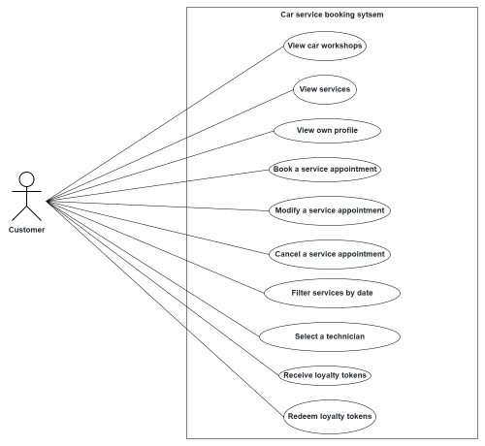

Figure 1: Use Case Diagram.

* + 1. Object Model

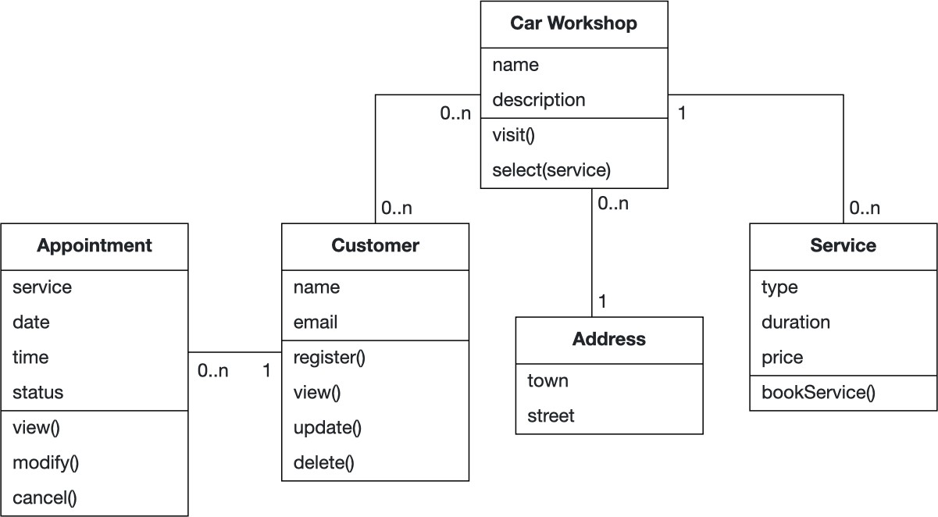

Figure 2: Class diagram from the application domain.

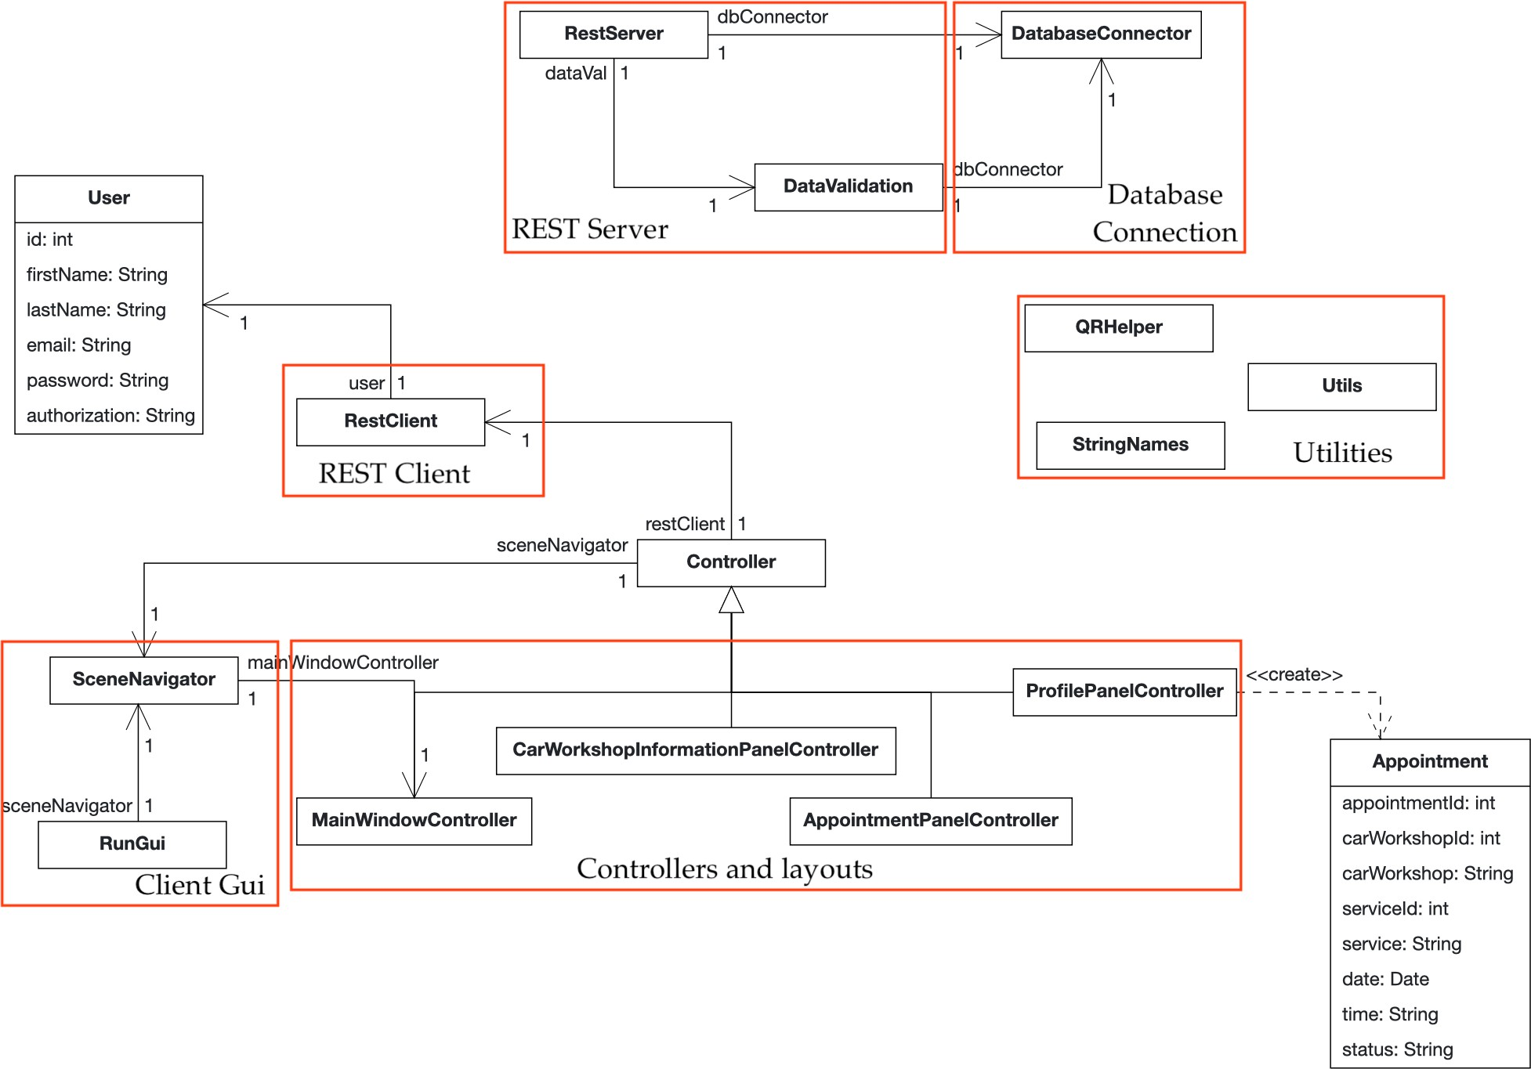

Figure 3: Class diagram from the solution domain.

* + 1. Dynamic Model

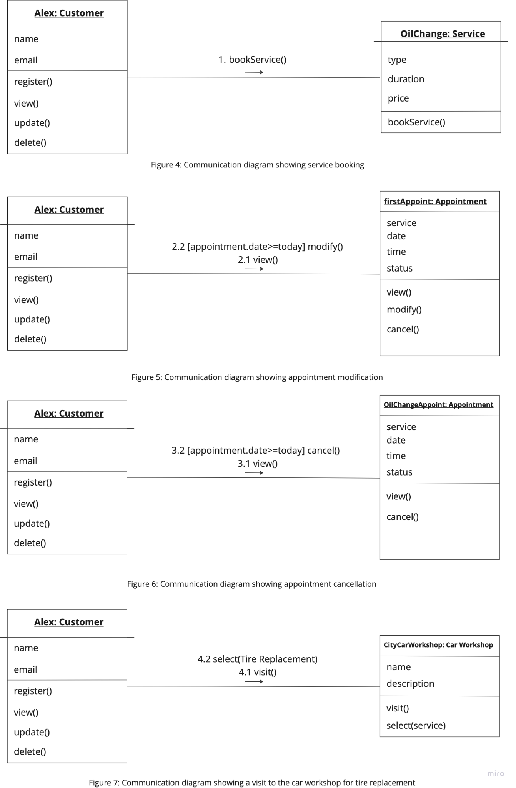

* + 1. User Interface – Navigational Paths and Screen Mock-ups

*This part of the document should illustrate the user interface of the system and navigational paths represented by the sequence of screens.*

***You can leave this part out*** *from your document or leave it empty, since you are only working on a small toy project for the purpose of the course.* ***This part will not be graded, but feel free to put mock ups here if you like****, especially if you created them during your discussions with your teammates. Here some mock ups are provided such that you get a clearer picture of what kind of content should go to this section. Mockups don’t need to be perfect. They should just provide an idea about what element goes where in the interface. There are many online tools for creating them, but you can also draw them in any way you like as long as they serve their purpose.*

# Glossary

User: A person who uses the system to browse, book, modify, or cancel vehicle maintenance services.

Workshop: A car service centre offering various maintenance and repair services, such as oil changes and tire replacements.

Service: A specific maintenance or repair task provided by the workshop, such as "Brake Inspection" or "Tire Replacement."

Reservation: The action of booking an appointment for a specific service at a selected workshop, date, and time.

Account: A personal profile created by the user containing login credentials, vehicle details, and personal information.

Login: The process of authenticating a user by entering their credentials (email and password).

Registration: The process of creating a new account in the system by providing necessary details, such as name and vehicle information.

Dashboard: The main interface where users can browse services, view upcoming appointments, and access features.

Appointment: A scheduled time for a user to receive a specific service at a workshop.

Vehicle Details: Information about the user's car, such as registration number, model, and make, is stored in their account.

Review: Feedback provided about a service or workshop, including ratings and comments. Reviews are tied to user accounts but displayed anonymously to ensure privacy.

Modify: The process of changing an existing service appointment, such as selecting a different time slot.

Cancel: The process of removing an existing service appointment from the system.

Forgot Password: A feature allowing users to recover their account by resetting their password.