First idea:   
  
Bit manipulation.   
  
An NxN matrix can be represented as an N^2 bit vector. There are N^2 overall states in the state space.   
  
For an N by N matrix, consider the binary number we would obtain by concatenating each matrix element from left to right , top to bottom. (1).

For an NxN matrix, there are 2^(NxN) possible configurations for the initial playing field. To each state, we associate the binary number we would obtain according to (1).

Let f(M,x,y) be a function that performs the operations “XOR 1” to all elements orthogonal to and including the (x,y) position in matrix M. f(M,x,y) can only perform the operation if the element at position (x,y) = 1. Applying the f(M,x,y) operation is considered to perform a transition between 2 of the possible states of the state space . For a matrix M, the number of transitions which can be performed are equal to the number of elements equal to 1. The maximum number of possible transitions is N^2 .

Consider the state transitions for the space 2x2.

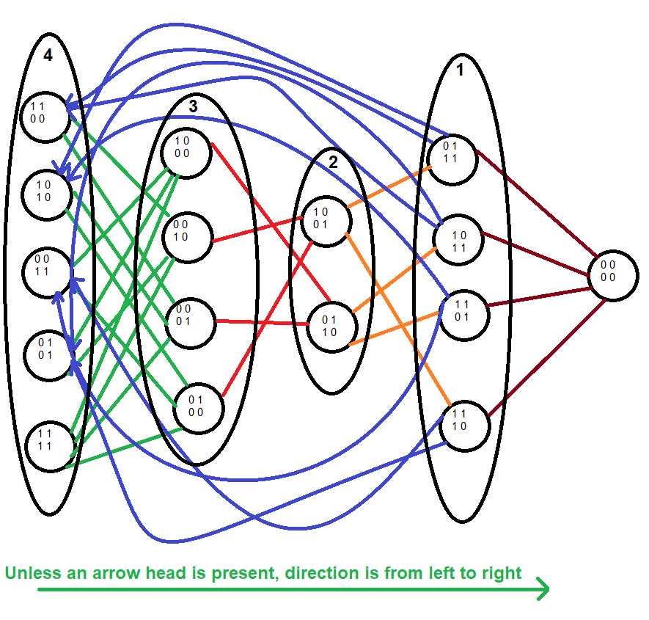

The matrix contains NxN elements.  
Each element can be either 0 or 1.  
There are 16 posibilities for a 2x2 matrix.  
Overall, there are 32 possible transitions.  
There is 1 element with 0 connections.  
There are 4 elements with 4 connections.  
There are 6 elements with 2 connections.  
There are 4 elements with 3 connections.  
There is 1 element with 4 connections.   
(1 + 1)^4 = C(4 0) + C(4 1) + C(4 2) + C(4 3) + C(4 4) =   
 = 1 + 4 + 6 + 4 + 1   
The overall number of connections that exist for   
an N x N matrix are given by the binomial formula elements  
(1 + 1)^(N x N)  
Overall, for an NxN matrix, there are  
C(N^2 0) elements with 0 connections  
C(N^2 1) elements for 1 connection  
C(N^2 2) elements for 2 connections  
.  
.  
.  
C(N^2 N^2) elements for N^2 connections  
Overall, there are   
0\*C(N^2 0) + 1\*C(N^2 1) + ... N^2 C(N^2 N^2) connections.   
We could use the fact that C(N^2 M) = C(N^2 N^2-M) to find that  
N^2\*C(N^2 0) + ... 0\*C(N^2 N^2)  
So N^2(C(N^2 0) + C(N^2 1) + ... C(N^2 N^2)) = N^2\*2^(N^2)  
Since 2\*(0\*C(N^2 0) + ... + N^2\*C(N^2 N^2)) = N^2\*2^(N^2)

There are , overall, 2^(N^2) states and N^2\*2^(N^2-1) connections between said states.

To build the N^2\*2^(N^2-1) connections, we could, for example, attempt to “whack” each possible flipped bit of every state of the state space. If we were to store the connections between the states in a 2^(N^2) x 2^(N^2) matrix, we would then be able to perform a depth first search

111 111 111

012 345 678