3.1. Các khái niệm cơ bản

CÁC TRẠNG THÁI CỦA TIẾN TRÌNH

PCB – Process Control Block

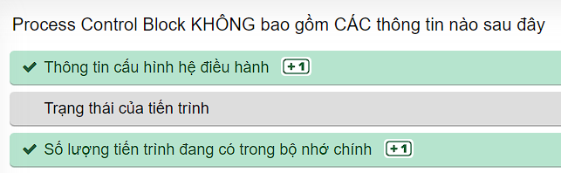

Định thời tiến trình

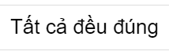

CÁC TÁC VỤ ĐỐI VỚI TIẾN TRÌNH

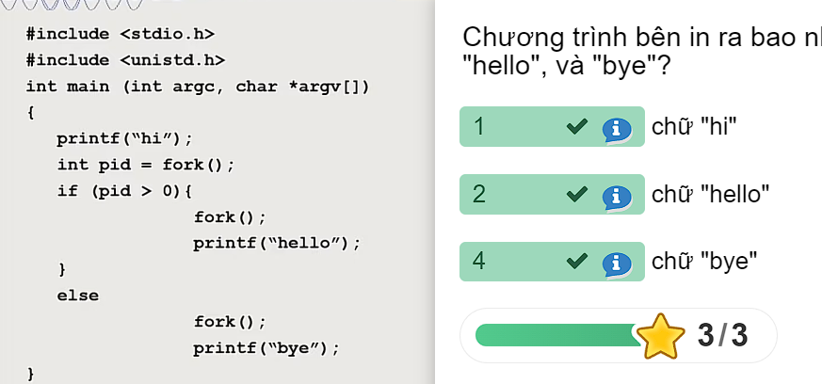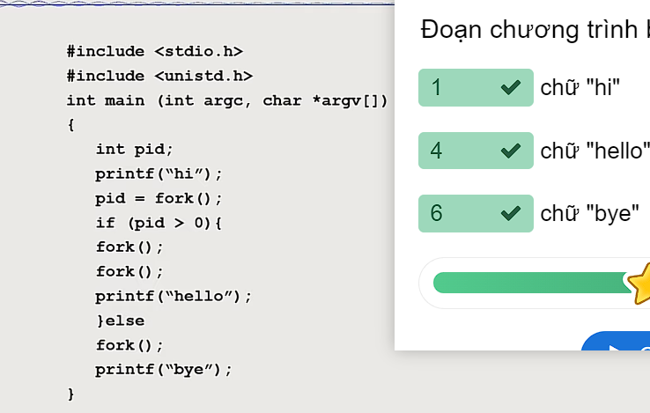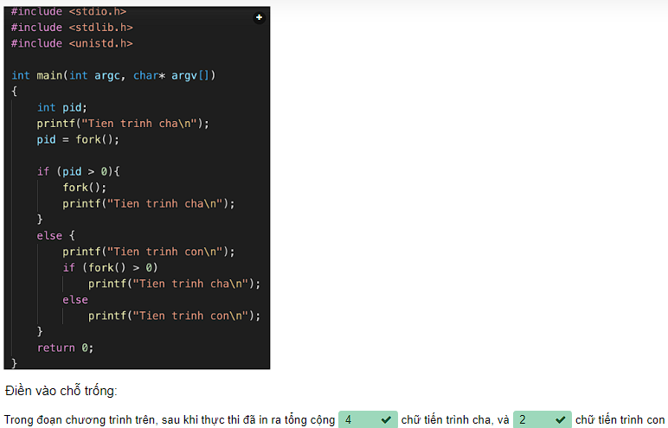

GIAO TIẾP LIÊN TIẾN TRÌNH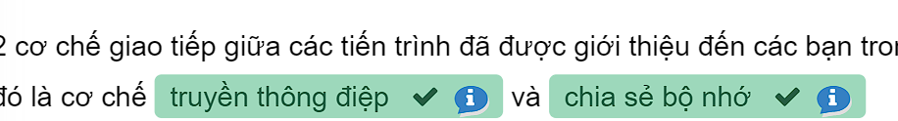

Thread - Tiểu trình

