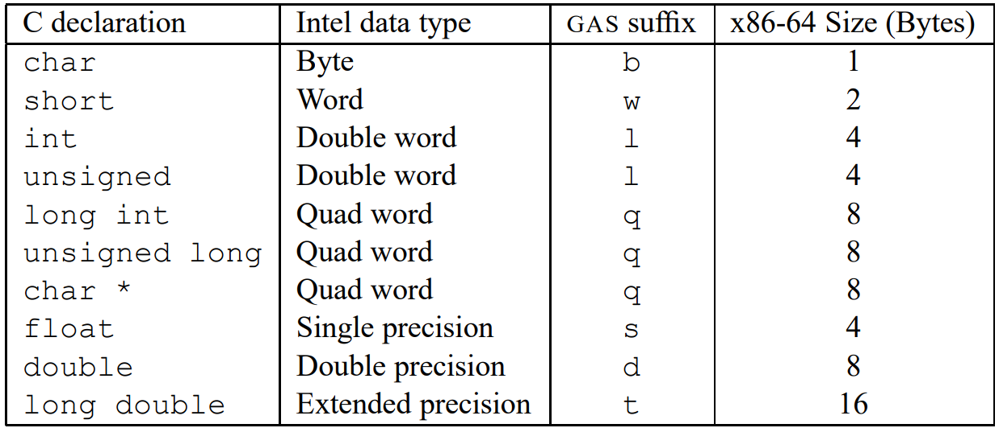

rbp: based pointer

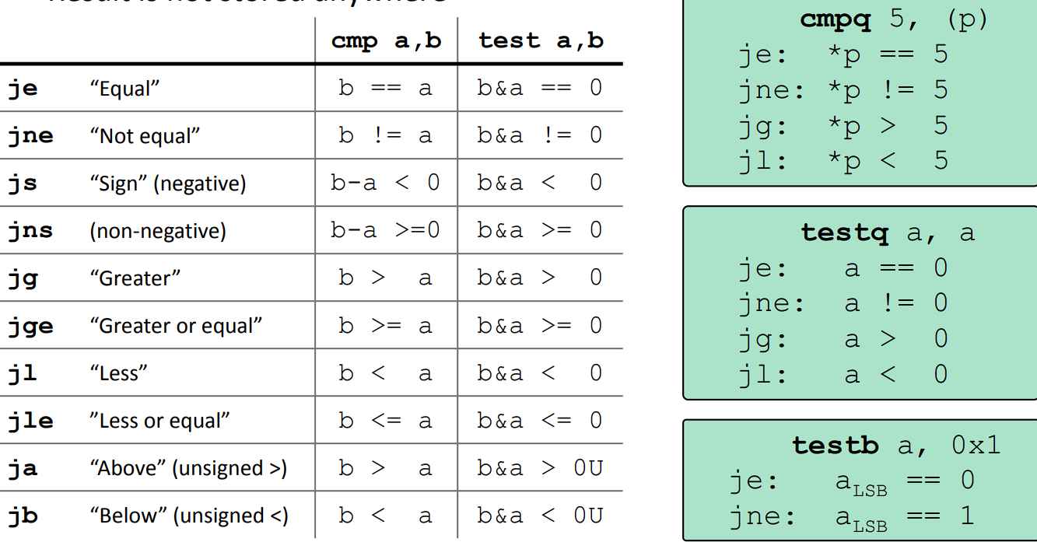

#include <stdio.h>

long int simple_l(long int *xp, long int y)

{

long int t = *xp + y;

*xp = t;

return t;

}

int main()

{

long a = 10, b = 15;

long x = simple_l (&a, b);

printf("%ld %ld %ld", x, a, b); //25 25 15

return 0;

}

32 bit: 8(%ebp) (xp) and 12(%ebp) (y). Return là %eax

64-bit: %rsi, %rdi . %rax: return value

