**Patrick Nibonkindi On 16th December, 2023**

**ID1006477**

**Advanced Computer Network**

**Final Project**

**Network Infrastructure Design Report**

**Introduction**

ZenTech, an emerging global leader in innovative technology solutions, is expanding its footprint to Kigali, Rwanda. HUZA Technologies has been tasked with configuring the network infrastructure for ZenTech's new facility in the Kigali Innovation City. This report outlines the design decisions, configurations, and recommendations for the network infrastructure.

**Network Topology**

The network is designed with VLANs to segregate different departments within ZenTech's facility. The components include an edge router (Zentech_Rwanda), a ISP router (Liquid_Rwanda_ISP), DHCP server, Zentech_USA server, two distribution switches and each department’s switch providing redundancy.

**Topology Design**

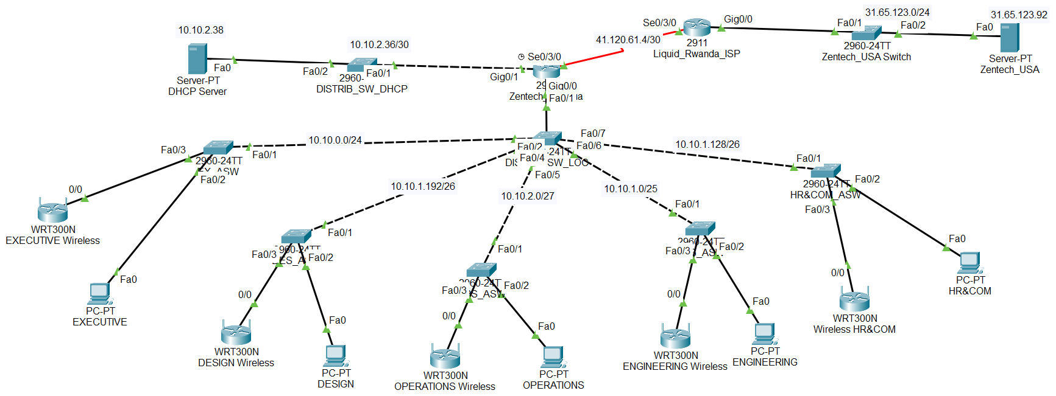

**VLAN Design**

|  |  |  |  |  |
| --- | --- | --- | --- | --- |
| **VLAN ID** | **Department** | **Subnet** | **IP Range** | **Broadcast Address** |
| 10 | Executive Management | 10.10.0.0/24 | 10.10.0.1-254 | 10.10.0.255 |
| 20 | Engineering Department | 10.10.1.0/26 | 10.10.1.1-62 | 10.10.1.63 |
| 30 | HR & Communications | 10.10.1.64/27 | 10.10.1.65-94 | 10.10.1.95 |
| 40 | Design Team | 10.10.1.96/26 | 10.10.1.97-158 | 10.10.1.159 |
| 50 | Operations Team | 10.10.1.160/26 | 10.10.1.161-222 | 10.10.1.223 |
|  | Router to Router | 41.120.61.4/30 | 41.120.61.5-6 | 41.120.61.7 |

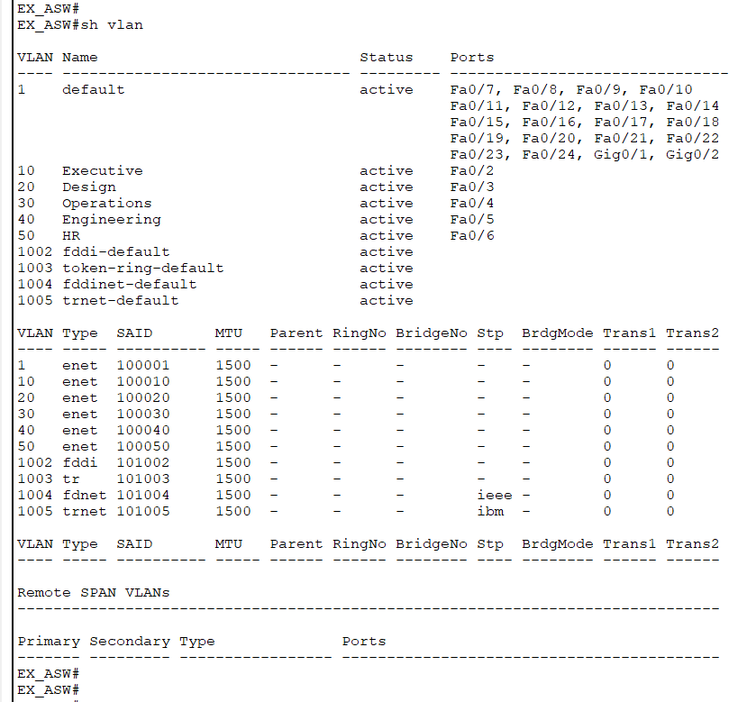

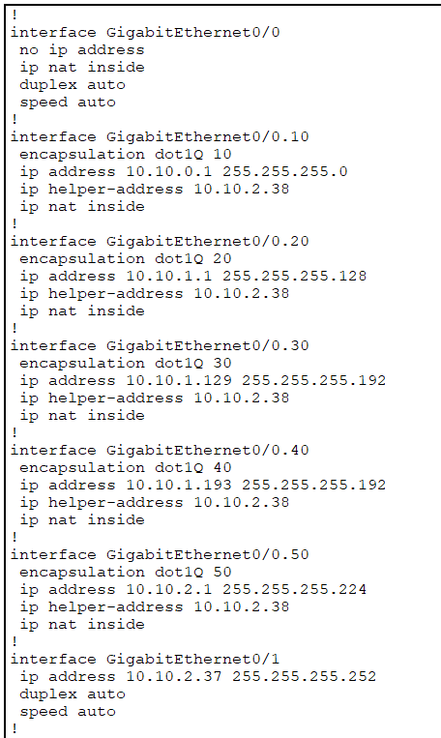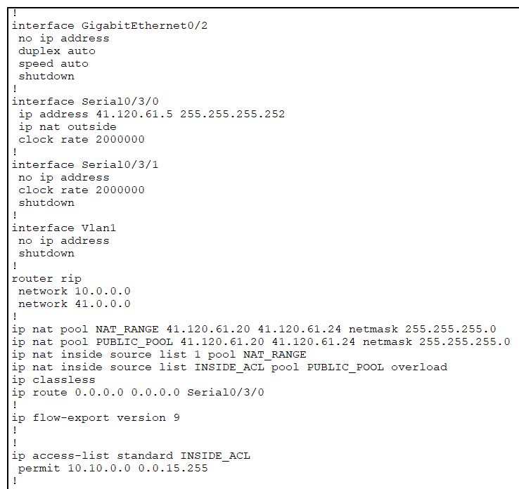

**Routing**

RIP is configured between Zentech_Rwanda and Liquid_Rwanda_ISP for dynamic routing. Static routes are used for internal VLANs on the Zentech_Rwanda core router.

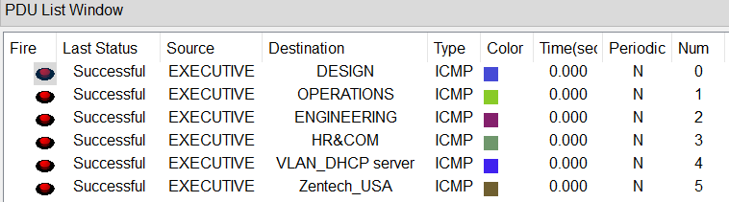

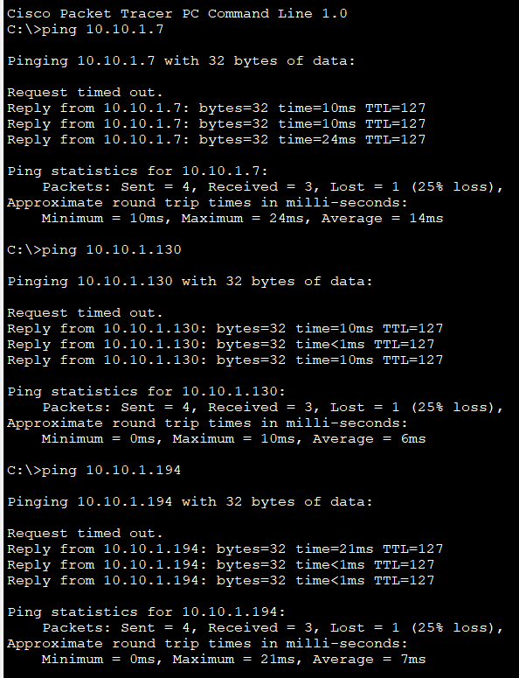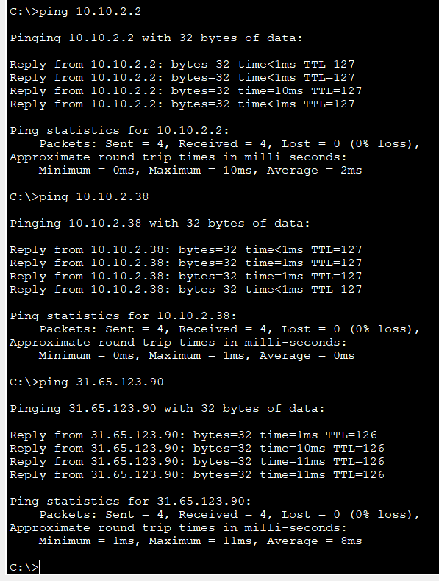

**DHCP Configuration**

A DHCP server is configured on the Zentech_Rwanda core router to assign IP addresses within each VLAN.

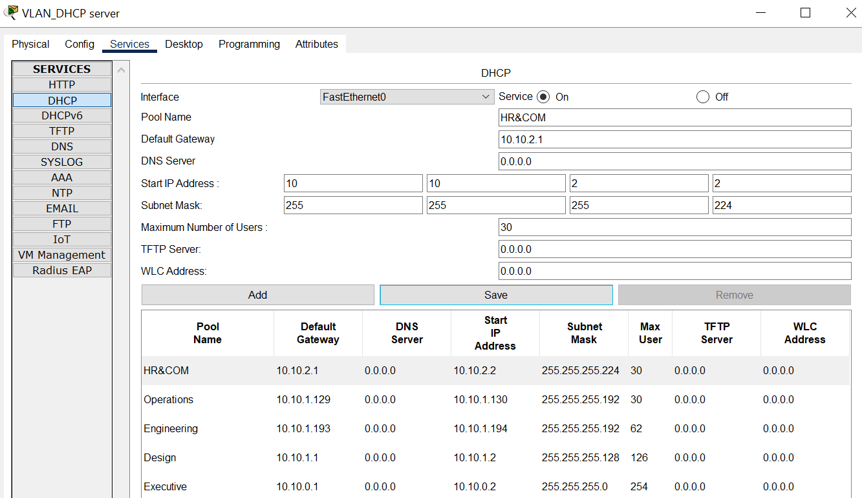

**NAT Configuration**

Dynamic NAT is configured on the Zentech_Rwanda edge router to allow access to the Zentech_USA server from the internal network using public IP addresses (41.120.61.20/24 - 41.120.61.24/24) provided by Liquid Telecom Rwanda.

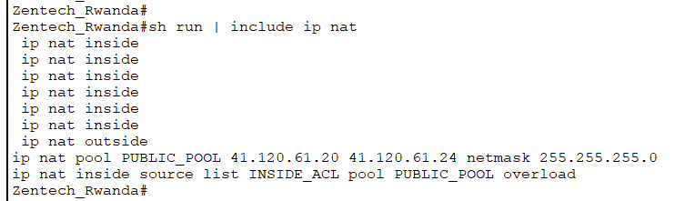

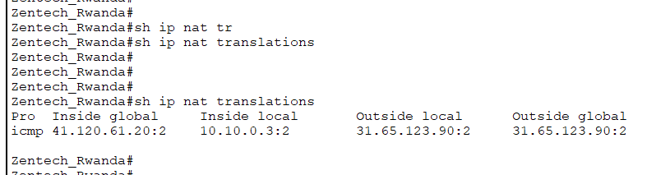

**Security Considerations**

Access control lists (ACLs) are implemented to control traffic and ensure security. VLAN segmentation adds an additional layer of security by isolating different departments.

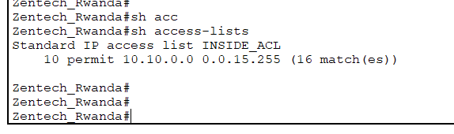

**Conclusion**

The proposed network infrastructure design ensures efficient communication between different departments within ZenTech's facility in Kigali Innovation City, Rwanda, provides redundancy, and enables secure access to the Zentech_USA server.