Patrick O’Brien

5.25.2020

IT FDN 100 A

Assignment 06

<https://github.com/POB768/IntroToProg-Python-Mod06>

**To Do List with Custom Functions**

**Introduction**

This document covers my process for approaching module 6 and completing the sixth assignment of IT FDN 100 A.

**Initial Learning**

As per usual, I watched the corresponding course video by Randal, read through the textbook chapter 6, and visited the two external resources suggested in the assignment 6 pdf.

**Processor Functions**

Creating the missing processor functions was fairly straightforward as it bore much similarity to the coding I did in assignment 5. So, creating the functions here was primarily a matter of utilizing the same coding as I did before but making it work in the context of an isolated function as shown in (figure 1).

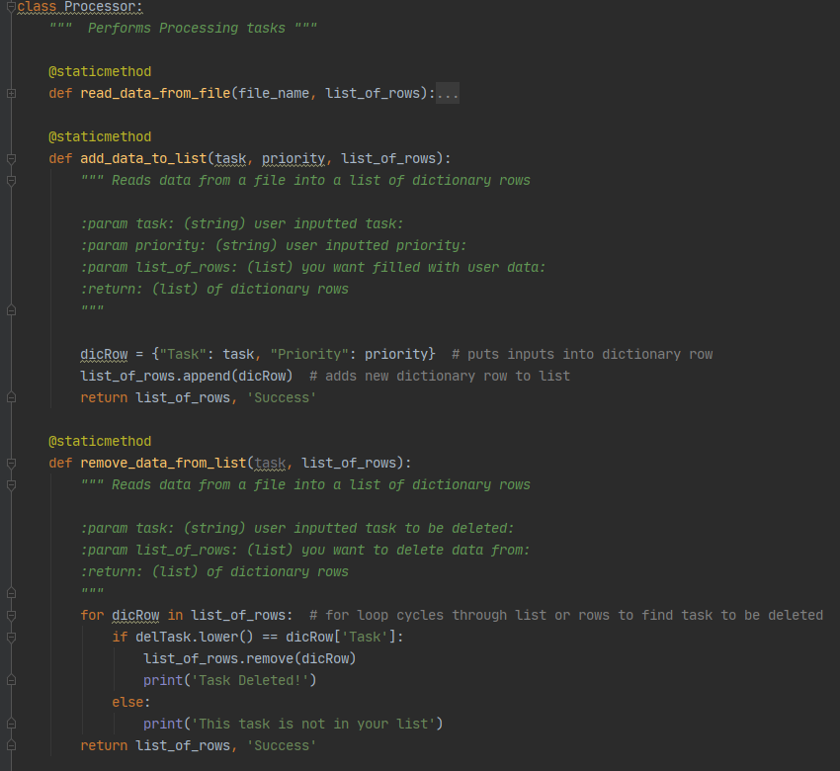

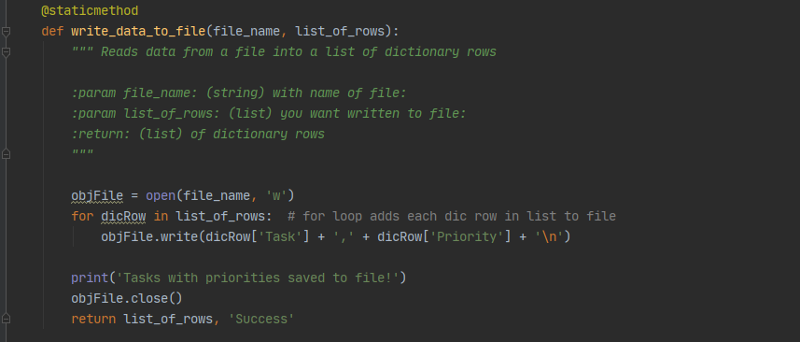

***Figure 1: My added Processor functions***

**I/O Functions**

Adding the two new I/O functions was a similar exercise of adapting my code from assignment 5 to the new circumstances of isolated functions. With a bit of trial and error, I was able to create functions which would take user input and return the necessary strings (figure 2) which I could ultimately plug into my processing functions in the main script.

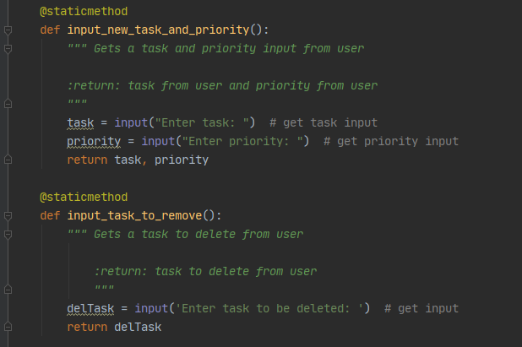

***Figure 2: Added I/O functions to receive user input***

**Main Script**

I worked on the main script last, and the most challenging problems I encountered were getting my processor functions to read my input functions returned data. I was able to solve the problem through trial and error, carefully reading PyCharm’s error notes, and reviewing the lecture notes. Eventually the formatting clicked, and my code worked (figure 3).

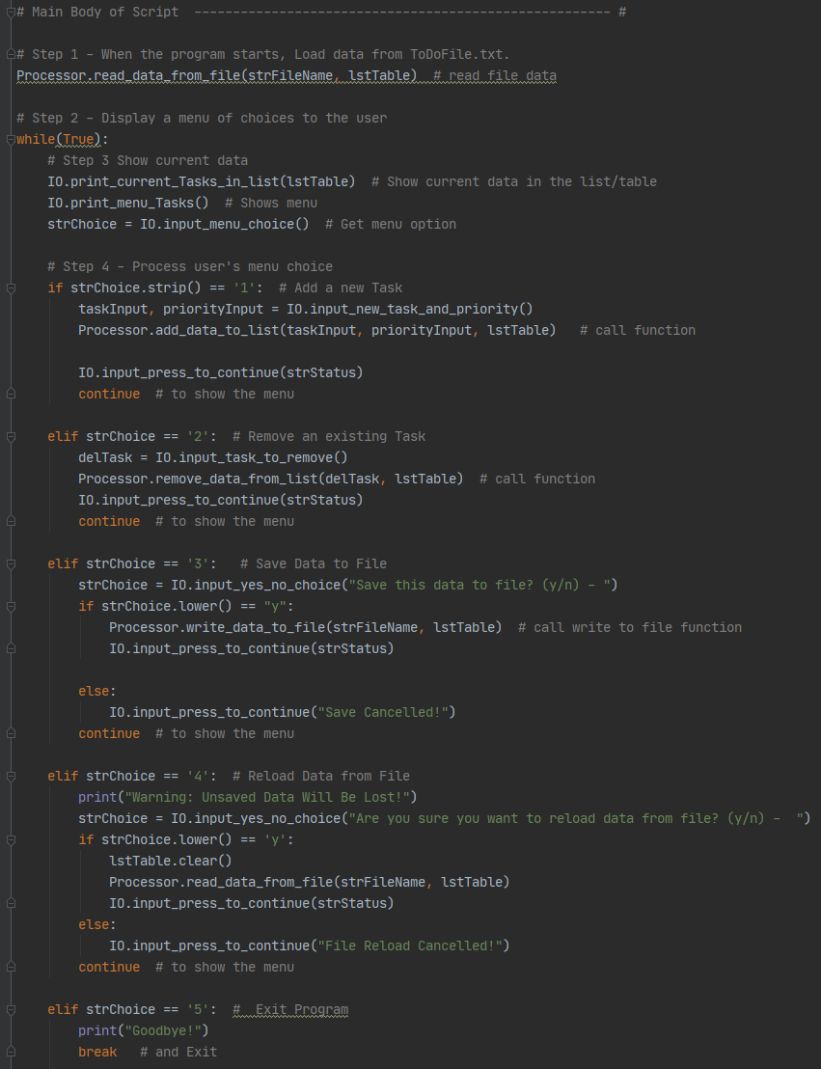

***Figure 3: Main Body of Script***

**Running Program**

(Figure 6) depicts the program running in PyCharm, (figure 7) shows the corresponding file that the program writes to, and (figure 8) shows it running in command prompt.

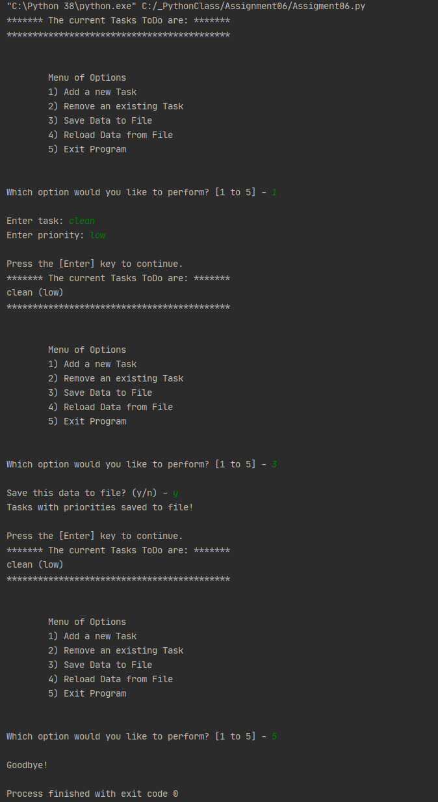

***Figure 6: Program running in PyCharm***

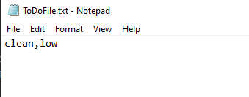

***Figure 7: Corresponding text file***

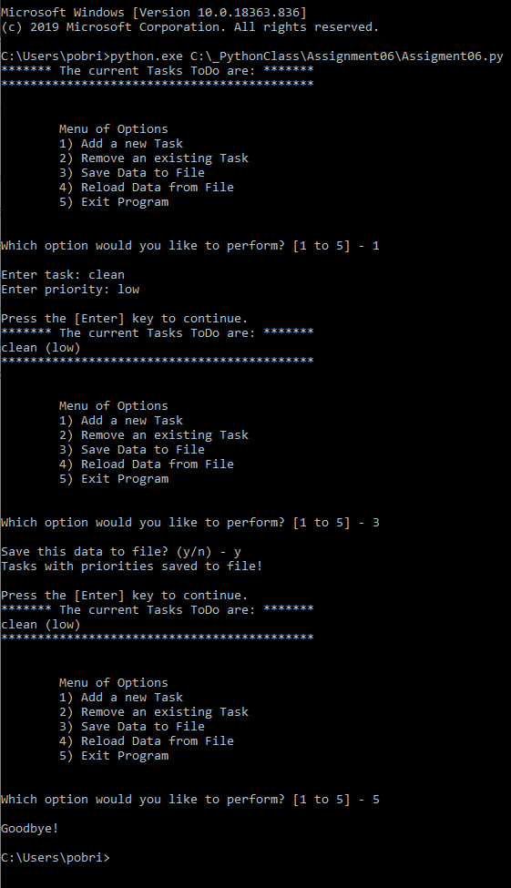

***Figure 8: Program running in Command Prompt***

**Summary**

This document described my process for working through module 6 of IT FDN 100. After watching the course video, reviewing the notes, and reading chapter 6 of the textbook, I attempted the assignment. My biggest struggles were in formatting the code properly, but I was able to overcome them through consistent trial and error.