Patrick O’Brien

6.1.2020

IT FDN 100 A

Assignment 07

[Github](https://github.com/POB768/IntroToProg-Python-Mod07)

**Pickling and Error Handling**

**Introduction**

This document covers my process for approaching module 7 and completing the seventh assignment of IT FDN 100 A.

**Initial Learning**

As per usual, I watched the corresponding course video by Randal, read through the textbook chapter 7, and then I found two external sources, [datacamp](https://www.datacamp.com/community/tutorials/pickle-python-tutorial) for pickling and [w3schools](https://www.w3schools.com/python/python_try_except.asp) for error handling.

**Creating Pickling Code**

I did this assignment in two steps. The first step was creating a simple script that demonstrated how I could take user inputs and pickle them into a binary file, and then un-pickle that binary file to read that data back to the user (figure 1). I found examples in the course textbook as well as [datacamp](https://www.datacamp.com/community/tutorials/pickle-python-tutorial) to be helpful in learning how pickling works. I found that datacamp has excellent step by step examples as well as descriptions of how and when it is useful to use pickling.

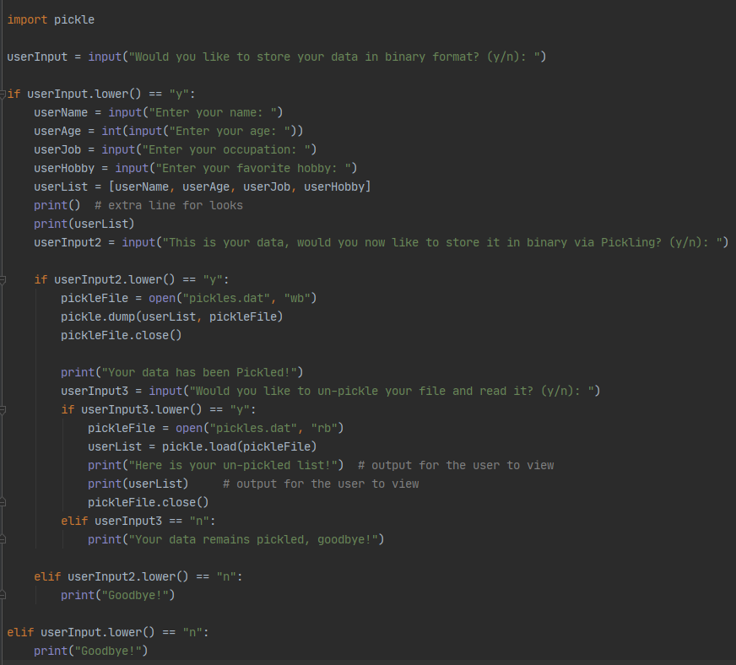

***Figure 1: Pickling and Un-Pickling Script***

**Adding Error Handling**

I decided to add a simple error handling feature that flags if the user does not enter an integer for his or her name. To do so, I used the Try, Except, and Else keywords as show in (figure 2) below. I found the demonstrations of this error handling capability on [w3schools](https://www.w3schools.com/python/python_try_except.asp) to be very easy to follow and understand. As shown in (figure 2) I have the try keyword above the userAge input, and if it detects a value error the except function prints the nature of the problem and terminates the program.

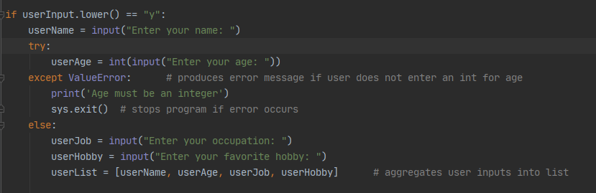

***Figure 2: Error Handling Addition***

**Running Program**

(Figure 3) depicts the program running in PyCharm, (figure 4) depicts the program running into an error in PyCharm, (figure 5) shows the corresponding .dat file that the program writes to, and (figure 6) shows it running in command prompt.

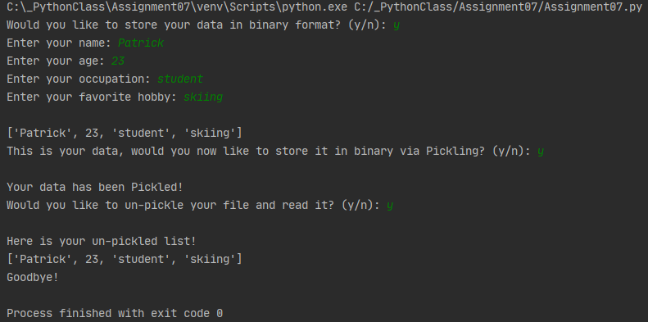

***Figure 3: Program running in PyCharm***

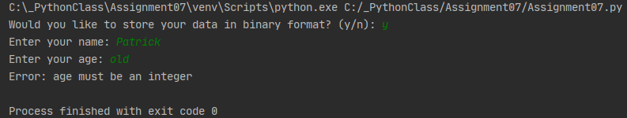

***Figure 4: Running into an Error in PyCharm***

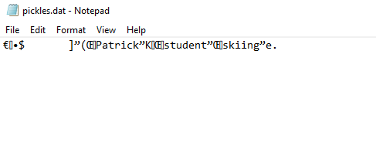

***Figure 5: Pickles.dat File in Notepad***

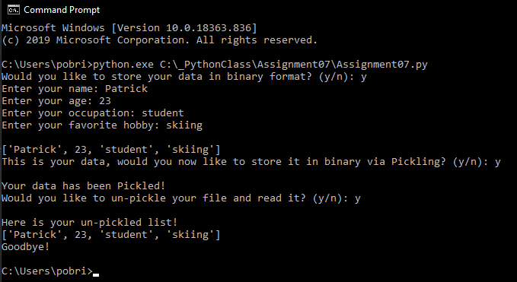

***Figure 6: Program running in Command Prompt***

**Summary**

This document described my process for working through module 7 of IT FDN 100. After watching the course video, reviewing the notes, reading chapter 7 of the textbook, and doing some independent online searching, I attempted the assignment. I had difficulties with getting the error handling code to work right but was able to solve it using w3schools to help figure out how to make my program behave the way I wanted it to.