Patrick O’Brien

5.18.2020

IT FDN 100 A

Assignment 05

<https://github.com/POB768/IntroToProg-Python>

**To Do List Added Code**

**Introduction**

This document covers my process for approaching module 5 and completing the fifth assignment of IT FDN 100 A.

**Initial Learning**

As per usual, I watched the corresponding course video by Randal, read through the textbook chapter 5, and visited the two external resources suggested in the assignment 5 pdf.

**Assignment Step 1**

Step 1 in assignment 5 was straightforward as I was able to refer to lab 5-2 to figure out how to accomplish the task. I created code that opens the ToDoList.txt file then using a for loop combs through the file separating items by commas to create individual lists then assigning the lists to dictionary rows which are then appended to a master list table (figure 1).

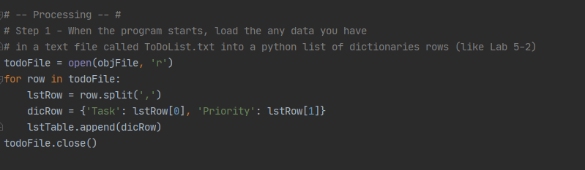

***Figure 1: Reading the ToDoList File, converting to dictionaries and adding to list table***

**Assignment Step 2**

Step 2 required no added code, so I left it as is.

**Assignment Step 3**

Step 3 bore similarity to what we did in assignment 4 for printing out data. I realized that a for loop would work well to iterate through the list table and pull out each dictionary row. Beyond that realization I just had to play with formatting a little to make sure it printed cleanly (figure 2).

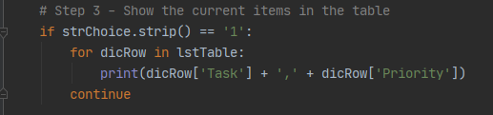

***Figure 2: Displaying list table data***

**Assignment Step 4**

Step 4 also shared similarities with how we added data in assignment 4. I coded in two user input sections for task and priority. After the inputs I had them assigned to a dictionary which I could then append to the list table (figure 3).

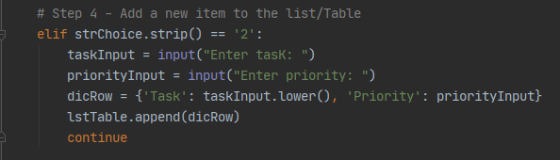

***Figure 3: User inputs being converted to a dictionary and appended to the list table***

**Assignment Step 5**

Step 5 was the most difficult step for me. I knew I needed to collect a user input on which task had to be deleted so I wrote the first line of code to do that. I did not know exactly how I would be able to remove that task from the list table. To find out more, I reviewed the module 4 notes on lists and re-discovered the remove function for lists. I figured that the deletion process would be a lot like the reading/displaying process as I would need code to read through the list and identify which dictionary row matched the desired deletion. So, I emulated the for loop I used in step 3 and added an if function within it to check for a matching task. Then I could use the remove function to delete any task that matched the user input from the list table (figure 4).

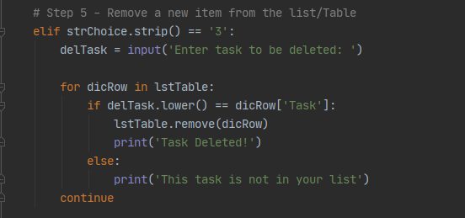

***Figure 4: Deleting a task from the list table***

**Assignment Step 6**

Step 6 bore similarity to the writing to file done in assignment 4. I began by opening the file and using a for loop to iterate through the list table to write each dictionary row to the file with my desired formatting. Then I closed out the file (figure 5).

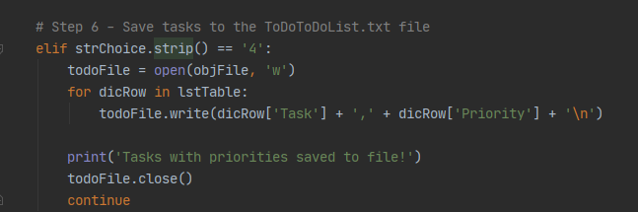

***Figure 5: Writing the list table to the file using a for loop***

**Assignment Step 7**

Step 7 required little added code, I merely put in a print statement that says “Goodbye” when the user exits.

**Running Program**

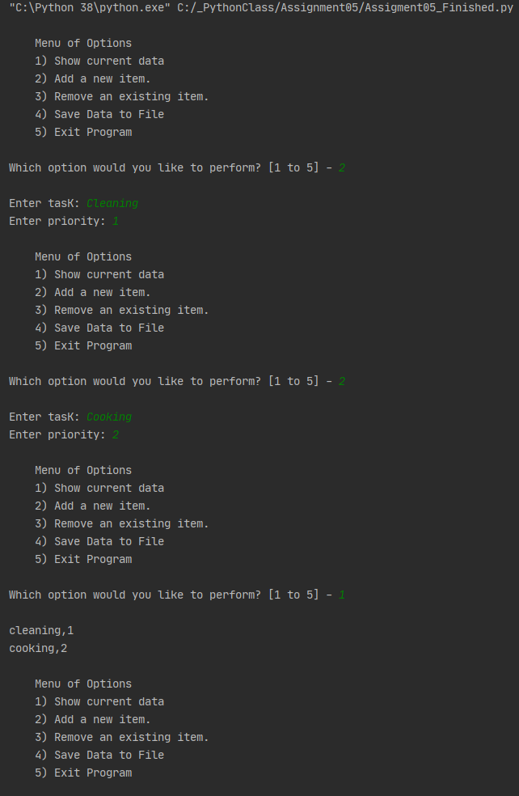(Figure 6) depicts the program running in PyCharm, (figure 7) shows the corresponding file that the program writes to, and (figure 8) shows it running in command prompt.

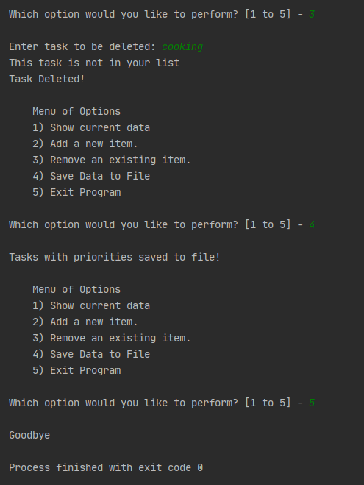

***Figure 6: Program running in PyCharm***

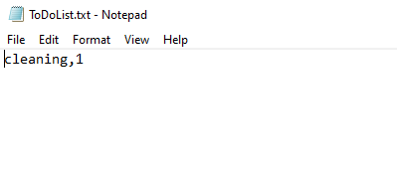

***Figure 7: Corresponding text file***

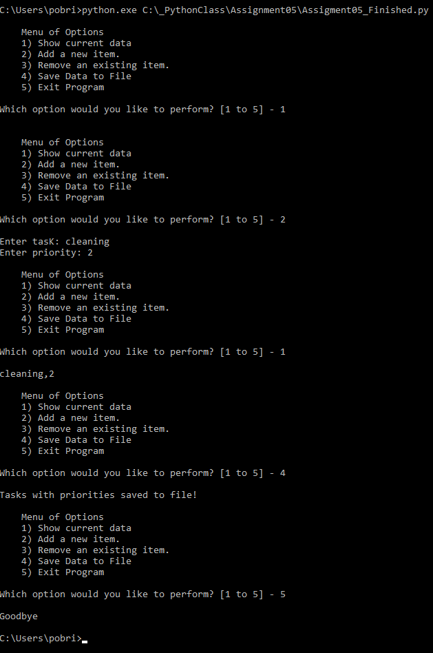

***Figure 8: Program running in Command Prompt***

**Summary**

This document described my process for working through module 5 of IT FDN 100. After watching the course video, reviewing the notes, and reading chapter 5 of the textbook, I attempted the assignment, but ran into some obstacles. I was able to progress by reviewing the material as well as the previous assignment which reminded me how to complete certain tasks with code like iterating through a list with a for loop.