Patrick O’Brien

Stat 3503 Problem Set 5

1)a)

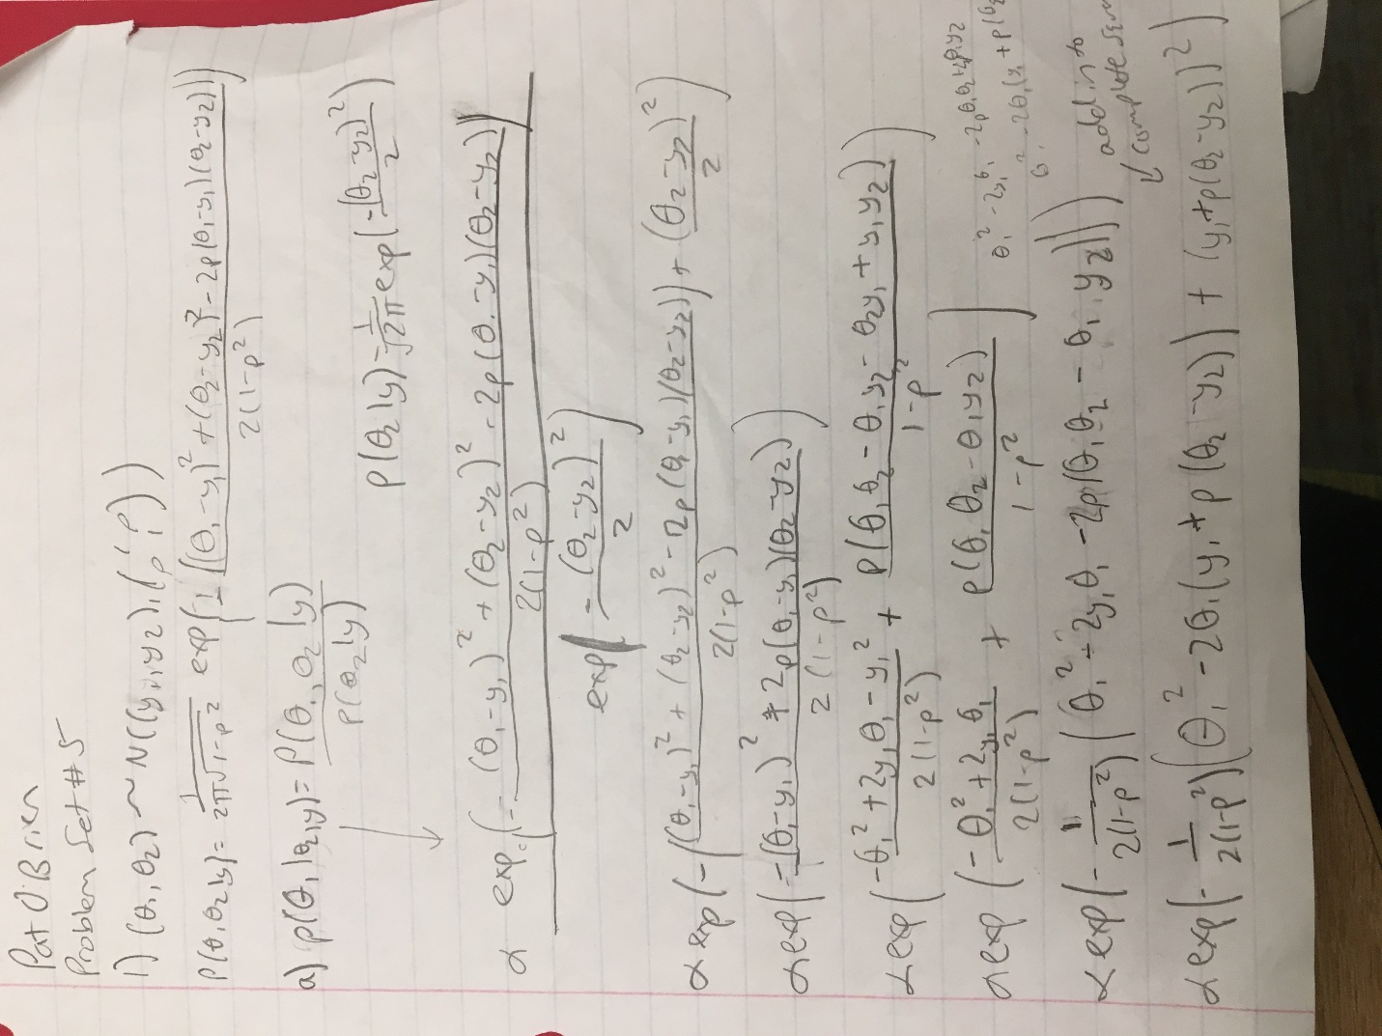



1)b)

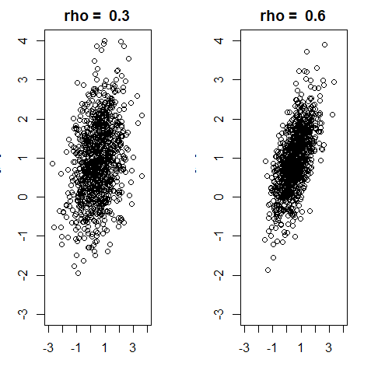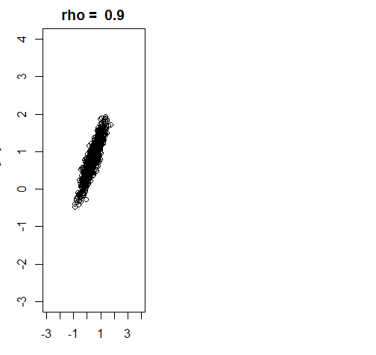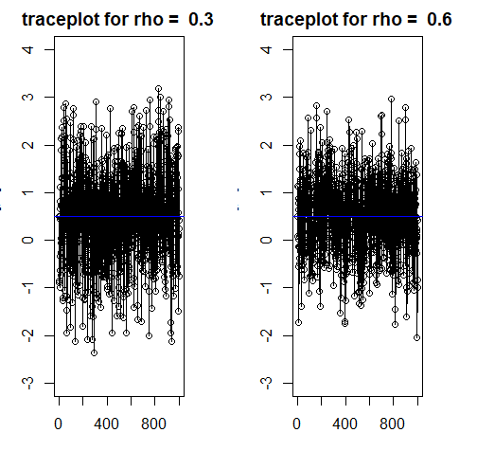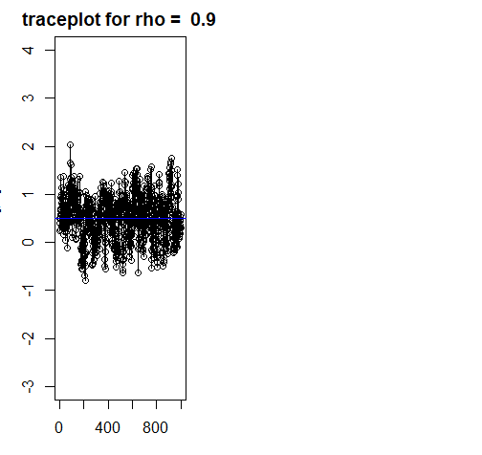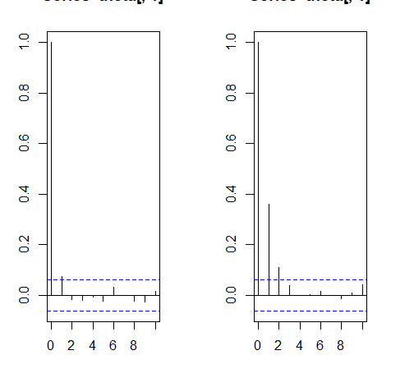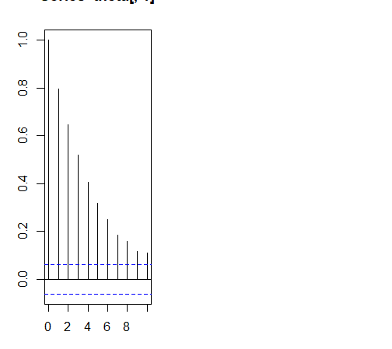

For the autocorrelation plots, they go from rho = .3, .6, .9 in that order.

Effective sample size for each value of rho:

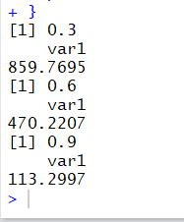

1)c)

As rho increases, the effectiveness of the sampler decreases. As you can see from the scatterplots and traceplots, the variance decreases as rho increases. This is also the case with the effective sample size. Additionally, there is a longer lag time on the autocorrelation when rho is higher. This shows that as our value of rho increases, our values become more and more similar. This makes sense because usually when we want to take a sample of something, we want the points to be as unrelated as possible to reduce the influence of any bias that may occur. If rho, the correlation coefficient, is higher, the points are more related to one another, therefore making the effectiveness of the sampler decrease.

CODE FOR PROBLEM 1:

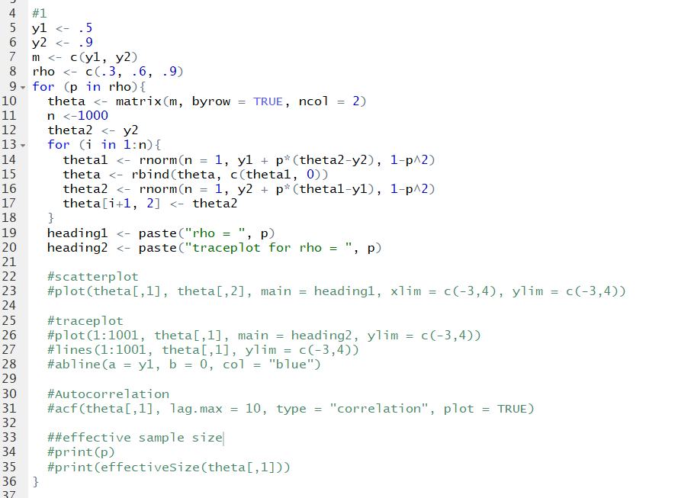

2)a)

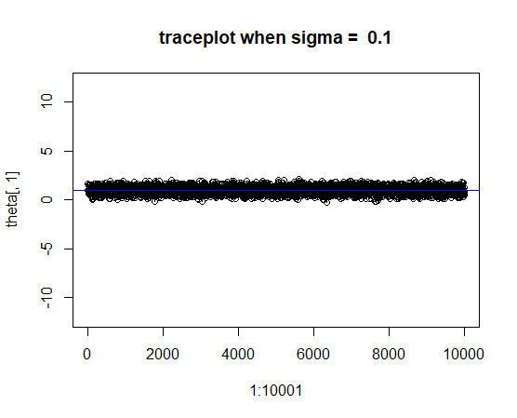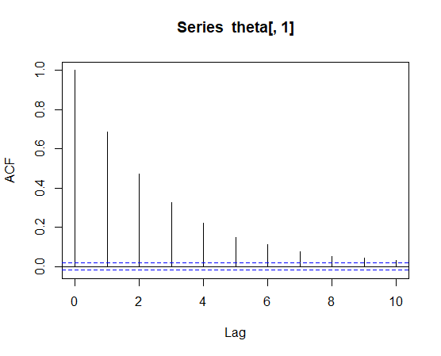

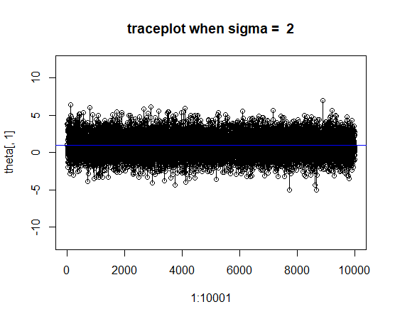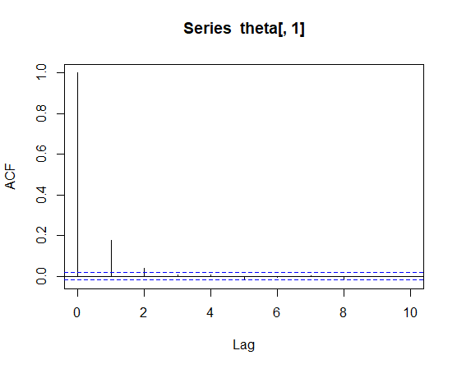

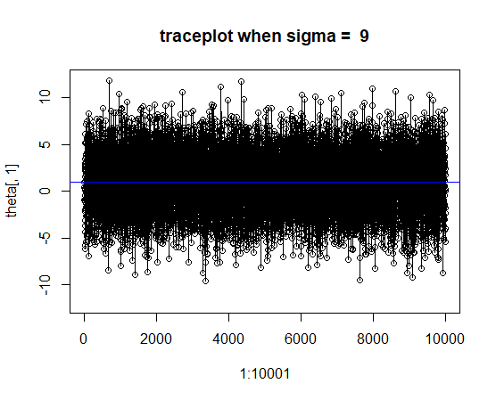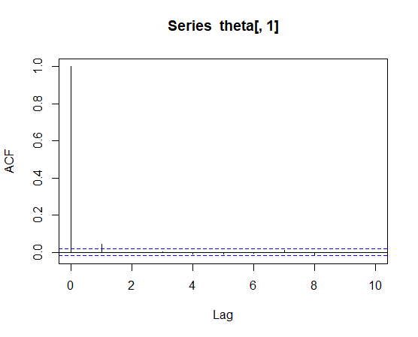

These are the traceplots and autocorrelation plots when N = 10000. To get a better look at the mixing behavior, here are the traceplots when N = 50:

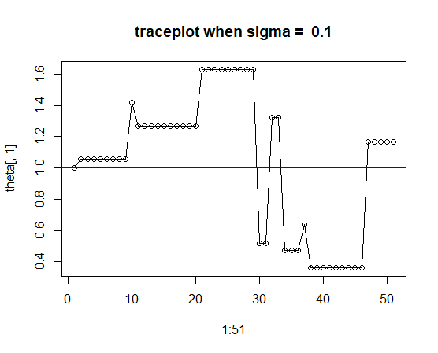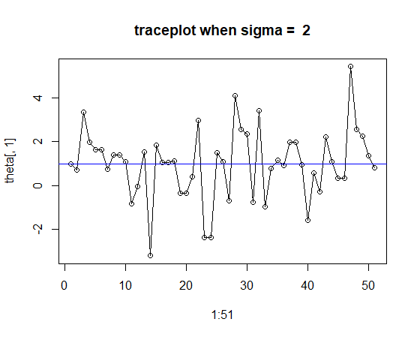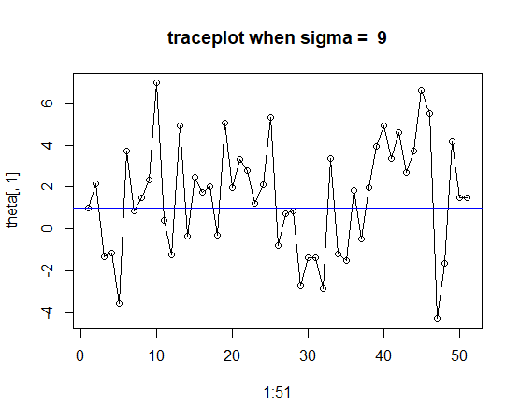

With a smaller sample size, we can see more clearly that when the variance is smaller, more points will get rejected from continuing in the Metropolis-Hastings Sampler. This can also be seen in the autocorrelation plots, as there is much less lag as variance increases. The chains mixing behavior becomes much more effective as variance increases, as there are much less points getting rejected and being forced to stay the same.

2)b/c)

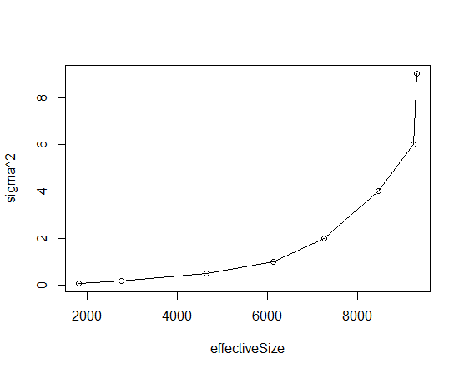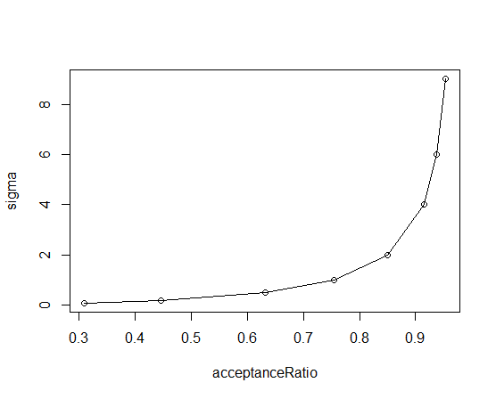

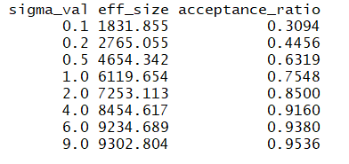

d) To get the most efficiency out of this sampler, we would want to big the highest value of sigma^2. From the values of the effective size and the acceptance ratio, we can see that as variance increases, the sampler rejects less proposed observations and the sample size becomes more effective. This makes sense because, again, samples are more effective the less related they are. The sampler will be more efficient when the samples are less related, ie. When variance is larger.

e)

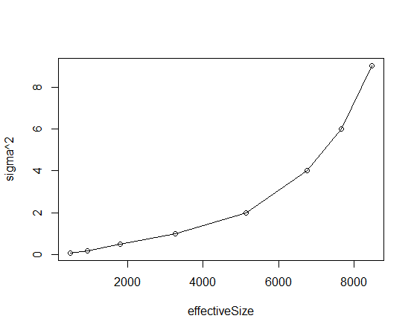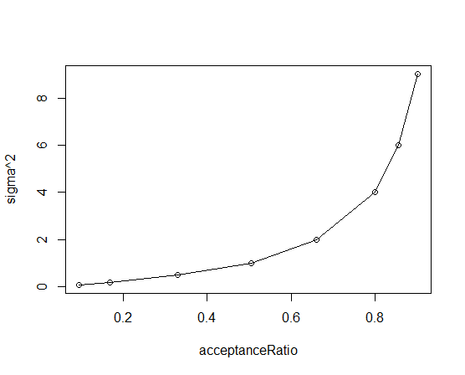

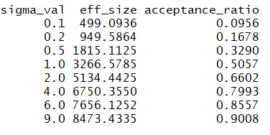

Comparing these results to the previous results in part d, the idea that the sampler is more efficient the less related the observations are still holds. In this new proposal distribution, the variance now includes a correlation coefficient of rho = .9. This value is greater than 0 that we had before, and the values are now much more closely correlated. This is seen through the graphs and the data as well. The values of the effective sample size and the acceptance ratio still increase as the value of sigma^2 increases, but are less than the values when rho = 0. This is because the higher correlation coefficient makes the increasing variance less effective. This tells us that the sampler will be the most efficient at the highest variance and the lowest correlation coefficient.

CODE FOR PROBLEM 2:

