Universal Interface Format (UIF)

Language definition
Object interface
Internals

V 1.3.1 ESD Group, Electronics and Computer Science
11 June 2008

V 1.4 Andrew Brown, Electronics Department
6 March 2012

V 1.5 Andrew Brown, Electronics Department
3 March 2020

1. Preamble
1.1 Getting started

2. Language definition
2.1 Putting it all together
2.2 Weirdness

3. Object interface
3.1 Constructors
3.1.1 The empty constructor
3.1.2 The command line constructor
3.1.3 Adding files
3.2 Error handling
3.2.1 Default error handling
3.2.2 User-supplied error handling
3.3 Interrogating the object
3.3.1 Datastructure - overview
3.3.2 Pretty print
3.3.3 Diagnostic dump
3.3.4 Callback functions
3.4 Deriving classes
3.4.1 The JNJ class

4. Internals
4.1 Language grammar
4.1.1 The comment bodge
4.1.2 Expressions
4.2 Data structure in detail

1. Preamble

The UIF is nothing more than a reasonably convenient way of storing strings and symbols in a reasonably convenient manner. It is technically a language, but an extremely simple one - think of a sophisticated scanf() capability.

The philosophy is that the .UIF file is a persistent form of a UIF object, that just happens to be laid out in a human-readable form. Thus you can write a UIF file by whatever means you choose and create the corresponding datastructure with a UIF constructor, or you can create an empty UIF object, load the datastructure from within your application, and save it with the class methods provided.

UIF started life as an INI file manager, providing little more than a u$oft .INI file parser. Diverse projects over the years have found this to be 'not quite sufficient', and led to the development of probably a dozen silly little formats, all similar in many respects and varying in slight degrees; each, of course, comes with its own parser and uniquely different set of bugs and shortcomings. UIF is an attempt to unify all this, and build an INI superset that is capable of supporting (most of) what most people seem to need. It does not contain the sophistication, power or flexibility of a hardware or software high level language. Think of a .UIF file as a free-format assembly language with expressions.

In general, the language is probably too flexible: any attempt to use every capability at every point will result in source text that is incomprehensible (think LISP, EDIF). The idea is to pick the subset you want, and then build a derived class from the UIF class that allows you to interface comfortably with the bits you want. UIF enforces a syntax, but has no semantics. It knows what a string is (virtually any numeric or alphanumeric), it knows how to interpret a string as a floating point number, or a binary, octal, decimal or hexadecimal integer, it knows what an operator is (virtually anything traditionally thought of as an operator in any language), and it enforces a (very unrestricted) way in which these can appear with respect to each other. It has no keywords, and knows nothing about any relationships between strings and operators. It knows nothing about what any operator means (as far as UIF is concerned, they don't mean anything anyway). It is up to the user to overlay these meanings (and enforce them) in any derived class.

It follows from this that UIF is by no means idiot-proof. UIF is designed to be used as a C++ base class and creating a derivation from it requires a reasonable knowledge of what you're doing. The internal structures are reasonably robust - it's hard to fall off a dangling pointer using the code provided but the internals are mainly public. You can break it if you must.

1.1 Getting started

In this section, we start from the very simplest possible UIF record, and build in complexity, adding extra sections of complexity as we go along. UIF is a syntax, which is a set of rules by which lexical tokens may be legally ordered. There is no semantic content to a piece of UIF text.

In the beginning, there was the u$oft .INI format. Using this, you could write in a file something like

left = 22
right = 88
top = 65
bottom = 44

and typically this would be picked up by a program and used to, maybe, define the position of a window. When the program closed, the last thing it would do would be to re-write the file with the new window coordinates, so that the program could 'start up where it left off'.

Very quickly, this can be extended - the right hand side (value field) becomes a comma separated sequence of strings.

left = 22
right = 88
top = 65,yellow
bottom = 44,green

u$oft then added the ability to enclose groups of records as sections:

licence = 506

[mainwindow]
left = 22
right = 88
top = 65,yellow
bottom = 44,green

The file is defined to start with one blank (untitled) section, followed by an arbitrary length set of sections, each containing an arbitrary number of records. Any section (blank or named) may be empty (contain no records).

This is pretty much where u$oft left off. UIF extends the syntax quite considerably, making it a suitable vehicle to describe a wide variety of declarative and sequential systems. UIF simply enforces a syntax; it says nothing about what the records actually mean. The 'output' of the UIF parser is a token tree, which can be traversed by the user to extract or enforce whatever semantics are required.

.INI has the notion of variable field (to the left of the '=' token) and value field (to the right of the '=' token. The value field may be multi-valued.

From here on, we describe UIF:

UIF introduces a third type of field, the label field, separated from the existing field structure with a ':' token:

user : licence = 506,7
system : licence = 8276

Multi-valued fields

UIF allows all three fields to be multi-valued:

u1,u1,u2 : LA,LB,LC,LD = 56,stuff

What exactly is a 'value'? For the moment, it's just a string. Call it a name. (It gets more complicated later.)

Name arguments

Names can take arguments, just like a function invocation:

u1(x,y,z),u1(a),u2() : LA(f(ff(fff))),LB,LC,LD = 56(stuff)

The brackets can contain comma-separated lists of more names, and the bracket depth can continue indefinitely.

Null names

Null names can be introduced with careful use of commas:

LA,LB,LC,LD

is a four-valued variable; so is

LA,,,

Name operators

Any name may be optionally prefixed with a monadic 'operator':

u1(x,~y,z),-u1(a),u2() : LA(f(ff(#fff))),LB,LC,LD = 56(^stuff)

Section headers

The names in section headers can also become arbitrarily complicated:

[n1,n2(*h,54)]

Continuation characters

UIF is a text-based language, with no restriction on the length of records. However, the end of record (EOR) is the record delimiter in UIF, so apart from adding whitespace, you can't (so far) reformat UIF records to make them look nice when printed out. The line continuation character ('\') allows you to 'flow' logical records over physical boundaries:

u1(x,~y,z),-u1(a),u2() : LA(f(ff(#fff))),LB,LC,LD = 56(^stuff)

is read exactly the same as

u1(x,~y,z),-u1(a),u2() : \
LA(f(ff(#fff))),LB,LC,LD \
= 56(^stuff)

Comments

UIF supports two comment delimiters: Anything between ';' and EOR, and anything between '//' and EOR is taken as a comment and ignored by the UIF grammar. However, it is not ignored by the lexer: a comment is a treated as a token, and stored, for potential retrieval by a user. This allows the possibility that a user can overlay a meta-language in the comments if desired.

[mainwindow] // Main window
left = 22 // Uh... left window position?
right = 88 ; Guess

Whitespace is ignored by UIF.

Missing bits out

The ':' and '=' delimiters may be omitted, along with any or all of the label, variable and value fields. What is left is interpreted as below:

label1 : ; Just a label
variable2 ; Just a variable
= value3 ; Just a value
label4 : variable4 ; A label and a variable
label5 : = value5 ; A label and a value
variable6 = value6 ; A variable and a value
label7 : = ; Just a label
variable8 = ; Just a variable
label9 : variable9 = ; A label and a variable
: = valueA ; Just a value
labelB : = ; Just a label

Commands

Another type of record is permitted in UIF: the command. This is delimited by angle brackets:

<weirdness>

Like label fields et al, the names in a command can become complicated:

<!weirdness(phew(No,really))>

Names

Depending on where they originate from, names can have internal structures of their own - recall a VAX VMS full filename:

NODE"account password"::$disk:[dir.subdir]filename.type;ver

or a WWW address:

http://www.stuff/~thing/oink.htmx

Depending on where they occur (see later) UIF can get confused with structures like the above. Enclosing things in double quotes allows you to encapsulate most weirdness:

"http://www.stuff/~thing/oink.htmx"

is unambiguously interpreted as a complete string. Note there is no way to escape the " character in UIF; you cannot encapsulate the VMS filename.

Syntactic entities are tokenised within the UIF parser. A name can be a string, a binary, octal, decimal or hexadecimal literal, a VHDL STD_LOGIC literal, or a floating point number.

Any sequence of alphanumeric characters is a string.
Any name prepended with a '%' is a binary literal (and must be composed of binary digits)
Any name prepended with a '&' is an octal literal (and must be composed of octal digits)
Any name starting with a decimal digit is a decimal literal (and must be composed of decimal digits)
Any name prepended with a '$' is a hex literal (and must be composed of hex digits)
Any name that looks like a floating point number (-675.9e-6, for example) is a floating point literal.

"http://www.stuff/~thing/oink.htmx"($abc123,&564),(%01010),57e-9 = erk

And then folk wanted expressions....

If only we'd stopped there.

The above describes a set of sections, composed of records, and you can leave it at that if that's all you need. The following describes a kind of 'behavioural assembly' extension to the syntax.

A logical record is now considered to consist of two parts (both optional), a body part and an attribute part. The body part is the material described above. The attribute part (optionally) follows the body part, and is enclosed in braces {}. The attribute part consists of a set of attributes, each of which is similar to the body part:

this : the = body {this : an = attribute ; this : another = attribute}

Individual attributes are separated by a semi-colon (not a comma, for reasons that will become clear). As in the body part, attributes contain labels and variables, and the construction rules are identical. Where attributes differ from the body part is in the third clause. In the body part, the value clause has the same syntax as the label and variable. In an attribute, it is an expression. So you can write things like

{ me = a+b }

or

{ you = (a^2) + (b^2) - (2*b*c*cos(alpha)) }

Functions obey the usual syntax, with multiple arguments separated by commas:

{ this := zonk(a,b,c) * plop(atan(b/c),$a65) }

which is why you can't use the comma as a separator, so we use the semicolon. You can't put comments inside the attribute part anyway, because you have to close the attribute part with a '}' which the comment would hide.

Output

UIF describes a syntax; what does the parser do with it? It turns the syntax into a token stream, and checks it obeys the rules. (If it doesn't, it reports the error, attempts recovery and continues.) As processing proceeds, the parser builds a token tree, and that is considered to be the 'output'. The interrogation of the tree is up to the user of the UIF class.

UIF is intended to be a base class; the idea is that the user will derive from it whatever interrogation or semantic checking/extracting classes they need.

As an example, consider three UIF files composed of the fragments used to illustrate this section (three, because the trees can get very big very quickly):
licence = 506

[mainwindow]
left = 22
bottom = 44,green
u1,u2 : LD = 56,stuff
u1(x,z),u1(a),u2() : LA(f(ff(fff))),LB,LC = 56(stuff)
LA,,,
u1(x,~y,z),-u1(a),u2() : LA(f(ff(#fff))),LC,LD = 56(^stuff)
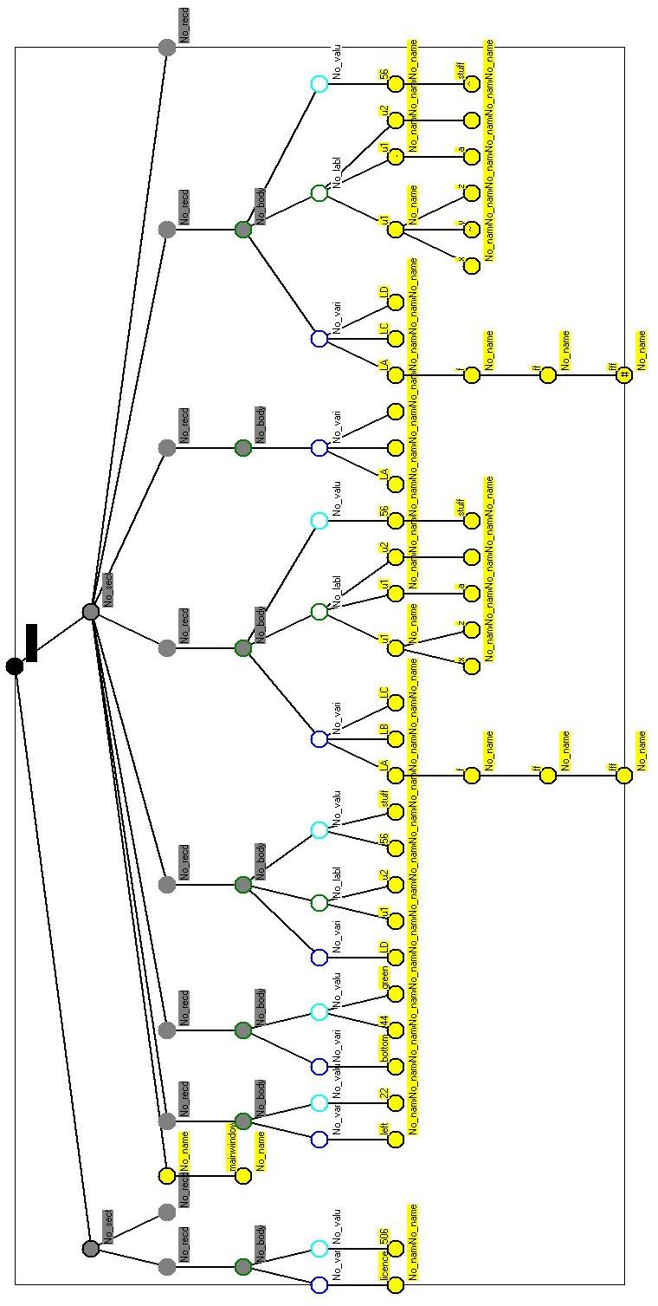
[n1,n2(*h,54)]
<weirdness>
<!weirdness(phew(No,really))>
"http://www.stuff/~thing/oink.htmx"($abc123,&564),(%01010),57e-9 = erk
this : the = body {this : an = attribute ; this : another = attribute}
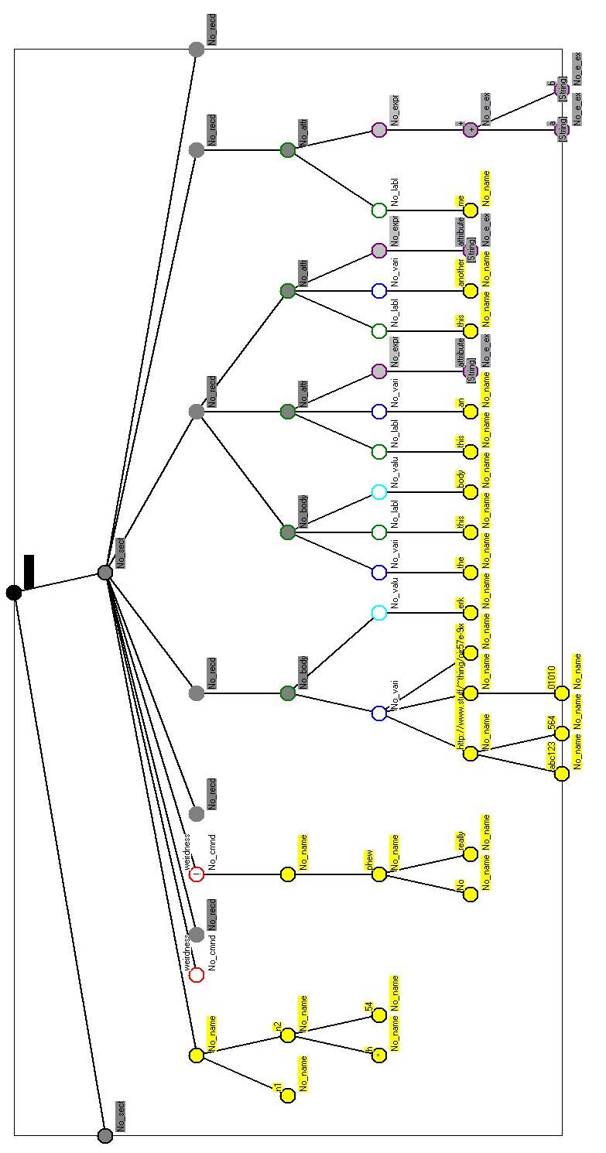
{ me = a+b }
{ you = (a^2) + (b^2) - (2*b*c*cos(alpha)) }
{ this := zonk(a,b,c) * plop(atan(b/c),$a65) }

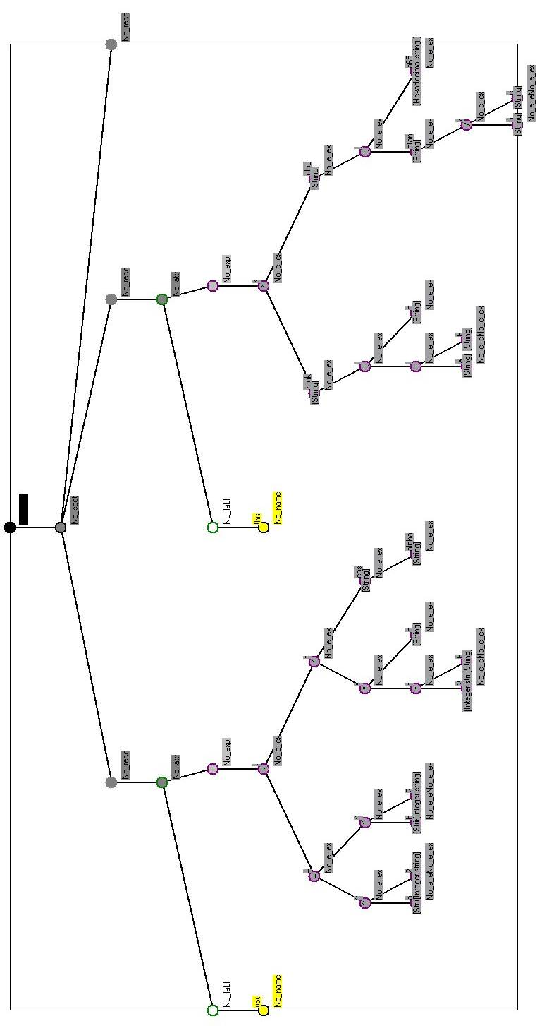
2. Language definition

UIF is an ASCII text language, consisting of an ordered set of sections contained in a file. Each section starts with a section header, and contains an ordered set of records. Just like an INI file. Blank records are significant, and every file is defined to start with a blank section (i.e. a section with an empty header). If the first physical record in the file is a section header, the blank section still exists, although it contains no records. Section headers and records may have comments associated with them.

Each record consists of an optional body part and an optional attribute part. The body part consists of three optional fields, a label field, a variable field and a value field. The attribute part consists of an ordered list of attributes enclosed in braces; each attribute consists of an optional label field, an optional variable field and an optional expression field.

In the body part, any combination of label, variable or value fields may be present or absent, for the simple reason of backwards compatibility. In the attribute part, there are restrictions on the combinations of what can be there or not. (Mainly because parsing the backwards compatibility flexibility on the body part turned out to be far more fiddly than I liked.)

A field (label, variable or value) consists of an ordered comma separated list of qualified names. A qualified name is a string, preceded by an optional operator, succeeded by an optional ordered comma separated list of qualified names in parentheses. The string may be empty, in which case no operator is permitted. A string is what you'd expect (numerics are treated as strings here), or anything at all enclosed in double quotes. There is no limit to the recursion (bracket) depth here.

An expression is what you'd expect; pretty much all the operators can be both monadic and dyadic (UIF ascribes no meaning to any of them - thus there is no concept of operator precedence). It falls out from this that inline conditionals may be supported - the parser thinks '?' and ':' are operators; if they are found in dyadic usage they will be placed in the parse tree. As with everything, it is up to the designer of the derived class - the user - to extract the semantics. Function calls are supported, with the argument separating comma being interpreted as a dyadic operator (and parsed accordingly). Brackets are interpreted as you would expect, and the parse tree reflects this.

Counter-intuitively, attributes in the attribute list are separated by semi-colons, not commas. (The perils of allowing a language to evolve: the comma in the attribute part is recognised as an operator, and so cannot be an expression separator. The body part does not support compound expressions, so the context of each symbol is unambiguous. Commas are used as separators here for backwards compatibility.)

The start of a comment in a record is indicated by a semi-colon or double forward slash (//). Anything between the comment delimiter and the corresponding end-of-record (EOR) is treated as a textual comment (and stored). Comments may not be embedded inside the attribute part.

Multiple physical records may be concatenated to form one humungous logical record; if the last character in a record is a backslash (\), the backslash will be ignored and the next record read as a continuation of the first. Continuation characters inside comments are treated as comments.

Formal syntax diagrams (used to derive the parse code) are given in section 4.

A BNF representation is below:

{ a } means zero or more “a”
[ a ] means optional “a”
a | b means “a” or “b”
Characters double underlined represent that character literal: { means the character '{'

UIF_file ::= { section } EOF

section ::= section_header { logical_record }

section_header ::= [ qualified_name { , qualified_name } ]

logical_record ::= record { \ record }

record ::= [ body_part ] [ attribute_part ]
record ::= < qualified_name >

body_part ::= [ label_field : ] [ variable_field ] [ = value_field ]

attribute_part ::= { attribute { ; attribute } }

attribute ::= [label_field :] [variable_field] [= expression_field]

label_field ::= qualified_name { , qualified_name }

varable field ::= qualified_name { , qualified_name }

value_field ::= qualified_name { , qualified_name }

qualified_name ::= [ operator ] string
qualified_name ::= qualified_name[ ( qualified_name { , qualified_name } ) ]

expression_field ::= No idea. Complicated.

name_operator ::= && | ^ | , | / | == | >= | > | # |
<= | | | | << | |\ | |/ | * | != | || | ! |
+ | £ | ? | >> | ' | - | ~ |
operator ::= name_operator | & | @ | $ | < | %
(|\ = inline minimum, |/ = inline maximum)

string ::= Ac { Ac}

Ac ::= 0..9 | a..z | A..Z

UIF is case-sensitive

2.1 Putting it all together

An example, showing pretty much everything:
;Box 1: UIF test file

; Blank section
label1 : ; Just a label
variable2 ; Just a variable
= value3 ; Just a value
label4 : variable4 ; A label and a variable
label5 : = value5 ; A label and a value
variable6 = value6 ; A variable and a value
label7 : = ; Just a label
variable8 = ; Just a variable
label9 : variable9 = ; A label and a variable
: = valueA
labelB : =

[SimpleSectionHead]
(0,1,2,3) : 00,11 = a(b(c(d))) ; A blank label with four sublabels and
; a pair of variables and a single value
; with a single subvalue and a single
; subsubvalue and a single subsubsubvalue
</DoIt> ; A command
<*DontDoIt> ; Another command
; With operators....
; Note all operators in the body are monadic
(a(!b,c),d(e,*f)) : (^00,(-11),(66,77(#88,99))) = @a,(b),((c))

[f(1)] ; Section head with a sublabel
[f,g] ; Two section heads....
[f(2),*g] ; One has an operator
[f,g(-3)]
[f(4),g(5)] ; ...and so on
[f(g(6))]
[f(g(7(8(9))))]
[f(g(h(1,2,+3(-4,*5,6,(!7,8,9(0))))),z)]
; Attributes
{a1;b1:;c1:d1;:;:e1} ; Labels and variables
{a2=11;b2:=22;c2:d2=33;:=44;:e2=55}; .... and expressions
{k=p- - - - q} ; Monadics and dyadics
{x=a+b/c} ; Labels, variables and expressions
d{k=(-8)} ; Brackets
{j=((9)+(-a--b))}
{f:3.4e-10}
{q=3.4e-10+3.2e-11}
{ic=(x)/(y^z)}
{th=((a+b))/((c))}
{a(0)=z+sin(y)} ; Function calls
{a(1)=sin(cos(x))} ; ...nested
{b(c)=cos(sin(a,b),3,tan(7))} ; ...with multiple arguments
{x:y=-sin(cos(y))-*tan(+x)}
{q:h(k,y)=-(a)*(-b+--3)}
{stuff=(2.0 ^ p_in1) < p_in1 ? (2.0 ^ p_in1) ! (p_ou1 + lg2(p_in1)*lg2(p_ou1))/2.0 }
; Bodies and attributes
s{a:j=8;b=3*7-(7+sin(97)+(22/9-j+(y==7)?9!6)-tan(76+98/(8+9^cos(66.5)*y)))}
*a(+b,-2),f(&k),-k2(~uy),SS(~1),%jj : q(&&4),g(>=c),*k3(<<3),s3(>=2) = 87,-99.2,1e4
d{k=((((((((9)-(8))/(6^7))+(((6)+a)*tt)-(p))+ooo)~5)*33.6)*77.3e5)-1}

2.2 Weirdness

UIF was originally designed to support (amongst other things) a language-independent intermediate form of VHDL, a hardware description language. One of the vagaries of VHDL is that '-' is, in certain contexts, considered to be an alphanumeric character. Thus in some situations where a name but not an expression is allowed by the VHDL grammar, "a-b" is a single token string. In other contexts, where expressions are allowed, "a-b" is treated as a three-token expression, as you might expect. To cope with this, a low-level switch is provided in the internal lexer (void Lex::SetMFlag(bool)) to allow the user to change the interpretation of the '-' character.

Slightly less weird is another low-level switch (void Lex::SetNFlag(bool)) which turns on and off the distinction between numbers and strings.

Neither of these functions are described in detail here, but they're there if you need them.

3. Object interface

Whilst the UIF code is certainly not self-documenting (a convenient, if entirely fictional, notion) it would help to have it available whilst reading this, if you really want to know how to drive it.

The method interface to the UIF class is simple, but then UIF is designed to be inherited from, so the there is little method functionality provided by the base class itself. In essence, you construct an empty object, and then add files to it. Each addition is parsed as an extension to the pre-existing contents. You can save it (in UIF format) or dump it (in a human-readable diagnostic form). To access the data, you have to either derive your own access class (the preferred method), or burgle the datastructure directly (not complicated, because everything is in one large, uniform tree).

3.1 Constructors

The UIF class has two constructors.

3.1.1 The empty constructor

UIF::UIF(void)

3.1.2 The command line constructor

This constructor provides a special way in non-standard, but incredibly useful.

UIF::UIF(int argc,char ** argv)

Parsing command line argument lists is simple if the command line is simple, and a nightmare if not. This constructor takes as input the command line arguments as passed into the main(int arg, char *argv[]) routine and parses them into a rudimentary UIF datastructure. This is nothing to do with UIF as such, it's just a convenient addition.

The argv[] strings are concatenated into one long string (with padding spaces between each string), which is then parsed according to the syntax diagram of figure 1.
;Box 2: UIF command line processor output

;C:\PlayPen\grants\Spin2\ZeDoings\Borland\Protein1.exe
;Pr1 /files = f1,f2,f99 ,, /88 2 ,,3 4,5
(0) : Pr1
[files]
files(0) : f1
files(1) : f2
files(2) : f99
files(3) :
[88]
88(0) : 2
88(1) :
88(2) : 3
88(3) : 4
88(4) : 5

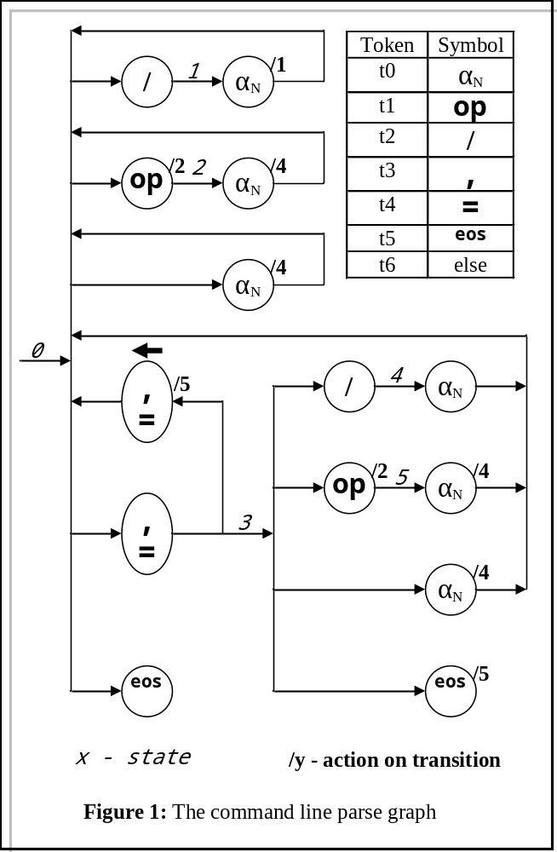
In essence, argument strings prepended with a '/' character are interpreted as section headers, everything else as records containing just one variable. Blank records can be forced by the judicious application of commas in the argument list.

For example, the command line argument list

Pr1 /files = f1,f2,f99 ,, /88 2 ,,3 4,5

will generate the UIF data in Box 2.

Note the calling program and command line itself are duplicated as comments in the UIF structure.

3.1.3 Adding files

Adding files to the object is accomplished with

void UIF::Add(string)

You might think a natural overload would be to provide a void UIF::Add(char *) as well, but if you then call Add(0) a certain compiler objects because it cannot disambiguate the two signatures. To add a char * defined filename, use

void UIF::Addx(char *)

3.2 Error handling

All error handling is provided by callback functions. UIF contains a default handler, which is basic, but this can be replaced by a user-defined callback, which can be as sophisticated as the user wishes.

3.2.1 Default error handling

If no user-defined error callback is provided, the default handler will be invoked on detection of every syntax error. On detection of a syntax error in the input file (which occurs when the input symbol stream falls off the permitted trajectory through the syntax state graphs), the UIF constructor discards all subsequent symbols until the resynchronisation character is encountered (currently EOR : '\n'). It then resets its internal state to "start of record" and continues.

For example, consider the UIF fragment

a=b
c:d=e
oink(

This will produce a dump of the last ten syntactic tokens the parser encountered before the error:

+------------------------+
UIF default error handler: id 1

(Line,Col)
( 3, 6) [End of record] <- Token (Sy_EOR [End of record]) out of sequence
( 3, 5) (
( 3, 4) oink
( 2, 6) [End of record]
( 2, 5) e
( 2, 4) =
( 2, 3) d
( 2, 2) :
( 2, 1) c
( 1, 4) [End of record]

+------------------------+

3.2.2 User-supplied error handling

The object will alternatively execute any user-supplied callback function. If the user provides a null callback, and an error is encountered, it will be recovered as described above and no indication that this has happened is given.

To register the an error handler callback, use

void UIF::SetECB(void * pThis,void(* pECB)(void *,void *,int))

The signature of the callback itself is

void fn(void * pThis,void * p,int id)

On detection of a syntax error, the callback will be invoked.

The first actual argument of the callback is the first argument supplied to the registration function.

The second argument requires some explanation: it's the address of the UIF object that invoked the callback. Why bother, you ask? Back in the day it started out as an address in the datastructure corresponding to the location of the error in the file, but it was so difficult to actually do anything with this (fighting the C++ strong typing all the way) it got relegated to this.

The third argument is supposed to be an indication of the severity of the problem, but it's always 1, because the only severity is "syntax error".

For example:

void FlatHandler(void * pThis,void * p,int id)
{
printf("FlatHandler pThis = %p, p = %p, id = %d\n",pThis,p,id);
}

//-----------------------------------------------------------------

int main(int argc, char* argv[])
{
JNJ J;
J.Add(argv[1]);
printf("Address of J = %p\n",&J);
J.SetECB((void *)0x99,FlatHandler);
J.Add(argv[1]);
return 0;
}

With the broken UIF fragment above, we get:

Address of J = 0013D690
FlatHandler pThis = 00000099, p = 0013D690, id = 1

3.3 Interrogating the object

3.3.1 Datastructure - overview

Needs pictures

3.3.2 Pretty print

The pretty print output is invoked by the method below

void UIF::Save(string="")

It provides a copy of the input, derived from the internal datastructure. If the original input is generated externally, it may differ in a few non-essential details, but a pretty-printed output should generate an exact copy of itself when fed back into UIF. (It was originally designed as a sanity-checker.) If the output file name is defaulted (i.e. set to ""), the output will be piped to stdout.

3.3.3 Diagnostic dump

The diagnostic dump routine

void UIF::Dump(string="")

Provides a human-readable snapshot of the internal datastructure of the UIF object. Primarily for debugging, it may provide some insight to the internal datastructures useful in designing any derived class. Apart from a handful of housekeeping and state variables, the entire representation of the UIF data is held in a tree of Node *, rooted on Node * UIF::UIF_root. Details are provided in section 4.

3.3.4 Callback functions

Callback functions are a very powerful concept in developing library software such as this. In essence, the user provides the address of a function (in their own program space) that the library software may call under certain pre-defined circumstances. As the callback is executed from within the scope of the library, it can access the current state of virtually anything (access permissions allowing, of course - and everything is public in UIF).

Callbacks are provided for execution on error detection (described previously), on the successful parsing of every record, on the successful parsing of every section, and on the successful parsing of every command.

The record callback registration function is

void UIF::SetRCB(void *,void(*)(void *,void *,void *))

(The final callback argument is the address of the internal node holding the record root.)

The section callback registration function is

void UIF::SetSCB(void *,void(*)(void *,void *,bool,void *))

This is called twice per section: on entry, where the bool argument is set to TRUE, and on exit, when it is FALSE. The final callback argument is the address of the internal node holding the section root.

The command callback registration function is

void UIF::SetCCB(void *,void(*)(void *,void *,void *))

Where again the final callback argument is the address of the internal node holding the command root.

3.4 Deriving classes

You pretty much have to derive a class from UIF; the alternative is to burgle the datastructures directly. While there's nothing wrong with that, if you're going to do it anyway you may as well encapsulate your interrogation in a derived class and be done with it.

3.4.1 The JNJ class

The UIF class provides a parser to create a datastructure, but aside from the callbacks, very little in the way of intelligently interrogating the information.

The JNJ class started out as 'just one example' of how to derive a class from UIF, but has become the de facto way of using it. It provides a coherent way of moving around the syntax tree, allowing the user to issue structured queries of the form "Give me all the variable fields that have a label 'xyz'", and so on.

It's also going to require far more diagrams than I have time for at the moment.

4. Internals

Whilst the source code is useful for understanding the previous sections, it is essential and assumed available for the following.

4.1 Language grammar

The syntax diagrams for UIF are given in figures 2..5. The code that supports the parsing is broken down into four methods, each one corresponding to one of the figures. Each method follows a standard template (not in the C++ sense) outlined below, built around a state transition matrix:

UIF::...
{
Initialise:
cb.err_cb = Ecb; ...

Declare and initialise the number of symbol tokens necessary:
enum loctok {t0=0,t1,t2,t3,t4,t5,t6,t7,t8,t9,t10,t11,t12} toktyp;

Declare and initialise the state transition table:
{{{1, 3},{1, 3},{X, X},...1, 3},{X, X},{R, 0}}, // 0

Loop:
for(int state=0;;) { ...

Pull in the next lexical token
Lx.GetTok(Td);

Execute any state entry actions
switch (state) { // Pre-transition (entry) actions
case 0 : RCB()...

Map the lexical token onto the appropriate matrix column
switch (Td.t) { // Map to array index
case Lex::Sy_col : toktyp = t2; break;

Extract from the table the next state and any action code
next = table[state][toktyp]; // Make the transition

Execute the action code
switch (next.ac) { // Post-transition (exit) actions
case 0 : break;
case X : problem = true; break;
case 1 : Lx.push_back();...

Update the state, leave or loop
if ((state=next.ns) == R) break; // Legit exit - we're done

Error recovery
if ((state==X)||(problem==true)) { // Error handler triggered
problem = false;...

The top level parse graph is given in figure 2:

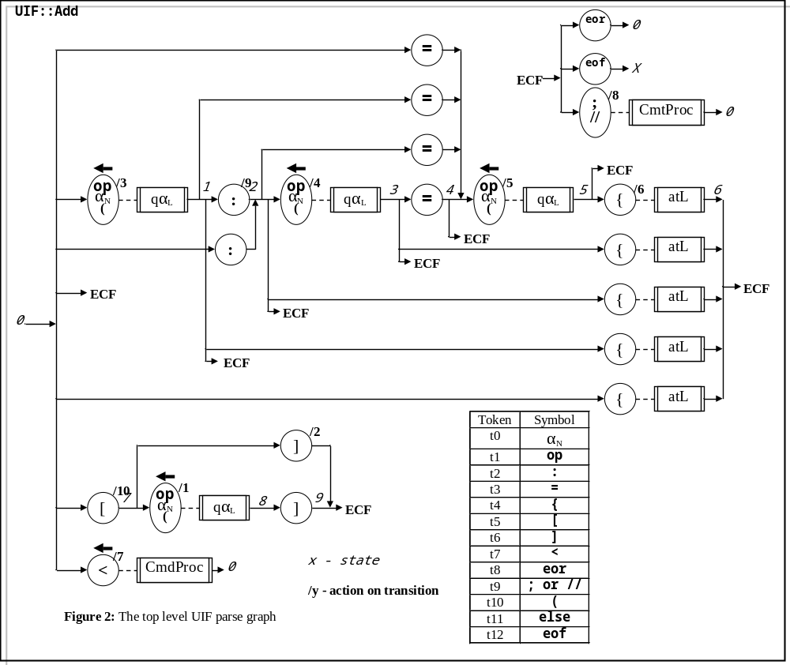

The attribute list parse graph is given in figure 3; it is handled by the function void UIF::pAtl()

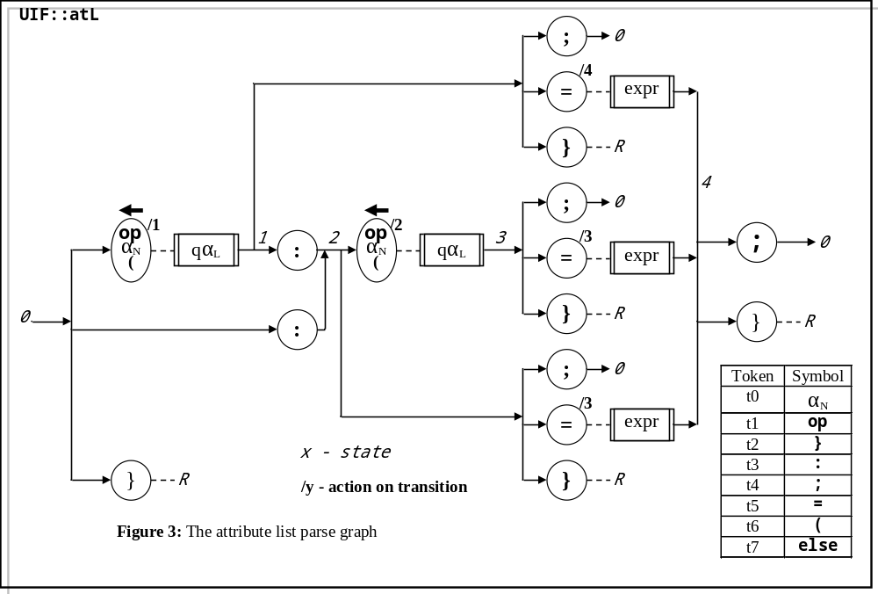

The expression parse graph is given in figure 4; it is handled by void UIF::Expr()
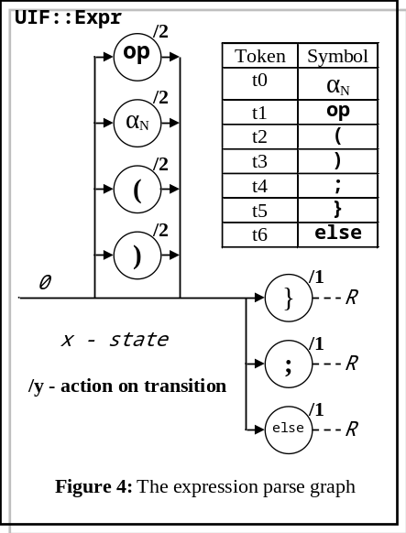

The qualified name parse graph is given in figure 5; this is handled by void UIF::pQal()

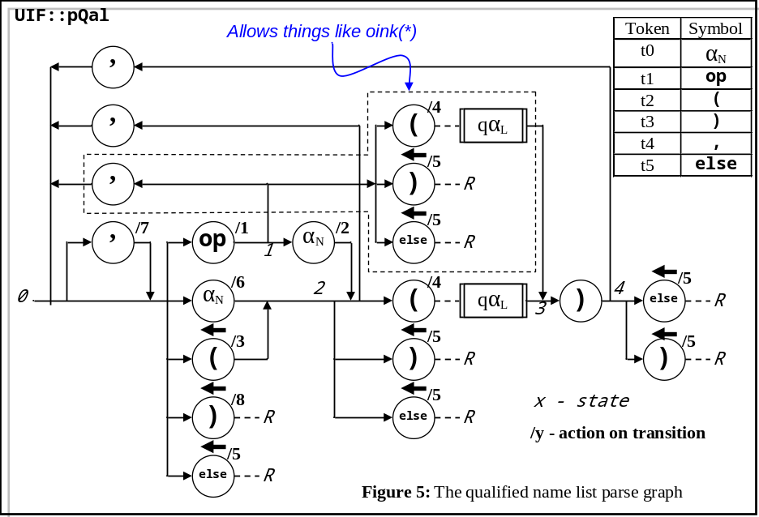
4.1.1 The comment bodge
The syntax is free format, in that the actual position of the syntactic elements is ignored by the parser. When the pretty printer outputs the text, it makes up the layout for itself. However, experience has shown that while this is OK in general, a lot of usage has comments laid out specifically to aid clarity, and the pretty printer destroys this by left justifying them all. The actual positions of all the syntactic elements in the original file are stored in the datastructure (but are not used by the pretty printer, because it's not really necessary) except the location of the start of the comments. Pure cockup on my part. The only place I could find to store them in the datastructure (without including another node, which, with hindsight, might have been a better solution) is this:

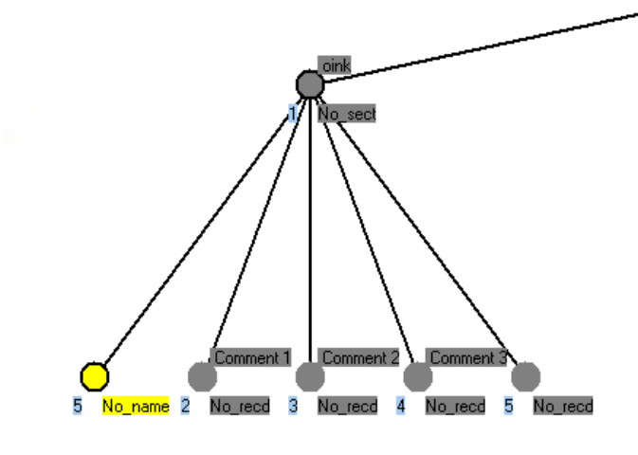
A comment on the same line as a section header:
[] // oink
// Comment 1
// Comment 2
// Comment 3
The comment text is in the section header .str field, the column address in the .pos field of the header section name node - even if there is no section name explicitly supplied.

A comment in a record:
The comment text is in the record header .str field, the column address is in the .pos field of the record body node.

A comment in a command:
The command string is in the command .str field, so there is no place to put the comment. To get round this, there is created immediately after the command node a record node (i.e. of type No_recd) containing the comment.
<weirdness> // Comment A
<!weirdness(phew(No,really))> // Comment B
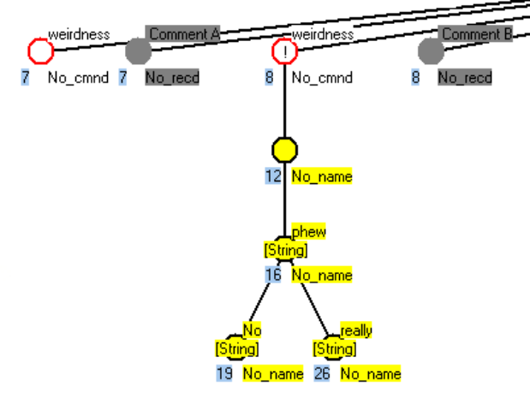
4.1.2 Expressions
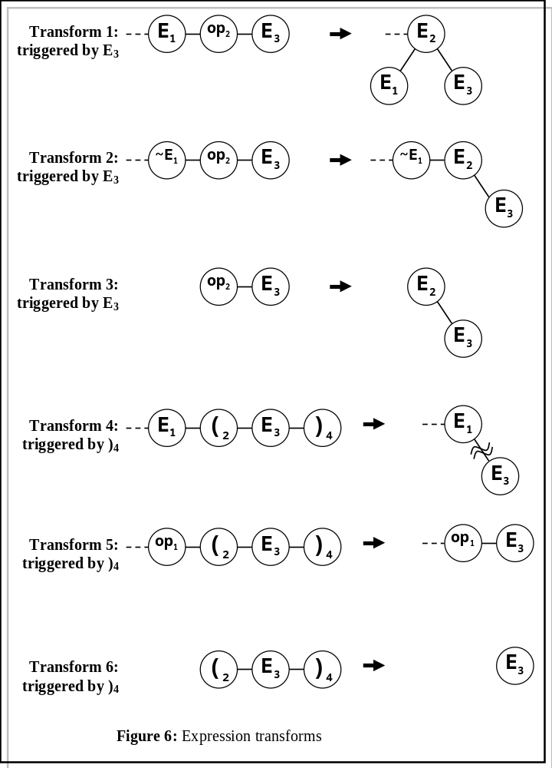
Expressions are handled slightly differently from the rest of the syntax. The method UIF::Expr() processes the expression according to the syntax graph of figure 4, but the only real functionality the graph provides is the recognition of the end of the expression. Most of the work is done by the method Collapse(). UIF::Expr() contains a local vector of Node *. Each time a lexical token is processed, a new Node is attached to the end of the vector. This (the vector) is then handed into the Collapse() method, which applies a set of transforms to the vector. The transforms interact, and sometimes some enable others, so Collapse() applies them all in an infinite loop that only terminates when it has attempted to apply all the transforms with no success after the last successful transformation. At the end of this process, all the token nodes should have been collapsed into a binary tree, and the local vector should contain exactly one element, the root of the expression tree. The most usual cause of this not being the case is mismatched parentheses somewhere.

The detection of a lexical token corresponding to an expression (i.e. a string) triggers the putative application of transforms 1, 2 and 3. The detection of ')' causes 3, 4 and 5 to be triggered.

Transform 1: If the end of the vector contains the sequence E₁-op₂-E₃, transform 1 will be applied. This removes E₁ and E₃ from the vector, and attaches them as L and R children of op₂, which is itself relabelled as an expression - here E₂. (Thus the node type of E₂ will be No_e_ex, although the .qop field will contain a Lexer operator symbol.)

Transform 2: If the end of the vector contains the sequence ~E₁-op₂-E₃, (i.e. anything that's not an expression followed by op₂-E₃), transform 2 will be applied. This removes E₃ from the end of the vector, and attaches it as the R child of op₂, which is itself relabelled as an expression - here E₂. ~E₁ is left in situ.

Transform 3: A corner case: It is the same transform as transform 2, adapted to cope with op₂-E₃ being the first tokens in the vector.

Transform 4: If the end of the vector contains the sequence E₁-(₂-E₃-)₄, transform 4 will be applied. This removes the parentheses from the vector and discards them, and then removes E₃ from the vector, and attaches it as the right-most R child of any tree that may be attached to E₁. This supports function calls. Its application may, of course, change the makeup of the end of the vector to allow some of the earlier transforms to become applicable.

Transform 5: If the end of the vector contains the sequence op₁-(₂-E₃-)₄, transform 5 will be applied. This simply removes redundant parentheses (which may arise as a consequence of other transforms or direct user input) from the vector and discards them.

Transform 6: Corner case version of transform 5.

Recall that UIF does not recognise -- and ++ as unary operators. (Easily done, if there's user-pull?)

On successful conclusion, the expression will have been reduced to a single, binary tree of nodes. All the node types will be No_e_ex. The leaves of the tree will contain Lexer strings, which should be interpreted as variables or constants. The non-leaves will contain operators or Lexer strings. Operators here can include ',', but this is only used to indicate separation of function arguments. If a Lexer string appears as a non-terminal, it represents a function call. 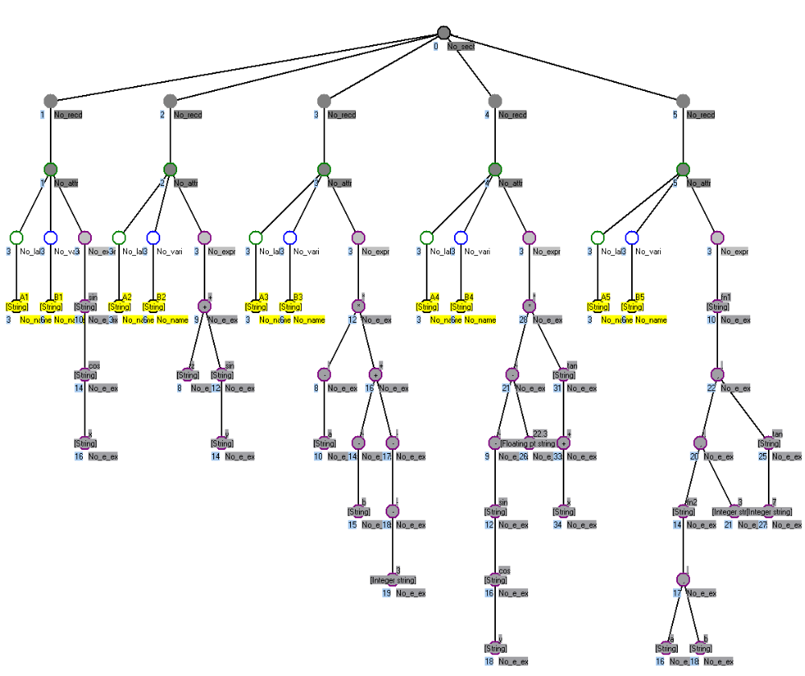The dyadic operators '?' and ':' can appear (syntactically) in any number and any order - as with everything in UIF, it is up to the user to untangle these and extract the semantics.
{A1:B1=sin(cos(x))}
{A2:B2=z+sin(y)}
{A3:B3=-(a)*(-b+--3)}
{A4:B4=(-sin(cos(y))-(22.3)*tan(+x))}
{A5:B5=fn1(fn2(a,b),3,tan(7))}

4.2 Data structure

Aside from a few housekeeping variables, the datastructure is a simple n-ary tree structure of type Node, which is a subclass of UIF:

Notype typ; // Node type
Lex::Sytype qop; // Node operator (!= UIF type)
string str; // Node string
int pos; // Location in file
vector <Node *> leaf; // Children

UIF::Notype UIF::Node::typ
The node type field. This is an enumerated type, defined in UIF (just to save typing). The types and their meanings are laid out below:

No_0000 is the null node, only used for the tree root.

No_sect, No_recd, No_cmnt, No_body, No_attr, No_labl, No_vari, No_valu, No_name and No_expr are pretty obvious - refer to figure 7.

No_e_ex (expression), No_e_op (operator), No_e_LB (left bracket) and No_e_RB (right bracket) refer to the types of nodes created and manipulated during the parsing of expressions. Unlike the symbol types in the parser, they are not constant for a given token.
The expression parser builds - and hands to the routine Collapse() - a daisy-chain of symbol tokens. After each token is added is added to the chain, Collapse() is called on the daisy-chain, to see if it can be collapsed in any way by one of the six transforms embodied in t123() or t456(). (There is no sinister reason why these are separate; it's just that 1, 2 and 3 are related and so are 4, 5 and 6. Collapse() applies these transform continuously until nothing further happens (some transforms enable others.)
As the daisy-chain is built, it consists of a mixture of each of these four types. During the collapsing transforms, the types of each node can (will) change dynamically, so that at the end of parsing and collapsing, the token daisy-chain (of various types of node) will have been transformed into a binary tree consisting solely of No_e_ex nodes.

No_XXXX is the end-of-enumeration element. (It is good programming practise to terminate an enumerated type list with an element that is never used. It enables the declaration of arrays indexed on the enumerated type - for example

static const char * Notype_str[No_XXXX+1];

to remain unchanged when extra (meaningful) elements are added to the list.

Lex::Sytype UIF::Node::qop
This holds the token type, as generated directly by the lexer. Note that the parser and the Node do not share a common view of what constitutes an operator, because it changes depending on whether we're in the body or the attribute section of a record. But then that's what happens when you let a bunch of other folk define a language.

string UIF::Node::str
Holds the actual character string representing the symbol.

int UIF::Node::pos
A single integer, holding the generating file map. In a section or record node, .pos holds the line number in the originating file that defined the section or record. In all other nodes, .pos holds the column number

vector <Node *> UIF::Node::leaf
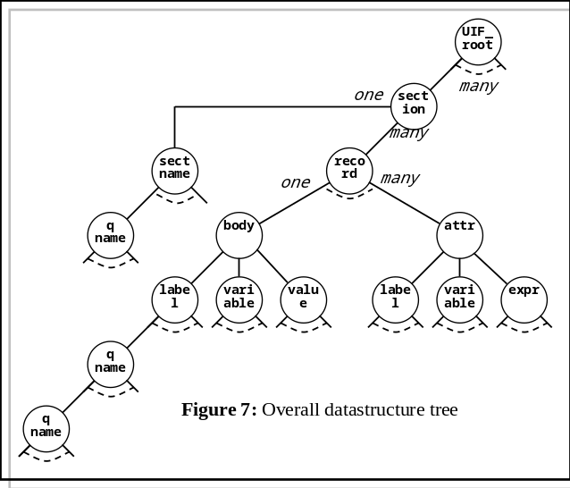A vector holding pointers to the child nodes. Note that it is entirely possible - under rather bizarre circumstances, which really ought to be tracked down, put up against a wall and shot - for these pointers to exist, but be null. Don't ask. Thus code interrogating this vector should be tolerant of this.

Any sequence of decimal digits containing one '.'; exponent notation ('e|E') is allowed.
Any sequence of binary starting with '%'.
Any sequence of octal digits starting with '&'.
Any sequence of hexadecimal digits (not case-sensitive) starting with '$'.

