Command line interpreter class

Ver 0.1 | 9 August 2017

Andrew Brown

1. Introduction

2. Usage
2.1 Input string
2.2 Data structure

3. Error handling

4. Formal syntax

5. Cli::Dump

6. Class methods
1. Introduction

Cli is a simple class, designed to take a single std::string input, and parse out a simple command from a pre-defined syntax. It has no error recovery, just a single point of notification before a premature exit. The data structures are all public, and designed to be burgled.

2. Usage

Cli uses the tokeniser Lex to interpret the symbols in the input string.

2.1 Input string

The input string to the class is assumed to be of the form

command [/clause = [[op]₁param,]_{n} [op]₁param]_{n}

this /thing = stuff,97.2 /that = ionk,whiffle,-jjj,+ggg
a /zing=zong /biff=baff /urk

will be interpreted as you would expect.

Commands and clauses must be alphanumeric strings, parameters may be strings or numeric literals. The (monadic) operators are defined in the Lex class.

Weirdness:
To allow wildcards in the parameter lists, we want to be able to write things like

system /ping = *

This would be parsed au natural as (command) (clause) (operator) (empty string), which is of little use. If Cli encounters an operator not followed by a string or number, the operator itself will be promoted to a single character string literal: thus the above is actually parsed as (command="system") (clause="ping") (null operator) (single character string="*").

2.2 Data structure

The Cli datastructure is shown in figure 1. Note the use of string literals, rather than pointers; the class is intended to be small in conventional use.
string Op
string Val
vector<Pa_t> Pa_v
vector<Cl_t> Cl_v
Cli
Pa_t
Cl_t
string Cl
string Co
Parameter operator

Parameter name

Vector of parameters (NOT pointers)

Clause name

Vector of clauses (NOT pointers)

Command name
Figure 1: Cli datastructure

3. Error handling

If the input string does not conform to the expected syntax, the constructor will exit prematurely - there is no attempt at recovery or diagnosis.
Calling Cli::Err() immediately after the constructor will indicate whether or not the string was successfully interpreted. A return value of TRUE indicates a problem; the reference arguments will provide an approximate location of the problem token within the string.

4. Formal syntax

The syntax state transition graph for the syntax parser is given in figure 2. Tokens t4 or t6 from any state will end processing.
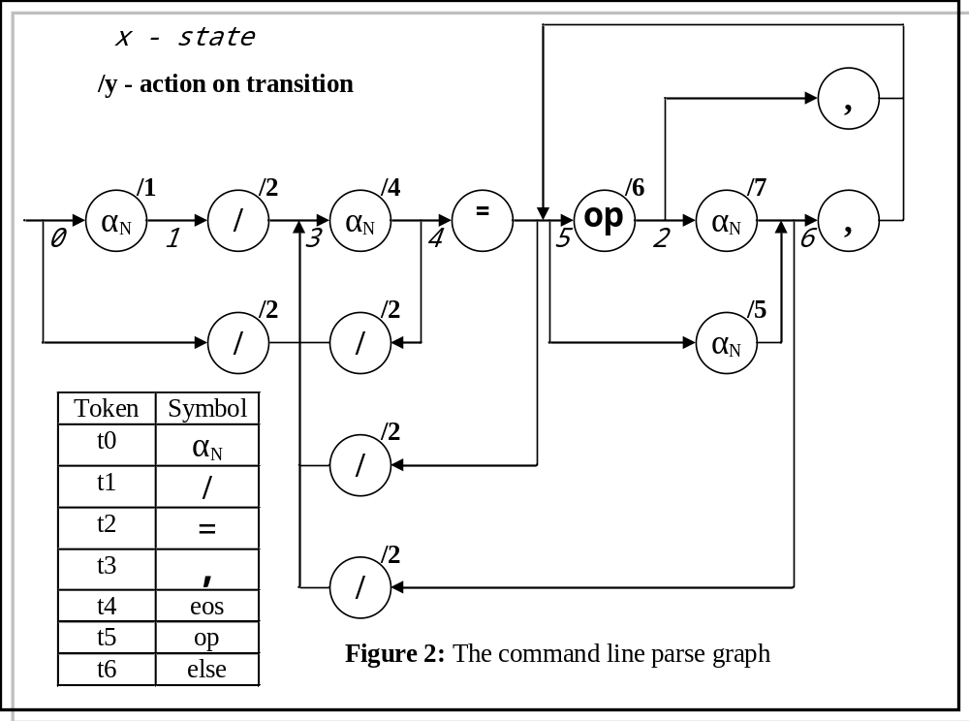

5. Cli::Dump

A pretty-print of the object datastructure state on processing the command

zing /stop = *25 , /start=again , think

is given below.

Cli dump+++++++++++++++++++++++++++++++++++++++++
Problem : FALSE
Orig = ||zing /stop = *25 , /start=again , think||
Co = ||zing||
Cl[0] = ||stop||
Pa_v[0] = ||*||25||
Cl[1] = ||start||
Pa_v[0] = ||||again||
Pa_v[1] = ||||think||
Cli dump-----------------------------------------

6. Class methods

Cli(string);
Constructor from string containing command.

virtual ~ Cli(void);
Uninteresting destructor.

void Dump(FILE * = stdout);
Produces pretty-print of data structure.

bool Err(int & row,int & col);
Returns TRUE if there is a problem (syntax failure), FALSE otherwise. If a problem has been detected, col contains the location in the string where the token that caused the error lies. Row is always 1 because I forgot to take it out.

void Fixup();
Forces the (operator)(empty string) promotion discussed earlier.

static bool StrEq(string,string,unsigned=4);
String equality test: this truncates the input strings to some length (default 4 characters), forces them all to lower case, and then tests for string equality. The original strings are not changed.

void Trim(unsigned=4);
Acts on the command name and all the clause names (but NOT the parameters).
They are trimmed to length, then forced to lower case. Note the weirdness: if you resize a string length 3 to 4 with padding nulls, you get a string where str.size() == 4, but strlen(str.c_str()) == 3.
So if you use this on input strings smaller than the trim length, be careful what you do with the answers.

