NameBase class

Ver 0.1 | 21 April 2009
Ver 0.2 | 6 September 2017

Andrew Brown

1. Introduction

2. Usage

3. Class methods

4. Things to do

1. Introduction

Names are expensive things to propagate, especially in a large system with a complicated hierarchical data structure, where fragments of a full name may be widely distributed throughout the system. NameBase provides a simple way to attach fragments of a name to different parts of a hierarchy, so that each fragment may be set/unset easily, and also the full symbolic name may be assembled and exported quickly and easily.

2. Usage

NameBase is intended to be used as a base class for everything in a datastructure that needs a name. It allows you to
● Read/write a string name for a class hierarchy, as you would expect.
● Associate with each instance an unsigned int identifier, alongside the string name.
● The entire set of instances can be searched quickly on the identifier.
● Retrieve the full hierarchical name of an entity as a string in a variety (8) of formats.

Attempts to create recursive names are detected and blocked, because if I didn't provide that capability some prat is bound to try it and then blame me for the carnage.

Figure 1 shows a fragment of a large and arbitrary data structure. The three classes C1, C2 and C3 are all derived from NameBase. When the constructor for, say, C2 is called, it is supplied with the name substring (here "XYZ" and a pointer to its parent (here the object C1). Interrogating C2 about its name with return "A.XYZ".
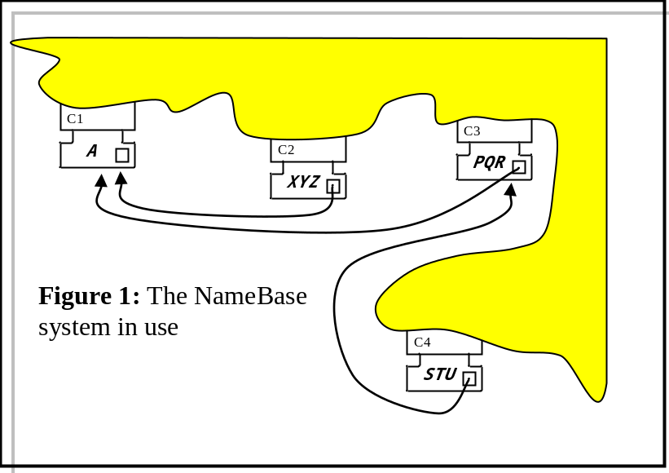

The program fragment below illustrates the example of figure 1, and the formatting capabilities for the full name generation.
NameBase * C1 = new NameBase();
NameBase * C2 = new NameBase();
NameBase * C3 = new NameBase();
NameBase * C4 = new NameBase();

C1->Name("A");
C2->Name("XYZ");
C3->Name("PQR");
C4->Name("STU");

C2->Par(C1);
C3->Par(C1);
C4->Par(C3);

C1->Id(1001);
C2->Id(1002);
C3->Id(1003);
C4->Id(1004);

printf("%s\n",C1->FullName(5).c_str());
printf("%s\n",C2->FullName(5).c_str());
printf("%s\n",C3->FullName(5).c_str());
printf("%s\n",C4->FullName(5).c_str());

printf("%s\n",C2->FullName(0).c_str());
printf("%s\n",C2->FullName(1).c_str());
printf("%s\n",C2->FullName(2).c_str());
printf("%s\n",C2->FullName(3).c_str());
printf("%s\n",C2->FullName(4).c_str());
printf("%s\n",C2->FullName(5).c_str());
printf("%s\n",C2->FullName(6).c_str());
printf("%s\n",C2->FullName(7).c_str());

C2->Dump();

will produce

A(0000001001)
XYZ(0000001002).A(0000001001)
PQR(0000001003).A(0000001001)
STU(0000001004).PQR(0000001003).A(0000001001)
.
XYZ.A
(0x000003ea).(0x000003e9)
XYZ(0x000003ea).A(0x000003e9)
(0000001002).(0000001001)
XYZ(0000001002).A(0000001001)
(0x000003ea=0000001002).(0x000003e9=0000001001)
XYZ(0x000003ea=0000001002).A(0x000003e9=0000001001)
NameBase dump+++++++++++++++++++++++++++++++
this 01FF3430
Name XYZ
Id 1002(0x000003ea)
Parent 01FF33FC
Recursion trap Unset
NameBase id Name
1001 : A(0x000003e9=0000001001)
1002 : XYZ(0x000003ea=0000001002).A(0x000003e9=0000001001)
1003 : PQR(0x000003eb=0000001003).A(0x000003e9=0000001001)
1004 : STU(0x000003ec=0000001004).PQR(0x000003eb=0000001003).A(0x000003e9=0000001001)
NameBase dump-------------------------------

3. Class methods

NameBase();
Uninteresting constructor.

virtual ~ NameBase();
Uninteresting destructor.

void Dump(FILE * = stdout);
Produces pretty-print of data structure.

static NameBase * Find(unsigned);
Interrogates a static map to locate the object containing the given id. Returns 0 if not found.

string FullName(unsigned =1);
Returns a string containing the full hierarchical name of the object, decorated according to the argument:
0 - none - bit pointless asking, really
1 - string
2 - hex id
3 - string + hex id
4 - dec id
5 - string + dec id
6 - hex id + dec id
7 - string + hex id + dec id

unsigned Id();
Return the unsigned id.

void Id(unsigned);
Assert the id, and load into the NameBase static map.

string Name();
Return the local short name.

void Name(string);
Assert the local short name.

NameBase * Par();
Return the parent object.

void Par(NameBase *);
Assert the parent object.

unsigned Uid();
Access a static variable and return a unique unsigned identifier. (Unique only if all the identifiers have been obtained from here.)

4. Things to do:

● Put another static map in so that you can search on local short name as well as identifier.
● Change Uid() so it really does return a unique id across the set of NameBase instances.

