Universal Interface Format (UIF)

Language definition
Object interface
Internals

V 1.3.1

11 June 2008

1. Preamble

2. Language definition
2.1 Putting it all together

3. Object interface
3.1 Constructors
3.1.1 The empty constructor
3.1.2 The file constructor
3.1.3 The command line constructor
3.2 Error handling
3.2.1 Internal error handling
3.2.2 User-supplied error handling
3.3 Interrogating the object
3.3.1 Pretty print
3.3.2 Diagnostic dump
3.3.3 Callback functions
3.3.4 Deriving classes
3.3.5 Example - an Ini_Manager

4. Internals
4.1 Language grammar
4.1.1 The comment bodge
4.1.2 Expressions
4.2 Data structure

1. Preamble

The UIF is nothing more than a reasonably convenient way of storing strings and symbols in a reasonably convenient manner. It is technically a language, but an extremely simple one - think of a sophisticated scanf() capability.

The philosophy is that the .UIF file is a persistent form of a UIF object, that just happens to be laid out in a human-readable form. Thus you can write a UIF file by whatever means you choose and create the corresponding datastructure with a UIF constructor, or you can create an empty UIF object, load the datastructure from within your application, and save it with the class methods provided.

UIF started life as an INI file manager, providing little more than a .INI file parser. Diverse projects over the years have found this to be 'not quite sufficient', and led to the development of probably a dozen silly little formats, all similar in many respects and varying in slight degrees; each, of course, comes with its own parser and uniquely different set of bugs and shortcomings. UIF is an attempt to unify all this, and build an INI superset that is capable of supporting (most of) what most people seem to need. It does not contain the sophistication, power of flexibility of a hardware or software high level language. Think of a .INI file or free-format assembly language with expressions.

In general, the language is probably too flexible: any attempt to use every capability at every point will result in source text that is incomprehensible (think LISP, EDIF). The idea is to pick the subset you want, and then build a derived class from the UIF class that allows you to interface comfortably with the bits you want. UIF enforces a syntax, but has no semantics. It knows what a string is (virtually any numeric or alphanumeric), it knows what an operator is (virtually anything traditionally thought of as an operator in any language), and it enforces a (very unrestricted) way in which these can appear with respect to each other. It has no keywords, and knows nothing about any relationships between strings and operators. It knows nothing about what any operator means (as far as UIF is concerned, they don't mean anything anyway). It is up to you to overlay these meanings (and enforce them) in your derived class.

It follows from this that UIF is by no means idiot-proof. UIF is designed to be used as a base class and creating a derivation from it requires a reasonable knowledge of what you're doing. The internal structures are reasonably robust - it's hard to fall off a dangling pointer using the code provided but the internals are mainly public. You can break it if you must.
2. Language definition

UIF is an ASCII text language, consisting of an ordered set of sections contained in a file. Each section starts with a section header, and contains an ordered set of records. Just like an INI file. Blank records are significant, and every file is defined to start with a blank section (i.e. a section with an empty header). If the first physical record in the file is a section header, the blank section still exists, although it contains no records. Section headers and records may have comments associated with them.

Each record consists of an optional body part and an optional attribute part. The body part consists of three optional fields, a label field, a variable field and a value field. The attribute part consists of an ordered list of attributes enclosed in braces; each attribute consists of an optional label field, an optional variable field and an optional expression field.

In the body part, any combination of label, variable or value fields may be present or absent, for the simple reason of backwards compatibility. In the attribute part, there are restrictions on the combinations of what can be there or not. Mainly because parsing the simple constraint on the body part turned out to be far more fiddly than I liked.

A field (label, variable or value) consists of an ordered comma separated list of qualified names. A qualified name is a string, preceded by an optional operator, succeeded by an optional ordered comma separated list of qualified names in parentheses. The string may be empty, in which case no operator is permitted. A string is what you'd expect (numerics are treated as strings here), or anything at all enclosed in double quotes. There is no limit to the recursion depth here.

An expression is what you'd expect; pretty much all the operators can be both monadic and dyadic (UIF ascribes no meaning to any of them - thus there is no concept of operator precedence). It falls out from this that inline conditionals may be supported - the parser thinks '?' and ':' are operators; if they are found in dyadic usage they will be placed in the parse tree. As with everything, it is up to the designer of the derived class - the user - to extract the semantics. Function calls are supported, with the argument separating comma being interpreted as a dyadic operator (and parsed accordingly). Brackets are interpreted as you would expect, and the parse tree reflects this.

Counter-intuitively, attributes in the attribute list are separated by semi-colons, not commas. (The perils of allowing a language to evolve: the comma in the attribute part is recognised as an operator, and so cannot be an expression separator. The body part does not support compound expressions, so the context of each symbol is unambiguous. Commas are used as separators here for backwards compatibility.)

The start of a comment in a record is indicated by a semi-colon. Anything between the semicolon and the corresponding end-of-record (EOR) is treated as a textual comment (and stored). Comments may not be embedded inside the attribute part.

Multiple physical records may be concatenated to form one humungous logical record; if the last character in a record is a backslash, the backslash will be ignored and the next record read as a continuation of the first.

Continuation characters inside comments are treated as comments.

Formal syntax diagrams (used to derive the parse code) are given in section 4.

A BNF representation is below:

{ a } means zero or more “a”
[ a ] means optional “a”
a | b means “a” or “b”

UIF_file ::= empty_section { section } EOF // empty section + 0 or more sections
section ::= section_header { logical_record } // each section must have a section header ?
section_header ::= [ qualified_name { , qualified_name } ] // I think I got this one right
logical_record ::= record { \ record } // this makes concatenating records allowed
record ::= [ body_part ] [ attribute_part ] // a record can be empty..
body_part ::= [ label_field : ] [ variable_field ] [ = value_field ] // must have “:” and “=” ? can be empty
attribute_part ::= { attribute { ; attribute } } // a semi- colon separated list of attributes
attribute ::= [ label_field : ] [ variable_field ] [ = expression_field ] // must have “:” and “=” ? can be empty
label_field = variable_field = value_field ::= qualified_name { , qualified_name } // I think !
qualified_name ::= [ operator ] string // can a qualified name be inside parentheses?
| qualified_name [ ( qualified_name { , qualified_name } ) ]
expression_field ::= not clearly defined.. is it just one qualified name? Or a list of names (separated or not?)
operator ::= anything.. // are parentheses treated as operators anywhere? My guess is no!
string ::= anything..
empty_section ::= what does it mean?

2.1 Putting it all together

An example, showing pretty much everything:
;Box 1: UIF test file

; Blank section
label1 : ; Just a label
variable2 ; Just a variable
= value3 ; Just a value
label4 : variable4 ; A label and a variable
label5 : = value5 ; A label and a value
variable6 = value6 ; A variable and a value
label7 : = ; Just a label
variable8 = ; Just a variable
label9 : variable9 = ; A label and a variable

[SimpleSectionHead]
; A blank label with four sublabels and
; a pair of variables and a single value
; with a single subvalue and a single
(0,1,2,3) : 00,11 = a(b(c(d))) ; subsubvalue and a single subsubsubvalue

; With operators....
; Note all operators in the body are monadic
(a(!b,c),d(e,*f)) : (^00,(-11),(66,77(#88,99))) = @a,(b),((c))

[f(1)] ; Section head with a sublabel
[f,g] ; Two section heads....
[f(2),*g] ; One has an operator
[f,g(-3)]
[f(4),g(5)] ; ...and so on
[f(g(6))]
[f(g(7(8(9))))]
[f(g(h(1,2,+3(-4,*5,6,(!7,8,9(0))))),z)]
; Attributes
{a1;b1:;c1:d1;:;:e1} ; Labels and variables
{a2=11;b2:=22;c2:d2=33;:=44;:e2=55}; .... and expressions
{k=p- - - - q} ; Monadics and dyadics
{x=a+b/c} ; Labels, variables and expressions
d{k=(-8)} ; Brackets
{j=((9)+(-a--b))}
{f:3.4e-10}
{q=3.4e-10+3.2e-11}
{ic=(x)/(y^z)}
{th=((a+b))/((c))}
{a(0)=z+sin(y)} ; Function calls
{a(1)=sin(cos(x))} ; ...nested
{b(c)=cos(sin(a,b),3,tan(7))} ; ...with multiple arguments
{x:y=-sin(cos(y))-*tan(+x)}
{q:h(k:y)=-(a)*(-b+--3)}
{stuff=(2.0 ^ p_in1) < p_in1 ? (2.0 ^ p_in1) ! (p_ou1 + lg2(p_in1)*lg2(p_ou1))/2.0 }
; Bodies and attributes
s{a:j=8;b=3*7-(7+sin(97)+(22/9-j+(y==7)?9!6)-tan(76+98/(8+9^cos(66.5)*y)))}
*a(+b:-2),f(:&k),-k2(uy:),SS(:),%jj : q(w:4),g(:c),*k3(3:),s3(:) = 87,-99.2,1e4
d{k=((((((((9)-(8))/(6^7))+(((6)+a)*tt)-(p))+ooo)~5)*33.6)*77.3e5)-1}

3. Object interface

Whilst the UIF code is certainly not self-documenting (a convenient, if entirely fictional, notion) it would help to have it available whilst reading this.

The method interface to the UIF class is simple, but then UIF is designed to be inherited from, so the there is little method functionality provided by the base class itself. In essence, you can construct the object, (either as an empty vessel, from a file, or from a command-line string), and you can save it (in UIF format) or dump it (in a human-readable diagnostic form). To access the data, you have to either derive your own access class (the preferred method), or burgle the datastructure directly (not complicated, because everything is in one large, uniform tree).

3.1 Constructors

The UIF class has three constructors.

3.1.1 The empty constructor

UIF::UIF(void (* Ecb)(void *)=0,void (* Rcb)(void *)=0,void (* Scb)(void *)=0)

Takes no arguments aside from the callback functions which are described later.

3.1.2 The file constructor

UIF::UIF(char * File,void (* Ecb)(void *)=0,void (* Rbc)(void *)=0,void (* Scb)(void *)=0)

Aside from the callbacks, it takes one argument, the file containing the UIF text that will be parsed to build the datastructure.

[To do:
(1) Create a UIF(string...) constructor that takes input from a string (or STL rope).
(2) Create an append function that allows multiple UIF files to be concatenated into one datastructure]

3.1.3 The command line constructor

UIF::UIF(int argc,char ** argv)

Parsing command line argument lists is simple if the command line is simple, and a nightmare if not. This constructor takes as input the command line arguments as passed into the main(int arg, char *argv[]) routine and parses them into a rudimentary UIF datastructure. This is nothing to do with UIF as such, it's just a convenient addition.

The argv[] strings are concatenated into one long string (with padding spaces between each string), which is then parsed according to the syntax diagram of figure 1.

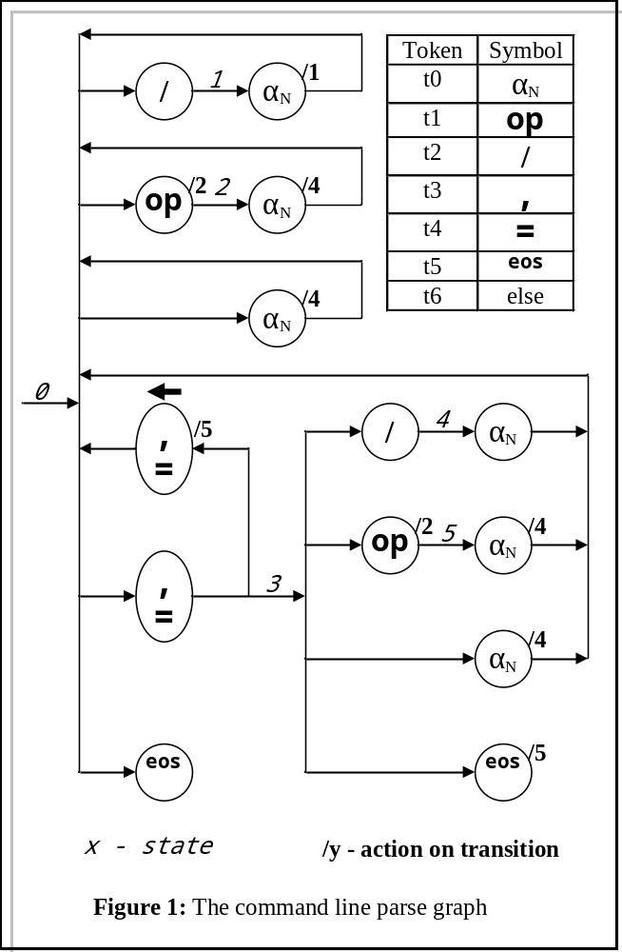

In essence, argument strings prepended with a '/' character are interpreted as section headers, everything else as records containing just one variable. Blank records can be forced by the judicious application of commas in the argument list. The command line argument list

Pr1 /files = f1,f2,f99 ,, /88 2 ,,3 4,5

will generate the UIF data below.
;Box 2: UIF command line processor output

;C:\PlayPen\grants\Spin2\ZeDoings\Borland\Protein1.exe
;Pr1 /files = f1,f2,f99 ,, /88 2 ,,3 4,5
(0) : Pr1
[files]
files(0) : f1
files(1) : f2
files(2) : f99
files(3) :
[88]
88(0) : 2
88(1) :
88(2) : 3
88(3) : 4
88(4) : 5

Note the calling program and command line itself are duplicated as comments in the UIF structure

3.2 Error handling

There are two layers to error handling: that provided by the UIF object, which is basic, and that provided by the user, which can be as sophisticated as the user wishes.

3.2.1 Internal error handling

On detection of a syntax error in the input file (which occurs when the input symbol stream falls off the permitted trajectory through the syntax state graphs), the UIF constructor discards all subsequent symbols until the resynchronisation character is encountered (currently EOR : '\n'). It then resets its internal state to "start of record" and continues.

3.2.2 User-supplied error handling

The constructor will also call any user-supplied callback function. If the user has not provided an error callback, and an error is encountered, it will be recovered as described above and no indication that this has happened is given.

3.3 Interrogating the object

3.3.1 Pretty print

The pretty print output is invoked by the method below

void UIF::Save(string="")

It provides a copy of the input, derived from the internal datastructure. If the original input is generated externally, it may differ in a few non-essential details, but a pretty-printed output should generate an exact copy of itself when fed back into UIF. (It was originally designed as a sanity-checker.) If the output file name is defaulted (i.e. set to ""), the output will be piped to stdout.

3.3.2 Diagnostic dump

The diagnostic dump routine

void UIF::Dump(string="")

Provides a human-readable snapshot of the internal datastructure of the UIF object. Primarily for debugging, it may provide some insight to the internal datastructures useful in designing any derived class. Apart from a handful of housekeeping and state variables, the entire representation of the UIF data is held in a tree of Node *, rooted on Node * UIF::UIF_root. Details are provided in section 4.

3.3.3 Callback functions

Callback functions are a very powerful concept in developing library software such as this. In essence, the user provides the address of a function (in their own program space) that the library software may call under certain pre-defined circumstances. As the callback is executed from within the scope of the library, it can access the current state of virtually anything (access permissions allowing, of course - and everything is public in UIF). Callback hooks are not provided for the CLI constructor because it is trivial; but the other two (empty and file) each provide three hooks: the error, record and section. The record and section callbacks are invoked just after a record or section is loaded, and hand out the node address in the tree of the appropriate record or section anchor. The error callback is invoked on detection of an error, and hands out the root node of the parse tree. A little pointless, perhaps, because the user has the object address and the internals are public anyway, so the root can be accessed at any time anyway.

Callback signatures run into an immediate problem with C++ typing, and there are two ways around this:

● Export the callback argument types from UIF, so the user can define the callback with a signature that is type-compatible with the callback declaration inside the UIF class.

● Cast the arguments to void *, so the signature matching is non-contentious, and trust the user to do a static_cast<>() if and when necessary.

An example: Box 3 shows a UIF file, full of errors. Box 4 shows the corresponding pretty print (after all the error recovery has wrought its magic). The code below shows how it was generated, and the output from the error callback.

//--------------------------------------------------------------------------------

#include <stdio.h>
#include "uif.h"

//================================================================================

void error(void *);

//================================================================================

int main(int argc, char* argv[])
{
printf("Hello, world .. %d arguments\n",argc);
UIF cli(argv[1],error);
cli.Save("stuff.txt");
return 0;
}

//--------------------------------------------------------------------------------

void error(void * p)
{
static int count = 0; // Count the errors
printf("Error count now %d\n",++count);
UIF * pN = static_cast<UIF *>(p); // Find and dump the error token
pN->Td.Dump();
printf("-------------------------\n");
}

//--------------------------------------------------------------------------------

This generates the output below. The lexer token dump gives the offending string and corresponding token, and the line and column address in the source file that gave rise to the error. Note it is not possible to extract the source record that contained the error, because the lexer does not buffer the input records; it reads a character at a time.

Hello, world .. 2 arguments
Error count now 1
tokdat:
.s==, .t==, .l=1, .c=2
-------------------------
Error count now 2
tokdat:
.s=), .t=), .l=3, .c=3
-------------------------
Error count now 3
tokdat:
.s=#, .t=#, .l=4, .c=3
-------------------------
Error count now 4
tokdat:
.s=;, .t=;, .l=5, .c=5
-------------------------
Error count now 5
tokdat:
.s=[, .t=[, .l=6, .c=6
-------------------------
Error count now 6
tokdat:
.s=[End of record], .t=[End of record], .l=7, .c=8
-------------------------
; Box 3: Sample (erroneous)
; UIF file

+=
/ "
[f))]
[f#'(1)]
[f,g;k]
[f(2)[,g]
[f,g(3)
; Box 4: Corresponding pretty
; print

++
/
[f]
[f]
[fg]
[f(2)]
[fg(3)]

3.3.4 Deriving classes

You pretty much have to derive a class from UIF; the alternative is to burgle the datastructures directly. While there's nothing wrong with that, if you're going to do it anyway you may as well encapsulate your interrogation in a derived class and be done with it.

3.3.5 Example - an Ini_Manager

This example places no constraints on the input UIF; it simply provides interrogation functions for the subset that represents the INI file format:

[section_name]
variable = value1,value2,value3....

Refer to the supplied source code.

The interface routines are
-------------------------------------------------------------------------------------------------------------
bool INI::section_exists(const string & name);

Given name, it tells you if the section exists or not.
-------------------------------------------------------------------------------------------------------------
string INI::filename();

Tells you what the generating file was called
-------------------------------------------------------------------------------------------------------------
vector<string> INI::section_names(void);

Returns a vector of all the section names in the object.
-------------------------------------------------------------------------------------------------------------
bool INI::variable_exists(const string & section,const string variable);

Tells you if the named variable exists in the named section
-------------------------------------------------------------------------------------------------------------
vector<string> INI::variable_names(const string & section);

Provides a vector of all the variable names in the named section
-------------------------------------------------------------------------------------------------------------
vector<string> INI::variable_values(const string & section,const string variable);

Provides a vector of all the values of the named variables in the named section.
-------------------------------------------------------------------------------------------------------------
================================================================

typedef const pair<string,string> & Tcpssr;
typedef vector<pair<string,string> > Tvpss;
typedef vector<string> Tvs;
typedef pair<string,string> Tpss

-------------------------------------------------------------------------------------------------------------
bool INI::section_exists(Tcpssr name);

Does the section name(arg) exist?
-------------------------------------------------------------------------------------------------------------
Tvpss INI::section_names_2(void);

Return the section name(arg) list
-------------------------------------------------------------------------------------------------------------
Tvs INI::section_names(string);

Return the vector of arguments for sections of name
-------------------------------------------------------------------------------------------------------------
bool INI::variable_exists(Tcpssr section, Tcpssr variable);

Does the variable name(arg) exist in the section name(arg)?
-------------------------------------------------------------------------------------------------------------
Tvpss INI::variable_names(Tcpssr section);

Return a vector of name(arg) from the section name(arg)
-------------------------------------------------------------------------------------------------------------
Tvpss INI::variable_values(Tcpssr section, Tcpssr variable);

Return a vector of name(arg) for the variable name(arg) in the section name(arg)
-------------------------------------------------------------------------------------------------------------
bool INI::label_exists(Tcpssr section, Tcpssr label);

Does the label name(arg) exist in the section name(arg)?
-------------------------------------------------------------------------------------------------------------
Tvpss INI::label_names(Tcpssr section);

Return a list of name(arg) labels in the section name(arg)
-------------------------------------------------------------------------------------------------------------
Tvpss INI::label_values(Tcpssr section, Tcpssr label);

Return a list of name(arg) values for the label name(arg) in the section name(arg)
-------------------------------------------------------------------------------------------------------------
Tvpss INI::label2variable(Tcpssr section, Tcpssr label);

Return the vector of name(arg) variables corresponding to the name(arg) label in the name(arg) section
-------------------------------------------------------------------------------------------------------------
Tvpss INI::variable2label(Tcpssr section, Tcpssr variable);

Return the vector of name(arg) labels corresponding to the name(arg) variable in the name(arg) section
-------------------------------------------------------------------------------------------------------------
Tvpss INI::values(Tcpssr section, Tcpssr label, Tcpssr variable);

Return the vector of name(arg) values of the name(arg) variable with the name(arg) label in the name(arg) section
-------------------------------------------------------------------------------------------------------------

[To do: Generalise the interrogation methods in INI and shove them into UIF]
4. Internals

Whilst the source code is useful for understanding the previous sections, it is essential and assumed available for the following.

4.1 Language grammar

The syntax diagrams for UIF are given in figures 2..5. The code that supports the parsing is broken down into four methods, each one corresponding to one of the figures. Each method follows a standard template (not in the C++ sense) outlined below, built around a state transition matrix:

UIF::...
{
Initialise:
cb.err_cb = Ecb; ...

Declare and initialise the number of symbol tokens necessary:
enum loctok {t0=0,t1,t2,t3,t4,t5,t6,t7,t8,t9,t10,t11,t12} toktyp;

Declare and initialise the state transition table:
{{{1, 3},{1, 3},{X, X},...1, 3},{X, X},{R, 0}}, // 0

Loop:
for(int state=0;;) { ...

Pull in the next lexical token
Lx.GetTok(Td);

Execute any state entry actions
switch (state) { // Pre-transition (entry) actions
case 0 : RCB()...

Map the lexical token onto the appropriate matrix column
switch (Td.t) { // Map to array index
case Lex::Sy_col : toktyp = t2; break;

Extract from the table the next state and any action code
next = table[state][toktyp]; // Make the transition

Execute the action code
switch (next.ac) { // Post-transition (exit) actions
case 0 : break;
case X : problem = true; break;
case 1 : Lx.push_back();...

Update the state, leave or loop
if ((state=next.ns) == R) break; // Legit exit - we're done

Error recovery
if ((state==X)||(problem==true)) { // Error handler triggered
problem = false;...

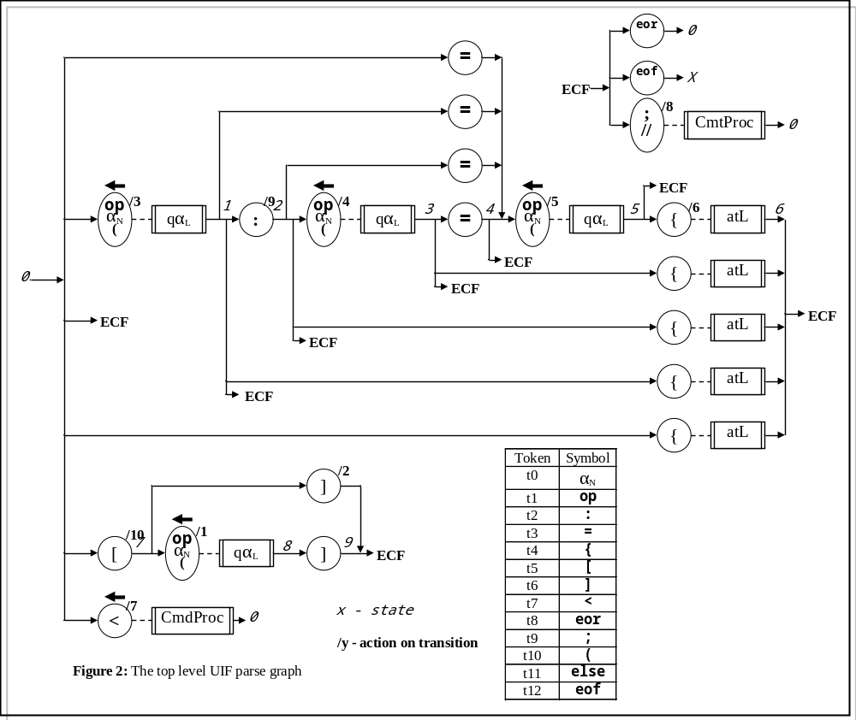

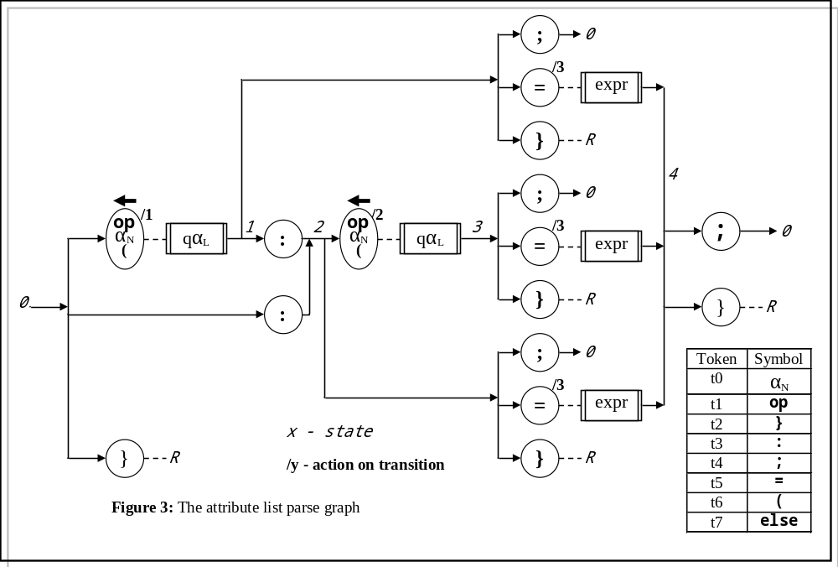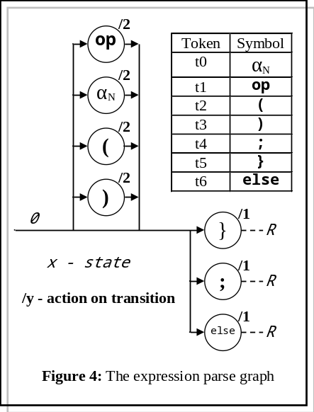

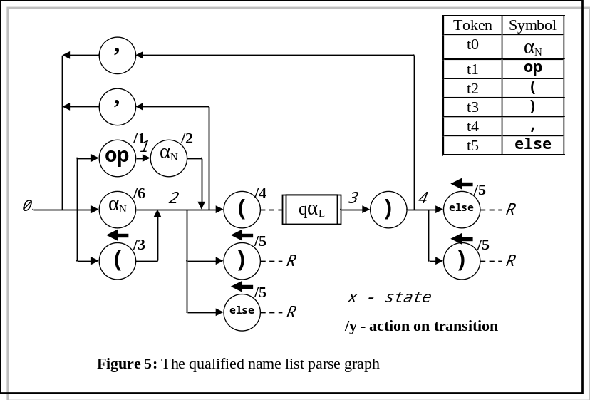

4.1.1 The comment bodge
The syntax is free format, in that the actual position of the syntactic elements is ignored by the parser. When the pretty printer outputs the text, it makes up the layout for itself. However, experience has shown that while this is OK in general, a lot of usage has comments laid out specifically to aid clarity, and the pretty printer destroys this by left justifying them all. The actual positions of all the syntactic elements in the original file are stored in the datastructure (but are not used by the pretty printer, because it's not really necessary) except the location of the start of the comments. Pure cockup on my part. The only place I could find to store them in the datastructure (without including another node, which, with hindsight, might have been a better solution) is this:

A comment on the same line as a section header:
The comment text is in the section header .str field, the column address in the .pos field of the head section name node.

A comment in a record:
The comment text is in the record header .str field, the column address is in the .pos field of the record body node.

4.1.2 Expressions

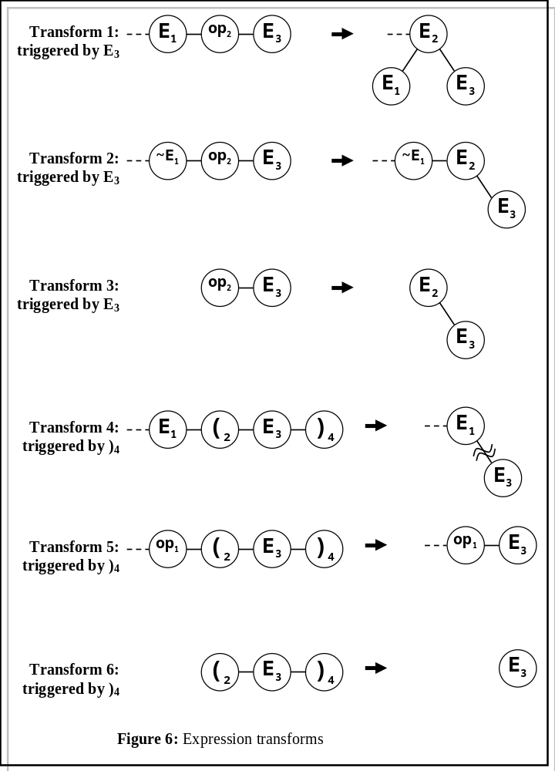Expressions are handled slightly differently from the rest of the syntax. The method UIF::Expr() processes the expression according to the syntax graph of figure 4, but the only real functionality the graph provides is the recognition of the end of the expression. Most of the work is done by the method Collapse(). UIF::Expr() contains a local vector of Node *. Each time a lexical token is processed, a new Node is attached to the end of the vector. This (the vector) is then handed into the Collapse() method, which applies a set of transforms to the vector. The transforms interact, and sometimes some enable others, so Collapse() applies them all in an infinite loop that only terminates when it has attempted to apply all the transforms with no success after the last successful transformation. At the end of this process, all the token nodes should have been collapsed into a binary tree, and the local vector should contain exactly one element, the root of the expression tree. The most usual cause of this not being the case is mismatched parentheses somewhere.

The detection of a lexical token corresponding to an expression (i.e. a string) triggers the putative application of transforms 1, 2 and 3. The detection of ')' causes 3, 4 and 5 to be triggered.

Transform 1: If the end of the vector contains the sequence E₁-op₂-E₃, transform 1 will be applied. This removes E₁ and E₃ from the vector, and attaches them as L and R children of op₂, which is itself relabelled as an expression - here E₂. (Thus the node type of E₂ will be No_e_ex, although the .qop field will contain a Lexer operator symbol.)

Transform 2: If the end of the vector contains the sequence ~E₁-op₂-E₃, (i.e. anything that's not an expression followed by op₂-E₃), transform 2 will be applied. This removes E₃ from the end of the vector, and attaches it as the R child of op₂, which is itself relabelled as an expression - here E₂. ~E₁ is left in situ.

Transform 3: A corner case: It is the same transform as transform 2, adapted to cope with op₂-E₃ being the first tokens in the vector.

Transform 4: If the end of the vector contains the sequence E₁-(₂-E₃-)₄, transform 4 will be applied. This removes the parentheses from the vector and discards them, and then removes E₃ from the vector, and attaches it as the right-most R child of any tree that may be attached to E₁. This supports function calls. Its application may, of course, change the makeup of the end of the vector to allow some of the earlier transforms to become applicable.

Transform 5: If the end of the vector contains the sequence op₁-(₂-E₃-)₄, transform 5 will be applied. This simply removes redundant parentheses (which may arise as a consequence of other transforms or direct user input) from the vector and discards them.

Transform 6: Corner case version of transform 5.

A useful set of test expressions is

sin(cos(x))
z+sin(y)
-(a)*(-b+--3)
(-sin(cos(y))-*tan(+x))
fn1(fn2(a,b),3,tan(7))

On successful conclusion, the expression will have been reduced to a single, binary tree of nodes. All the node types will be No_e_ex. The leaves of the tree will contain Lexer strings, which should be interpreted as variables or constants. The non-leaves will contain operators or Lexer strings. Operators here can include ',', but this is only used to indicate separation of function arguments. If a Lexer string appears as a non-terminal, it represents a function call. The dyadic operators '?' and ':' can appear (syntactically) in any number and any order - as with everything in UIF, it is up to the user to untangle these and extract the semantics.

4.2 Data structure

Aside from a few housekeeping variables, the datastructure is a simple n-ary tree structure of type Node, which is a subclass of UIF:

Notype typ; // Node type
Lex::Sytype qop; // Node operator (!= UIF type)
string str; // Node string
int pos; // Location in file
vector <Node *> leaf; // Children

UIF::Notype UIF::Node::typ
The node type field. This is an enumerated type, defined in UIF (just to save typing). The types and their meanings are laid out below:

No_0000 is the null node, only used for the tree root.

No_sect, No_recd, No_cmnt, No_body, No_attr, No_labl, No_vari, No_valu, No_name and No_expr are pretty obvious - refer to figure 7.

No_e_ex (expression), No_e_op (operator), No_e_LB (left bracket) and No_e_RB (right bracket) refer to the types of nodes created and manipulated during the parsing of expressions. Unlike the symbol types in the parser, they are not constant for a given token.
The expression parser builds - and hands to the routine Collapse() - a daisy-chain of symbol tokens. After each token is added is added to the chain, Collapse() is called on the daisy-chain, to see if it can be collapsed in any way by one of the six transforms embodied in t123() or t456(). (There is no sinister reason why these are separate; it's just that 1, 2 and 3 are related and so are 4, 5 and 6. Collapse() applies these transform continuously until nothing further happens (some transforms enable others.)
As the daisy-chain is built, it consists of a mixture of each of these four types. During the collapsing transforms, the types of each node can (will) change dynamically, so that at the end of parsing and collapsing, the token daisy-chain (of various types of node) will have been transformed into a binary tree consisting solely of No_e_ex nodes.

No_XXXX is the end-of-enumeration element. (It is good programming practise to terminate an enumerated type list with an element that is never used. It enables the declaration of arrays indexed on the enumerated type - for example

static const char * Notype_str[No_XXXX+1];

to remain unchanged when extra (meaningful) elements are added to the list.

Lex::Sytype UIF::Node::qop
This holds the token type, as generated directly by the lexer. Note that the parser and the Node do not share a common view of what constitutes an operator, because it changes depending on whether we're in the body or the attribute section of a record.

string UIF::Node::str
Holds the actual character string representing the symbol.

int UIF::Node::pos
A single integer, holding the generating file map. In a section or record node, .pos holds the line number in the originating file that defined the section or record. In all other nodes, .pos holds the column number

vector <Node *> UIF::Node::leaf
A vector holding pointers to the child nodes. Note that it is entirely possible - under rather bizarre circumstances, which really ought to be tracked down, put up against a wall and shot - for these pointers to exist, but be null. Don't ask. Thus code interrogating this vector should be tolerant of this.

