Msg_p and PMsg_p message classes

Ver 0.1 | 7 June 2010
Ver 0.2 | 26 July 2022

Andrew Brown

1. Introduction

2. Usage
2.1 PMsg_p and Msg_p
2.2 #include file layout
2.3 Decoration fields
2.4 Use cases
2.5 User defined structures/classes

3. Class methods

4. Internal datastructure

5. Streaming

6. Msg_p::Dump() and template <class T> Msg_p::Dump()
1. Introduction

Msg_p is a class designed to encapsulate and transport heterogeneous tranches of data, both PoD and user-defined. It is effectively a tuple, with two extra capabilities:

● Data items may be referenced by a signature: {user key,type}. Data items may be inserted and extracted in any order, and the class reacts sensibly to attempts to access non-existent data (you can't, and it tells you) and overwrite existing data (it silently replaces the old data).

● The entire Msg_p tuple can stream itself to a byte sequence, which can be ferried about like any other byte array, and then unstreamed to a destination tuple. This is of some utility in a single process, but the capability becomes really useful when the derived class, PMsg_p, is used. This links against MPI, and allows the tuple to be transmitted over the MPI backplane with a single call, and likewise unpacked at the receiving end. It is the users responsibility to ensure that the definitions of any user-defined types match in the sending and receiving processes; PMsg_p has no defence against this source of errors.

As everything is stored as a byte sequence inside the class, this should work with heterogeneous MPI universes (as with MPI user-defined types, although this has never been tested).

2. Usage

(P)Msg_p does not have the simplest interface ever designed. This is partly because it was designed alongside being used - which made it inconvenient to implement sweeping changes - and partly because there are complexities with argument type promotion and template specialisation that make the interface less general than was originally intended.

2.1 PMsg_p and Msg_p
Msg_p is a stand-alone class that can be used to encapsulate and transmit heterogeneous tuples (PoD and user-defined) around a single process. It does not require linking against MPI. The derived class PMsg_p contains a single non-trivial method (Send()) that allows a tuple to be streamed into a byte sequence and sent to an MPI process of whatever rank.

2.2 #include file layout
Msg_p is a non-template class that contains templated methods. The non-template components must be compiled as a separate translation unit, and the template components specialised at compile time in the invoking translation units. The translation unit file layout is given in figure 1.

2.3 Decoration fields
Aside from the data itself, the class also supports a number of decorative fields. Despite the names, these are simply values that can be associated (read from/written to) with each tuple, and they can be used for any purpose, with one exception: the tgt field can be used by PMsg_p to select the message target rank. The field description is summarised in the table below.

Field name | Type | Set by | Read by | Original purpose
tag | int | void Tag(int); | int Tag(); | MPI tag
subkey[4] | byte | Individually:  void L(int,byte);  Together:  void Key(byte,byte,byte,byte); | Individually:  byte L(int);  Together:  unsigned Key(); | Hierarchical label
ztime[4] | double | void Ztime(int,double); | double Ztime(int); | MPI timing
id | int | void Id(int); | int Id(); | Unique identifier
mode | int | void Mode(int); | int Mode(); | Legacy project
src | int | void Src(int); | int Src(); | MPI rank
tgt | int | void Tgt(int); | int Tgt(); | MPI rank

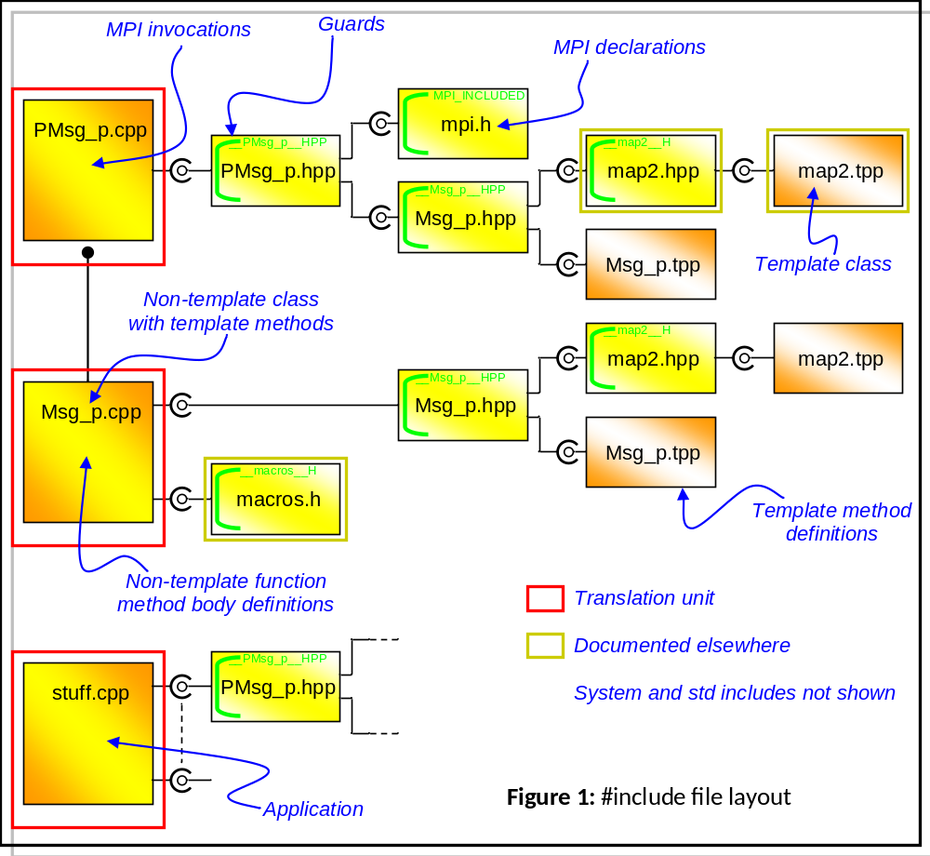

2.4 Use cases
A handful of examples:

Plain old data (PoD)
Putting | Getting
double d=1.2;  T6.Put<double>(7,&d); | double * pd = T6.Get<double>(7,cnt);  if (pd!=0) d = *pd; (cnt=1)
long double ld=9.8;  long double * pld = &ld;  T6.Put<long double *>(7,&pld); | long double ** ppld = T6.Get<long double *>(7,cnt);  if (ppld!=0) pld = *ppld; (cnt = 1)

The signature of the data item is {key,type}, so the first to go in is identified as {7,double}, the second as {7,long double *} - there is no signature clash. The count field returned by Get() each time is 1, as there was only one element to the item.

Arrays of plain old data
Putting | Getting
double d[2]={1.2,2.3};  T6.Put<double>(7,d,2); | double * pd = T6.Get<double>(7,cnt);  if (pd!=0) for(unsigned i=0;i<2;i++) d[i] = pd[i];
char ibuf[512] = "oinksplat";  T6.Put<char>(97,ibuf,strlen(ibuf)); | char * obuf = T6.Get<char>(97,cnt);

The two signatures here are {7,double} with a length of 2 items, and {97,char} with a length of 9. I'm not very sure where the trailing '\0' on the output comes from, but it seems to work.....

Strings
Putting | Getting
string sss1 = string("aargh");  X1.Put(-87,&sss1); | string sss2;  X1.Get(-87,sss2);
vector<char> vi;  M1.Put<char>(42,&vi); | vector<char> vi2;  M1.Get<char>(42,vi2);
vector<string> vin;  M1.PutX(9942,&vin); | vector<string> vout;  M1.GetX(9942,vout);

Std::strings and std::vectors of std::strings are so useful there is a specific overload just for them. Due (I think) to the way C++ handles type promotion and template specialisation, string, char and char * all share the same keyspace, so you cannot, for example, put a string into a Msg_p with a key of 88 and an array of chars in with a key of 88. (There is nothing to stop you putting the latter in - and out - as an array of integers, and re-interpreting the data afterwards, but don't you have anything better to do with your time? You could just use a different key value.). Note also that C++ does not (seem to be able to) disambiguate

template <class T> void Get(int,vector<T> &);
void Get(int,vector<string> &);

hence the different names in the last example.

User-defined types
Putting | Getting
struct XYZ {...} q1 = XYZ(...);  M1.Put<XYZ>(99,&q1); | M7.Put<XYZ>();  XYZ * pXYZ = M7.Get<XYZ>(99,count);  if (pXYZ!=0) ....
XYZ bog[4];  M1.Put<XYZ>(42,bog,4); | M8.Put<XYZ>();  XYZ * pbog = M8.Get<XYZ>(42,count);

2.5 User defined structures/classes

Msg_p comes 'pre-loaded' with the set of PoD types enumerated in section 4. If it becomes necessary to manipulate user-defined types, the class must know about them before it can use them. For single process use, this is not a problem, but in an MPI application, the attempt to read a Msg_p may be the first time the object has seen the user defined type. In an MPI environment, then, it is necessary to do an empty Put<T>() before the first Get<T>(). Arrays of user-defined structures are also fine.
Experimentally, it seems that user defined classes are also OK, subject to certain constraints. Putting a user-defined class into a Msg_p results in a faithful image of the data elements of the class. Extracting data (Get<>() et al) is done using placement syntax, where Get* simply picks up a region of bytes and creates the object, with the data fields creating the object.
If a default constructor for the class is defined (for example, to initialise the data), this will be applied after the object is created, and the values picked up from the byte stream will be overwritten.
The way around this is to partition the class data a priori into a simple structure and a class "body" that contains the code, and derive the class proper from that structure after it has been unstreamed.

3. Class methods

Msg_p:

Msg_p();
Uninteresting constructor.

Msg_p(byte *,int);
Unstreaming constructor from byte array.

Msg_p(Msg_p &);
Copy constructor.

virtual ~ Msg_p(void);
Uninteresting destructor.

void Clear();
Empty the datastructure.

void Dump(FILE * = stdout);
template <class T> void Dump(FILE * = stdout);
See section 6.

void FDump(string=string())
Dump() outputs the pretty-print on the (assumed open) file stream supplied as the argument. This is fine for normal programs, but Windoze doesn't allow direct output to stdout. Intercepting the stream and redirecting it to a Windoze console is not hard, but it is obviously OS-specific. FDump() supplies a way around this, by encapsulating an individual call to Dump() and directing the output to a named file. The file name is internally generated, and guaranteed to be process-unique. Name clashes within an MPI universe can be avoided by supplying a user-defined string argument that is appended to the machine-generated name.

template <class T> T * Get(int key,int & cnt);
Extract an item of data, signature {key,T} from the object. cnt returns the number of items found.

void Get(int,string &);
Extraction function for strings. This occupies the same keyspace as char.

template <class T> void Get(int,vector<T> &);
Extraction function for vectors.

void GetX(int,vector<string> &);
Special case extraction function for vectors of strings.

int Id();
void Id(int);
Read/write id field.

unsigned Key();
Read key field array as a single unsigned.

void Key(byte,byte=0x00,byte=0x00,byte=0x00);
Set key field array as a set of bytes.

static unsigned KEY(byte=0x00,byte=0x00,byte=0x00,byte=0x00);
Pure conversion function to translate a set of byte subkeys into a single unsigned.

byte L(int);
void L(int,byte);
Read/write subkey fields directly.

int Length();
Return the length of the streamed data structure. (Calling this forces the creation of the stream if it does not already exist.)

int Mode();
void Mode(int);
Read/write the mode field.

template <class T> int Put();
Force the insertion of a previously unseen type into the internal type map of the object. The return value is the internal type key; of little use to a non-developer user.

template <class T> void Put(int key,T * pdata,int cnt=1);
Insertion method; this puts cnt items starting from address pdata into the object, with an integer key.

void Put(int,string *);
A special insertion method for strings. Strings share a keyspace with chars.

template <class T> void Put(int,vector<T> *);
Insertion method for vectors.

void PutX(int,vector<string> *);
Insertion method for vectors of strings.

void SubKey(byte * sk);
Loads sk with the base address of the subkey array.

int Src();
void Src(int);
Read/write the src field.

byte * Stream();
Force creation of the internal byte stream representation of the object (only if it is dirty or does not exist). This returns a pointer to an internal (i.e. non-persistent) structure. This leads to some counter-intuitive behaviour (i.e. it's weird). If you Stream() a Msg_p, the internal byte vector is created and Stream() returns a pointer to it. The pointer remains valid as long as the object is in scope, and if you attempt another Stream(), nothing happens because the internal byte vector is still there. If you subsequently change a field and do another Stream(), you get the previous unmodified buffer back, which is probably not what you expect. To fix this means changing the behaviour of Stream(), and I don't really want to do that because Msg_p has been out there a long time. The next function is introduced as a fix for this.

vector<byte> Stream_v();
As Stream(), but the internal buffer is wiped and reformed with every call. The new streamed byte vector is then copied out as a return value, so it doesn't matter if the original object goes out of scope, or gets fiddled with. Any pointer value handed out previously now addresses the new, up-to-date buffer.

void Tag(int);
int Tag();
Read/write the tag field.

int Tgt();
void Tgt(int);
Read/write the tgt field.

double Ztime(int);
void Ztime(int,double);
Read/write the time fields individually. (These are intended for MPI wallclock time values, which are stored as doubles.)

private: template <class Z> void AddToMap();
Loads a previously unseen type into the internal type map.

private: template <class Z> Z pullB(int &);
private: template <class Z> void pushB(vector<byte> &,Z);
Read/write the internal stream buffer

protected: void Load(byte *,int);
Recreate the object internal data structure from a byte stream.

PMsg_p:

PMsg_p():Msg_p(){}
Uninteresting constructor

PMsg_p(byte * pb,int l):Msg_p(pb,l){}
Unstreaming constructor

PMsg_p(PMsg_p & r):Msg_p(r){}
Copy constructor

virtual ~ PMsg_p(void){}
Uninteresting destructor.

void Send();
Stream the message and send it to the MPI process rank value held in tgt.

void Send(int);
Stream the message and send it to an arbitrary process rank.
4. Internal datastructure

The internal datastructure consists broadly of four levels of indirection, outlined in figure 2.
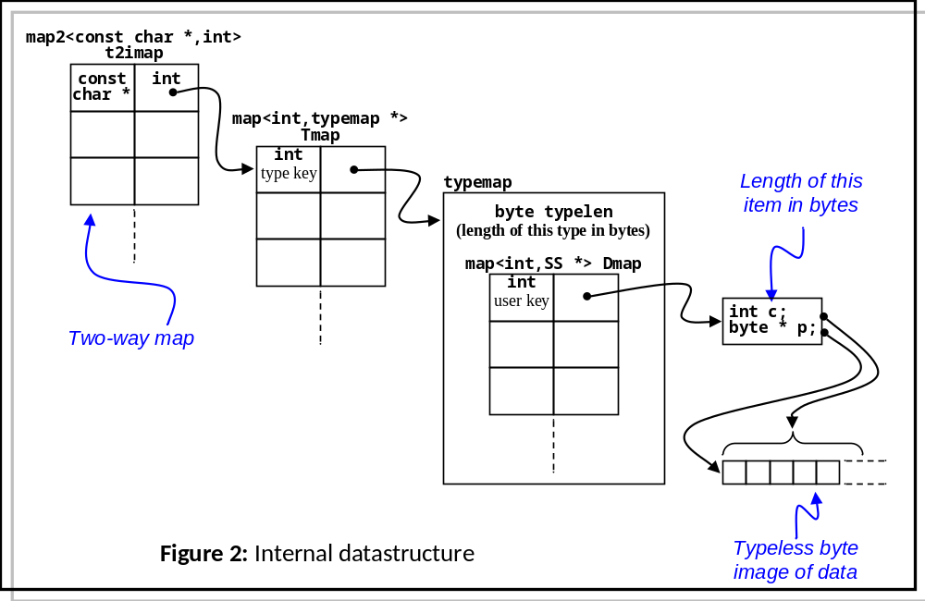The two-way map establishes a link between the character representation of a type name (taken from RTTI), and a unique internally generated integer (the internal type key). This is used as a key to another (asymmetric) map that leads to a typemap object. Each typemap object is dedicated to the storage of one type of data item (which may be arrays). The data field of this map points to an SS (stepping stone) object, which is associated 1:1 with each individual data item. The stepping stone stores the base address in memory of the data, plus the overall length of this particular piece of data.

The two-way map (t2imap) is pre-loaded on construction with the set of types below.

bool bool *
char char *
double double *
float float *
int int *
long long *
long double long double *
short int short int *
unsigned char unsigned char *
unsigned int unsigned int *
unsigned long unsigned long *
unsigned short int unsigned short int *
void *

User-defined types are added as they are encountered.

5. Streaming

The object contains a vector<byte> vm which is used to stream the datastructure of figure 2 and the decoration fields into a single byte stream. The layout of the data in the linear array is given in figure 3.
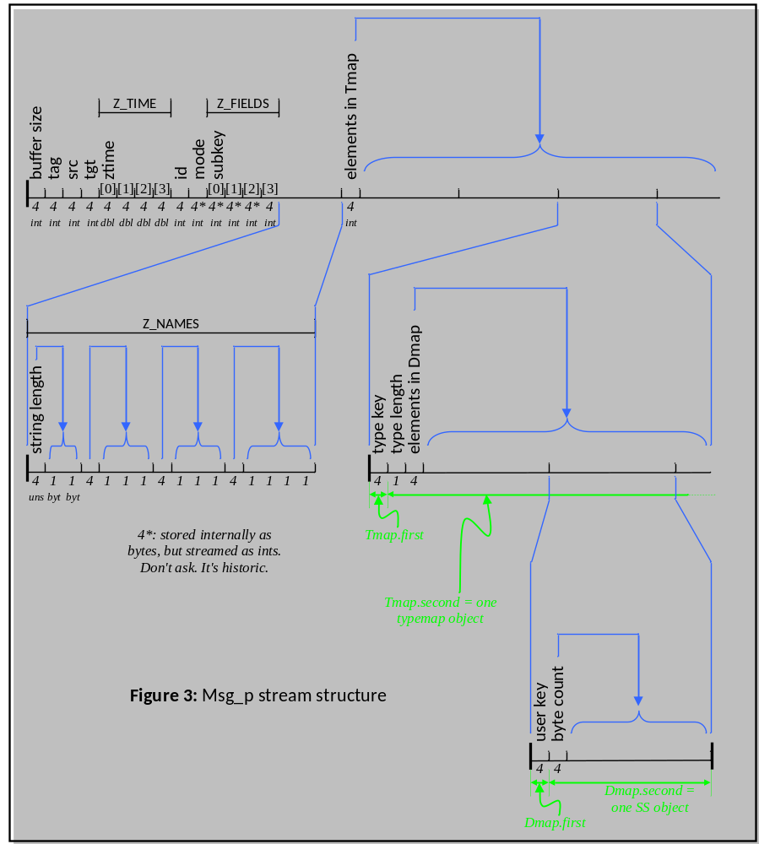

The id field: This is a process-unique label for an individual Msg_p. It is faithfully copied into the stream buffer on creation (so if you choose to introspect the byte buffer manually you'll get the "correct" - that is, original value), but when used in the constructor of a Msg_p object it is overwritten so that the (new) value is local and process-unique.

Stream length: Reading the code (byte * Msg_p::Stream() in Msg_p.cpp) may cause some intellectual discomfort. The first field (the byte stream length) is pushed into the buffer vm as 0, and the variable offset initialised as the empty buffer size - i.e. always exactly 0. At the end of the method, placement syntax is used to write the overall stream length into the first element of the buffer:

new(&vm[offset]) int(vm.size());

Keeping in mind that the value of offset is always 0, you're probably thinking what's wrong with

vm[0] = int(vm.size());

The answer is that nothing is wrong with it. The whole mess is historic: originally Stream() did a direct write to disk, and the buffer length wasn't even stored, then the length was shoved in the middle (at a position called "offset"), then it got moved to the front, then the disk write was replaced with a memory buffer.

Evolution of code, and all that.
(Another) Borland bug:
CodeGuard seems to have difficulty keeping track of variables allocated with placement syntax.

For example

char ibuf[512] = "oinksplat";
W1.Put<char>(97,ibuf,strlen(ibuf));
char * obuf = W1.Get<char>(97,cnt);
printf("cnt = %d, obuf = %s\n",cnt,obuf);

Will compile and execute correctly, but CodeGuard insists the write statement has an access overrun because it wants 10 bytes.
strlen() returns 9 (correctly) and cnt comes out as 9 (correctly).
6. Dump() and template <class T> Dump()

A generic Msg_p dump is shown below. The decoration fields are displayed first, followed by the user data items, then the type map. Note that the dump cannot in general reproduce the data in a form sympathetic to the user; it is stored as a byte stream, and Msg_p has no knowledge of the internal structure of any user-defined types (here XYZ, PQR and ABC). The utility of this display is to support checking of the stream buffer.

---------------------------------------------
Raw dumping Msg_p

Source : -1, Target : -1
Tag : 101, Identifier: 1636252, Mode : 0
Source launch timestamp : 0.000000e+00
M_server arrive timestamp : 0.000000e+00
M_server forward launch timestamp : 0.000000e+00
Target arrive timestamp : 0.000000e+00
Labels : 0| 0| 0| 0
Raw data dump:
Type key = 26 (XYZ)
Type length = 16
User key = 42
Byte count = 64
0a 00 00 00 00 00 00 00 33 33 33 33 33 33 f3 3f
14 00 00 00 14 eb 18 00 33 33 33 33 33 33 0b 40
1e 00 00 00 10 00 00 00 66 66 66 66 66 66 16 40
28 00 00 00 30 67 c2 1f 33 33 33 33 33 33 1f 40

Type key = 27 (PQR)
Type length = 8
User key = 43
Byte count = 24
50 f3 18 00 cd cc 1c c1 51 d0 fd 01 33 33 f3 c0
52 47 4f 77 cd cc ac c0

Type key = 28 (ABC)
Type length = 24
User key = 44
Byte count = 72
e9 03 00 00 17 fc ff ff d2 07 00 00 2e f8 ff ff
9a 99 99 99 99 99 28 40 bb 0b 00 00 45 f4 ff ff
a4 0f 00 00 5c f0 ff ff cd cc cc cc cc cc 46 40
8d 13 00 00 73 ec ff ff 76 17 00 00 8a e8 ff ff
8f c2 f5 28 5c 8f 1f 40

1 <-> bool
2 <-> bool *
3 <-> char
4 <-> char *
5 <-> double
6 <-> double *
7 <-> float
8 <-> float *
9 <-> int
10 <-> int *
11 <-> long
12 <-> long *
13 <-> long double
14 <-> long double *
15 <-> short
16 <-> short *
17 <-> unsigned char
18 <-> unsigned char *
19 <-> unsigned int
20 <-> unsigned int *
21 <-> unsigned long
22 <-> unsigned long *
23 <-> unsigned short
24 <-> unsigned short *
25 <-> void *
26 <-> XYZ
27 <-> PQR
28 <-> ABC
The type specific template function Dump gives a slightly different set of data - the RTTI typename is presented - and the data is printed as a hex and character string, irrespective of the real type.

---------------------------------------------
Type specific dumping Msg_p

Type "string" is mapped to "char"
Type ||_STL::basic_string<char,_STL::char_traits<char>,_STL::allocator<char> >|| has type key 3
Typemap: Type length (in bytes) 1
User Byte
key count Data
37 7 77 68 69 66 66 6c 65
w h i f f l e
94 9 7a 6f 6f 6d 73 70 6c 61 74
z o o m s p l a t
---------------------------------------------

