Socket classes

Ver 0.1 | 26 August 2022

Andrew Brown

1. Introduction
1.1 Callbacks and skyhooks

2. Inheritance hierarchy

3. The common base class

4. The server class

5. The client class
1. Introduction

Socket capability is encapsulated here in three class definitions, Pserver_t and Pclient_t, both of which are derived from a common base class, PcsBase_t.

The connection protocol is TCP via IPV4. The code is 32-bit C++98 developed under Borland CBuilder6, and uses components from the Generics library, but is OS agnostic. It is intended (but obviously not limited) to support communication between processes running on different operating systems (i.e. Windoze and Linux).

The common base class encapsulates a common message subsystem that handles things like connections being broken, clients refusing to exist, or effectively anything that causes the normal flow of control to not work properly.

The system makes heavy use of detached threads from the pthreads library (obviously not C11 threads, because it's developed under a C98 compiler).

The server class main thread encapsulates
(1) The server connection behaviour: the main thread spins off a detached thread for every connection made to it, and each of these spins off a further detached thread for every client. All this enables multiple clients to connect simultaneously to the server. (Server receive-side behaviour.)
(2) The server send-side behaviour, which is controlled by a callback.

The client class main thread encapsulates connection and send-side behaviour, and it spins off a detached thread to handle the receive-side via a callback.

Both client and server support skyhooks into their callbacks.

The classes interact with unstructured byte (i.e. unsigned char) blocks. Each byte block is prepended by a four-byte integer containing the length of the unstructured block to come.
1.1 Callbacks and skyhooks

The conventional and simplified control flow through a callback routine is shown in figure 1.
The class should defend itself against improper use: pf should be initialised to NULL and SomeClassMethod() should check it isn't trying to dereference a NULL pointer before executing the call; alternatively, some default flat function supplied with the class definition (the prototype forward declared in the class header, but not part of the class definition) so that some sensible behaviour occurs if the user fails to set the callback address.
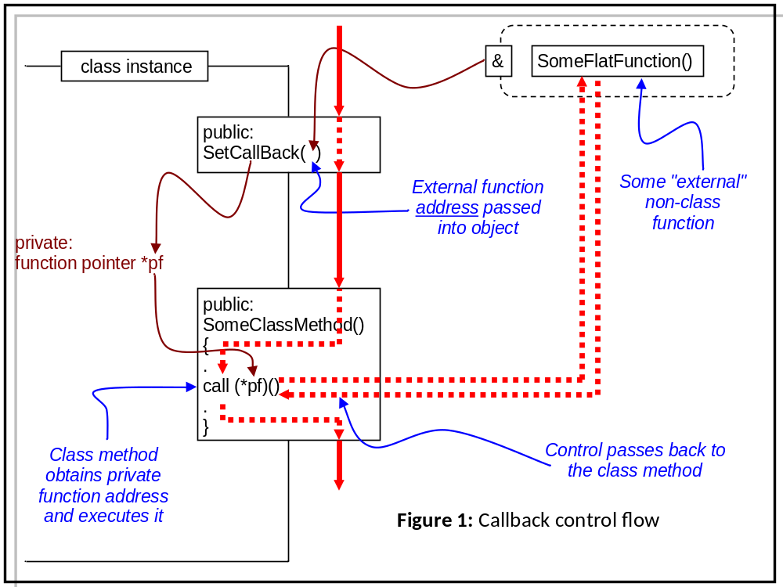
This is fine, but difficulties may arise with scope and datastructure visibility. When control passes into SomeFlatFunction(), it will have access to its own internal data - obviously - and anything with external linkage in the source file in which it was defined. With suitable use of extern directives, you can do anything from here, but this is seriously uncool and very hard to extend in a stable manner.

Better (safer) is the use of skyhook pointers - this is outlined in figure 2.

The important point is that the skyhook is stored internally in the class as a void *, which means that the class has and needs no knowledge of the domain in which the callback operates, and so can be in some, say, Generic library developed elsewhere. It is up to the internals of the callback to get the static cast right, but that is not unreasonable if it is going to operate on the structure addressed by the callback.
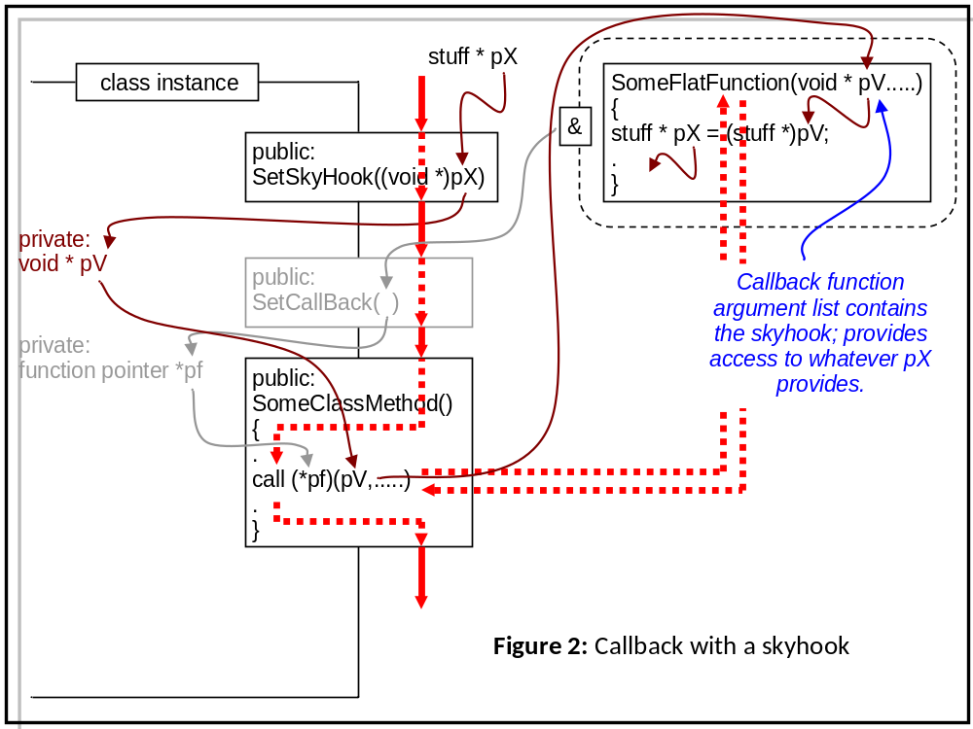

2. The inheritance hierarchy

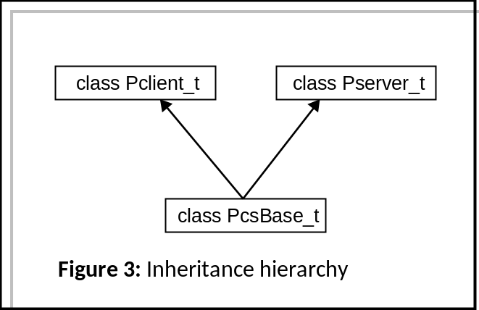Hardly worth a diagram and I never know what sort of arrows we're supposed to use anyway.

3. The common base class

PcsBase_t contains two components: (1) Trivially, the skyhook setter for both derived classes:

void PcsBase_t::SetSkyHook(void * _S) { pSkyHook = _S; }

and (2) the error subsystem. The data underlying this is a vector of strings. It is written to by a call to

int PcsBase_t::PsMessage(int severity,string mess)

The severity argument is passed out as the return value; this enables you to write things like

if (PsMessage(0,"thing")!=0) return;

and saves a conditional. An overload

int PcsBase_t::PsMessage(int sev, string mess, int arg)

allows you to append a numeric value to the error string.

The state of the message vector may be interrogated with

int PcsBase_t::Status(vector<string> & rmessBuf)

which allows RW access to the message vector and returns the (final) length as an argument. This routine can thus be used to reset the vector if needed.

A callback is supported:

void PcsBase_t::SetMCB(void (* _pMCB)(void * pSky, string err_str))

(*_pMCB)() is called by PsMessage.

If the user calls SetMCB() with a NULL function pointer, a (supplied) default stub is executed:

void DefMCB(void * pSkyHook,string mess)

If the user really doesn't want anything to happen, an empty stub can be provided to override the default. But, really, guys.....
4. The server class

The layout of the server class is given in figures 4 and 5.

To use the server class, the user must define and connect two callbacks, with the following signatures:

Message handler:

void MessageHandlerCallBack(void * pSkyHook,string message)
void * pSkyHook Can be anything (see section 1.1)
string message The message that needs handling. This can be copied to stdout in a conventional environment, copied to the Console or sent to a window in a Windoze environment.

Incoming packet handler:

void SocketReceiveHandler(int socket,void * pSkyHook,vector<byte> buffer,int len)
int socket The socket id assigned by the class when the connection was established
void * pSkyHook Can be anything (see section 1.1)
vector<byte> buffer The buffer to receive the incoming byte stream
int len The expected length of the incoming byte block. The receiver will not let go until it has received the expected number of bytes (or the connection is broken.)

