NAME  John Marklenard M. Macatangay |  | DATE  February 4, 2017 | SCORE
SCHEDULE  Satruday – 10:00AM – 13:00PM | SCORE |  | SCORE

LABORATORY EXERCISES
RECURSION

OBJECTIVES:
- Understand recursion and its parts
- Use recursion to solve programming problems

PROCEDURE:
- Encode the C++ program below.
- Save as rec1.cpp,and rec2.cpp, respectively.
- Compile and run the program by pressing Ctrl + F9.
- For each syntax or logical error encountered in the given program, do the following:
- Correct the error
- Recompile the program
- Repeat step 4 until no errors are encountered in the program.
- Illustrate the output of the modified program.

Program No. 1

#include <iostream>
Output:
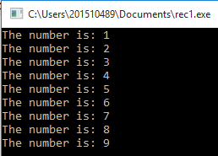

using namespace std;

void numberFunction(int i) {
cout << "The number is: " << i << endl;
i++;
if(i<10) {
numberFunction(i);
}
}

int main() {

int i = 1;
numberFunction(i);

return 0;
}

Program No. 2

#include <iostream>
using namespace std;

int factorial(int);

int main() {
int n;
cout<<"Enter a number to find factorial: ";
cin>>n;
cout<<"Factorial of "<<n<<" = "<<factorial(n);
return 0;
}
Output:
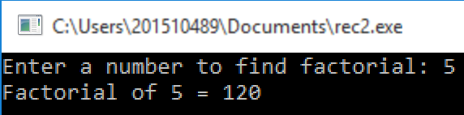

int factorial(int n) {
if (n>1) {
return n*factorial(n-1);
}
else {
return 1;
}
}

Supplementary Problem

- A recursive function that sums up the 10 integers in an array.

Program:

#include<iostream>
using namespace std;
int sum(int Array[], int Size) {
if (Size==0) {
return *Array;
}
else {
return *Array + sum(++Array, Size-1);
}
}

int main() {
int Arraay[]={1,2,3,4,5,6,7,8,9,10};
cout << "The sum of all array is : " << sum(Arraay,9);
}

Output:

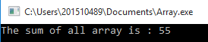

- A recursive function to produce the Fibonacci number for a given index in the series.
Use the function int fibonacci(int n)

Program:

#include<iostream>
using namespace std;

int fibonacci(int n ) {
if (n==1) {
return 1;
}
else if (n==0) {
return 0;
}
else {
return fibonacci(n-1) + fibonacci(n-2);
}
}
int main() {
cout << fibonacci(5);
return 0;
}

Output:

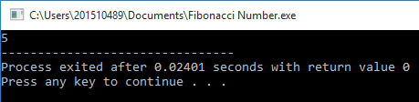

- A recursive function which raises its first parameter to the power of its second parameter.
Use the function int power(int number, int power)

Program:

#include<iostream>
using namespace std;

int pow(int number, int power) {
if (power==0) {
return number*power;
}
if (power==1) {
return number;
}
else {
return number*pow(number,power-1);
}
}
int main() {
int x,s;
cout << "Input Number: ";
cin >> x;
cout << "Input Exponent: ";
cin >> s;
cout << "Answer: " << pow(x,s);
return 0;
}

Output:
