**Individual Report Sample**

# Introduction

Automata theory is an area of theoretical computer science that investigates abstract machines and the computing problems that these machines can solve. Automata are abstract devices that are used to model the behavior of real-world systems.

The finite automaton (FA), which is a machine with a finite number of states, is one of the most important forms of automata. Regular languages, a sort of formal language that may be described using regular expressions, can be recognized using FAs.

Automata theory is a complex and difficult area, yet it is also extremely rewarding. By studying automata, we can obtain a better knowledge of the theoretical basis of computer science as well as its practical applications.

# Group Contribution

## Delete Program

Use delete to delete all existing data in programming, and then to delete data, we must write id and name if they exist. So, we see "Delete Successful" right away.

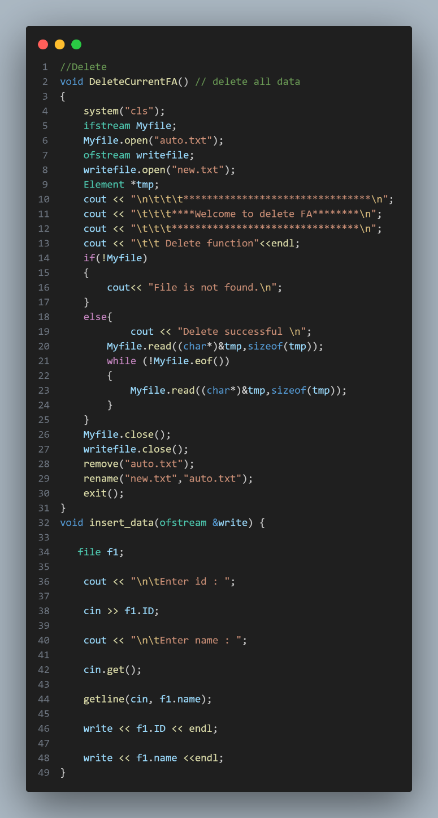

## Update Program

Use update to update existing data in programming, and then write old id for old function before updating data. We can only update for new ids. As a result, you must enter the update name.

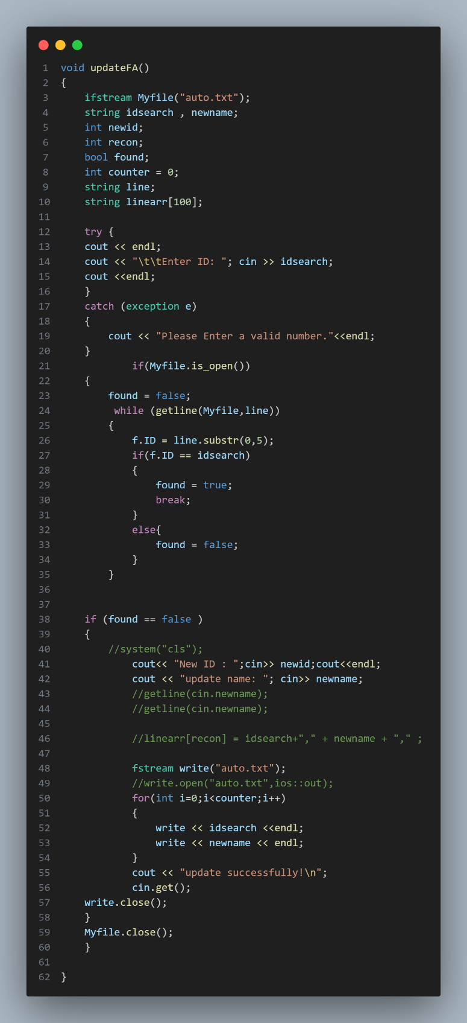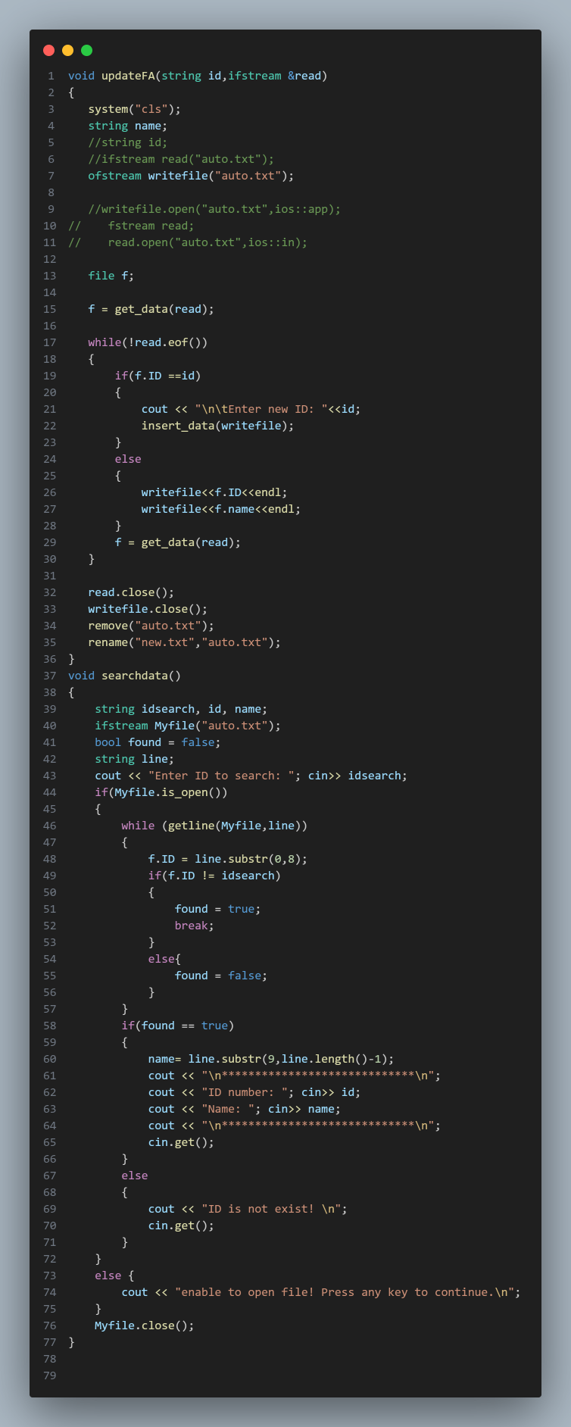

## Exit Program

Finally, when you click on the program's last number. The program has ended.

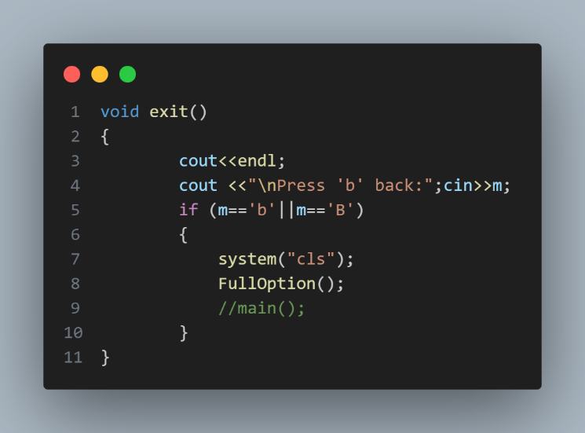

## …

# Conclusion

Automata theory is a diverse and difficult science with several applications. In this section, we will examine briefly some of the important points from our discussion.

To begin, automata are abstract devices that can be utilized to mimic real-world system behavior. As a result, they are a powerful tool for comprehending and developing complicated systems.

Second, formal languages can be recognized using automata. This is a strong tool for natural language analysis and processing, as well as for creating compilers and other software tools.

Third, automata theory has a solid mathematical basis. As a result, it is a rigorous and well-founded subject of research.

Finally, automata theory is a rapidly expanding topic with a plethora of fascinating new applications. As computer science advances, automata theory is anticipated to play a larger role in the development of new technologies.

# Member Evaluation

|  |  |
| --- | --- |
| **Name** | **Group Contribution Score** |
| SOEM Seakmeng | 27% |
| PIN Seavmuy | 20% |
| RORN Makara | 15% |
| RATHA Sothea | 15% |
| POM Mouylang | 23% |