Institute of Technology of Cambodia

Department of information and communication engineering

Automata Theory

Group 9

Lecture: Dr. DONA Valy

Students: SOEM Seakmeng ID: e20201193

POM Mouylang e20201008

PIN Seavmuy e20201618

RORN Makara e20201716

RATHA Sothea e20201208

2023 - 2024

**project technical Report Sample**

# Introduction

This project Automata Theory do on Finite automata. This project is to develop an application and manipulate finite automata. The goal is to develop an application to manage and manipulate finite automata by applying what we have learned in Algorithm and Programming class such as linked-list and the basic theory on Automata Theory.

# Functions and Features

There are 8 main functions.

1. Load FA from file

This feature is about insert the data of Finite Automata in string form then convert these strings into data to text file.

Input ID: 2023

Input file name: DFA

Enter number of states: 3

Enter the number of symbols: 2

Start state: q0

End state: q2

=> ID: 2023

=> File Name: DFA

a b

q0 q1 q0

q1 q2 q1

q2 q2 q2

1. Create New FA

Create new DFA and NFA for this function. For store in database.

1. Convert NFA to DFA

Every DFA is an NFA and not every NFA can be call DFA. But we can convert NFA to an equivalent DFA.

1. Minimize a DFA

To activate this function, FA have to be DFA, if it is NFA have to convert it first, then it will do the minimization and return new DFA if DFA can be minimized.

1. Test if S­­­tring is accept by FA

A string ω is accepted by a finite automaton, M = (Q, Σ, δ, q0, F), if δ(q0, ω) = F, where q0 is initial (start) state and F is the final state.

1. Delete FA file

Use delete to delete all existing data in programming, and then to delete data, we must write id and name if they exist. So, we see "Delete Successful" right away.

1. Update FA file

Use update to update existing data in programming, and then write old id for old function before updating data. We can only update for new ids. As a result, you must enter the update name.

1. Exit program

Finally, when you click on the program's last number. The program has ended.

# Data Structure

We use Link-List for this project.

# Database Design

We use text file to store data. Then it shows the tables when user input DFA or NFA.

# Implementation

This diagram shows all functions that we use in this project.

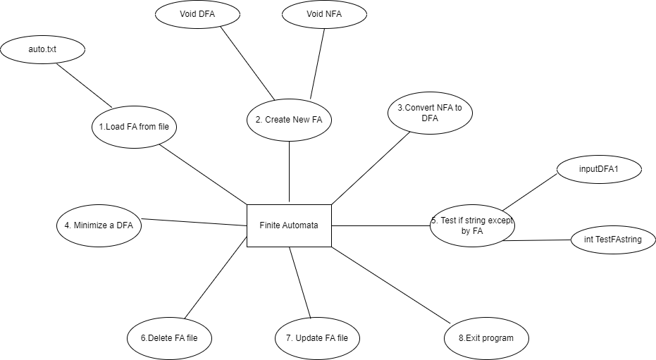

# Result

The program able to do all the 6 functionalities

* User can input FA data and save
* User can check if FA is NFA or DFA
* User can input string to test FA
* User can convert FA when it is NFA to DFA
* User can minimize FA when it is DFA
* User can load, delete and update saved FA.

# Conclusion and Perspective

Now it’s is finished. We become much clear about Automata theory. In the future, we hope not to mess up like this

**activity history Report Sample**

|  |  |  |  |  |
| --- | --- | --- | --- | --- |
| **Date** | **Time** | **Location** | **Attendance** | **Topic** |
| 19 June | 9AM – 11AM | ITC | Absent: member1  Name: RATHA Sothea | * Divide work |
| 26 June | 9AM – 11AM | ITC | Everyone | * Progress work on function |
| 05 July | 1PM – 3PM | ITC | Everyone | * Finish function and features |
| 12 July | 1PM – 3PM | ITC | Absent: member1  Name: RATHA Sothea | * Database |
| 19 July | 1PM – 3PM | ITC | Absent: member1  Name: RATHA Sothea | * Database |
| 28 July | 1PM – 3PM | ITC | Everyone | * Testing Code |