Advance Image Downloader/Extractor(Job)

***Wireframe Documentation***

**HOME PAGE**

Homepage will consist of single page, which consist of different user inputs and the single button that will either lead user to submit page or error page.

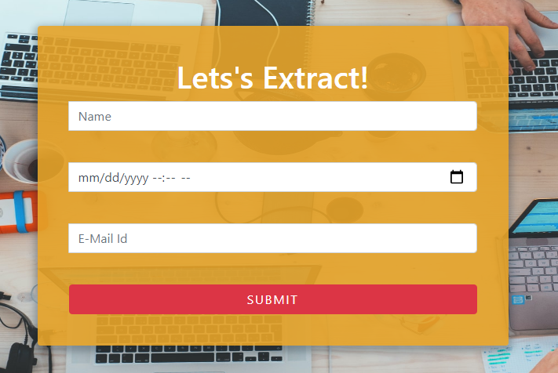

User has to enter all the inputs in order to see either of the two pages.

**Job Submitted**

If the user query satisfies all the requirement, then query get submitted and the job submitted page will be shown. Single button will be present to let user again submit the job if he/she wants

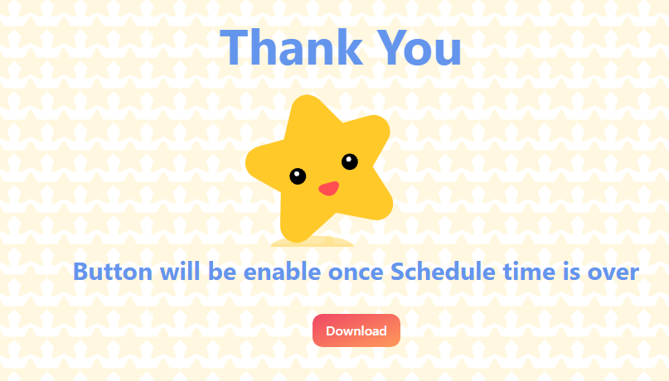

**Error**

If there are any error occurs while submitting the job i.e. If user enters incorrect date and time, then user will be treated with the Error page. Single button will be present to let user again submit the job if he/she wants.

