Ex.no:6b | DATA VISUALIZATION USING POWER BI

AIM

To visualize and analyze the Food Waste Prediction Dataset using Line Chart, Bar Chart, Pie Chart, Histogram, Scatter Plot, and Box Plot with Matplotlib to understand food waste trends, city-wise and restaurant-wise comparisons, food item distribution, waste patterns, and relationships between food waste-related attributes.

ALGORITHM

Step 1: Import Pandas and Matplotlib libraries.

Step 2: Load the Food Waste Prediction dataset into a DataFrame.

Step 3: Group the food waste data according to City and calculate the total food waste for each city.

Step 4: Plot the city-wise food waste using a Line Chart to observe variations in food waste across different cities.

Step 5: Group the dataset according to Restaurant_Name and calculate the total food waste for each restaurant.

Step 6: Plot the restaurant-wise food waste using a Bar Chart to compare food waste across different restaurants.

Step 7: Select the major Food_Item categories and calculate their food waste proportions.

Step 8: Plot the food-item waste distribution using a Pie Chart.

Step 9: Add suitable titles, axis labels, legends, and display the visualizations.

CODE

import pandas as pd

import matplotlib.pyplot as plt

# Load Food Waste Prediction dataset

df = pd.read_csv(

"Food_Waste_Prediction_Dataset.csv",

encoding="latin1",

low_memory=False

)

# --------------------------------

# 1. Line Chart – Food Waste by City

# --------------------------------

city_waste = df.groupby("City")["Waste_Amount_kg"].sum()

plt.figure(figsize=(10, 5))

plt.plot(

city_waste.index,

city_waste.values

)

plt.title("Food Waste by City")

plt.xlabel("City")

plt.ylabel("Total Food Waste (kg)")

plt.xticks(rotation=45)

plt.grid(True)

plt.tight_layout()

plt.show()

# --------------------------------

# 2. Bar Chart – Food Waste by Restaurant

# --------------------------------

restaurant_waste = df.groupby(

"Restaurant_Name"

)["Waste_Amount_kg"].sum()

plt.figure(figsize=(12, 6))

plt.bar(

restaurant_waste.index,

restaurant_waste.values)

plt.title("Food Waste by Restaurant")

plt.xlabel("Restaurant")

plt.ylabel("Total Food Waste (kg)")

plt.xticks(rotation=45, ha="right")

plt.tight_layout()

plt.show()

# --------------------------------

# 3. Pie Chart – Food Item Distribution

# --------------------------------

food_waste = df.groupby(

"Food_Item"

)["Waste_Amount_kg"].sum()

top_food_items = food_waste.sort_values(

ascending=False

).head(6)

plt.figure(figsize=(8, 8))

plt.pie(

top_food_items.values,

labels=top_food_items.index,

autopct="%1.1f%%"

)

plt.title("Top 6 Food Items by Food Waste")

plt.show()

OUTPUT

LINE CHART
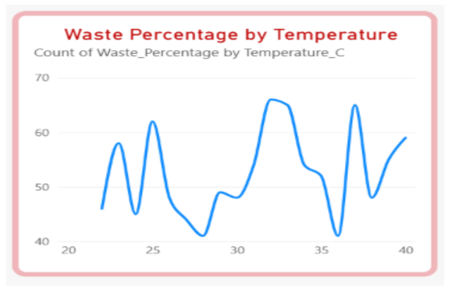

BAR CHART
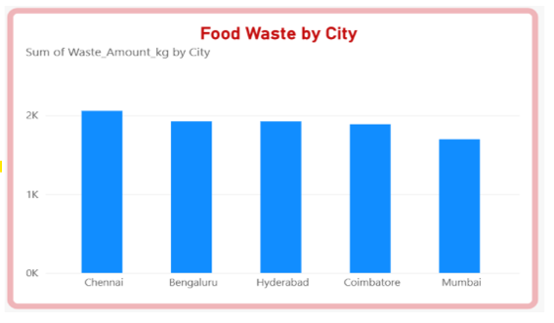

PIE CHART
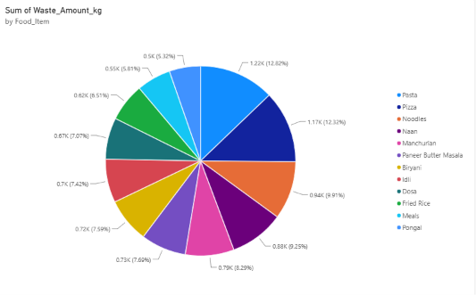

RESULT

