Ex.no:6c | DATA VISUALIZATION USING POWER BI  (FOOD WASTE PREDICTION)

Aim:
To clean, preprocess, and transform the raw Food Waste Prediction dataset, load the cleaned data into Power BI, and build an interactive visual dashboard to analyze food preparation, sales, remaining food, and food waste patterns.
Algorithm:
- Import Dataset: Load Food_Waste_Prediction_Dataset.csv into the environment.
- Deduplication: Identify and delete duplicate rows across all fields.
- Remove Blank Rows: Identify and remove completely blank records from the dataset.
- Handle Missing Values: Identify missing values in each column and replace or remove them appropriately to maintain data consistency.
- Handle Data Type Errors: Convert numerical attributes such as Prepared_Quantity, Sold_Quantity, Remaining_Quantity, and Waste_Amount_kg into appropriate numerical data types.
- Clean Text Data: Remove unnecessary spaces and standardize categorical values such as Restaurant_Name, City, and Food_Item.
- Create Waste Calculation: Calculate the remaining food quantity and food waste values where required using the prepared and sold quantities.
- Load Clean Data: Load the cleaned Food Waste dataset into Power BI Desktop using Get Data → Text/CSV and select Transform Data if further cleaning is required.
- Create Core Metric: Create a measure in Power BI to calculate the total food waste.
Total Food Waste = SUM(Food_Waste_Prediction[Waste_Amount_kg])
- Create Dashboard: Build interactive visualizations such as KPI cards, bar charts, pie/donut charts, and slicers to analyze restaurant-wise, city-wise, and food-item-wise waste patterns.

Output:
1.BAR CHART
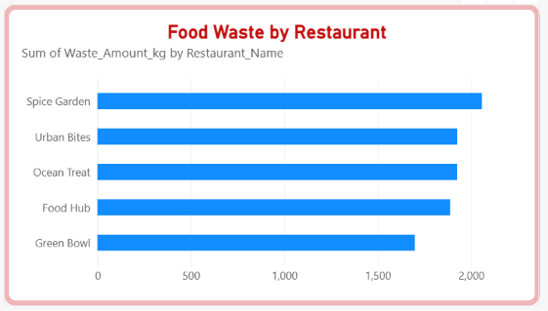
2.Column Chart
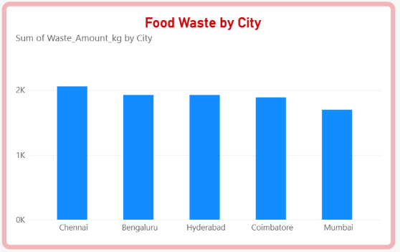

3.Donut Chart
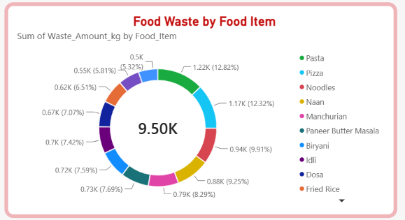
4.KPI CARD
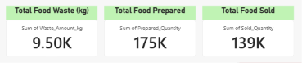
5.Line Chart
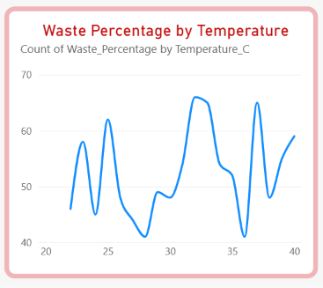

6.Clustered Column Chart
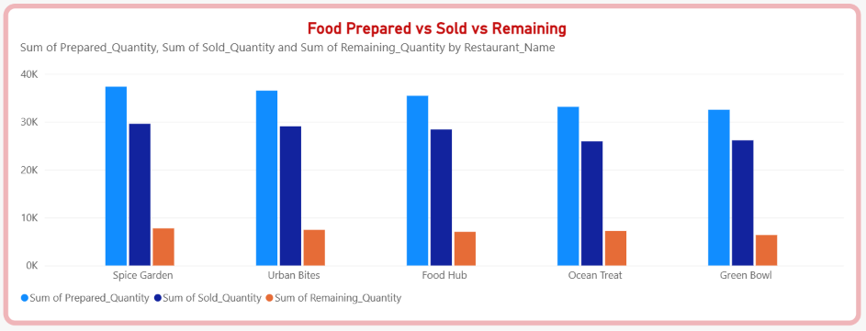

7.DASHBOARD

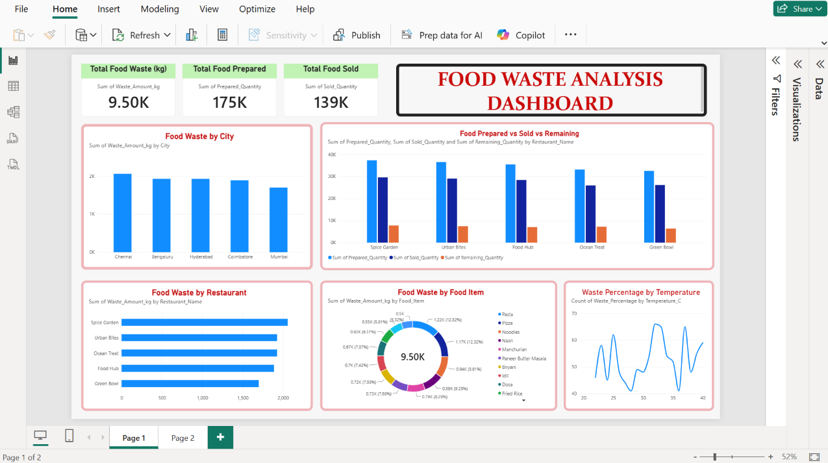

Result:

