Ex.no:7b | DATA VISUALIZATION USING TABLEAU-  FOOD WASTE PREDICTION DATASET

Aim

To connect, analyze, visualize, and create an interactive dashboard using Tableau with the Food Waste Prediction Dataset to analyze food waste patterns, restaurant-wise waste, city-wise waste, food-item distribution, waste percentage, and the factors influencing food waste.

Software Requirements

• Tableau Desktop / Tableau Public
• Microsoft Excel
• CSV Dataset
• Windows Operating System

Theory

Tableau is a powerful Business Intelligence (BI) and Data Visualization tool used to create interactive dashboards and reports.

The Food Waste Prediction Dataset contains information related to food preparation, sales, remaining food, and waste generated by different restaurants.

The dataset includes:

• City
• Cuisine
• Date
• Food Item
• Holiday
• Restaurant ID
• Restaurant Name
• Weather
• Weekend
• Customers
• Discount Percent
• Prepared Quantity
• Remaining Quantity
• Sold Quantity
• Temperature
• Waste Amount
• Waste Percentage

Tableau allows users to analyze this data and identify food waste trends, high-waste restaurants, city-wise waste patterns, food-item contributions, and waste percentages.

Tableau Architecture

Food Waste Prediction Dataset

↓

Data Connection

↓

Worksheets

↓

Visualizations

↓

Dashboard

↓

Story

Learning Outcomes

After completing this experiment, students will be able to:

✓ Connect the Food Waste Prediction Dataset to Tableau

✓ Create worksheets using dimensions and measures

✓ Generate different charts and visualizations

✓ Analyze food waste trends over time

✓ Compare waste across cities and restaurants

✓ Analyze food-item-wise waste distribution

✓ Apply filters and parameters

✓ Create calculated fields

✓ Build interactive dashboards

✓ Create stories for food waste analysis

Sample Dataset

Food Waste Prediction Dataset

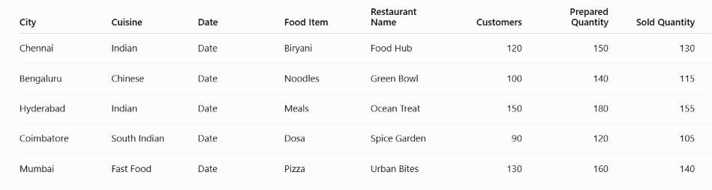

The actual GTD contains a much larger number of records and columns.

Algorithm 1 – Connecting Data Source

Step 1

Open Tableau Desktop.

Step 2

Select Connect.

Step 3

Choose Microsoft Excel or Text File depending on the dataset format.

Step 4

Browse and select the Food Waste Prediction Dataset.

Step 5

Open the dataset.

Step 6

Verify the imported fields such as:
- City
- Cuisine
- Date
- Food Item
- Restaurant Name
- Customers
- Prepared Quantity
- Sold Quantity
- Remaining Quantity
- Waste Amount kg
- Waste Percentage

Procedure

Tableau

↓

Connect

↓

Excel / Text File

↓

Food Waste Prediction Dataset

↓

Open

↓

Verify Data

Output

Food Waste Prediction Dataset loaded into Tableau successfully.

Algorithm 2 – Creating Worksheet

Step 1

Open Sheet 1.

Step 2

Drag City to Rows.

Step 3

Drag Waste Amount kg to Columns.

Step 4

Select Bar Chart from the visualization options.

Step 5

Enable Show Mark Labels to display the total waste amount for each city.

Step 6

Sort the cities in descending order based on Waste Amount kg.

Step 7

Add the title City Food Waste.

Output

Worksheet created successfully.

Interpretation

The bar chart displays the total food waste generated by each city. It helps compare waste levels across cities and identify the cities generating the highest and lowest amounts of food waste.

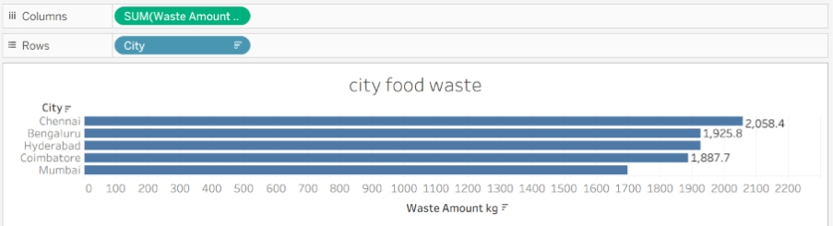

Algorithm 3 – Bar Chart Creation

Objective

To compare the amount of food waste across different restaurants.

Step 1

Drag Restaurant Name → Rows.

Step 2

Drag Waste Amount kg → Columns.

Step 3

Select Bar Chart from Show Me.

Step 4

Enable Show Mark Labels.

Step 5

Sort the restaurants in descending order

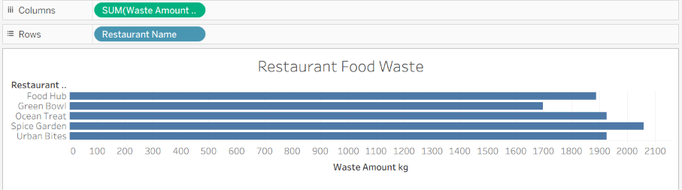
Output Visualization

Interpretation

The bar chart helps identify restaurants generating higher and lower amounts of food waste.

Algorithm 4 – Pie Chart Creation

Objective

To analyze the distribution of food waste based on different food items.

Step 1

Drag Food Item to the view.

Step 2

Select Pie Chart from Show Me.

Step 3

Drag Waste Amount kg to Angle.

Step 4

Drag Food Item to Color.

Step 5

Enable Show Labels.

Output Visualization

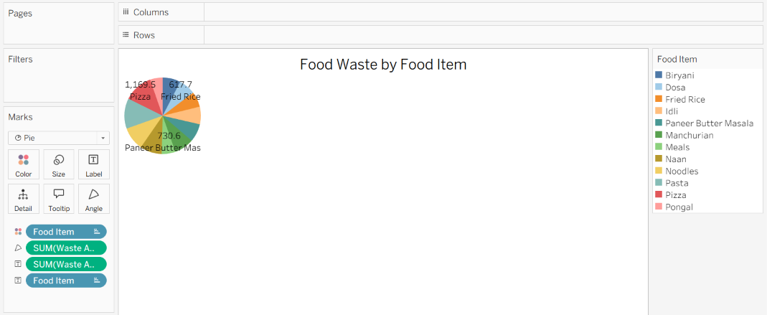
Food Waste by Food Item Pie Chart

Interpretation

The pie chart shows the contribution of different food items to the total food waste.

Algorithm 5 – Line Chart Creation

Objective

To analyze the trend of food waste over time.

Step 1

Drag Date → Columns.

Step 2

Drag Waste Amount kg → Rows.

Step 3

Select Line Chart.

Step 4

Enable data labels if required.

Step 5

Analyze the waste trend over different dates.

Output Visualization

Food Waste Trend Over Time

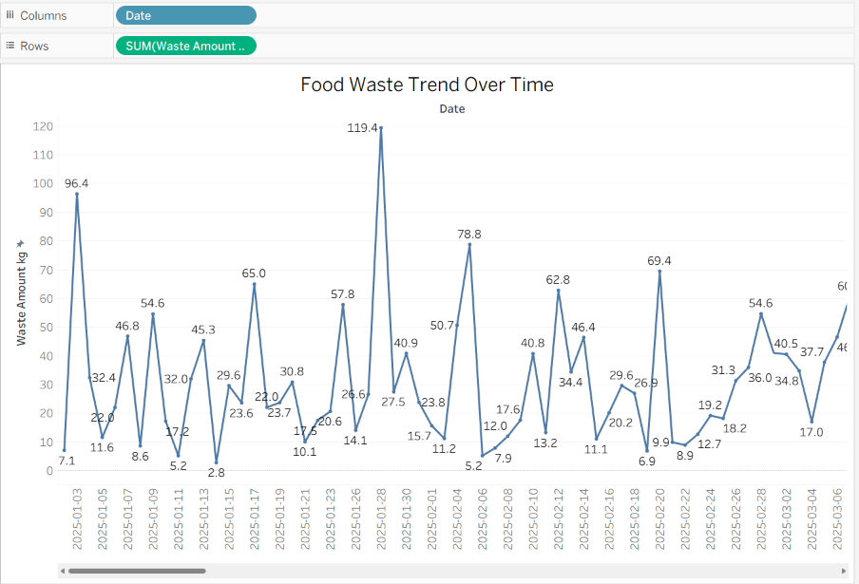

Interpretation

The line chart shows how food waste changes over time.

It helps identify:

• Increasing waste trends

• Decreasing waste trends

• Peak waste periods

• Low waste periods

• Changes in food waste generation

Algorithm 6 – Creating Calculated Field

Objective

To calculate the percentage of prepared food that remains unsold.

Step 1

Select:

Analysis → Create Calculated Field

Step 2

Enter the field name:

Remaining Food Percentage

Step 3

Enter the formula:

([Remaining Quantity] / [Prepared Quantity]) * 100

Step 4

Click OK.

Output
Restaurant Name | Prepared Quantity | Remaining Quantity | Remaining Food Percentage
Food Hub | 150 | 20 | 13.33%
Green Bowl | 140 | 25 | 17.86%
Ocean Treat | 180 | 25 | 13.89%

Interpretation

The calculated field determines the percentage of prepared food that remains unsold, helping identify restaurants with higher leftover food.

Algorithm 7 – Applying Filters

Objective

To analyze food waste for a specific city.

Step 1

Drag City to the Filters shelf.

Step 2

Select the required city.

Step 3

Click Show Filter.

Step 4

Select a city such as Chennai.

Step 5

Observe the updated charts.

Example

Filter: City = Chennai

Output

The visualizations display only food waste records belonging to Chennai.

Interpretation

The City filter allows users to focus on a particular location and perform detailed food waste analysis.

Algorithm 8 – Creating Parameter

Objective

To dynamically display restaurants based on a user-defined minimum food waste value.

Step 1

Select:

Create Parameter

Step 2

Specify the parameter name:

Minimum Waste Amount

Step 3

Set the data type as:

Float

Step 4

Set the required minimum value.

Step 5

Create a calculated field using the parameter.

Formula

[Waste Amount kg] >= [Minimum Waste Amount]

Example

Minimum Waste Amount = 30

Output

The visualization displays records where the Waste Amount is 30 kg or more.

Interpretation

The parameter allows users to dynamically identify high-food-waste records based on a selected threshold.

Algorithm 9 – Dashboard Creation

Objective

To create an interactive Food Waste Analysis Dashboard.

Step 1

Create multiple worksheets.

Step 2

Select Dashboard → New Dashboard.

Step 3

Drag the required worksheets into the dashboard.

Step 4

Arrange the charts clearly.

Step 5

Add filters for:
- City
- Cuisine
- Food Item
- Restaurant Name
- Weather
- Weekend
- Holiday

Step 6

Add the Minimum Waste Amount parameter.

Step 7

Add appropriate titles and labels.

Dashboard Analysis

Total Food Waste

Sum of Waste Amount kg.

Average Waste Percentage

Average of Waste Percentage.

Total Prepared Quantity

Sum of Prepared Quantity.

Total Sold Quantity

Sum of Sold Quantity.

Total Remaining Quantity

Sum of Remaining Quantity.

Interpretation

The dashboard provides a consolidated view of food waste generation, restaurant performance, food-item contribution, and waste trends and allows users to interactively analyze the data using filters and parameters.

Algorithm 10 – Story Creation

Objective

To present the analysis of food waste generation and restaurant performance through a sequence of visual insights.

Step 1

Create the required worksheets.

Step 2

Create the Food Waste Analysis Dashboard.

Step 3

Select Story → New Story.

Step 4

Add the dashboard and required worksheets as story points.

Step 5

Arrange the story points in a logical sequence.

Step 6

Present the findings.

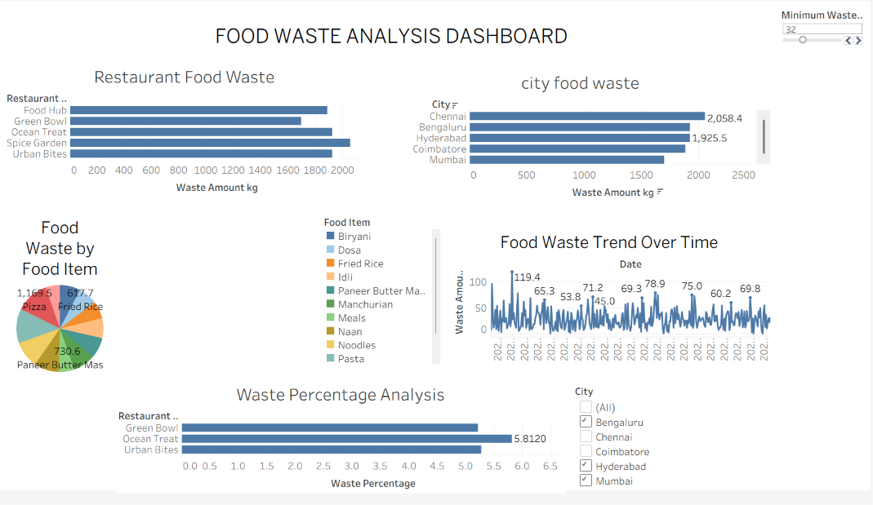

Example Story

Story Point 1

Overall Food Waste Analysis

Displays total food waste, average waste percentage, prepared quantity, sold quantity, and remaining quantity.

Story Point 2

Food Waste Trend Over Time

Shows how food waste changes across different dates.

Story Point 3

City-wise Food Waste Analysis

Compares food waste generated across different cities.

Story Point 4

Food Item-wise Waste Analysis

Shows which food items contribute the most to total food waste.

Story Point 5

Restaurant-wise Waste Analysis

Compares waste amounts across different restaurants.

Story Point 6

Final Food Waste Analysis

Summarizes the major patterns and observations obtained from the dataset.

Applications

Restaurant Management

Analysis of food preparation, sales, remaining food, and waste generation.

Food Waste Reduction

Identification of restaurants and food items generating high amounts of waste.

Demand Planning

Analysis of customer counts, food sales, and historical waste patterns for better preparation planning.

Business Intelligence

Interactive visualization and dashboard-based food waste analysis.

Decision Making

Identification of high-waste locations, restaurants, and food items for better operational planning.

Sustainability Analysis

Monitoring food waste and identifying opportunities to reduce unnecessary food disposal.

Data Analytics

Interactive visualization and exploratory analysis of food waste patterns.

Result

