Ex.no:2 | EDA-DATA IMPORT AND EXPORT

Aim:
To inspect dataset features, detect null values, and export data into CSV, Excel, and SQLite database formats.
Algorithm:
- Import pandas and sqlite3 libraries.
- Read Food_Waste_Output.csv using pd.read_csv().
- Inspect the data structure using .head(), .tail(), .info(), .describe(), and .isnull().sum().
- Export the DataFrame to .csv and .xlsx formats using .to_csv() and .to_excel().
- Connect to food_waste.db using sqlite3 and write the data into an SQL table using .to_sql().
- Close the database connection and end execution.
Program:
import os
import pandas as pd
path = "/content"
print("Dataset path:", path)
print("\nFiles in dataset:")
print(os.listdir(path))
csv_files = [f for f in os.listdir(path) if f.lower().endswith(".csv")]
if not csv_files:
raise FileNotFoundError("No CSV file found in the dataset path.")
csv_file = csv_files[0]
print("\nCSV file:", csv_file)
df = pd.read_csv(
os.path.join(path, csv_file),
encoding="latin1",
low_memory=False
)
print("\nFirst 5 rows:")
display(df.head())
print("\nLast 5 rows:")
display(df.tail())
print("\nDataset information:")
df.info()
print("\nShape:")
print(df.shape)
print("\nColumns:")
print(df.columns.tolist())
print("\nData types:")
print(df.dtypes)
print("\nStatistical description:")
display(df.describe(include="all").T)
print("\nMissing values:")
display(df.isnull().sum().sort_values(ascending=False))
print("\nDuplicate rows:")
print(df.duplicated().sum())
print("\nRestaurant names:")
display(df["Restaurant_Name"].value_counts())
print("\nCities:")
display(df["City"].value_counts())
print("\nCuisine types:")
display(df["Cuisine"].value_counts())
print("\nFood items:")
display(df["Food_Item"].value_counts())
print("\nWeather conditions:")
display(df["Weather"].value_counts())
print("\nWeekend status:")
display(df["Weekend"].value_counts())
print("\nHoliday status:")
display(df["Holiday"].value_counts())
print("\nTop restaurants based on food waste:")
display(
df.groupby("Restaurant_Name")["Waste_Amount_kg"]
.sum()
.sort_values(ascending=False)
.head(10)
)
print("\nTop cities based on food waste:")
display(
df.groupby("City")["Waste_Amount_kg"]
.sum()
.sort_values(ascending=False)
)
print("\nTop food items based on food waste:")
display(
df.groupby("Food_Item")["Waste_Amount_kg"]
.sum()
.sort_values(ascending=False)
)
print("\nCorrelation:")
display(df.corr(numeric_only=True))
df["Remaining_Quantity_Calculated"] = (
df["Prepared_Quantity"] - df["Sold_Quantity"]
)
print("\nCalculated Remaining Quantity:")
display(
df[
[
"Prepared_Quantity",
"Sold_Quantity",
"Remaining_Quantity_Calculated"
]
].head()
)

df["Waste_Percentage"] = (
df["Waste_Amount_kg"] /
df["Prepared_Quantity"]
) * 100

print("\nWaste Percentage:")

display(
df[
[
"Restaurant_Name",
"Prepared_Quantity",
"Waste_Amount_kg",
"Waste_Percentage"
]
].head()
)
df.to_excel(
"food_waste_data.xlsx",
index=False
)
df.to_json(
"food_waste_data.json",
orient="records",
indent=4
)
df.to_csv(
"food_waste_data.csv",
index=False)
print("\nCSV, Excel and JSON files created successfully.")

Output:
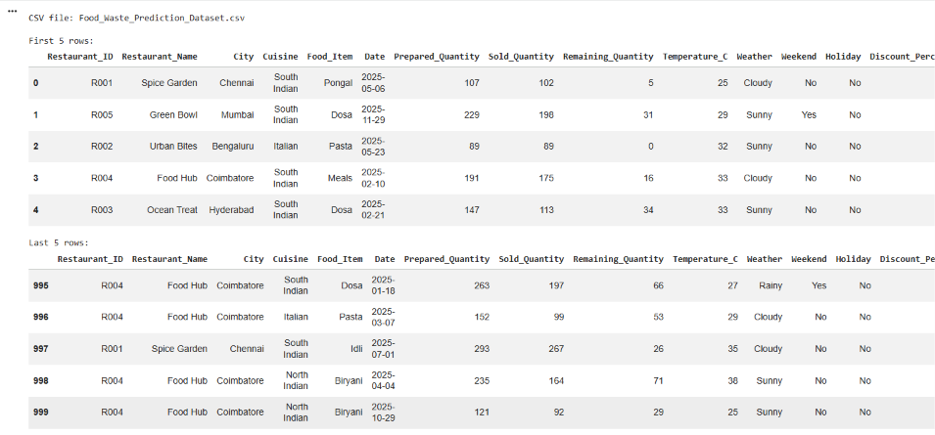

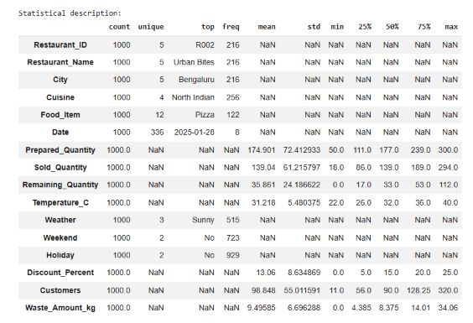

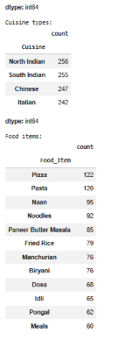
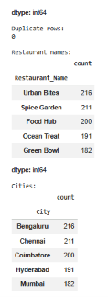
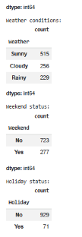

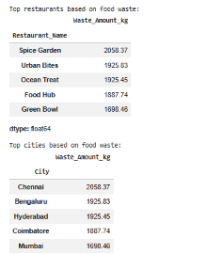
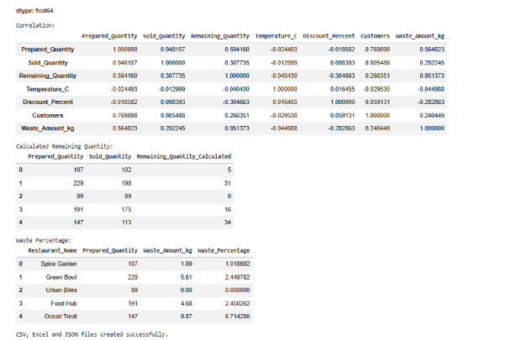

Result:

