Ex.no:4b | EXPLORATORY DATA ANALYSIS (EDA) – DATA INSPECTION, FILTERING, STATISTICAL ANALYSIS AND CORRELATION

AIM

To perform data inspection, filtering, sorting, grouping, aggregation, descriptive statistical analysis, and correlation analysis on the Food Waste Analysis dataset using Pandas, and to visualize the analytical results using Matplotlib.

ALGORITHM
Algorithm 1: Dataset Inspection
- Import the Food Waste Analysis dataset.
- Display the first few records of the dataset.
- Check the dimensions of the dataset.
- Display the data types of the attributes.
- Generate a statistical summary of the numerical attributes.
Algorithm 2: Filtering Data
- Select the required attribute such as Waste Amount or Customers.
- Specify a suitable filtering condition.
- Apply the condition to the dataset.
- Display the filtered records.
Algorithm 3: Sorting Data
- Select the attribute to be sorted such as Waste Amount or Customers.
- Apply the sort_values() function.
- Specify the sorting order.
- Display the sorted dataset.
Algorithm 4: Statistical Analysis
- Select the required numerical attribute such as Waste Amount.
- Calculate the mean.
- Calculate the median.
- Calculate the mode.
- Calculate the standard deviation.
- Display the calculated statistical measures
Algorithm 5: Grouping and Aggregation
- Select a categorical attribute such as City, Restaurant Name, or Food Item.
- Apply the groupby() function.
- Select the required numerical attribute such as Waste Amount.
- Calculate an aggregate measure such as mean or sum.
- Display the grouped results.
Algorithm 6: Correlation Analysis
- Select the required numerical attributes such as Prepared Quantity, Sold Quantity, Customers, and Waste Amount.
- Apply the corr() function.
- Generate the correlation matrix.
- Analyze the correlation coefficient between the selected attributes.
- Visualize the relationship using an appropriate graph.

CODE
import kagglehub
import pandas as pd
import numpy as np
import matplotlib.pyplot as plt
import seaborn as sns
import os

# ============================================================
# LOAD DATASET FROM KAGGLE
# ============================================================
import kagglehub
import os
import pandas as pd
import numpy as np

path = "/content"

print("Dataset Path:")

print(path)

csv_files = [f for f in os.listdir(path) if f.endswith(".csv")]

print("\nCSV Files Found:")

print(csv_files)

csv_file = "Food_Waste_Output.csv"

print("\nSelected CSV File:")

print(csv_file)

df = pd.read_csv(
os.path.join(path, csv_file),
encoding="latin1",
low_memory=False
)

print("\nDataset Loaded Successfully")

# ============================================================

# PROGRAM 1 - DATA INSPECTION

# ============================================================

print("\nFirst 5 Records")

print(df.head())

print("\nLast 5 Records")

print(df.tail())

# ============================================================

# PROGRAM 2 - SHAPE

# ============================================================

print("\nShape of Dataset")

print(df.shape)

print("\nRows =", df.shape[0])

print("Columns =", df.shape[1])

# ============================================================

# PROGRAM 3 - DATA TYPES

# ============================================================

print("\nData Types")

print(df.dtypes)

print("\nDataset Info")

df.info()

# ============================================================

# PROGRAM 4 - FILTERING

# Food Waste Greater Than 10 kg

# ============================================================

high_waste = df[df["Waste_Amount_kg"] > 10]

print("\nRecords with Food Waste Greater Than 10 kg")

print(
high_waste[
[
"Restaurant_Name",
"City",
"Food_Item",
"Prepared_Quantity",
"Sold_Quantity",
"Waste_Amount_kg"
]
].head(10)
)

# ============================================================

# PROGRAM 5 - FILTER HIGH CUSTOMER COUNT

# ============================================================

high_customers = df[df["Customers"] > 100]

print("\nRecords with Customers Greater Than 100")

print(
high_customers[
[
"Restaurant_Name",
"City",
"Food_Item",
"Customers",
"Prepared_Quantity",
"Waste_Amount_kg"
]
].head(10)
)
# ============================================================

# PROGRAM 6 - SORTING

# Sort by Waste Amount

# ============================================================

sorted_df = df.sort_values(
by="Waste_Amount_kg",
ascending=False
)

print("\nTop Records by Food Waste Amount")

print(
sorted_df[
[
"Restaurant_Name",
"City",
"Food_Item",
"Prepared_Quantity",
"Sold_Quantity",
"Waste_Amount_kg"
]
].head(10)
)

# ============================================================

# BAR CHART

# TOP 10 RECORDS BY FOOD WASTE

# ============================================================

top10 = sorted_df.head(10)

plt.figure(figsize=(10, 5))

plt.bar(
range(len(top10)),
top10["Waste_Amount_kg"]
)

plt.xticks(
range(len(top10)),
top10["Restaurant_Name"],
rotation=90
)

plt.xlabel("Restaurant")

plt.ylabel("Waste Amount (kg)")

plt.title("Top 10 Restaurants by Food Waste")

plt.show()

# ============================================================

# PROGRAM 7 - STATISTICAL ANALYSIS

# ============================================================

print("\nMean Food Waste =")

print(df["Waste_Amount_kg"].mean())

print("\nMedian Food Waste =")

print(df["Waste_Amount_kg"].median())

print("\nMode Food Waste =")

print(df["Waste_Amount_kg"].mode())

print("\nStandard Deviation =")

print(df["Waste_Amount_kg"].std())

print("\nMinimum Food Waste =")

print(df["Waste_Amount_kg"].min())

print("\nMaximum Food Waste =")

print(df["Waste_Amount_kg"].max())

# ============================================================

# PROGRAM 8 - DESCRIPTIVE STATISTICS

# ============================================================

print("\nDescriptive Statistics")

print(
df[
[
"Prepared_Quantity",
"Sold_Quantity",
"Remaining_Quantity",
"Customers",
"Discount_Percent",
"Waste_Amount_kg"
]
].describe()
)

# ============================================================

# PROGRAM 9 - GROUPING

# Average Food Waste by City

# ============================================================

group = df.groupby(
"City"
)["Waste_Amount_kg"].mean().sort_values(ascending=False)

print("\nAverage Food Waste by City")

print(group)

# Visualization

group.plot(
kind="bar",
figsize=(8, 5)
)

plt.xlabel("City")

plt.ylabel("Average Food Waste (kg)")

plt.title("Average Food Waste by City")

plt.xticks(rotation=45)

plt.show()

# ============================================================

# PROGRAM 10 - AGGREGATION

# ============================================================

summary = df.groupby("City").agg({

"Waste_Amount_kg": "mean",

"Prepared_Quantity": "mean",

"Sold_Quantity": "mean",

"Customers": "mean"

})

print("\nCity-wise Aggregation")

print(summary)
# ============================================================

# PROGRAM 11 - CORRELATION

# ============================================================

numeric = df.select_dtypes(
include=np.number
)

corr = numeric.corr()

print("\nCorrelation Matrix")

print(corr)

plt.figure(figsize=(12, 8))

sns.heatmap(
corr,
annot=False,
cmap="coolwarm"
)

plt.title("Food Waste Prediction Dataset Correlation Heatmap")

plt.show()

# ============================================================

# PROGRAM 12 - SCATTER PLOT

# Prepared Quantity vs Waste Amount

# ============================================================

plt.figure(figsize=(7, 5))

plt.scatter(
df["Prepared_Quantity"],
df["Waste_Amount_kg"]
)

plt.xlabel("Prepared Quantity")

plt.ylabel("Waste Amount (kg)")

plt.title("Prepared Quantity vs Food Waste")

plt.show()

# ============================================================

# PROGRAM 13 - HISTOGRAM

# Food Waste Distribution

# ============================================================

plt.figure(figsize=(7, 5))

plt.hist(
df["Waste_Amount_kg"].dropna(),
bins=30
)

plt.xlabel("Waste Amount (kg)")

plt.ylabel("Frequency")

plt.title("Distribution of Food Waste")

plt.show()

# ============================================================

# PROGRAM 14 - BOXPLOT

# ============================================================

plt.figure(figsize=(7, 5))

sns.boxplot(
x=df["Waste_Amount_kg"].dropna()
)

plt.title("Food Waste Boxplot")

plt.xlabel("Waste Amount (kg)")

plt.show()

# ============================================================

# PROGRAM 15 - VALUE COUNTS

# ============================================================

print("\nRestaurant Counts")

print(
df["Restaurant_Name"].value_counts()
)

# ============================================================

# PROGRAM 16 - UNIQUE VALUES

# ============================================================

print("\nUnique Restaurants")

print(
df["Restaurant_Name"].unique()
)

print("\nUnique Cities")

print(
df["City"].unique()
)

print("\nUnique Cuisine Types")

print(
df["Cuisine"].unique()
)

print("\nUnique Food Items")

print(
df["Food_Item"].unique()
)

# ============================================================

# PROGRAM 17 - TOP 10 RESTAURANTS BY FOOD WASTE

# ============================================================

print("\nTop 10 Restaurants by Food Waste")

restaurant_waste = (
df.groupby("Restaurant_Name")["Waste_Amount_kg"]
.sum()
.sort_values(ascending=False)
.head(10)
)

print(restaurant_waste)

# ============================================================

# PROGRAM 18 - FOOD WASTE BY CITY

# ============================================================

print("\nFood Waste by City")

city_waste = (
df.groupby("City")["Waste_Amount_kg"]
.sum()
.sort_values(ascending=False)
)

print(city_waste)

# ============================================================

# PROGRAM 19 - TOP 10 FOOD ITEMS BY FOOD WASTE

# ============================================================

print("\nTop 10 Food Items by Food Waste")

food_waste = (
df.groupby("Food_Item")["Waste_Amount_kg"]
.sum()
.sort_values(ascending=False)
.head(10)
)

print(food_waste)

# ============================================================

# PROGRAM 20 - MOST COMMON CUISINES

# ============================================================

print("\nMost Common Cuisine Types")

cuisines = (
df["Cuisine"]
.value_counts()
.head(10)
)

print(cuisines)
# ============================================================
# PROGRAM 21 - EXPORT DATA
============================================================

df.to_csv(
"food_waste_data.csv",
index=False
)
df.to_excel(
"food_waste_data.xlsx",
index=False
)
df.to_json(
"food_waste_data.json",
orient="records",
indent=4
)

print("\nCSV, Excel and JSON files exported successfully.")
# ============================================================
# FINAL REPORT
# ============================================================
print("\n==============================================")
print("EXPERIMENT COMPLETED SUCCESSFULLY")
print("==============================================")
print("Dataset Shape :", df.shape)
print(
"Missing Values :",
df.isnull().sum().sum()
)
print(
"Total Records :",
len(df)
)
print(
"Total Prepared Quantity :",
df["Prepared_Quantity"].sum()
)

print(
"Total Sold Quantity :",
df["Sold_Quantity"].sum()
)

print(
"Total Food Waste :",
df["Waste_Amount_kg"].sum()
)

print(
"Average Food Waste :",
df["Waste_Amount_kg"].mean()
)
print(
"Number of Restaurants :",
df["Restaurant_Name"].nunique()
)
print(
"Number of Cities :",
df["City"].nunique()
)
print(
"Number of Cuisines :",
df["Cuisine"].nunique()
)
print(
"Number of Food Items :",
df["Food_Item"].nunique()
)
print("Correlation Matrix Generated")
print("==============================================")
OUTPUT:
Dataset Path:
/content/Food_Waste_Prediction_Dataset.csv

CSV File Found:
Food_Waste_Prediction_Dataset.csv

Dataset Loaded Successfully

First 5 Records
Restaurant_ID Restaurant_Name City Cuisine Food_Item \
0 R001 Spice Garden Chennai South Indian Pongal
1 R005 Green Bowl Mumbai South Indian Dosa
2 R002 Urban Bites Bengaluru Italian Pasta
3 R004 Food Hub Coimbatore South Indian Meals
4 R003 Ocean Treat Hyderabad South Indian Dosa

Date Prepared_Quantity Sold_Quantity Remaining_Quantity \
0 2025-05-06 107 102 5
1 2025-11-29 229 198 31
2 2025-05-23 89 89 0
3 2025-02-10 191 175 16
4 2025-02-21 147 113 34

Temperature_C Weather Weekend Holiday Discount_Percent Customers \
0 25 Cloudy No No 20 121
1 29 Sunny Yes No 10 102
2 32 Sunny No No 15 54
3 33 Cloudy No No 25 195
4 33 Sunny No No 10 53

Waste_Amount_kg
0 1.09
1 5.61
2 0.00
3 4.68
4 9.87

Last 5 Records
Restaurant_ID Restaurant_Name City Cuisine Food_Item \
995 R004 Food Hub Coimbatore South Indian Dosa
996 R004 Food Hub Coimbatore Italian Pasta
997 R001 Spice Garden Chennai South Indian Idli
998 R004 Food Hub Coimbatore North Indian Biryani
999 R004 Food Hub Coimbatore North Indian Biryani

Date Prepared_Quantity Sold_Quantity Remaining_Quantity \
995 2025-01-18 263 197 66
996 2025-03-07 152 99 53
997 2025-07-01 293 267 26
998 2025-04-04 235 164 71
999 2025-10-29 121 92 29

Temperature_C Weather Weekend Holiday Discount_Percent Customers \
995 27 Rainy Yes No 5 129
996 29 Cloudy No No 0 77
997 35 Cloudy No No 25 135
998 38 Sunny No No 0 95
999 25 Sunny No No 15 72

Waste_Amount_kg
995 17.82
996 15.02
997 5.96
998 17.36
999 8.00

Shape of Dataset
(1000, 16)

Rows = 1000
Columns = 16

Data Types
Restaurant_ID object
Restaurant_Name object
City object
Cuisine object
Food_Item object
Date object
Prepared_Quantity int64
Sold_Quantity int64
Remaining_Quantity int64
Temperature_C int64
Weather object
Weekend object
Holiday object
Discount_Percent int64
Customers int64
Waste_Amount_kg float64
dtype: object

Dataset Info
<class 'pandas.core.frame.DataFrame'>
RangeIndex: 1000 entries, 0 to 999
Data columns (total 16 columns):
# Column Non-Null Count Dtype
--- ------ -------------- -----
0 Restaurant_ID 1000 non-null object
1 Restaurant_Name 1000 non-null object
2 City 1000 non-null object
3 Cuisine 1000 non-null object
4 Food_Item 1000 non-null object
5 Date 1000 non-null object
6 Prepared_Quantity 1000 non-null int64
7 Sold_Quantity 1000 non-null int64
8 Remaining_Quantity 1000 non-null int64
9 Temperature_C 1000 non-null int64
10 Weather 1000 non-null object
11 Weekend 1000 non-null object
12 Holiday 1000 non-null object
13 Discount_Percent 1000 non-null int64
14 Customers 1000 non-null int64
15 Waste_Amount_kg 1000 non-null float64
dtypes: float64(1), int64(6), object(9)
memory usage: 125.1+ KB

Records with Food Waste Greater Than 10 kg
Restaurant_Name City Food_Item Prepared_Quantity \
8 Ocean Treat Hyderabad Paneer Butter Masala 176
9 Food Hub Coimbatore Pasta 270
10 Ocean Treat Hyderabad Pongal 90
11 Green Bowl Mumbai Paneer Butter Masala 245
13 Food Hub Coimbatore Naan 273
15 Spice Garden Chennai Paneer Butter Masala 270
19 Urban Bites Bengaluru Naan 173
26 Green Bowl Mumbai Manchurian 290
27 Ocean Treat Hyderabad Biryani 268
28 Ocean Treat Hyderabad Idli 247

Sold_Quantity Waste_Amount_kg
8 99 14.69
9 226 13.67
10 53 11.95
11 183 11.37
13 188 25.60
15 218 14.13
19 129 15.29
26 240 10.79
27 192 19.15
28 189 11.18

Records with Customers Greater Than 100
Restaurant_Name City Food_Item Customers \
0 Spice Garden Chennai Pongal 121
1 Green Bowl Mumbai Dosa 102
3 Food Hub Coimbatore Meals 195
6 Ocean Treat Hyderabad Dosa 128
9 Food Hub Coimbatore Pasta 122
11 Green Bowl Mumbai Paneer Butter Masala 145
13 Food Hub Coimbatore Naan 106
14 Food Hub Coimbatore Noodles 102
15 Spice Garden Chennai Paneer Butter Masala 147
16 Green Bowl Mumbai Pizza 110

Prepared_Quantity Waste_Amount_kg
0 107 1.09
1 229 5.61
3 191 4.68
6 256 8.65
9 270 13.67
11 245 11.37
13 273 25.60
14 165 9.80
15 270 14.13
16 256 6.24
Top Records by Food Waste Amount
Restaurant_Name City Food_Item Prepared_Quantity Sold_Quantity \
693 Ocean Treat Hyderabad Pasta 266 168
696 Spice Garden Chennai Pizza 235 128
278 Green Bowl Mumbai Manchurian 299 198
816 Spice Garden Chennai Pasta 239 148
316 Food Hub Coimbatore Meals 271 171
797 Food Hub Coimbatore Pasta 217 117
590 Ocean Treat Hyderabad Biryani 299 201
980 Ocean Treat Hyderabad Pasta 234 148
145 Urban Bites Bengaluru Noodles 293 201
893 Ocean Treat Hyderabad Pizza 280 192

Waste_Amount_kg
693 34.06
696 31.67
278 31.30
816 30.02
316 29.57
797 28.90
590 28.86
980 28.75
145 28.49
893 28.42
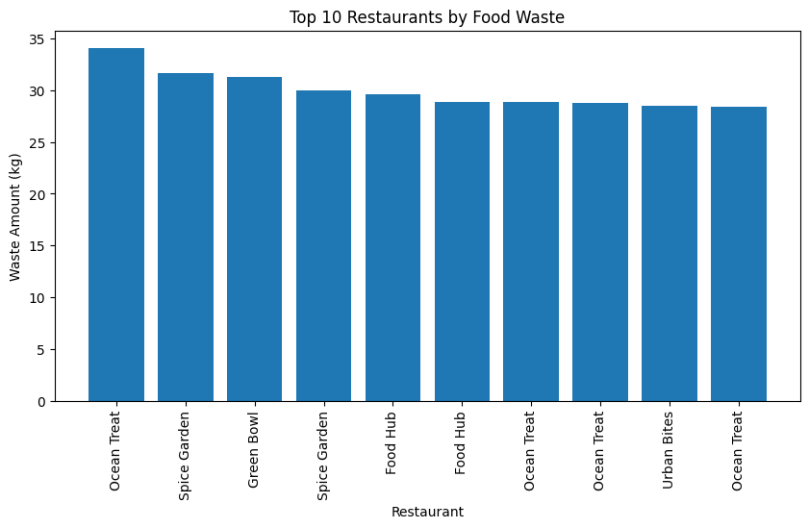

Mean Food Waste =
9.495849999999999

Median Food Waste =
8.375

Mode Food Waste =
0 0.0
Name: Waste_Amount_kg, dtype: float64

Standard Deviation =
6.696287833437881

Minimum Food Waste =
0.0

Maximum Food Waste =
34.06

Descriptive Statistics
Prepared_Quantity Sold_Quantity Remaining_Quantity Customers \
count 1000.000000 1000.000000 1000.000000 1000.000000
mean 174.901000 139.040000 35.861000 98.848000
std 72.412933 61.215797 24.186622 55.011591
min 50.000000 18.000000 0.000000 11.000000
25% 111.000000 86.000000 17.000000 56.000000
50% 177.000000 139.000000 33.000000 90.000000
75% 239.000000 189.000000 53.000000 128.250000
max 300.000000 294.000000 112.000000 320.000000

Discount_Percent Waste_Amount_kg
count 1000.000000 1000.000000
mean 13.060000 9.495850
std 8.634869 6.696288
min 0.000000 0.000000
25% 5.000000 4.385000
50% 15.000000 8.375000
75% 20.000000 14.010000
max 25.000000 34.060000

Average Food Waste by City
City
Hyderabad 10.080890
Chennai 9.755308
Coimbatore 9.438700
Mumbai 9.332198
Bengaluru 8.915880
Name: Waste_Amount_kg, dtype: float64
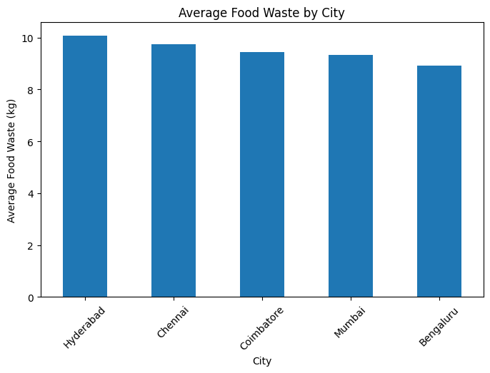

City-wise Aggregation
Waste_Amount_kg Prepared_Quantity Sold_Quantity Customers
City
Bengaluru 8.915880 169.018519 134.467593 96.500000
Chennai 9.755308 176.933649 140.165877 103.440758
Coimbatore 9.438700 177.150000 141.910000 99.150000
Hyderabad 10.080890 173.450262 135.670157 94.534031
Mumbai 9.332198 178.576923 143.543956 100.505495
Correlation Matrix
Prepared_Quantity Sold_Quantity Remaining_Quantity \
Prepared_Quantity 1.000000 0.948157 0.594160
Sold_Quantity 0.948157 1.000000 0.307735
Remaining_Quantity 0.594160 0.307735 1.000000
Temperature_C -0.024493 -0.012999 -0.040430
Discount_Percent -0.018582 0.098393 -0.304663
Customers 0.769898 0.805486 0.266351
Waste_Amount_kg 0.564823 0.292245 0.951373

Temperature_C Discount_Percent Customers \
Prepared_Quantity -0.024493 -0.018582 0.769898
Sold_Quantity -0.012999 0.098393 0.805486
Remaining_Quantity -0.040430 -0.304663 0.266351
Temperature_C 1.000000 0.016455 -0.029530
Discount_Percent 0.016455 1.000000 0.059131
Customers -0.029530 0.059131 1.000000
Waste_Amount_kg -0.044988 -0.282863 0.240449

Waste_Amount_kg
Prepared_Quantity 0.564823
Sold_Quantity 0.292245
Remaining_Quantity 0.951373
Temperature_C -0.044988
Discount_Percent -0.282863
Customers 0.240449
Waste_Amount_kg 1.000000
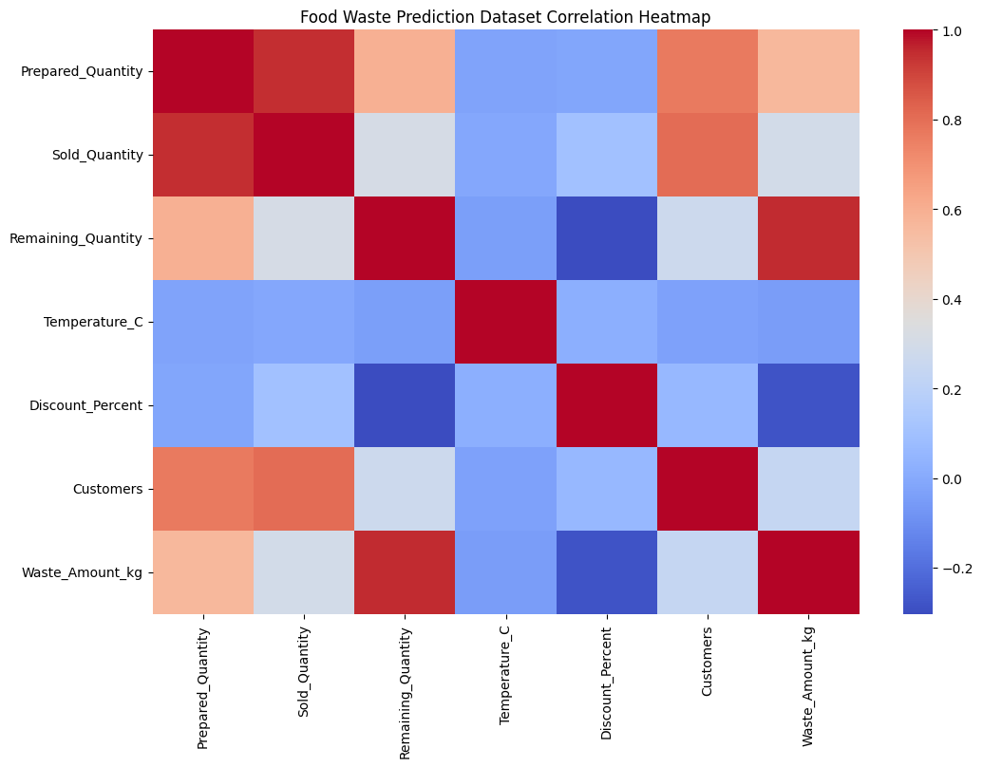
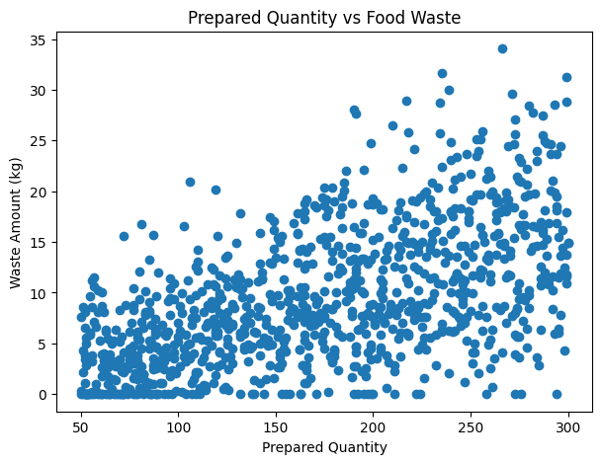
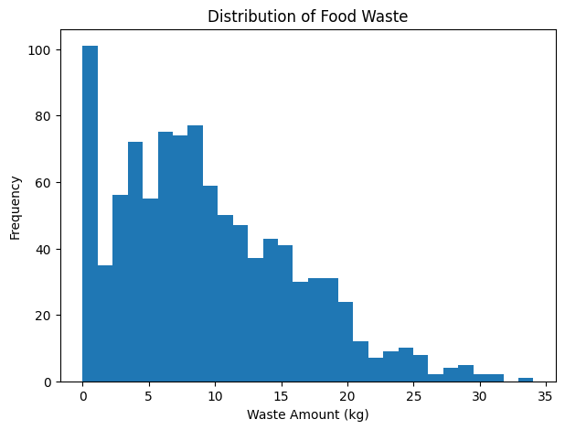
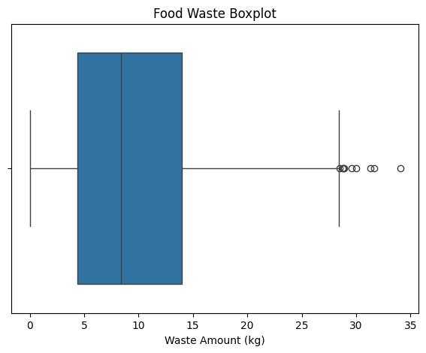

Restaurant Counts
Restaurant_Name
Urban Bites 216
Spice Garden 211
Food Hub 200
Ocean Treat 191
Green Bowl 182
Name: count, dtype: int64

Unique Restaurants
['Spice Garden' 'Green Bowl' 'Urban Bites' 'Food Hub' 'Ocean Treat']

Unique Cities
['Chennai' 'Mumbai' 'Bengaluru' 'Coimbatore' 'Hyderabad']

Unique Cuisine Types
['South Indian' 'Italian' 'North Indian' 'Chinese']

Unique Food Items
['Pongal' 'Dosa' 'Pasta' 'Meals' 'Biryani' 'Naan' 'Paneer Butter Masala'
'Fried Rice' 'Noodles' 'Pizza' 'Idli' 'Manchurian']

Top 10 Restaurants by Food Waste
Restaurant_Name
Spice Garden 2058.37
Urban Bites 1925.83
Ocean Treat 1925.45
Food Hub 1887.74
Green Bowl 1698.46
Name: Waste_Amount_kg, dtype: float64

Food Waste by City
City
Chennai 2058.37
Bengaluru 1925.83
Hyderabad 1925.45
Coimbatore 1887.74
Mumbai 1698.46
Name: Waste_Amount_kg, dtype: float64

Top 10 Food Items by Food Waste
Food_Item
Pasta 1217.42
Pizza 1169.46
Noodles 941.37
Naan 877.92
Manchurian 787.13
Paneer Butter Masala 730.63
Biryani 721.16
Idli 704.77
Dosa 671.38
Fried Rice 617.72
Name: Waste_Amount_kg, dtype: float64

Most Common Cuisine Types
Cuisine
North Indian 256
South Indian 255
Chinese 247
Italian 242
Name: count, dtype: int64
CSV, Excel and JSON files exported successfully.

==============================================
EXPERIMENT COMPLETED SUCCESSFULLY
==============================================
Dataset Shape : (1000, 16)
Missing Values : 0
Total Records : 1000
Total Prepared Quantity : 174901
Total Sold Quantity : 139040
Total Food Waste : 9495.849999999999
Average Food Waste : 9.495849999999999
Number of Restaurants : 5
Number of Cities : 5
Number of Cuisines : 4
Number of Food Items : 12
Correlation Matrix Generated
==============================================

RESULT

