Ex.no:5b | DATA VISUALIZATION USING MATPLOTLIB –  SALES DATA

AIM

To visualize and analyze the Food Waste Prediction dataset using Line Chart, Bar Chart, and Pie Chart with Matplotlib to understand food waste trends, restaurant-wise comparisons, and food-item waste distribution

ALGORITHM

Step 1: Import Pandas and Matplotlib libraries.

Step 2: Load the Food Waste Prediction dataset into a DataFrame.

Step 3: Group the food waste data according to city and calculate the total food waste for each city.

Step 4: Plot the city-wise food waste using a Line Chart to observe variations in food waste across cities.

Step 5: Group the dataset according to restaurant and calculate the total food waste for each restaurant.

Step 6: Plot the restaurant-wise food waste using a Bar Chart to compare food waste across different restaurants.

Step 7: Select the major food items and calculate their food waste proportions.

Step 8: Plot the food-item waste distribution using a Pie Chart.

Step 9: Add suitable titles, axis labels, legends, and display the visualizations.

CODE
import pandas as pd

import matplotlib.pyplot as plt

# Load Food Waste Prediction dataset

df = pd.read_csv(
"Food_Waste_Prediction_Dataset.csv",
encoding="latin1",
low_memory=False
)
# --------------------------------
# 1. Line Chart – Food Waste by City
# --------------------------------

city_waste = df.groupby("City")["Waste_Amount_kg"].sum()
plt.figure(figsize=(10, 5))
plt.plot(
city_waste.index,
city_waste.values,
marker="o"
)
plt.title("Food Waste by City")
plt.xlabel("City")
plt.ylabel("Total Food Waste (kg)")
plt.xticks(rotation=45)
plt.grid(True)
plt.tight_layout()
plt.show()

# --------------------------------
# 2. Bar Chart – Food Waste by Restaurant
# --------------------------------
restaurant_waste = (
df.groupby("Restaurant_Name")["Waste_Amount_kg"]
.sum()
.sort_values(ascending=False)
)

plt.figure(figsize=(12, 6))

plt.bar(
restaurant_waste.index,
restaurant_waste.values
)
plt.title("Food Waste by Restaurant")
plt.xlabel("Restaurant")
plt.ylabel("Total Food Waste (kg)")
plt.xticks(rotation=45, ha="right")
plt.tight_layout()
plt.show()
# --------------------------------
# 3. Pie Chart – Food Item Waste Distribution
# --------------------------------

food_waste = (
df.groupby("Food_Item")["Waste_Amount_kg"]
.sum()
.sort_values(ascending=False)
)
top_food_items = food_waste.head(6)
plt.figure(figsize=(8, 8))
plt.pie(
top_food_items.values,
labels=top_food_items.index,
autopct="%1.1f%%"
)
plt.title("Top 6 Food Items by Waste")
plt.show()

OUTPUT
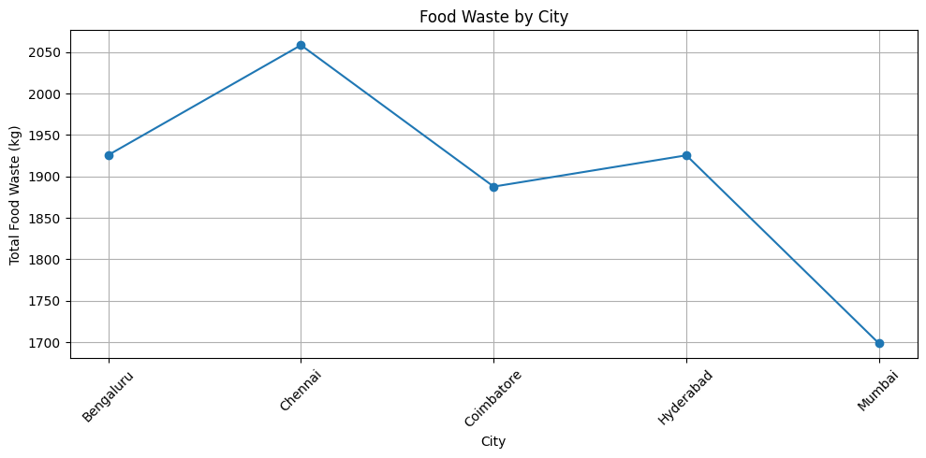
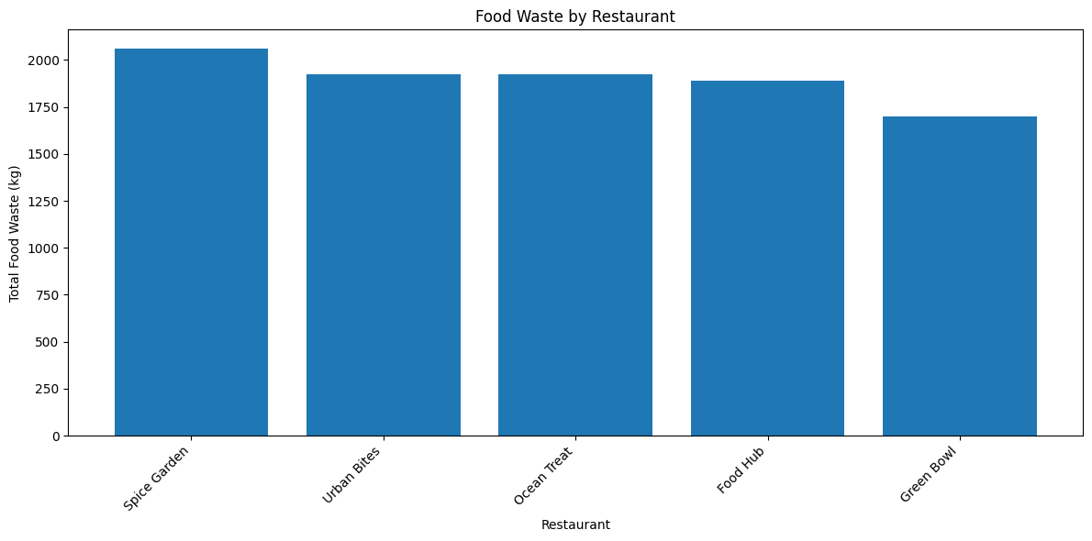
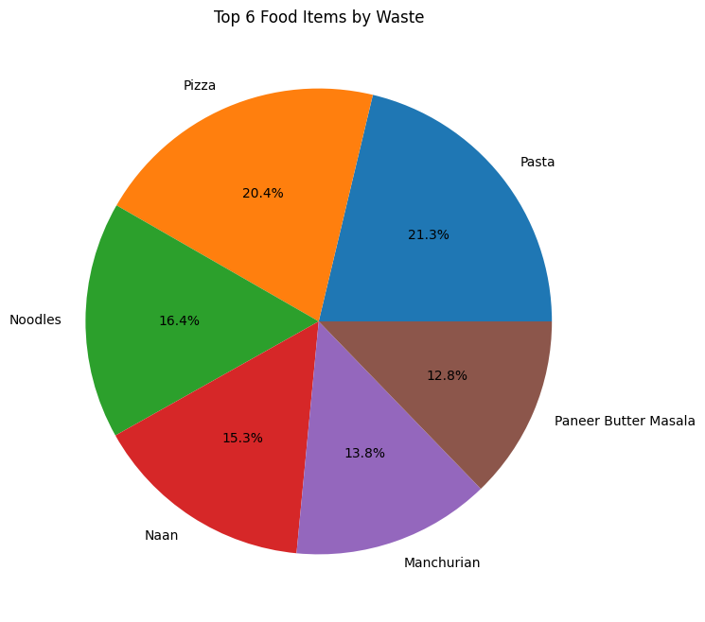

RESULT

