CUSTOMER SEGMENTATION USING K-MEANS CLUSTERING
Customer segmentation is the process of dividing customers into groups based on similar characteristics and purchasing behaviour. This project uses the K-Means clustering algorithm to identify customer groups using machine learning techniques.
The objective of this project is to segment customers based on Age and Annual Income to understand customer behaviour patterns and improve business decision-making.
Tools Used:
• Python
• Pandas
• Matplotlib
• Jupyter Notebook
The dataset contains customer information such as Customer ID, Gender, Age, Annual Income, and Spending Score.
Process:
1. Loaded the dataset using Pandas.
2. Selected Age and Annual Income as features.
3. Applied K-Means clustering algorithm.
4. Visualized customer segments using a scatter plot.
Code:
import pandas as pd
import matplotlib.pyplot as plt
from sklearn.cluster import KMeans
from sklearn.preprocessing import StandardScaler
df = pd.read_csv("Mall_Customers.csv")
X = df[['Age', 'Annual_Income']]
scaler = StandardScaler()
X_scaled = scaler.fit_transform(X)
kmeans = KMeans(n_clusters=5,random_state=42)
df['Cluster'] = kmeans.fit_predict(X_scaled)
plt.figure(figsize=(10,6))
plt.scatter(df['Age'],df['Annual_Income'],c=df['Cluster'],s=70,alpha=0.7)
centers = scaler.inverse_transform(kmeans.cluster_centers_)
plt.scatter(centers[:,0],centers[:,1],s=300,c='red',marker='X',label='Centroids')

plt.xlabel("Age")
plt.ylabel("Annual Income")
plt.title("Customer Segmentation using K-Means")
plt.legend()
plt.show()
print("\nCluster Analysis:\n")
print(df.groupby('Cluster')[['Age', 'Annual_Income']].mean())
Output:
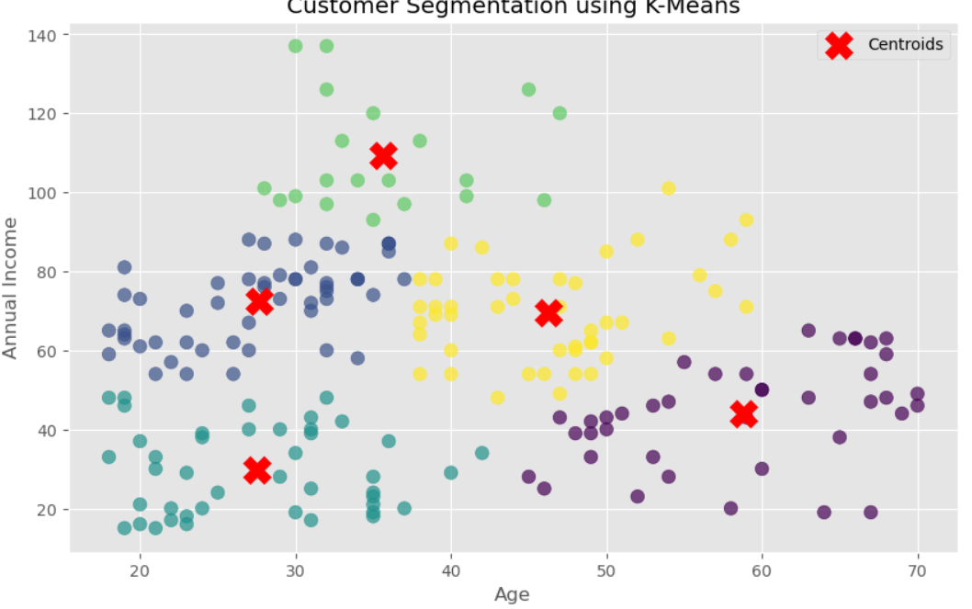
Cluster Analysis:

Age Annual_Income
Cluster
0 58.775000 44.025000
1 27.692308 72.403846
2 27.511628 29.697674
3 35.650000 109.300000
4 46.288889 69.400000
The project successfully segmented customers into different groups based on Age and Annual Income. Customer segmentation helps businesses understand customer behaviour and improve marketing strategies.

