EXERCISE NO:1

DATE:15/10/2020

-----------------------------------------------------------------------------------------------------------------------------------------------------------------------------------------------------------------------------

**AIM:**

To print the calendar of a give month and year.

**PROGRAM:**

import calendar

month=int(input("enter month:"))

year=int(input("enter year:"))

if(999<year<10000):

if(1<month<=12):

print(calendar.month(year,month))

else:

print("Invalid input")

else:

print("Invaild input")

**LINK:**

[http://103.53.53.18/mod/vpl/forms/edit.php?id=229&userid=1714#](http://103.53.53.18/mod/vpl/forms/edit.php?id=229&userid=1714)

**OUTPUT:**

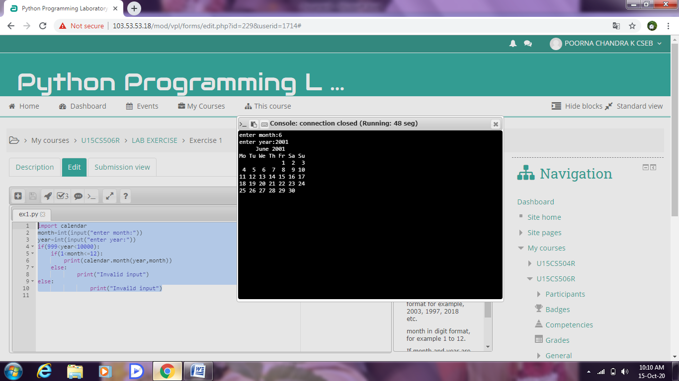

**RESULT:**

Thus the above code has been successfully executed and verified.