Exercise:10

Register No:1518102709

Date:20.11.2020

**Aim:**

To write a python program print the number of uppercase and lowercase letter in given string.

**Program:**

def string_test(s):

d={"UPPER_CASE":0, "LOWER_CASE":0}

for c in s:

if c.isupper():

d["UPPER_CASE"]+=1

elif c.islower():

d["LOWER_CASE"]+=1

else:

pass

print("Original String :", s)

print("No. of Upper case characters : ",d["UPPER_CASE"])

print("No. of lower case characters : ",d["LOWER_CASE"])

string_test('Sona College of Technology')

**Link:**

http://103.53.53.18/mod/vpl/forms/edit.php?id=325&userid=1714#

**Ouput:**

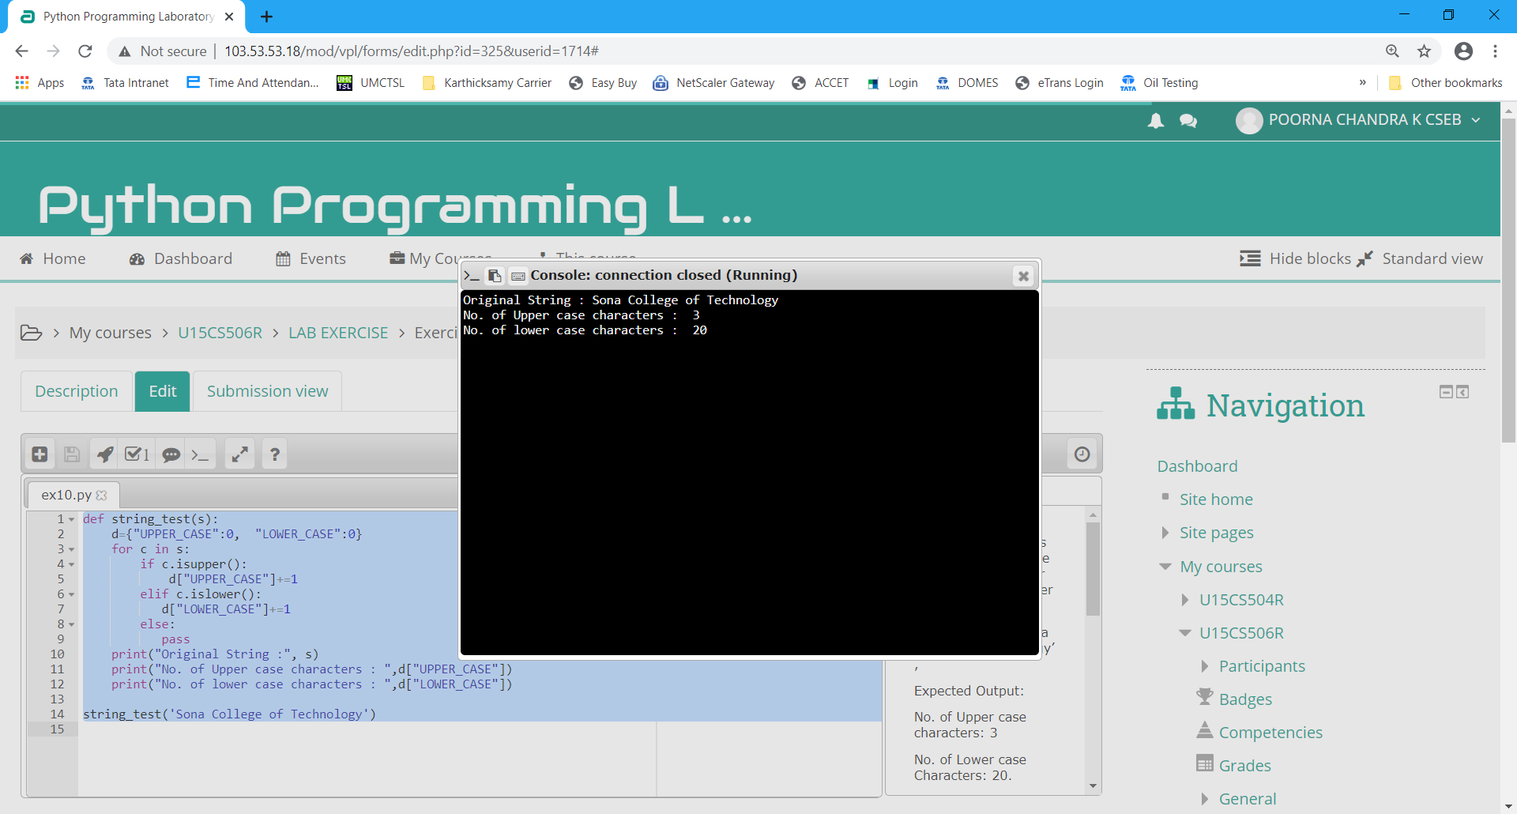

**Result:**

Thus the program executed successfully and the output is verified.