Exercise:11

Register No:1518102709

Date:20.11.2020

**Aim:**

To write a python obtain greatest common Divisor(GCD) of two given number.

**Program:**

def gcd(a,b):

if(a==0):

return a

if(b==0):

return b

if(a==b):

return b

if(a>b):

return(gcd(a-b,b))

else:

return gcd(a,b-a)

a=int(input("enter frist number."))

b=int(input("enter second number."))

GCD=gcd(a,b)

print("GCD is:")

print(GCD)

**Link:**

http://103.53.53.18/mod/vpl/forms/edit.php?id=326&userid=1714#

**Ouput:**

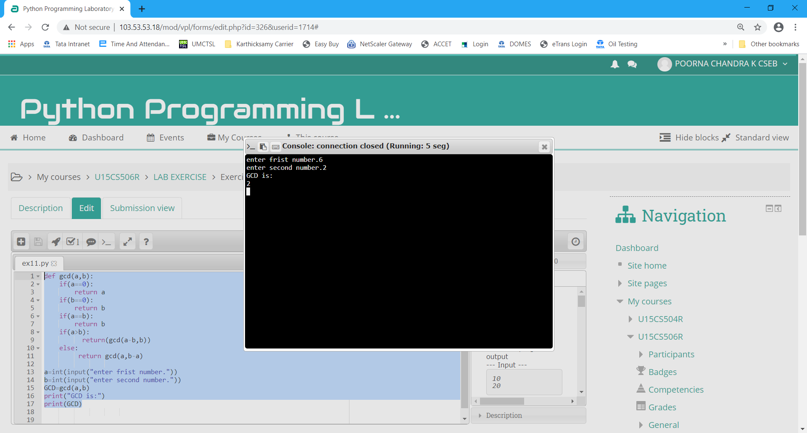

**Result:**

Thus the program executed successfully and the output is verified.