EXERCISE NO:2

DATE:15/10/2020

------------------------------------------------------------------------------------------------------------------------------------------------------------------------------------------------**----------------------------**

**AIM:**

To print the count number x in a given list of numbers.

**PROGRAM:**

def count(lst,x):

count = 0

for ele in lst:

if ele == x :

count=count+1

print(count)

lst =[]

n = int(input())

for i in range (0,n):

ele = int(input())

lst.append(ele)

x = int(input ())

count(lst,x)

**LINK:**

[http://103.53.53.18/mod/vpl/forms/edit.php?id=230&userid=1714#](http://103.53.53.18/mod/vpl/forms/edit.php?id=230&userid=1714)

**OUTPUT:**

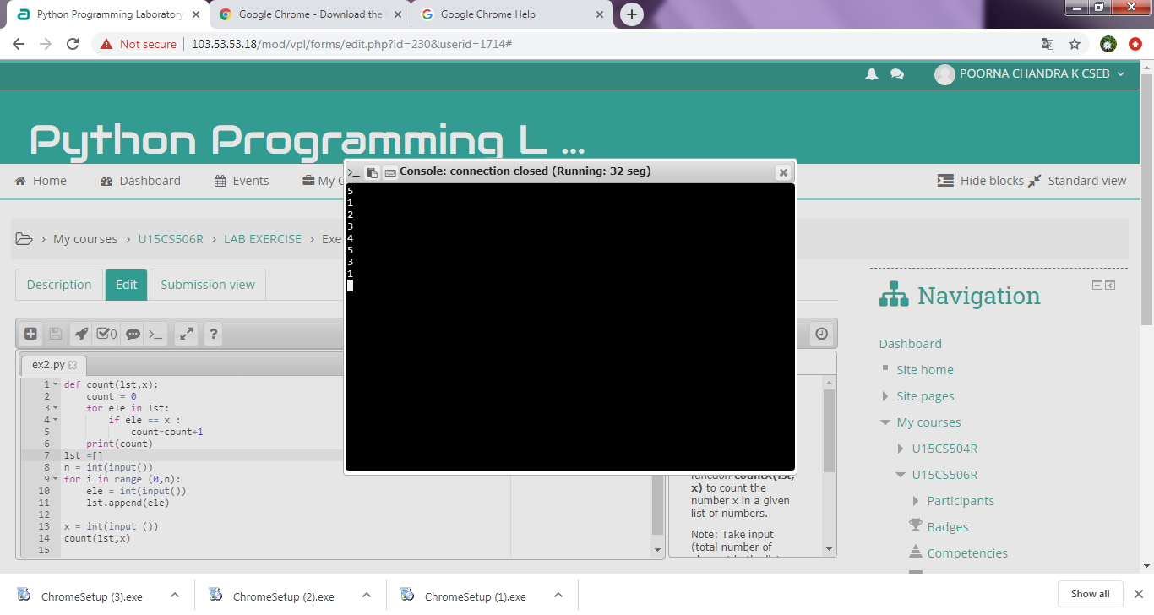

**RESULT:**

Thus the code has been successfully executed and output is verified.