EXERCISE NO:3

DATE:15/10/2020

------------------------------------------------------------------------------------------------------------------------------------------------------------------------------------------------**----------------------------**

**AIM**:

To remove and print every second number from a list of number until the list become empty.

**PROGRAM:**

def removeThirdNumber(lst):

lst1=[]

pos=1

s=0

for i in range(0,len(lst)):

s=(pos+s)%len(lst)

e1=lst.pop(s)

lst1.append(e1)

return lst1

n=int(input("enter number of element:"))

int_list=[]

for i in range(0,n):

e=int(input())

int_list.append(e)

p=removeThirdNumber(int_list)

print(p)

**LINK:**

[http://103.53.53.18/mod/vpl/forms/edit.php?id=231&userid=1714#](http://103.53.53.18/mod/vpl/forms/edit.php?id=231&userid=1714)

**OUTPUT:**

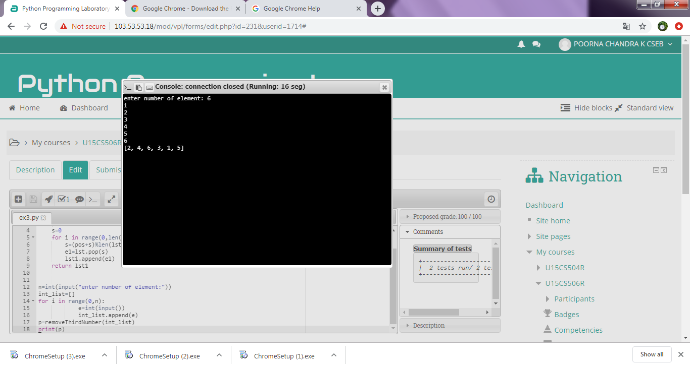

**RESULT:**

Thus the code has been successfully executed and output verified.