EXERCISE NO:4

DATE:15/10/2020

----------------------------------------------------------------------------------------------------------------------------------------------------------------------------------------------------------------------------**AIM**:

To print a single string from two set of string received from user and swap the frist two character of each string.

**PROGRAM:**

a = input()

b = input()

s1 = a.strip()

s2 = b.strip()

x =a[0:2]

a = a.replace(a[0:2],b[0:2])

b = b.replace(b[0:2],x)

if(len(s1)>2 and len(s2)>2):

print(a,b)

else:

print("Invalid input")

**LINK:**

[http://103.53.53.18/mod/vpl/forms/edit.php?id=234&userid=1714#](http://103.53.53.18/mod/vpl/forms/edit.php?id=234&userid=1714)

**OUTPUT:**

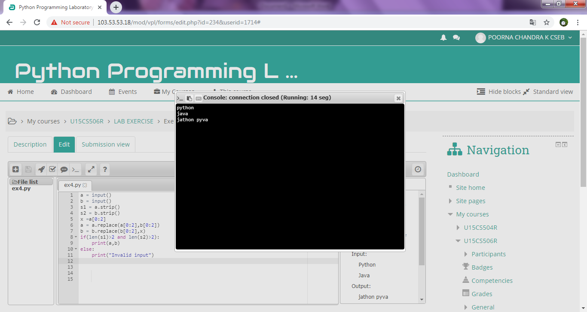

**RESULT:**

Thus the code has been successfully executed and output is verified.