EXERCISE NO:5

DATE:15/10/2020

----------------------------------------------------------------------------------------------------------------------------------------------------------------------------------------------------------------------------

AIM:

To print the missing character to make string pangram.

PROGRAM:

a=input()

a=set(a.strip())

a.remove(chr(32))

b="abcdefghijklmnopqrstuvwxyz"

b=set(b)

b=b.difference(a)

b=list(b)

b.sort()

print("".join(b))

LINK:

[http://103.53.53.18/mod/vpl/forms/edit.php?id=235&userid=1714#](http://103.53.53.18/mod/vpl/forms/edit.php?id=235&userid=1714)

OUTPUT:

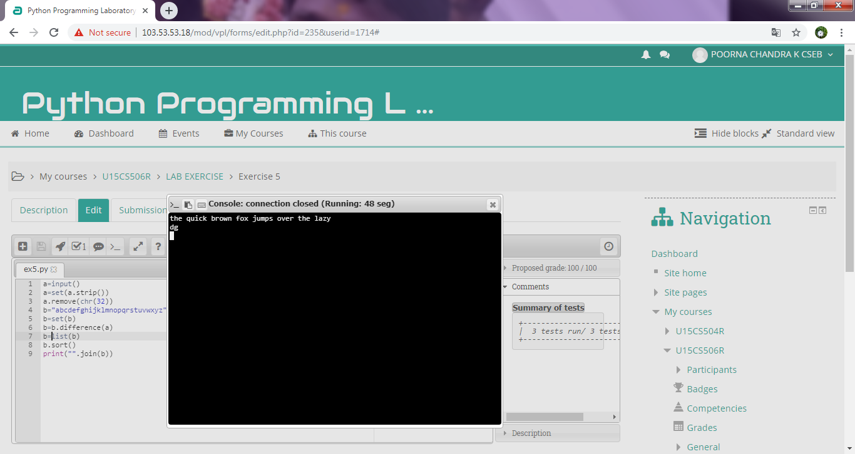

RESULT:

Thus the code has been successfully executed and output is verified.