Exercise:8

Register No:1518102709

Date:20.11.2020

**Aim:**

To write a python program to get list,sorted in increasing order by the last element in each tuple from a given list of non empty tuples.

**Program:**

def last(n): return n [-1 ]

def sort_list_last(tuples):

return sorted(tuples, key=last)

print(sort_list_last([(2, 5), (1, 2), (4, 4), (2, 3), (2, 1)]))

**Link:**

http://103.53.53.18/mod/vpl/forms/edit.php?id=317&userid=1714#

**Ouput:**

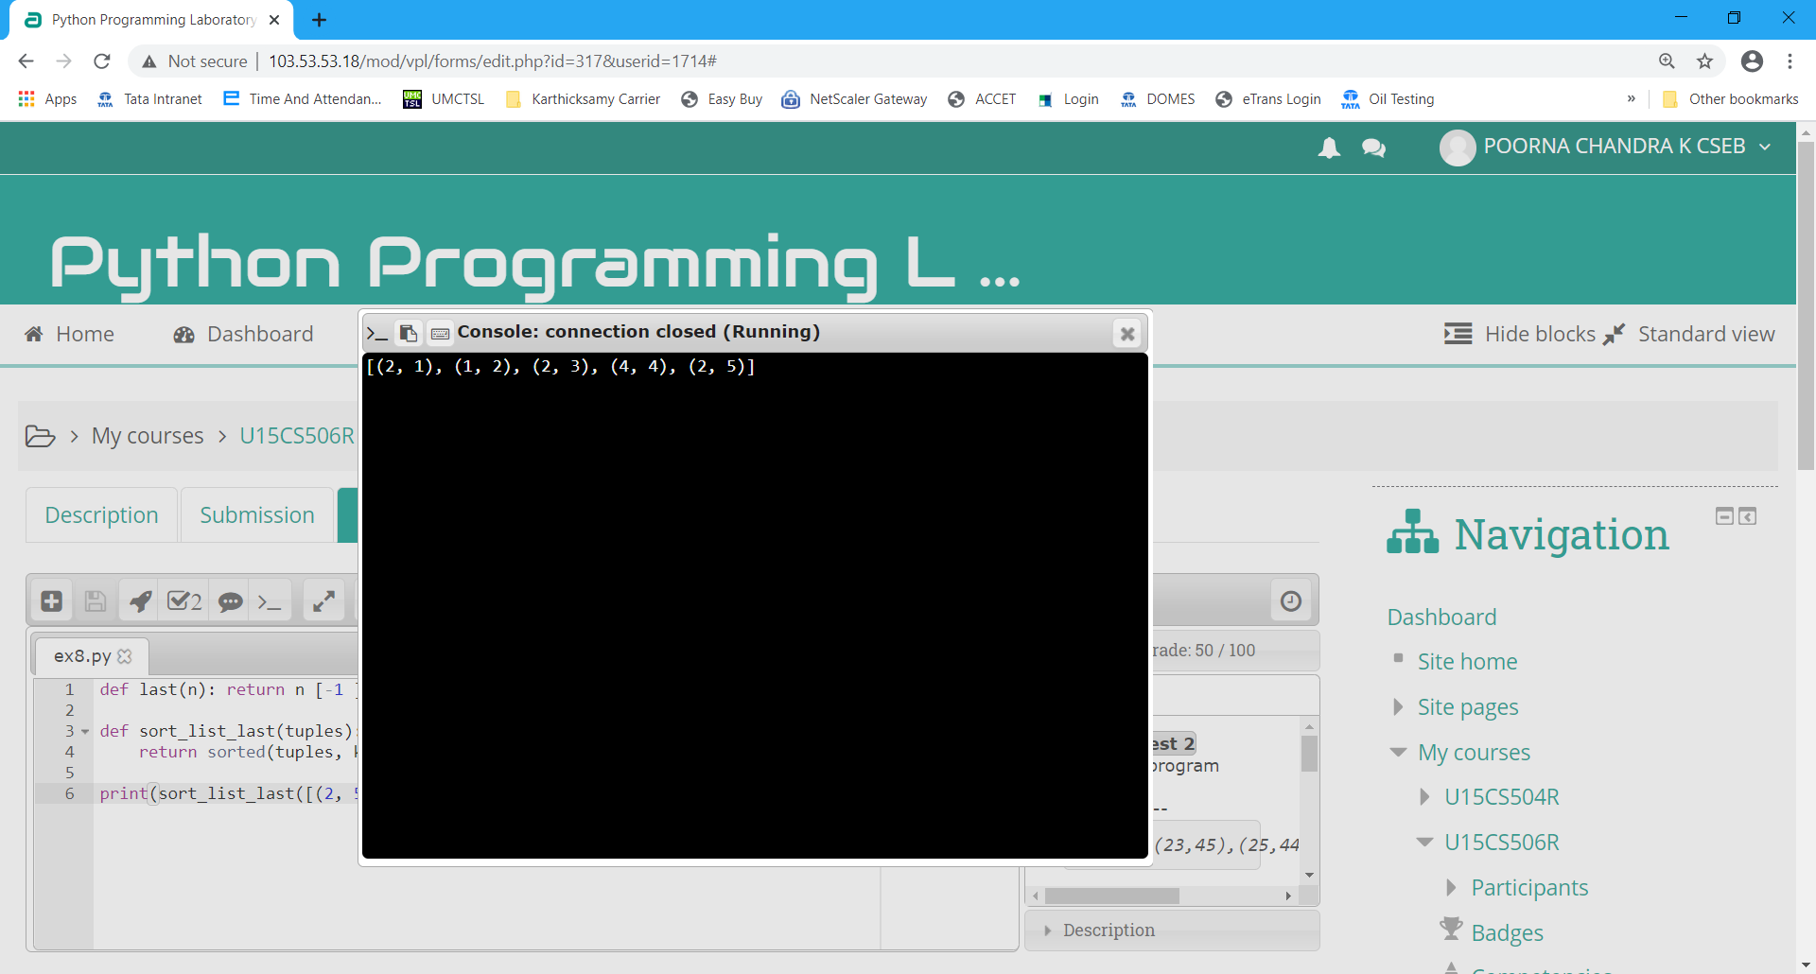

**Result:**

Thus the program executed successfully and the output is verified.