3. Project Introduction & Product Vision
Project Title: AFK Wellness (Away From Keyboard Wellness)
Target SDG: SDG 3 - Good Health and Well-Being
3.1 The Problem: University students, programmers, and gamers in the digital arena have become major health risks due to a long time sedentary lifestyle. It can be code development projects of hours or nonstop playing of competitive mobile games like Honor of Kings and Teamfight Tactics, young adults tend to spend hours sitting at their computer monitors without pauses. This causes backache, vision problems and ill health in the long-term. Conventional health reminder applications are unsuccessful due to their easy rejection and disconnection to engage the consumer.
3.2 The Solution: AFK Wellness- is a gamified health tracking app that targets the digital generation. The app, rather than dull alarms, involves creating healthy habits by playing games.
- Virtual Avatar & HP System: Users have a virtual avatar. If the system detects no physical movement for over 2 hours, the avatar loses "HP" (Health Points).
- EXP & Leveling Up: Completing real-world healthy tasks (e.g., drinking a glass of water, standing up to stretch for 5 minutes) rewards the user with "EXP" (Experience Points) to level up their avatar.
3.3 SDG Justification: The project is one that greatly aligns with SDG 3 (Good Health and Well-Being). AFK Wellness promotes preventive health efforts by converting health directions into interacting digital games. It assists users to monitor their physical activity and daily hydration and intervene on-time to minimize the threats which accompany a sedentary lifestyle.

4. Agile Process & Trello Usage
In the case of the development of AFK Wellness our team embraced the Agile Scrum approach such that the development cycle would consist of continuous progress, flexibility, and effective collaboration. Trello is the main Agile tracking tool that we used in order to handle this process in a systematic manner.
4.1 Iterative Planning & Sprint Breakdown We had broken down our Software Development Life Cycle (SDLC) into 3 distinct Sprints making the cycles of our work and the workflow manageable. To accommodate this structure, we designed certain lists on Trello:
Product Backlog: This list served as our central repository for all project requirements, feature ideas, and documentation tasks.
- Sprint 1 Backlog (Planning & Design): We prioritized tasks from the Product Backlog and moved them here to focus on UML modeling (Use Case & Class Diagrams), UI wireframing, and initial GitHub repository setup.
- Sprint 2 Backlog (Prototype Development): This sprint was dedicated to building the core AFK Wellness prototype, specifically developing the gamified features like the Avatar HP system and EXP tracking.
- Sprint 3 Backlog (Testing & Finalization): The final sprint focused on running user tests, recording feedback, compiling the final project report, and preparing the presentation slides.

4.2 Task Prioritization and User Stories Replacing a vague task with an actual Agile User Story In our Trello cards, we employed the concept of a User Story in order to make sure that every feature brings real value to our target audience (e.g., As a sedentary user, I want a visual HP bar so that I will be motivated to take breaks). Task order was decided according to the significance of the task to the fundamental phases of SDLC.

4.3 Workflow Management & Tool Utilization To visualize a daily workflow and avoid the bottlenecks, we applied the regular Kanban-style task flow: To Do - Doing - Done. The built-in capabilities of Trello helped us considerably to explicitly follow the responsibilities and deadlines:
- Task Assignment & Deadlines: Every card was explicitly assigned to the relevant team member (e.g., Member 2 for Systems Analysis, Member 3 for UI/UX) with a strict "Due Date" to maintain our schedule.
- Color-Coded Labels: We created a custom label system to categorize tasks by SDLC phases. For example, Blue represented Planning & Requirements, Yellow for Analysis & Design, and Red for Testing. This provided a quick visual summary of our project's current focus.
(Note: Please refer to the Appendices below for visual evidence of our Trello board setup, task flow, and detailed user stories.)

Appendices: Agile Process & Trello Evidence
Appendix A: Initial Board Setup & Sprint Planning
(This snapshot demonstrates our initial Kanban board structure, cleanly separating our Product Backlog and defining the three core Sprints for the SDLC.)
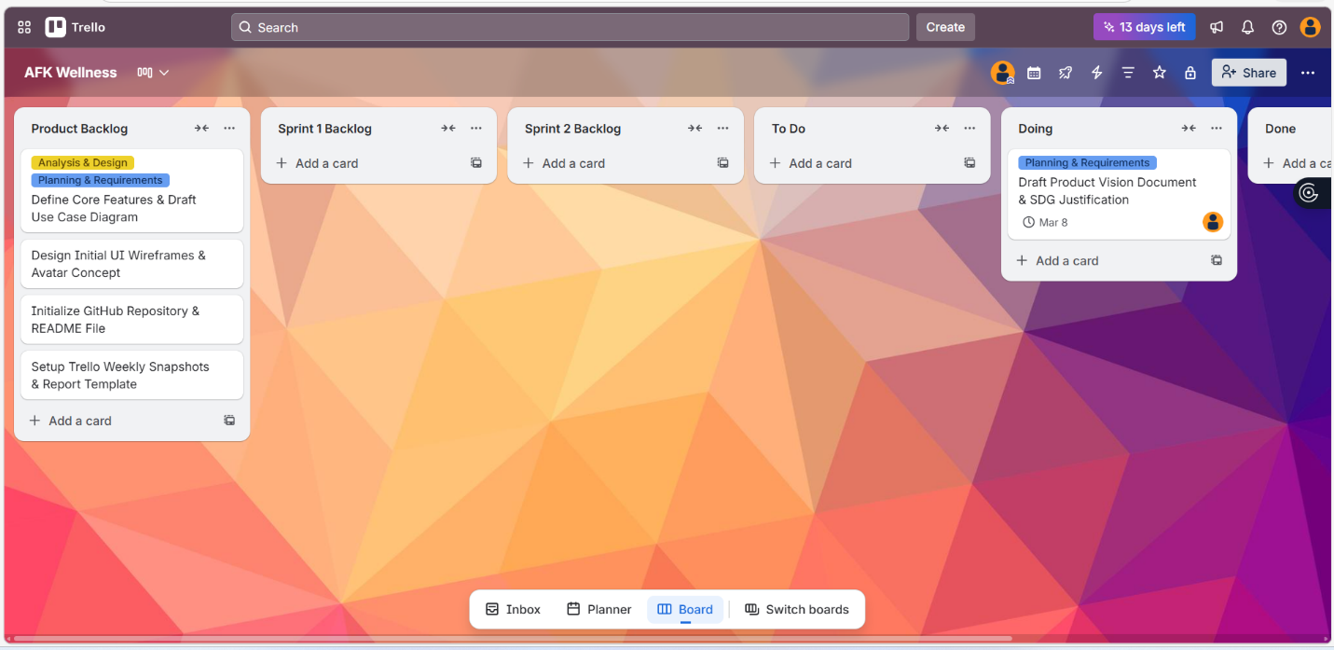

Appendix B: Week 1 - Project Initiation & Task Assignment
(Evidence of our early Agile workflow. The first task is assigned to the Project Manager and moved into the "Doing" list to kick off the Planning phase.)


Appendix C: Sprint Backlog Management & Labeling System
(This view shows our comprehensive task prioritization. Cards are categorized using custom color-coded labels representing different SDLC phases, such as Testing (Red) and Documentation (Purple).)
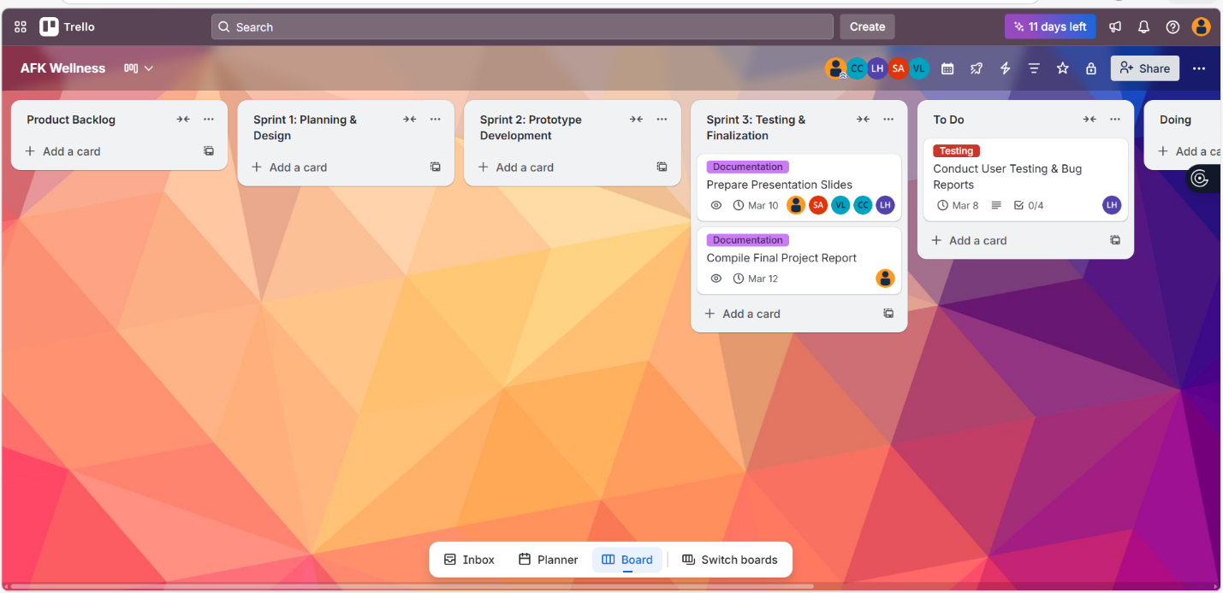

Appendix D: Detailed Task Breakdown (User Stories & Checklists)
(A detailed view of a task card. It proves our utilization of the Agile "User Story" format and strictly managed Checklists to track specific functional requirements and progress.)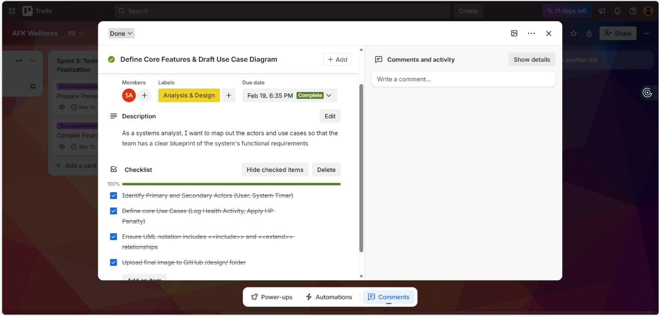
Appendix E: Active Workflow & Kanban Tracking
(Evidence of active mid-sprint execution. Tasks are actively flowing from "To Do" to "Doing" to "Done". The checklist progress indicator (e.g., 2/4) highlights real-time tracking.)
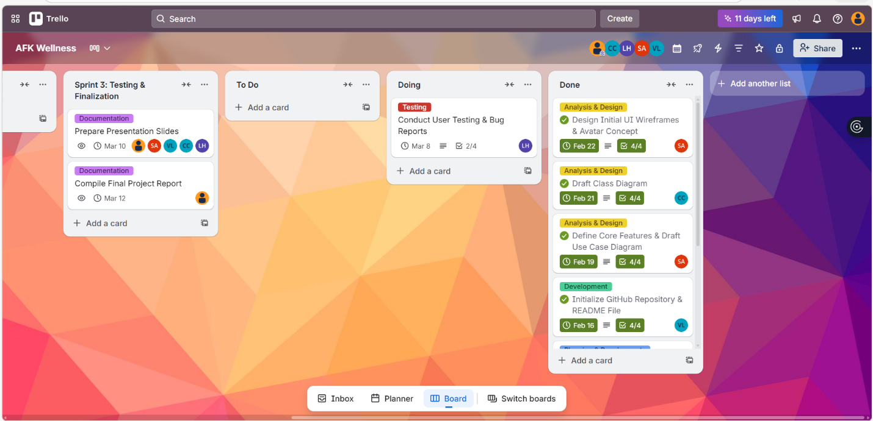

Appendix F: Sprint Completion & Final Deliverables
(Our final board state. A heavily populated "Done" list with green "Complete" due dates proves that our team successfully executed and delivered all SDLC tasks on schedule.)
