TECHNICAL PROJECT REPORT

POT GARDEN

Team Members / Inventors:

|  |  |  |  |  |  |
| --- | --- | --- | --- | --- | --- |
| **S. No.** | **Name** | **Department** | **Designation** | **Mobile** | **E-Mail** |
| 1. | K.Haradeep | CSE-IBM-BIG DATA ANALATYCS | student | 7729946923 | haradeepkaki2001@gmail.com |
| 2. | Avn.Vineeth sai | CSE-IBM-BIG DATA ANALATYCS | student | 7095757307 | [appanavineeth@gmail.com](mailto:appanavineeth@gmail.com) |
| 3. | V.Gnaneshwar Reddy | CSE-IBM-BIG DATA ANALATYCS | student | 8179392950 | gnaneshwar13143@gmail.com |
| 4. | Khushal Thakur | ECE | Mentor | 9646030764 | [khushal.thakur@cumail.in](mailto:khushal.thakur@cumail.in) |
| 5. | Anshul Sharma | ECE | Mentor | 9478697475 | anshulsharma.ece@cumail.in |
| 6. | Kiran Jot Singh | ECE | Mentor | 9463909689 | [kiranjotsingh.ece@cumal.in](mailto:kiranjotsingh.ece@cumal.in) |
| 7. | Divneet Singh Kapoor | ECE | Mentor | 9878422653 | [divneet.ece@cumail.in](mailto:divneet.ece@cumail.in) |

***Section – 1 (IPR Related)***

Brief Abstract:

This project prevents from diseases and weeds, pumping a lot of water wastely as it conserves water and time. And it also prevents soil structure and nutrients. It also gives garden flexibility. No need to watering the plant manually….. as humidity decreases in plant water will be pumped automatically.In this project the moisture sensor senses the humidity level in the plants and it sends and signal to arduino. By sensing the signal arduino sends a signal to relay to release water or not. By that, relay sends operates the pump.We are using humidity sensors in soil to detect the humidity and water supplies through pipe to plant as per indication of humidity. We can use this as decorative automated in hotels, houses, etc.

Existing state-of-the-art and Drawbacks in existing state-of-the-art

(*Brief background of the existing knowledge*)

|  |  |  |
| --- | --- | --- |
| **S. No.** | **Existing state of art** | **Drawbacks in existing state of art** |
| 1 | Moisture sensor | Only used for one plant |
| 2 | Water pump | Water should be regulated to water pump regularly |

Novel/Additional modifications that you can propose to improve upon drawbacks

*(List down the features)*

* It cannot be used in the large scale of agriculture.
* We can see the the humidity level in LCD by connecting to it.
* By using solenoidal pump we can pump water directly from tank.

Advantages

(*List down the advantages, if each feature is incorporated)*

* No need of more man work
* Water pumps at exact time when the plant is inneed
* Helping in management of higher flow rates

Block Diagram

(*Functional diagram depicting the flow of information in your system. Do not define exact components, only use generic terms. Must include modifications as well.)*

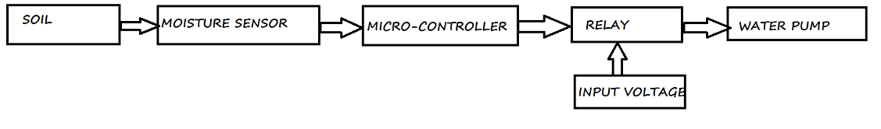

***Section – 2 (Real Project)***

Materials:

|  |  |  |
| --- | --- | --- |
| NAME OF THE PART | QUANTITY | PRICE |
| ARDUINO | 1 | 550 |
| WATER PUMP | 1 | 214 |
| RELAY | 1 | 170 |
| MOISTURE SENSOR | 1 | 135 |
| JUMPER WIRES | 8 | 20 |
| PLANT | 1 | 100 |
| POT | 1 | 250 |

Circuit Diagram:

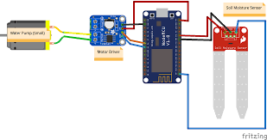

Steps of Circuit Completion

1. First we have to connect moisture sensor to Arduino for giving input to arduino.

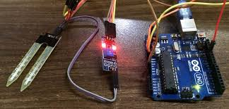

2. Then we have to connect relay to Arduino to take output.

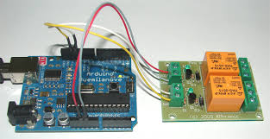

3. Then a wire is connected from relay to plug and other one is connected to water pump.

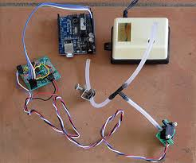

4. Finally second wire of water pump is connected to the plug.

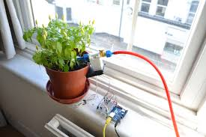

Program Code:

<https://github.com/POTGARDEN/POTGARDEN/blob/master/POTGARDEN1.ino>

Document code:

<https://github.com/POTGARDEN/POTGARDEN/blob/master/POTGARDEN.docx>