Exp no :05 Date :
Use Autopsy to create a case and import evidence

Description
Autopsy is an open-source digital forensics platform used for analyzing and extracting data from digital devices. Here's a step-by-step process on how to use Autopsy for a basic forensic investigation:
Drive link: https://drive.google.com/drive/u/1/folders/1ilSFY7Tqn2L7AjQGhq8yJ8kixc_xTU-v
Download files: 4Dell Latitude CPi.E01, 4Dell Latitude CPi.E02
1. Installation
- Download and Install: Autopsy can be downloaded from the official website. Follow the installation instructions based on your operating system (Windows, Linux, or macOS).
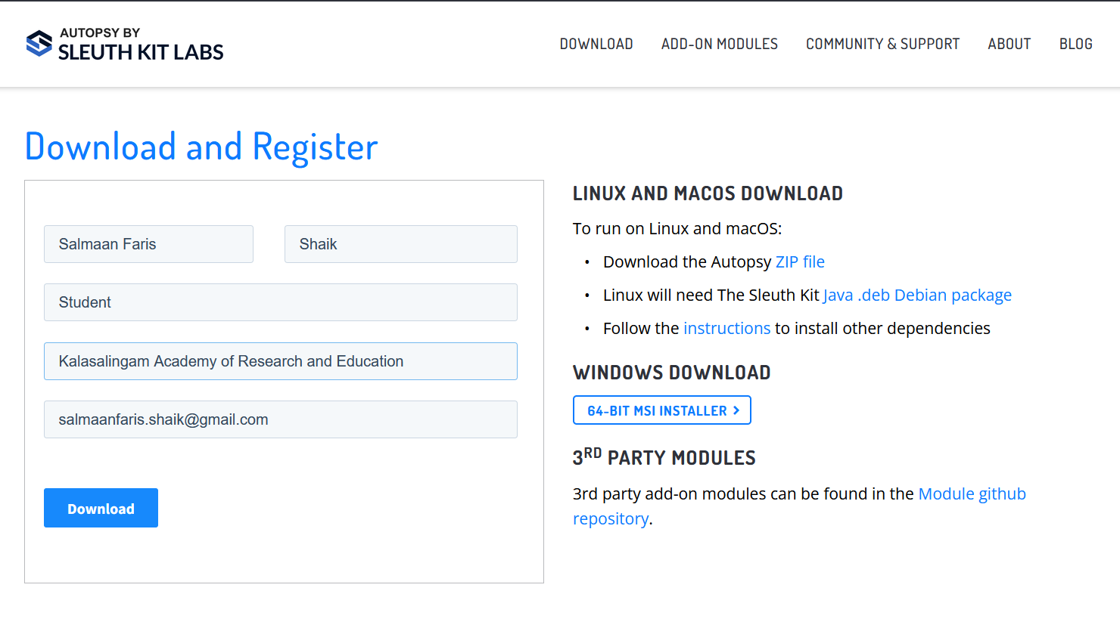
2. Starting a New Case
- Open Autopsy: Launch the application after installation.
- Create a New Case:
  - Click on New Case.
  - Enter the case name and location where the case data will be stored.
  - Fill in the details like the case number, examiner's name, etc., and click Next.

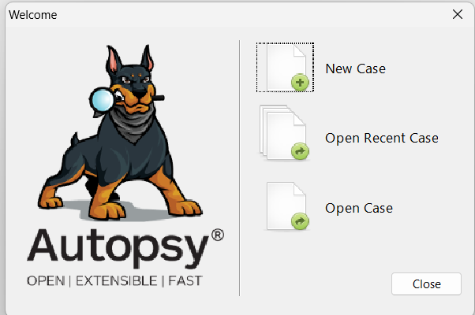

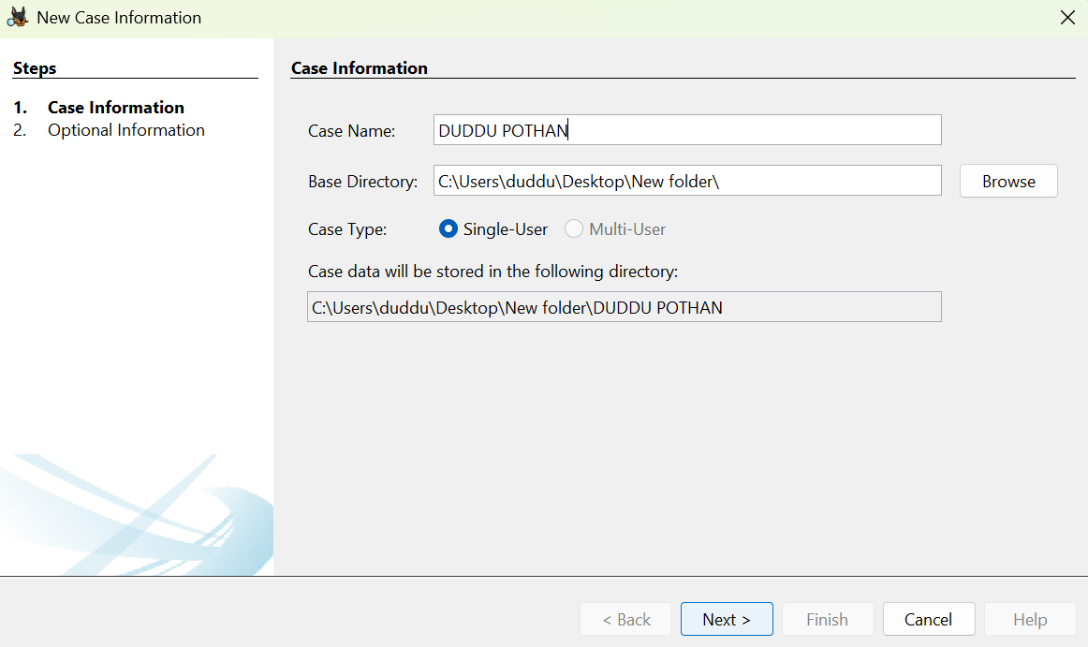

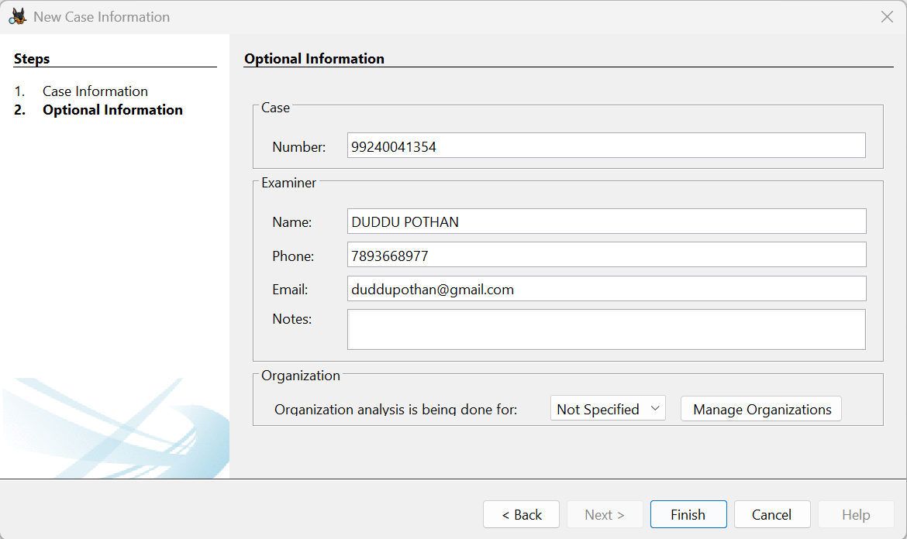

3. Adding a Data Source
- Choose the Type of Data Source:
  - After creating a case, you'll be prompted to add a data source.
  - You can add disk images, directories, logical files, or local disks.
- Select the Data Source:
  - Browse to the location of the image file (e.g., .E01, .dd, or .raw), physical disk, or directory you want to analyze.
  - https://drive.google.com/drive/u/1/folders/1ilSFY7Tqn2L7AjQGhq8yJ8kixc_xTU-v
- Configure Ingest Modules:
  - Autopsy allows you to select specific analysis modules such as File Type Identification, Keyword Search, Hash Lookup, etc.
  - You can enable or disable these based on your investigation needs.
- Start Analysis: Click Next to start the analysis.

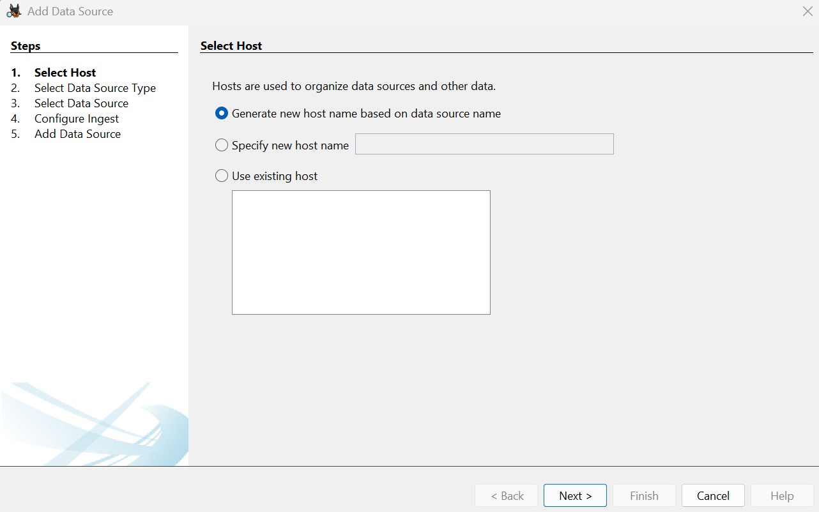

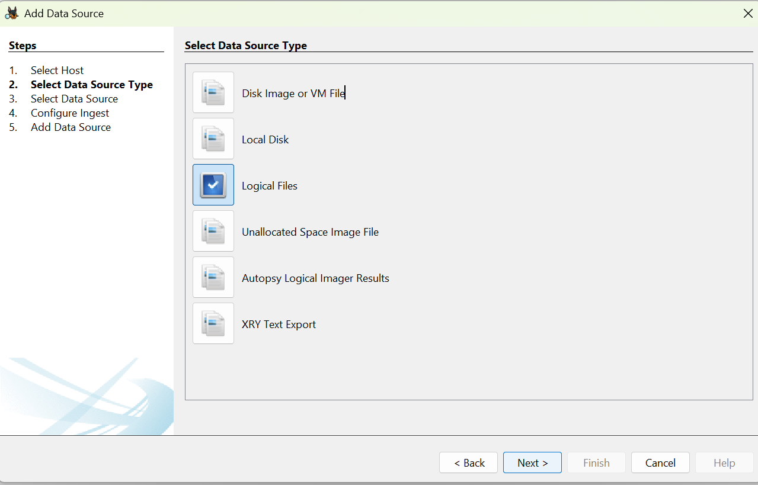

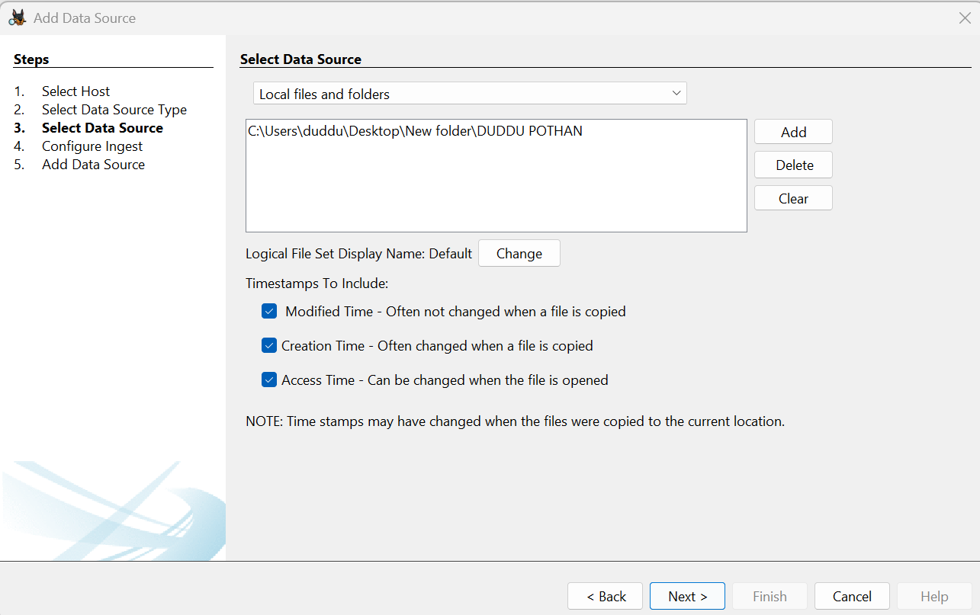

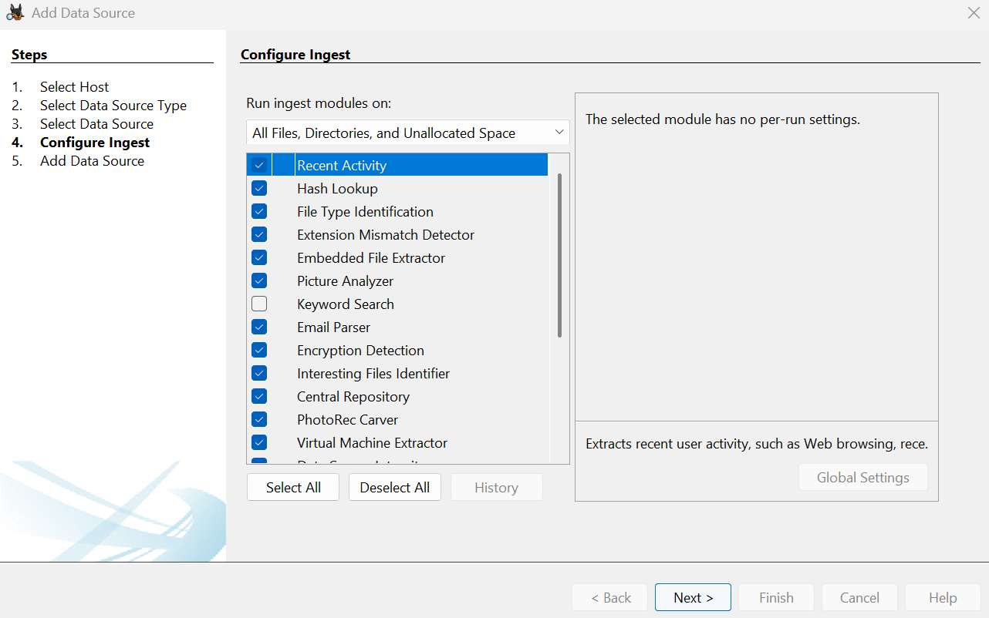

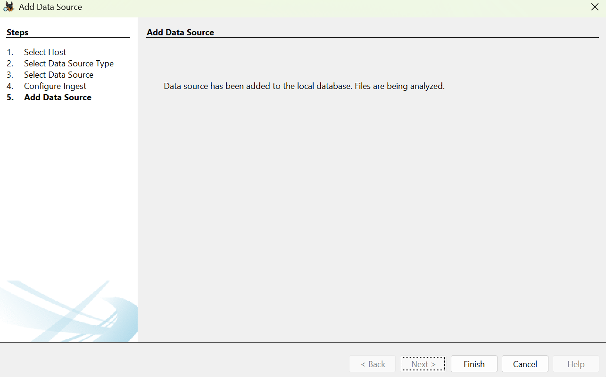

4. Initial Analysis and Overview
- Ingest Progress: As Autopsy processes the data source, you'll see the progress in the lower-left corner.
- Explore the Resulting Artifacts:
  - Autopsy automatically categorizes findings such as web artifacts, file system metadata, and communication records.
- Use the Tree Viewer:
  - On the left pane, you’ll see a tree structure where you can explore different aspects like File System, Web History, Email, etc.
5. Detailed Analysis
- Keyword Search:
  - You can perform specific keyword searches using the Keyword Search module.
  - Use pre-configured lists or enter custom keywords.
- File Analysis:
  - Navigate through files and folders under the File Types or File System section.
  - Open, view, or export files for further examination.
- Timeline Analysis:
  - Use the Timeline module to visualize events based on timestamps.
  - This can help track user activity over time.
- Hash Analysis:
  - Compare file hashes with known databases to identify known good or bad files.

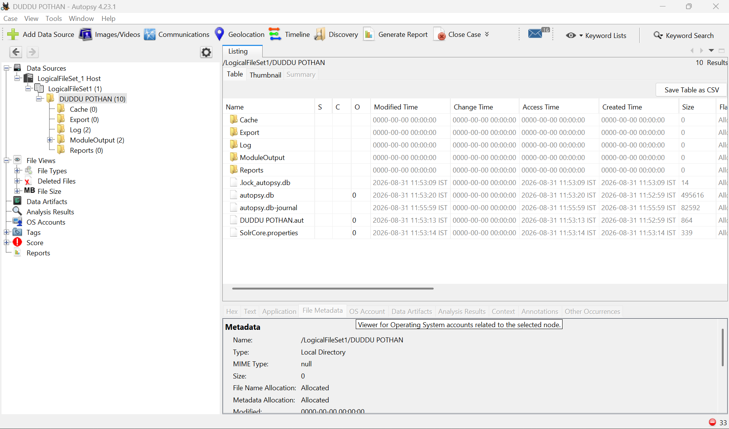

6. Reporting
- Generate a Report:
  - After analyzing the data, click on Generate Report from the toolbar.
  - Choose the type of report (HTML, CSV, Excel, etc.).
  - Select which parts of the analysis you want to include in the report.
- Export Findings:
  - Export individual files or artifacts that you need for your report or further analysis.
- Final Review:
  - Review the report to ensure it includes all relevant information.
  - Save or print the report for use in your case.

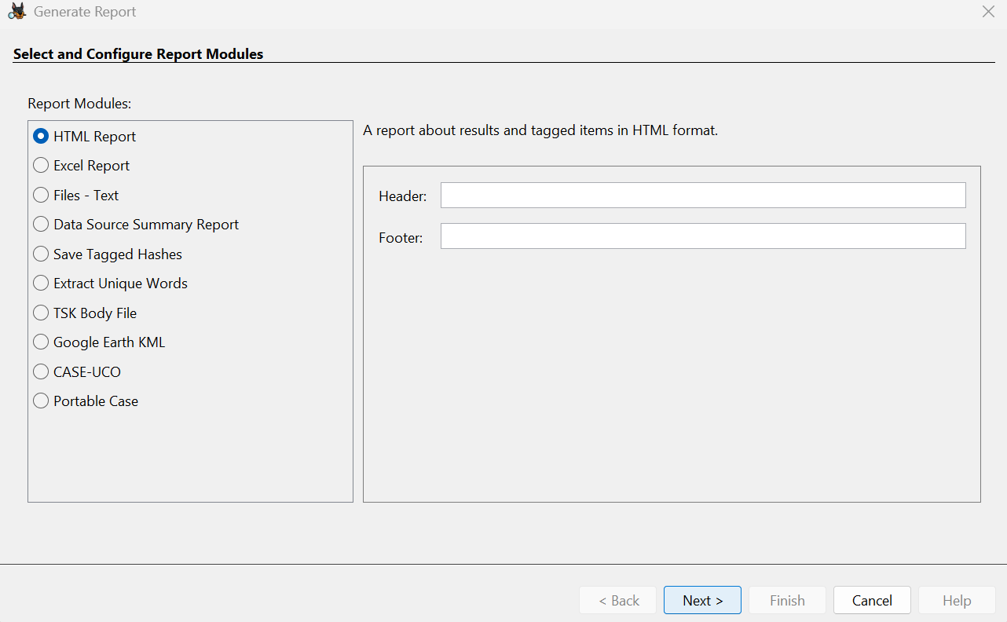

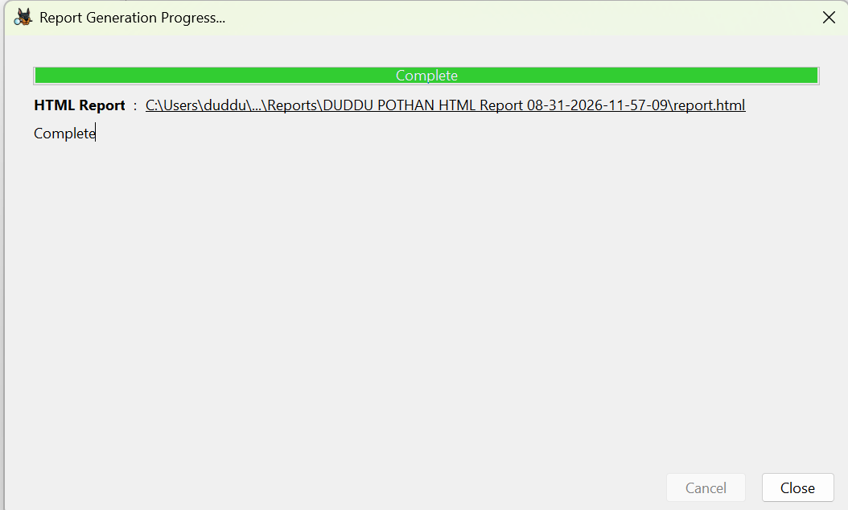

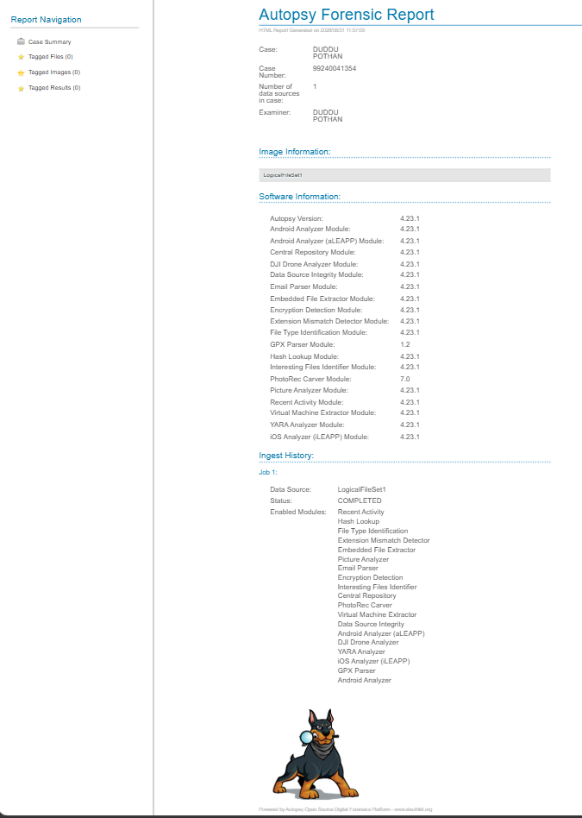
7. Case Closure
- Close the Case:
  - Once you have completed your investigation, close the case within Autopsy.
- Archiving:
  - Ensure all data and reports are properly archived according to your organization's policies.
8. Advanced Features (Optional)
- Custom Ingest Modules:
  - Autopsy allows for custom modules to be added if you need specific analysis tools not included by default.
- Collaboration:
  - Autopsy can be configured for multi-user cases if you’re working in a team environment.

