Data Appendix — RPE/Cluster Synthesis (v0.1)
We applied lightweight embeddings + soft clustering to your research corpus (MD/DOCX/HTML). Clusters below reflect dominant themes to inform the proposal.
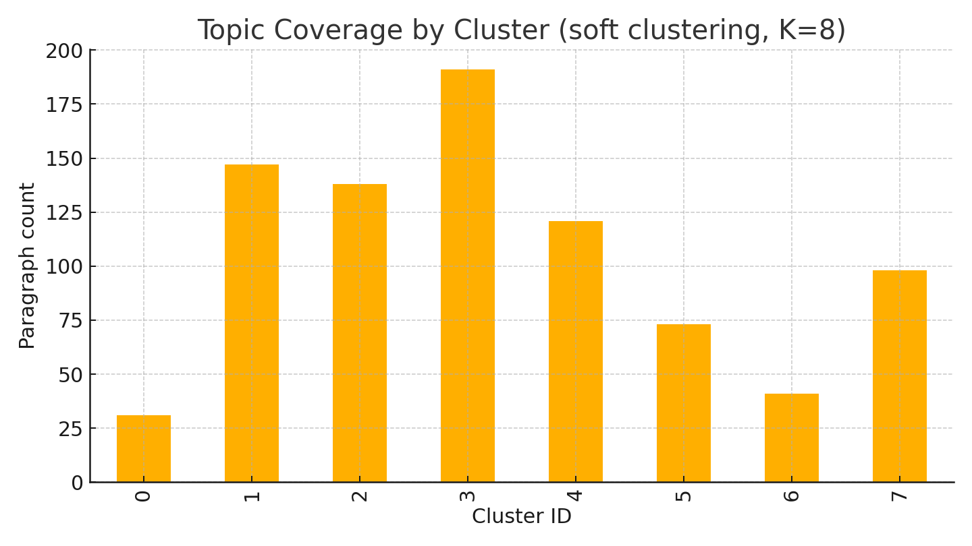
Figure: Topic coverage across the corpus.

Cluster 0
Top terms: 000, roi, community, investment, months, payback, 11, token, local, 25
• **Young Adults**: Technology leverage + social impact focus through digital collectives and urban agriculture[^11][^12] [Community Wealth Building Through Diverse Resident.md]
• Start with **Young Adults** and **Community College Students** who have high digital fluency and can become peer mentors for other groups.[^11][^25] [Community Wealth Building Through Diverse Resident.md]
• - Shared creative studio with AI tools and revenue sharing tokens
- Capitalizes on tech fluency and social media expertise
- High scalability serving local businesses and events[^11][^12] [Community Wealth Building Through Diverse Resident.md]
• **Young Adults** - **Digital Content Creator Collective** (7,992% ROI) [Community Wealth Building Through Diverse Resident.md]
• **Focus on local networks** - build trust and adoption gradually[^6][^8][^20]
4. [5-Year Business Projections_ AI + Tokenomics Model.md]
• ### **Deliverables:**
- A **system blueprint** covering architecture, technical design, and implementation details. [POWERFULMOVES_and TOKENOMICS_DETAILS.md]

Cluster 1
Top terms: ai, contract, frontend, backend, blockchain, user, contracts, api, smart, voting
• The architecture would remain the same, just the RPC endpoints and contract addresses change. [POWERFULMOVES_and TOKENOMICS_DETAILS.md]
• After deducting the appropriate voting power (simulated by `lockTokens`), the contract adds the *raw vote count* to the proposal’s total. [POWERFULMOVES_and TOKENOMICS_DETAILS.md]
• Upon submission, the frontend calls `createProposal` on the DAO contract (user signs the tx). [POWERFULMOVES_and TOKENOMICS_DETAILS.md]
• The Node server might expose endpoints that the AI calls when it has results (e.g. [POWERFULMOVES_and TOKENOMICS_DETAILS.md]
• For example, if the user asked a question, the planner might route the answer to the TTS engine (H). [POWERFULMOVES_and TOKENOMICS_DETAILS.md]
• The member or an AI agent can then also initiate a corresponding group buy order: the frontend calls the backend `POST /api/orders` or directly the `createGroupBuy` on the smart contract. [POWERFULMOVES_and TOKENOMICS_DETAILS.md]

Cluster 2
Top terms: https, com, www, org, pdf, 10, article, php, index, view
• [^38]: https://risetpress.com/index.php/jcsse/article/view/592 [Community Wealth Building Through Diverse Resident.md]
• [^33]: https://econjournals.com/index.php/ijeep/article/view/15699 [5-Year Business Projections_ AI + Tokenomics Model.md]
• [^11]: https://rayyanjurnal.com/index.php/jamparing/article/view/4993 [Containerized Micro Business Model_ Docker-Like Sc.md]
• [^5]: https://wsj.westscience-press.com/index.php/wsee/article/view/448 [5-Year Business Projections_ AI + Tokenomics Model.md]
• [^9]: https://ijc.ilearning.co/index.php/ATM/article/view/2363 [5-Year Business Projections_ AI + Tokenomics Model.md]
• [^12]: https://epress.lib.uts.edu.au/journals/index.php/cjlg/article/download/2413/2649 [Community Wealth Building Through Diverse Resident.md]

Cluster 3
Top terms: ai, files, file, https, supabase, code, like, text, web, com
• For example, a `security.yml` might define:
```yaml
services:
tls-proxy:
image: nginx:latest
ports:
- "443:443"
volumes:
- ./ssl:/etc/ssl # mount your SSL certs
environment:… [POWERFULMOVES_and TOKENOMICS_DETAILS.md]
• The communication between services is secured – e.g., the Supabase REST endpoint is HTTPS with an API key required, and we may run an Nginx reverse proxy to terminate TLS for local services that don’t support it natively ([POWERFULMOVES v2.… [POWERFULMOVES_and TOKENOMICS_DETAILS.md]
• For example, after performing speech-to-text (STT) on audio input, the Jetson could send an HTTP request with a JSON payload to the Supabase REST endpoint, which writes to a table ([Integrating Supabase Database with POWERFULMOVES A.md](fil… [POWERFULMOVES_and TOKENOMICS_DETAILS.md]
• As the project grows, we will continue to refine each module (for example, upgrading AI models for better reasoning efficiency – already version 2.0 shows **3.9× efficiency and 72% latency improvement** over the initial version ([POWERFULMO… [POWERFULMOVES_and TOKENOMICS_DETAILS.md]
• In our architecture, this is handled via the **Hardware-Aware Router** (the “Input Router” B in Perception layer, and the “Compute Router” in the v2 diagram) which decides where to send tasks ([POWERFULMOVES v2.0_ Next-Generation Modular AI… [POWERFULMOVES_and TOKENOMICS_DETAILS.md]
• def forward(self, x):
for _ in range(self.max_depth):
x = self.recurrent_block(x)
if self.iteration_controller.should_halt(x):
break # exit early if result is confident
return x
```
*… [POWERFULMOVES_and TOKENOMICS_DETAILS.md]

Cluster 4
Top terms: file, model, text, ai, md, supabase, database, 20, architecture, community
• On Jetson, an **EfficientNet-B0** or similar lightweight model runs at modest FPS for object recognition ([Integrating Supabase Database with POWERFULMOVES A.md](file://file-R4SKbWQxEDLRFL5CpyApNM#:~:text=)), while the Windows PC can run a … [POWERFULMOVES_and TOKENOMICS_DETAILS.md]
• For example, when the Jetson Nano processes audio via speech-to-text, it could send the transcribed text and some metadata to a `sensor_data` or `transcripts` table in Supabase via a REST endpoint ([Integrating Supabase Database with POWERF… [POWERFULMOVES_and TOKENOMICS_DETAILS.md]
• Devices communicate with the database and backend over HTTPS with API keys ([Integrating Supabase Database with POWERFULMOVES A.md](file://file-R4SKbWQxEDLRFL5CpyApNM#:~:text=)). [POWERFULMOVES_and TOKENOMICS_DETAILS.md]
• We also utilize hardware security modules where possible (TPM 2.0 on the Windows PC for storing keys) ([PMOVES_Core Architecture Layers.md](file://file-EBcmZsLhM9bRqYWuQQAU51#:~:text=,0%20storage%20on%20Windows)). [POWERFULMOVES_and TOKENOMICS_DETAILS.md]
• void loop() {
// Example: insert a temperature reading
int status = db.insert("sensor_data", "{\"device_id\":\"esp32-01\",\"temp\":25.4}");
delay(1000);
}
```
*ESP32 sending data to Supabase (pseudo-code) ([Integrating Supabase Data… [POWERFULMOVES_and TOKENOMICS_DETAILS.md]
• The Jetson’s STT engine transcribes this to text “check if we need more rice” ([Integrating Supabase Database with POWERFULMOVES A.md](file://file-R4SKbWQxEDLRFL5CpyApNM#:~:text=)). [POWERFULMOVES_and TOKENOMICS_DETAILS.md]

Cluster 5
Top terms: ai, design, food, group, solidity, diagram, file, buying, _orderid, contract
• Below is the simplified Solidity code for the group buying mechanism, with annotations explaining each part: [POWERFULMOVES_and TOKENOMICS_DETAILS.md]
• Below is an illustrative Solidity snippet for the governance contract: [POWERFULMOVES_and TOKENOMICS_DETAILS.md]
• **Architecture Layers:** The AI’s internal design can be visualized in the following diagram: [POWERFULMOVES_and TOKENOMICS_DETAILS.md]
• - **Task Planner / Orchestrator:** This component (G in the first AI diagram) decides what to do with the output of the reasoning engine. [POWERFULMOVES_and TOKENOMICS_DETAILS.md]
• (In many cases, the frontend can interact directly with the blockchain, but the backend is useful for off-chain services or as a trusted relay for certain operations.) [POWERFULMOVES_and TOKENOMICS_DETAILS.md]
• Below is a conceptual diagram of the key components and their interactions: [POWERFULMOVES_and TOKENOMICS_DETAILS.md]

Cluster 6
Top terms: community, local, models, enterprises, wealth, token, service, building, businesses, cooperative
• When residents develop enterprises that serve their community, money circulates **2-4 times more** than traditional employment models.[^4][^5][^6][^7] [Community Wealth Building Through Diverse Resident.md]
• 14% for traditional employment[^4][^20]
- **Money velocity**: 3.2 annual circulation cycles
- **Community retention rate**: 85% average across all enterprise models
- **Local supplier development**: 40% increase in community-to-community tr… [Community Wealth Building Through Diverse Resident.md]
• Your vision perfectly aligns with **micro-franchising** and **platform cooperativism** models that create replicable, scalable business "containers" owned by community members[^1][^2][^3][^4]. [Docker-Style Scalable Community Business Container.md]
• **Distribution & Reward:** Members receive their rice when it’s delivered. [POWERFULMOVES_and TOKENOMICS_DETAILS.md]
• Each successful container becomes a template for deployment in other communities, creating a **federated network of community-owned enterprises**. [Docker-Style Scalable Community Business Container.md]
• # Containerized Micro Business Model: Docker-Like Scaling for Community Enterprises [Containerized Micro Business Model_ Docker-Like Sc.md]

Cluster 7
Top terms: ai, data, contract, use, entropy, backend, jetson, local, order, token
• This contract ensures transparency in pooling funds and only executes the payment when the threshold is reached. [POWERFULMOVES_and TOKENOMICS_DETAILS.md]
• A supply limit variable is present in the smart contract to enable closing the initial offering after 360 days if the supply limit is not reached. [Agent Zero Project Paper.html]
• The Node backend picks this up and marks order #5 as “completed” in the DB. [POWERFULMOVES_and TOKENOMICS_DETAILS.md]
• Throughout this process, the AI agent might assist (perhaps announcing via speakers “The rice order has been fully funded and is being processed!” when it detects the event, or updating a screen in a community center). [POWERFULMOVES_and TOKENOMICS_DETAILS.md]
• Since funds are held in the contract until execution, the code must be carefully reviewed for re-entrancy (here we use a simple call and immediately mark completion, minimizing risk). [POWERFULMOVES_and TOKENOMICS_DETAILS.md]
• Suppose it finds the inventory is below a threshold – this information (perhaps already present in the knowledge graph from IoT weight sensors) leads the AI to decide that a new group-buy should be proposed. [POWERFULMOVES_and TOKENOMICS_DETAILS.md]

