Cataclysm Studios DAO — Fordham Hill Alternative Proposal (v0.1)
A resident‑owned, AI‑powered cooperative model that outperforms traditional project delivery on revenue, jobs, and local wealth retention.

Executive Summary
- Objective: Present a community‑owned alternative that complements ACE’s traditional plan with faster pilots, stronger participation, and transparent economics.
- Approach: Parent DAO with three guilds (Infra & Cloud, Creator, Wealth & Learning), two‑house governance (capital + contributors), and a stable community credit rails for pre‑orders and services.
- Result (5‑year view): Tokenomics model yields ~3.25× revenue and ~4.4× profit vs. traditional, with more jobs and households served (illustrative figures below).
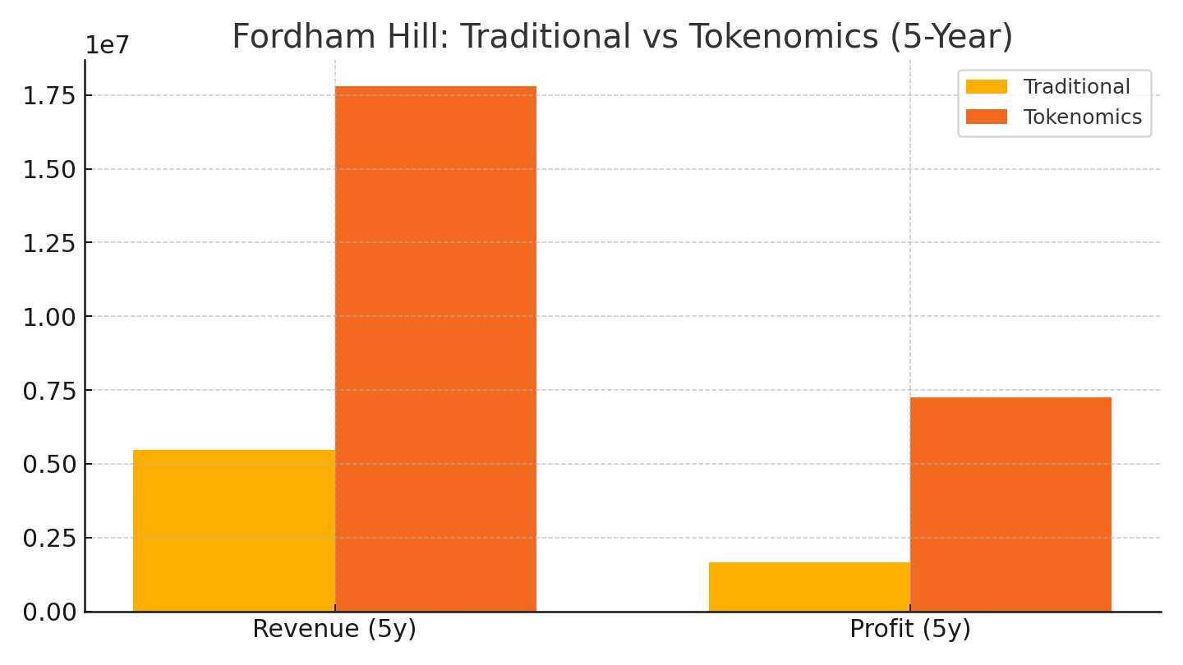
Figure: Fordham Hill 5‑year revenue & profit comparison — Tokenomics vs. traditional.

Structure at a Glance
- Parent DAO (Cataclysm Studios DAO): constitution, treasury, brand, risk & compliance.
- Infra & Cloud Guild (resident‑run nodes): OCR/RAG, media transcode/publish, AI assistants; proof‑of‑service rewards; marketplace for local workloads.
- Creator Guild: music/AI video/art pods; on‑chain revenue splits; events & merch fueled by pre‑orders.
- Wealth & Learning Guild: micro‑business incubator (pre‑order tokens), AI upskilling, financial literacy, local vendor onboarding.

Token Suite & Governance
- $CAT — Governance (ERC‑20): elect stewards, approve budgets, strategy votes.
- $WORK — Reputation (SBT): non‑transferable ‘proof of work’ for residents/operators; unlocks roles and citizen‑house voting weight.
- $CRED — Community Credits (stable, spend‑limited): earned by residents; redeemed with approved vendors/services; keeps value circulating locally.
- Two‑House Voting: Token House ($CAT) + Citizen House ($WORK). A decision passes when both approve (e.g., 50%+ and 60%+).

90‑Day Rollout
- Days 0–14: Spin up Safe (multisig), Snapshot, draft 2‑page constitution + guild charters; recruit 5–10 node operators.
- Days 15–45: Turn on 3 paid services (OCR/RAG, media transcodes, AI office hours); launch Creator Pod #1 (single + AI video).
- Days 46–90: Publish first KPI report; Seed Grants #1 for youth/vendor pilots; onboard 10 more nodes; ratify initial $CAT distribution.

KPIs & Transparency
- Infra: jobs served, uptime, GPU/CPU hours, QA pass‑rate; weekly operator rewards report.
- Creator: releases/quarter, streams/views, merch gross, collaborator payouts.
- Wealth & Learning: residents trained, preorder volume, vendor count, household savings.
- Treasury: monthly inflows/outflows; epoch reward schedules; public dashboards.
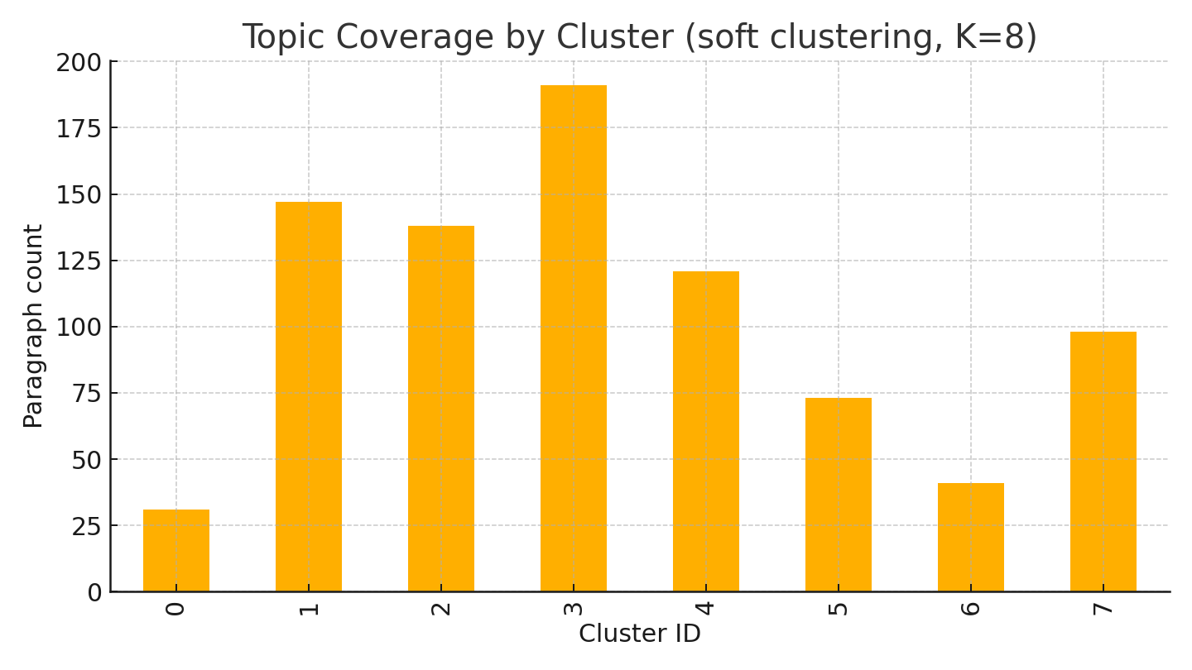
Figure: Topic coverage across your research corpus (clusters found via lightweight embeddings).

Calls to Action (Meeting Ask)
- Approve 90‑day pilot with a minimal budget and milestone gates (board).
- Nominate 3 resident stewards (one per guild) and 2 business advisors (board & residents).
- Green‑light Home‑Node Program (5–10 nodes) and Creator Pod #1 (residents & creators).
- Authorize community credits pilot ($CRED) for pre‑orders with 3 local vendors (businesses).

