**The following technologies used to develop the APP**

1. ASP.Net with MVC frame work
2. Javascirpt – Jquery
3. Bootstrap, Datatables(pagination) – Multiple device responsive design
4. WCF Business logic
5. Read the config entry(app setting)
6. SQL server Database
7. T-SQL program to generate SQL task

Musicalog - Architecture

BootStrap

JQuery

SQL Database

Tables and SPs

WCF

Musicalog CONTROLLER

View

List album

Add Album

Edit/Delete Album

Model

Read config setting - pagecount

**SQL Server**

SQL_Setup.sql - Create table and SP’s

Entity Model Diagram

Tbl_Album

Tbl_AlbumType

**MVC – Technical Details**

1. List Album

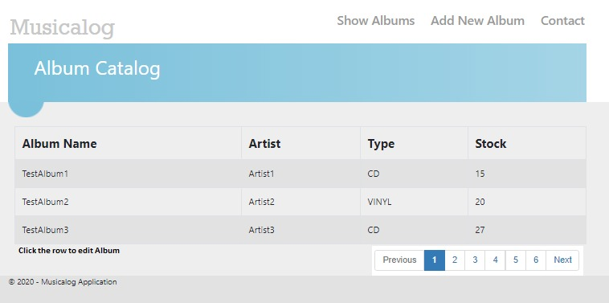

1. Add Album

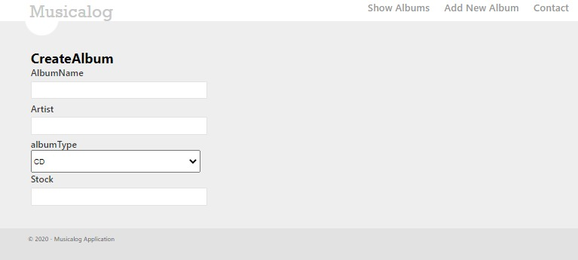

1. Edit Album (Update and Delete)

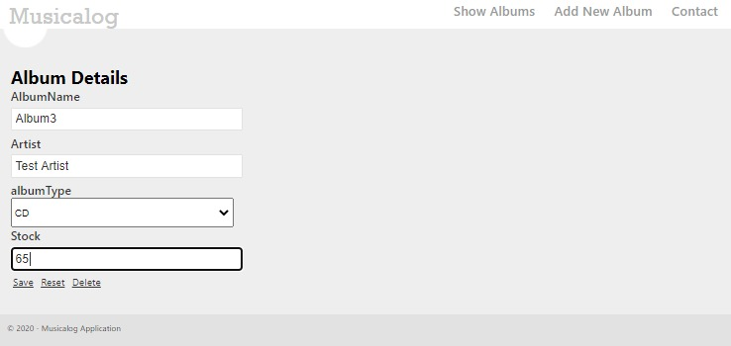

1. File Structure

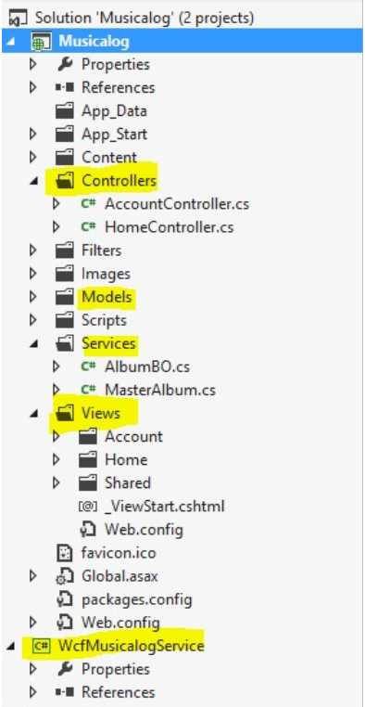

Data base scripts

