User Administration

I've developed the testcase using java, hibernate and as database backend postgreSQL 11. I used NetBeans 8.2 as IDE to developer exercise.

I have divided the application into the following layers:

View: It´s the part of the front. I've developed the view with console commands, and besides the controller, which directs its to the appropriate service according to the option sent by the view.

Services: Layer of bussines. This Receives the request of controller and make the call to backend to recover data and then sen them back to the cotroller.

Persistence: It is the layer in charge of interacting with the database. Receives data request from the service, connects to the database and carries out the operation concerned, insert, modify, read or delete.

Besides I've developed four unit test using junit 4.12, one for each operation of the CRUD, create, recover, modify and delete.

How to setup:

The database used in this implementation is postgreSQL 11. In the repository is incluided the file install.sql with the scripts necessary to test the aplication.
Our database has only three tables:

- Roles: In this table we have the two types of users: administrator or user.
- Authorities: We use it for application logging and to restrict manipulation operations. Fields are username, password and rol (foreign key with the table roles).
- Users: En esta tabla se almacenan las cuentas del usuario con el first name, last name, iban y con la columna createdby (foreign key con la table Authorities). This last column contains the user administrator who creates the user account.This way we can control who can to modify, recover or delete this user.

In the install.sql we have same inserts to start the application. This is:

- In table Rol: two rows for two types of users: administratos and user. Although we’re just gonna use the type administrator.
- In table Authorities: two rows for two possible users administrator, with these we can already to test the application.One of them is admin and the another isn admin2 (the password is admin and admin2 respectively).

The application is compiled as a console application generated a file jar in the folder dist from proyect.

How to run:

The application has been implemented as a command console application. We will perform all operations as to create, list, update and delete users using console commands.
To run the application we must open a command window in the dist folder of the project, where is the Users.jar and run java -jar Users.jar to lunch the application:

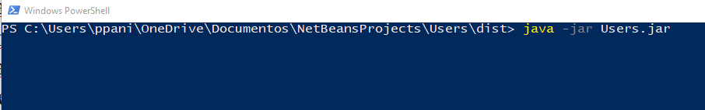

How to use:

The first thing we’ll have to do when starting the application is to authenticate:


when we are already logged into the application whith a user administrator from table authorities (if the file has already been executed we have two possible users admin and admin2) already appears all the options:

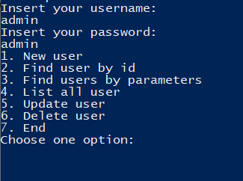
If we select option 1, The application prompts you the first name, last name and iban of user account.
the system will validate that we include all those fields and and also that the ban does not exist, in that case the user will be created.
For example:

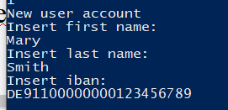

We can check that it has been correctly inserted into the database:



If we want to search by id this user account we choose the second option and to insert the id, in this case the id is 19:

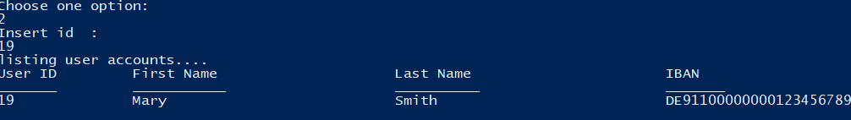
If we want to search for several fields, then we choose the option three. The application will ask us if we want to search for each of the user account fields of user account and then the applciation will return the results of the search in database:

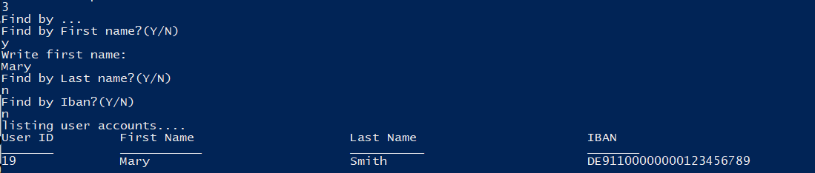
If we want to show all the user account in the system (only those user accounts created by the user administrator logged) the wue choose the option 4:

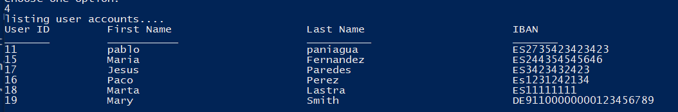
If we want to modify a user account we select option 5.Initially we insert the id of the user account to modify. The application will ask us for each new field value, if we want to modify and the new value in the affirmative:

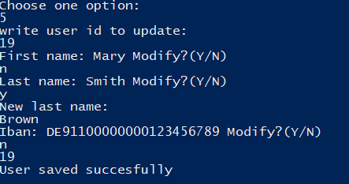

We checked in database that the last name has changed:

If we want to modify the field iban, then the application will check that the new iban is no exist in another user account:
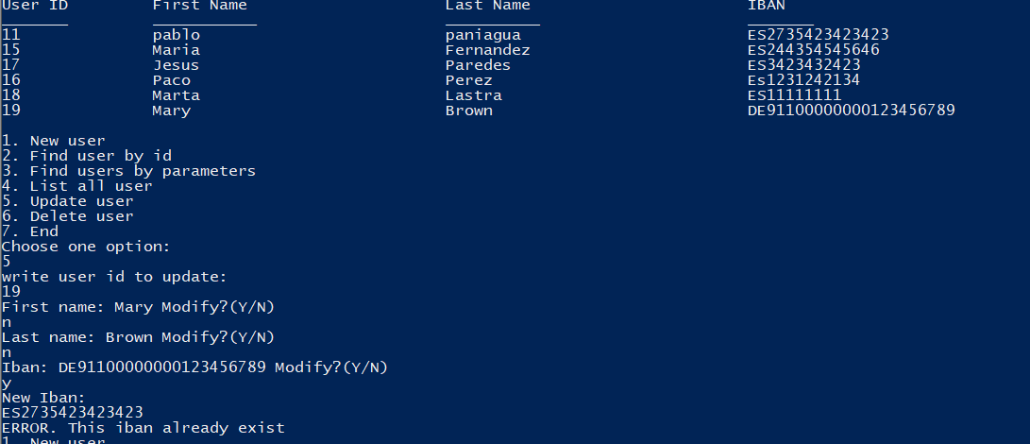
If we want to delete a user account that we've created before, then we select the option 6, to insert the id to delete and then we check that it no exists in the system:

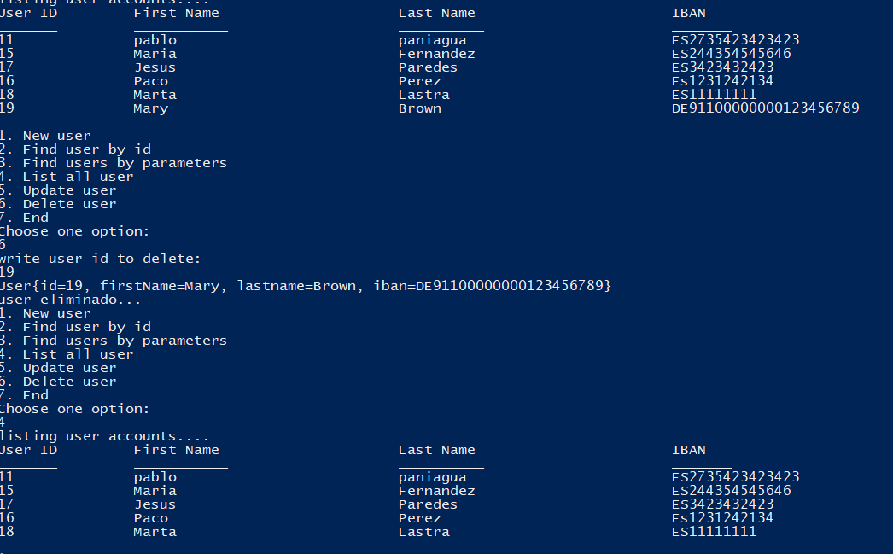

And finally if we want to leave the application we select the 7.

Tests

In addition I have developed 4 junit tests using version 4. Cada uno realiza un test sobre cada operación del Each one performs a test on each operation of the crud:

TestNewUserAccounts: to prove the insert of new user account. We insert a new user account and then to use the user’s parameters to verify that it exists in database.

TestGetUserAccount: to prove the reading of user accounts. We created new user accounts and we'll use user parameters to recover it from database with administrator user who created it. The we'll try to recover with another administrator user to check it isn't possibly.

TestModifyUserAccount: to test the modified of user account. We recover from database a user account and we'll modify it. We will use the user’s parameters and verify that it update in database.

TestDeleteUserAccount: to prove the delete of user account. We created new user accounts in database and then we delete it and we'll use user account parameters to check that it don´t exist in database.

