Link: <https://mercury.swin.edu.au/cos10026/s104188405/lab10/addcar.html>

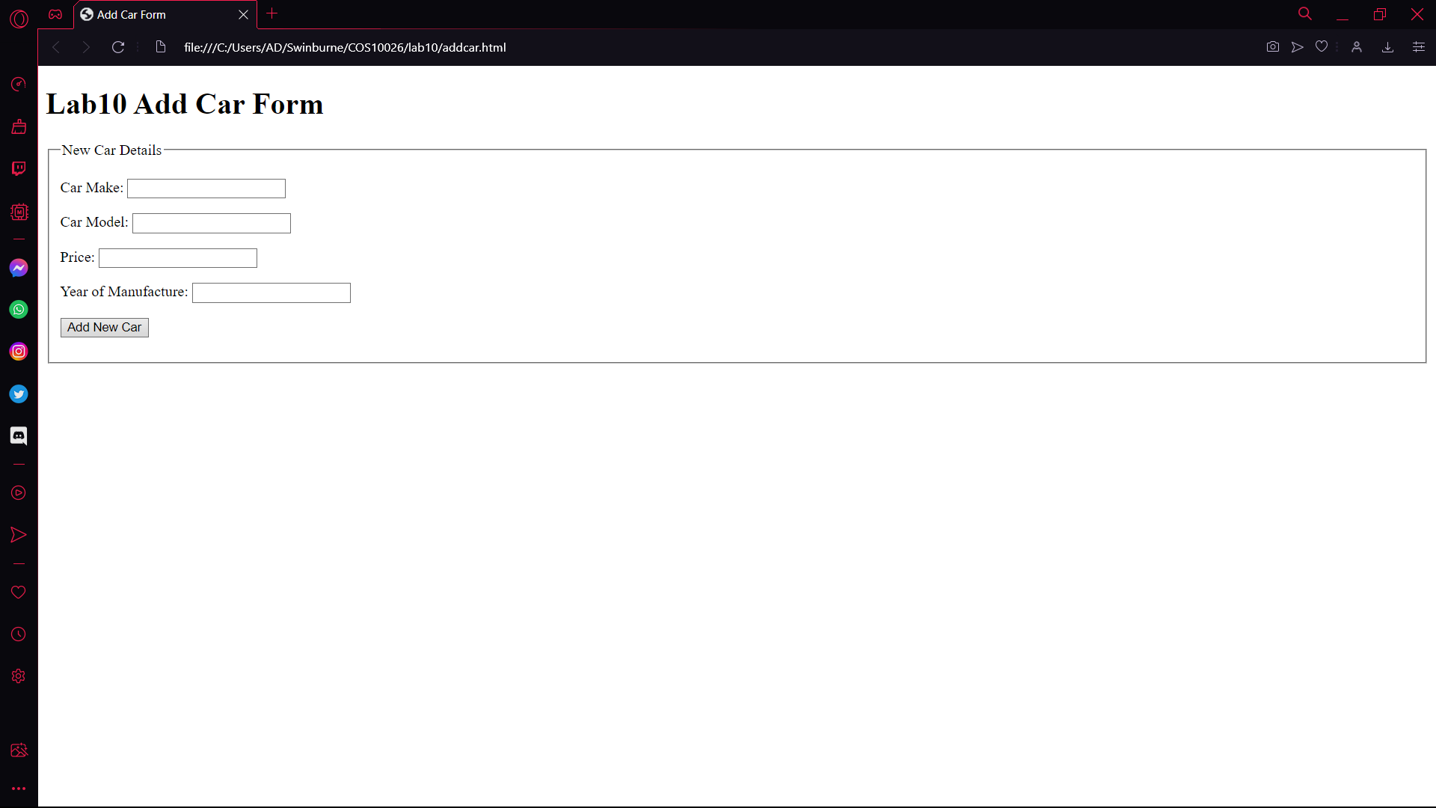

Link: <https://mercury.swin.edu.au/cos10026/s104188405/lab10/search_car.html>

